**SHOE-NERATOR: AN ADAPTIVE PIEZO ELECTRIC TECHNIC**

**ABSTRACT**

The commercial uses of the electronic gadgets are progressing in the human life, At the same time power requirement for the gadgets are also increasing tremendously which is provided by primary electricity supplies. This leads to increase in energy demand and creates more indirect effects in the environment. The alternative way to charge these electronic gadgets is by producing green energy with cost free technology. The keynote now–a-days is everyone having power bank in their hands powered by electricity supply. Piezoelectric crystal will be a better replacement for primary electric supply and carrying battery banks. The piezoelectric crystals are playing major role in charging the smart phones, they are user friendly to the consumers who are using piezoelectricity. This can be made very effective through a pair of shoe and piezoelectric crystals. When we are walking on the piezoelectric crystal placed in shoe bottom, it produces the dc voltage which is used to charge the battery, due to the piezoelectric effect. The charging of the battery is made possible by additional circuits connected with the piezoelectric crystal. While walking, continuous implication of mechanical pressure impacts the crystals placed appropriately in the shoes, will continuously charge the battery. This sort of continuous process is obtained when we are going for walking, jogging or even for office uses, where the novel adaptive technology is placed. This is a compact equipment so that the user can take it anywhere, even at the reserved forest and some remote places where getting primary source of electricity is not possible. The cost of this adaptive technology is much lesser and economical to the users compared to the branded power banks. The main feature of this proposed work is to charge devices using green energy and also to ensure the availability of electric energy anywhere in the world. The piezoelectric crystal will be a better carrying replacement for the electric supply by the State electricity board and conventional power banks.

**I INTRODUCTION**

**1.1 MOTIVATION FOR THIS PROJECT**

Electronic devices play a vital role in everyone’s rotten life. Electronic devices such as mobile phones, laptops, tablets and so on are necessary charged often for their proper functioning and this is where terrible mistakes happen. These mistakes lead to loss of energy. Moreover, we cannot expect the required power supply for charging the electronic devices. To

overcome such obstacles our ideology named shoe-nerator is introduced. It is purely based on generation of electricity using green energy and without using any fuel.

**1.2 THE IMPECCABLE MISTAKES**

According to measurements from **Lawrence and Berkeley National** **Laboratory**, the average cell phone consumes 3.68W power from the outlet while it is charging and 2.24W while fully charged. In cases like over juicing your mobile phone which is fully charged for the entire night. As a result, the phone is charged for the eight unnecessary hours and so an average of 0.18kWh of electricity is wasted. If this happens for one entire year, the grand total of 65kWh of electricity is wasted. Another dreadful wastage of power is carried over by almost everyone by leaving his/her phone charger plugged in all the time even when the phone itself isn’t attached. By the figures from **Berkeley Laboratory**, it can be stated that if the charger is plugged in for the entire 8760 hours of an year it will use about 23kWh of electricity.

**1.3 INNOVATIVE IDEOLOGY**

We humans averagely spend, 0.59kJ of energy for walking. Our ideology concentrates on using this energy effectively for the cumulative generation of electricity and thus using it for charging the electronic devices. This ideology is made possible by the application of the concept piezoelectricity generation. Highly advanced technological and electronical development, the hydrogenic super capacitors(capacitors with short charging cycles and long discharging cycles) is used. This piezoelectric crystal is placed in particular positions in the sole of the shoe such that maximum pressure is efficiently applied on them. The unused energy spend by human beings are in necessary form to convert that mechanical energy in to the electrical energy.

**EXISTING SYSTEMS**

Power banks are current technological option for charging the mobile phones at places where no electric transmission is possible. Obviously, power banks too require electric power to charge in similar way as mobile phones. As a matter of fact all the loses that we discussed suits to this too.

One more such emerging source is the concept of wireless charging of the electronic device. Unconditionally this technology has the disadvantage of loss of energy in the form of radiation.

**HYDROGENIC SUPERCONDUCTOR**

These are highly advanced, cutting edge developing technology that gives us the possibility of everlasting power supply. An actual capacitor has fast charging cycle and fast discharging cycle; a lead battery has slow charging cycle and slow discharging cycle. A super capacitor has the combination of both of its advantages, i.e., it has fast charging cycle and slow discharging cycle. As for example, it charges in less than 500 cycles whereas a normal battery charges in about 5000 cycles and to our fascination, a super capacitor discharges in highly slow rate which is approximately 50,000 cycles. The uniqueness of the super capacitor that distinguishes it from the normal capacitors is that it uses electrostatic double layer capacitance and electrochemical pseudocapacitance.

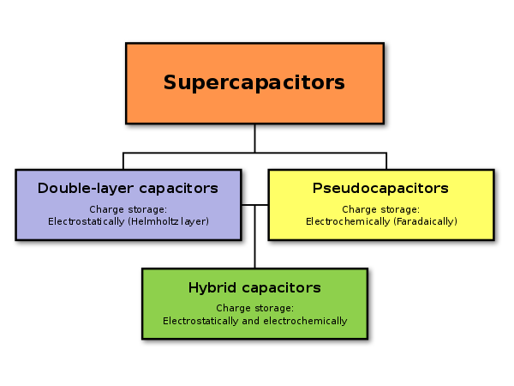

Electrostatic double-layer capacitors use carbon electrodes or derivatives with much higher electrostatic double-layer capacitance than electrochemical pseudocapacitance, achieving separation of charge in a Helmholtz double layer at the interface between the surface of a conductive electrode and an electrolyte. The separation of charge is of the order of a few ångströms (0.3–0.8 nm), much smaller than in a conventional capacitor.

Electrochemical pseudocapacitors use metal oxide or conducting polymer electrodes with a high amount of electrochemical pseudocapacitance additional to the double-layer capacitance. Pseudocapacitance is achieved by Faradaic electron charge-transfer with redox reactions, intercalation or electrosorption.

Hybrid capacitors, such as the lithium-ion capacitor, use electrodes with differing characteristics: one exhibiting mostly electrostatic capacitance and the other mostly electrochemical capacitance.

The electrolyte forms an ionic conductive connection between the two electrodes which distinguishes them from conventional electrolytic capacitors where a dielectric layer always exists, and the so-called electrolyte (e.g. MnO2 or conducting polymer) is in fact part of the second electrode (the cathode, or more correctly the positive electrode). Supercapacitors are polarized by design with asymmetric electrodes, or, for symmetric electrodes, by a potential applied during manufacture.

**DESIGN OF THE PROTOTYPE**

The basic blocks of the prototype is explained by the following block diagram:

1.A series of 6 pairs of piezoelectric generators such as conventional piezoelectric crystals are placed in the region of high pressure experience in the sole of the shoe.

2.The series of piezoelectric crystals is directly connected to the super capacitor.

3.The output is taken from the super capacitor and fed to the electronic device (say mobile phone) through a normal USB cable which is readily available anywhere.

The highlight of this prototype is that every component of it is economic, durable and highly compatible.

**WORKING:**