***Scada For Power System Automation***

* Automation of power distribution system has increasingly been adopted by power utilities worldwide in recent years. As part of its efforts to provide a more supply to the customer and to enhance operational efficiency.
* The automation of the power system can be achieved by SCADA. It is a boon to the automation concept of dynamic technology.
* SCADA refers to “SUPERVISORY CONTROL & DATA ACQUISITION.

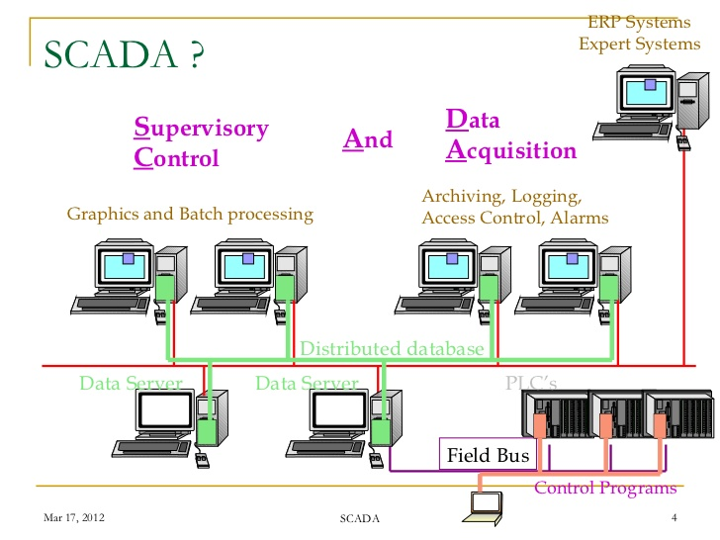

* This paper the approach adopted in implementing the SCADA system and the benefits accrued through incorporating system.
* Electric power distribution system is an important part of electric power system in delivery of electricity to consumers.
* Electric power utilities worldwide are increasingly adopting the computer aided monitoring , control and management of electric power distribution system to provide better service to electric consumers.

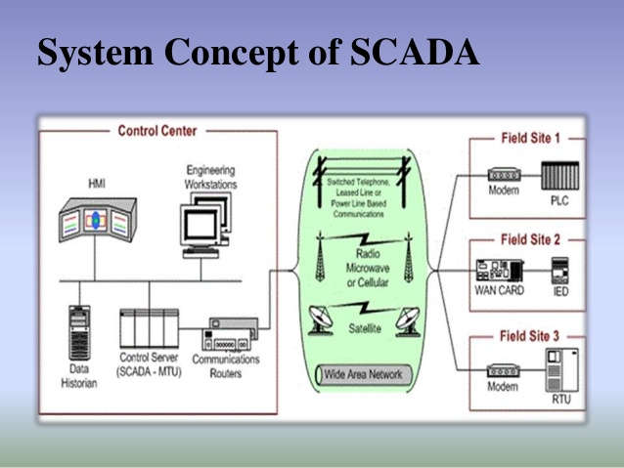

* Therefore research and development activities worldwide are being carried out to automate the electric power distribution system utilizing recent advancement in the area of information technology and data communication system.
* Our ultimate aim is to reduce the cost but more user friendlier environment. This may be small step for us, we hope this may be a giant leap for the power sector.

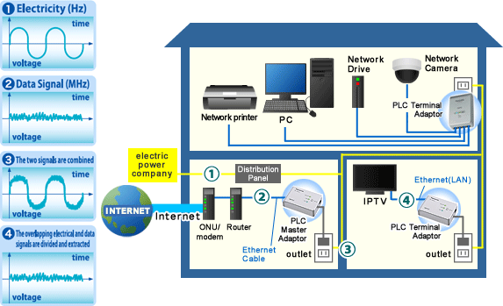

* A computer based SCADA system equipped with

automated generation control function is proposed.

* To supervise and control generation and transmission system as well as to cater for their increasing sophistication in system operation and co-ordination. In order to serve such a high number of RTU by a control center and to avoid any communication bottleneck at the master station, a distributed system approach is suggested.

* This paper deals with the implementation of high frequency digitally controlled PWM pulse generation using VLSI technology. The rapid progress in motor control and micro electronics has made the dc drives a major field of interest. The existing control schemes have many drawbacks.
* In phase angle control, extinction angle control, symmetrical angle control schemes, the lowest order harmonic is third, and is very difficult to filter out the lower order harmonics. Also input power factor of controlled converter decreases as firing angle increases. Lower order harmonics can be eliminated or reduced by selecting type of modulation for width and number of pulses per half cycles.
* Though lower order harmonics are eliminated by PWM control schemes. The analog or microprocessor based PWM control schemes have their own drawbacks. The analog control methods have various drawbacks such as temperature drift, aging susceptibility to electro magnetic interference.
* Some digital control methods also had many drawbacks. Firstly, discrete principally RAM and counter are combined together switching times are calculated and stored in RAM , resulting in simple circuit. However frequency of motor speed is difficult to control and is not compact. Secondly, to obtain higher switching frequency, a fast processor such as DSP is necessary resulting in high cost and also a long time is required to develop software circuit, which generates lot of noise, resulting in hign risk of collapse.
* Dynamic and ever progressing change in VLSI has radically affected the design process cheap, reliable time saving. Moreover the FPGA based design is more reliable than microprocessor based system and they don’t need any control software.

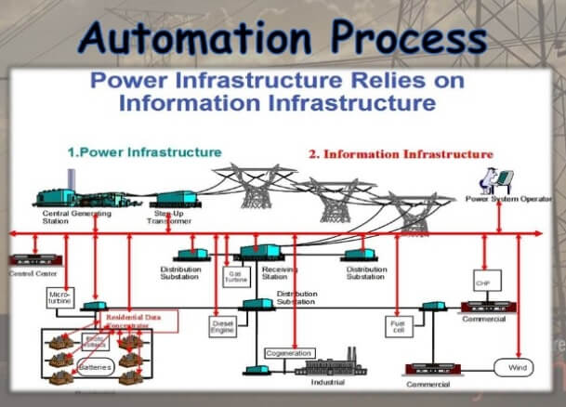

* A single chip for the implementation of modulator ,rather than a system consisting of microprocessor and external memory, as many advantage including less use of power and space, short design time, greater speed, reliability and less electromagnetic interference.
* The conventional implementation of this technique , which had some shortcoming. In the existing control scheme work, a DPWM converter is implemented DC motor load. The AC input is rectified bridge rectifier, DPWM is obtained by power transistors.
* A high frequency DPWM controller IC designed by VLSI technology generates driving pulses required by power transistors.
* The average value of output voltage is varied by varying width of pulses, which is done by varying width of driving pulses from DPWM, Since firing angle is not changed in this method, power factor is maintained unity.

THANK YOU FOR READING OUR THESIS

# 

# -THALLA BHAVANI

# -ANJU RIJU

# -AMANAGANTI SRAVYA

(CMR College Of Engineering And Technology , Medchal , Hyderabad )

# 

# 