**ABSTRACT**

**TITLE: SELF HEALING MATERIALS FOR AIRCRAFT APPLICATIONS**

A composite material that is used in **aeronautical engineering** has limitations about maintenance. Any damage that happened in composite materials requires different methods of maintenance. Composite materials have damage tolerances in normal conditions. According to damage degree that is possible to maintain related part. In normal conditions scarfing and making patches are common methods for composite material repairing.

However, there are new material types and technologies for composite materials. Self healing technology for aircraft structure is one of them. By using healing technology on composite materials that is possible to have advanced maintenance capabilities. Combining self healing structure with alternative materials can star new era of design.

Human body has healing function. Any organ or our skin of our body can heal itself. This situation is possible for materials. Concept of self healing materials has basic ideas behind itself. The technology of self repairing technology has functional agents and structures. Functional agents that used during self healing process have biomimetic capabilities. Fiber structure of composite led having healing capabilities during any damage.

It is possible to use self healing composites as healing agent. By this way aerospace engineers can increase lifetime of any aircraft part.

Beginning of failure has critical situation in engineering. Initial and propagation of damage can result failure of different parts. Crack on the surface can go deeper in any case. But preventing any crack that is on the surface can help increasing lifetime of related part.

Self healing technology that is used in aeronautical engineering materials has two main ideas. One of the self healing technologies basic is nanotechnology. And another self healing technology basic is biological structure.

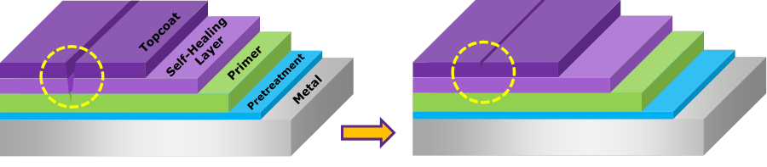

Fiber reinforced composites are common materials that can have self healing capabilities. Using 3D vascular networks in material structure led to have healing capabilities. Healing agent in composite materials is epoxy resin. Liquid epoxy resin and hardener can reach damage area and heal it.

Research and development studies have huge costs. But it is possible to decrease production and flight costs by using self healing materials. Using composite materials during manufacturing of aircraft can decrease weight by 20%. Maintenance cost can be less. But these inventions and applications need time.

Self healing has 100% success in laboratory applications. That is new smart material type. Beginning stage of damage has major effects on material specifications. Only polymer materials can have self healing properties. Aircraft wings are first places for proper application of self healing composites. In the future self healing aircrafts can be an amazing project. Amazing developments are needed from engine parts to coatings in aeronautical engineering*.*

In fiber reinforced composites some structures has defects that are not easily detected or impossible to repair. Modern aircrafts has a lot of composite materials that have this limitation. Any crack or repair limitation of material prevents widespread usage of composite in aeronautical engineering.