Smart Helmet

**INTRODUCTION:**

Road accidents are on the rise day by day, and in countries like India where bikes are more prevalent many people die due to carelessness caused in wearing motorcycle helmets. Even though there have been continuous awareness from the government authorities regarding helmets and seat belts a majority of the drivers do not heed them.

In order to put an end to this misery we have developed the smart helmet for motorcycle, a way to stop starting of vehicles without wearing helmet or even if the driver is boozed. In addition, it has a great feature of detecting accidents and informs specific people via SMS with location and speed of the bike before the accident occurs with the help of GPS GSM based tracking system, thus aiding ambulance to reach the correct location

.We have implemented all the sensors within the helmet, which will send the information to the module connected with the bike engine wirelessly. A display is provided to monitor the status This smart bike helmet system has two modules, one on the helmet and another one on the bike. Accident sensor, helmet sensor and alcohol sensor are attached with the helmet module and GPS and GSM are connected with the module on the bike that has display to monitor status. These two modules communicate wirelessly using RF transmitter and receiver

**COMPONENTS REQUIRED :**

1.forced sensor resistors

2.lilypad arduino

3.mq-3 alcohol sensor

4.solar charge regulator circuit

5.wireless transmitter-nRF24L01

6.max232

7.gsm module

8.gps module

9.wireless receiver

10.Arm lpc2148

11.lcd display

**Working:**

We already mentioned that we divide a project in two units namely helmet and bike. In helmet unit, the force sensing resister is placed on inside upper part of the helmet where actually head was touched with sensor surface. And alcohol sensor is placed on in front of rider’s mouth. It can sense easily. Solar panels are mounted on upper side of helmet which is in direct sunlight. And the battery and regular circuits was fixed inside the helmet. Secondary controller and RF transmitter circuit was also placed on inside the helmet, antenna are located outside the helmet

**CONSTRUCTION:-**

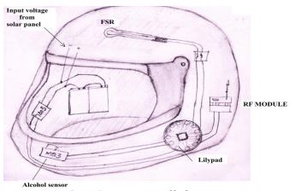

Helmet module

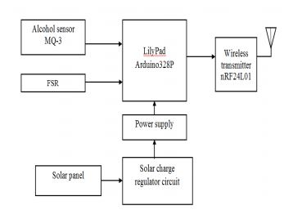

Bike module

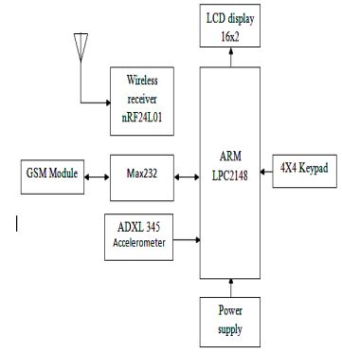

**APPLICATION:**

1.It can be used in real time safety system.

We can implement the whole circuit into small module later.

2. Less power consuming safety system.

3. This safety system technology can further be

enhanced in car and also by replacing the helmet with seat belt.

**FUTURE SCOPE:**

1.We can implement various bioelectric sensors on

the helmet to measure various activity.

2.We can use small camera for the recording the drivers activity.

3. It can be used for passing message from the one vehicle to another vehicle by using wireless transmitter.

4. We have used solar panel for helmet power supply by using same power supply we can charge our mobile.