**TACTILE DISPLAY: SENSE OF TOUCH**

**We are more and more accustomed to interacting physically with technology - using touchscreens for example. We now routinely “thumb-flick” through information on our phones or tablets rather than pressing keys. We thought that this kind of technology needs to be pushed beyond a flat interaction with the screen beneath our fingers - instead we should be able to feel what we are currently touching. Only by doing so can we fully interact with the information we are accessing.**

Behind all of these innovations lies a shared aspiration: to harness the rich sensory possibilities of touch to improve our relationship with the technology we use every day. The ambition is that a sea change in technology will lead to interactions that come naturally to us without the need to learn to use the technology. This means for example that medical students could concentrate on key surgical techniques, rather than on the medical device interface itself. Similarly, car drivers could focus on a safe and pleasurable driving experience rather than worrying about the dashboard controls. New display devices developed in this project will multiply the possibilities for applications of the technology: particularly in terms of teaching aids and in-vehicular interfaces.

[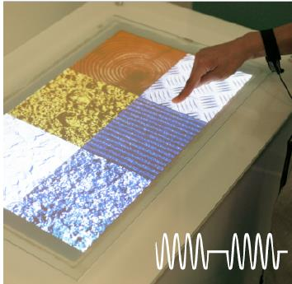](https://www.google.co.in/url?sa=i&rct=j&q=&esrc=s&source=images&cd=&cad=rja&uact=8&ved=0ahUKEwjah_OpuPjYAhXJK48KHQi1DfcQjRwIBw&url=https%3A%2F%2Fwww.researchgate.net%2Ffigure%2F280777071_fig4_Figure-11-TeslaTouch-tactile-display-using-vibrations-to-communicate-textures&psig=AOvVaw07-g9xhCml8TdldoDa3QkC&ust=1517152664523920)

**WORKING OF TACTILE DISPLAY:**

Tactation is the sensation perceived by the sense of touch, and is based on the skin’s receptors. Touch is a common medium used by the general population and the sensory impaired.

The tactile display is based on electric stimulation of the mechanoreceptors’ nerve fibres through the skin at the fingertip. In that manner, the tactile display shall produce the same feeling as mechanic stimulation of the receptors. The skin nerves can be stimulated through six types of receptors by mechanical, electrical, or thermal stimuli. Modalities, such as vibration and pressure, can stimulate these receptors. Advances in tactile communication using implementations of the actuating devices have been developed via several new technologies which include static or vibrating pins, focused ultrasound, electrical stimulation, etc.

The design and control of flat screen tactile feedback displays are based on the control of the friction like for an example, A step increase in the friction will provide the illusion of a step. The friction is decreased by out-of-plane ultrasonic vibrations and increased by electro vibrations. Analytical modelling coupled with tribological measurements have established that vibrations induce intermittent contact with the finger, which reduces the friction either by reducing the dwell time required for establishing strong intermolecular interactions or by a **deocclusion mechanism** (the friction of the finger pad increases during contact with a flat screen display due to the accumulation of sweat that softens the finger print ridges, which is known as an occlusion mechanism.)

[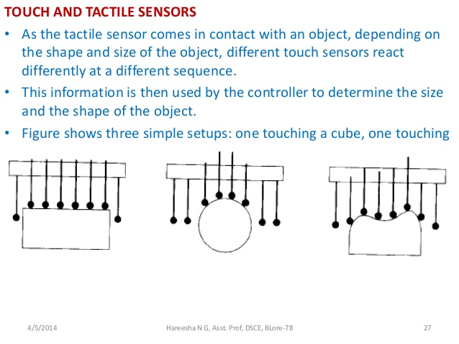](https://www.google.co.in/url?sa=i&rct=j&q=&esrc=s&source=images&cd=&cad=rja&uact=8&ved=0ahUKEwipmOKCufjYAhXIN48KHYTPA90QjRwIBw&url=https%3A%2F%2Fwww.slideshare.net%2Fhareeshang%2Funit-8-sensors&psig=AOvVaw3VwJ7yonKhzwMP3LX6P67C&ust=1517152821107014)

**APPLICATIONS:**

* In medicine, these make it possible for a surgeon to feel palpated tissue during minimally invasive surgery.
* Tactile substitution can be used by the blind or deaf in order to:  
  (i) Enhance access to computer graphical user interfaces.   
  (ii) Enhance mobility in controlled environments.
* For other experience purposes.