**DESIGN AND REAL-TIME IMPLEMENTATION OF AUTOMATIC POLYBAG**

**THREAD CUTTING AND COLLECTING PROCESS**

**Mr.M.Nirmal Raj1,Mr.D.Saravanan2,Mr.C.Sathish3**

**UG Scholars,Department of Mechatronics Engineering,Kongu Engineering College,Erode-638052**

**ELAN ID:EN18IITH002471, EN18IITH013802, EN18IITH003103**

**TEAM ID: EN18IITHT0112**

**Emailid:nirmalraj610@gmail.com1,saravanansds0912@gmail.com2,sathish131998@gmail.com3**

**Introduction**

Now a day’s polymer sacks are used in both industries and domestic purpose. During manufacturing process the sacks are taken as separate sheets and corners are stitched based on the weight carrying capacity and size into make as sacks. While stitching the bags continuously, the thread between two sacks occurs. The process of cutting this thread is done manually by an additional labor with tailor.

**Objective**

To design and fabricate the automatic sack thread cutting machine for polymer bag sewing machine.

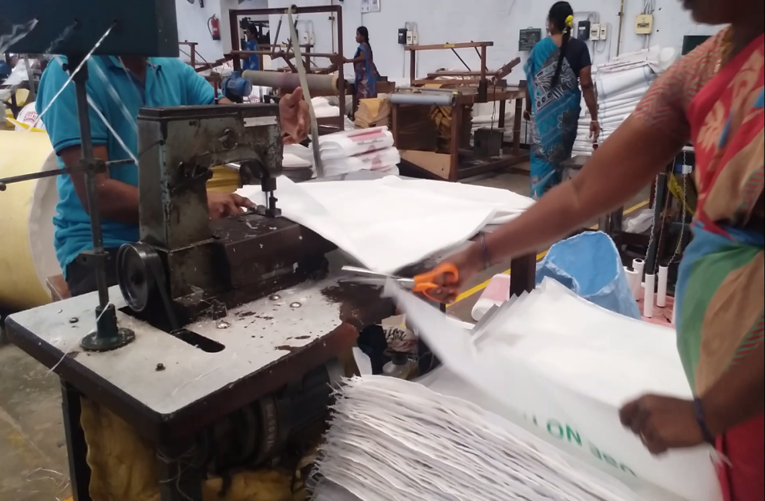

Fig 1.Existing Manual polybag stiching and thread cutting process

**Technical details**

The main scope of the process is to automate the thread cutting process during stitching of the polymer sacks through stitching machine. In the proposed system, the motor used in sewing machine is enough to provide the torque for the roller conveyor setup to run. The single acting pneumatic cylinder with electric heating element actuates the cutter. The gap detection is done by using capacitive proximity sensor. The signal from the sensor helps in the actuation of the solenoid DCV which in turn control the pneumatics. This can be implemented with the help of arduino micro controller. The controller has a single input single output program with only time delay which has less complexity.

The solid works model of the design is shown in fig 2.

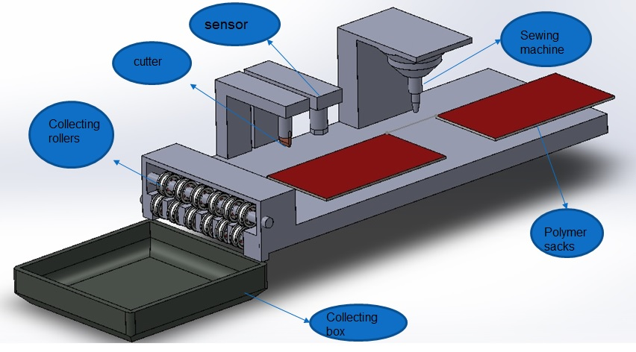

Fig 2.Overall System Design: Solid works

**Market potential**

The project has automated the manual process of cutting of threads hence it eliminates the human interference for the above said process. In the current method the cost of labor rejuvenation is around  [Indian Rupee symbol.svg](https://en.wikipedia.org/wiki/File:Indian_Rupee_symbol.svg).18,000/- per month also they may suffer from a severe back pain while working for continuous working hours. The system is designed economically with an overall cost of  [Indian Rupee symbol.svg](https://en.wikipedia.org/wiki/File:Indian_Rupee_symbol.svg).45,000/-.Hence this project will be economically beneficial to the industries.

**Advantages**

The advantages of the system are as follows:

1. Low cost of manufacturing and easy to maintain
2. The power requirement for the system is very low
3. Human resource Interference and uniform process execution.

The real time photographic view of the project is shown in fig 4.

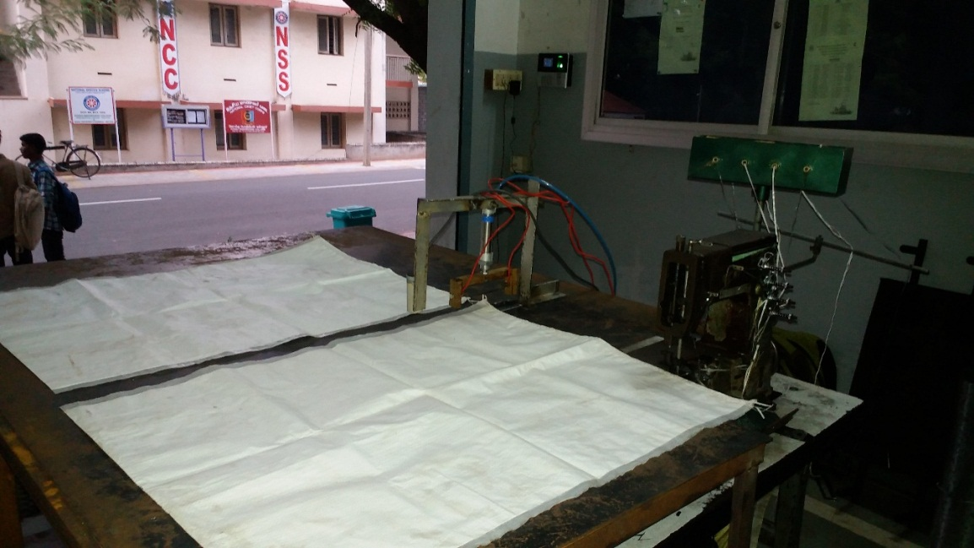

Fig4.Photographic view of the Developed Automatic Polybag stretching and Thread cutting machine

**Conclusion:**

This system provides low cost automation solution for industry which reduces the labor intervention required for the process. By the elimination of separate labor for cutting the thread the fatigue caused to the labors due to severe back pain can be eliminated.

The system can be fully automated by eliminating the use of the tailor. For this the sacks have to be loaded automatically into the sewing machine. A conveyor setup can be designed which takes each sack into the system. By achieving this full automation of the system the distance between the two sacks can also be kept a constant which eliminates any mismatch in the cutting process.