Abstract- The power of Nanogenerator

As the population of the world is increasing exponentially every day, so is the demand for energy to cater the needs of millions.It is certain to create chaos and alter world order if the problem of over exploitation of energy is not resolved amicably. Renewable energy is undergoing a slow death whereas the non-renewable resources cannot be completely relied upon, as they take ages to get replenished. The dire consequences of the over-exploitation of energy resources by human beings has landed us in a turmoil whose far-reaching implications can be felt by the future generations as well. Panacea to all the problems engulfing the ongoing battle of energy crisis comes from the technology that has aggravated its usage in the first place. The scientists across the globe have been working round the clock to arrive at an efficient way that would foster better energy management and develop advanced energy harvesting devices to maximize the outcome.

Nano-generators are one among such energy devices that are aimed at providing efficient management and generation of power through human gestures like tapping and heartbeat. Power can be generated through these devices just by being alive. The technology mentioned here converts mechanical/thermal energy into electrical energy using either of the three approaches-piezoelectric, triboelectric and pyroelectric. The technology has seen significant advancement ever since it was first developed by Dr. Z.L. Wang of Georgia Institute of Technology in the year 1999. He first used ZnO as the piezoelectric material used in the nanogenerator which has integrated circuit as its internal component. The nanowires having 100 to 300 nanometers in diameter and 100 micron in length are etched onto a substrate on one side, with the other side being connected to an electrode with zigzag pattern on it. As the physical pressure is applied to the device, the nanowire flexes and generates electricity which runs through the circuit energizing it.

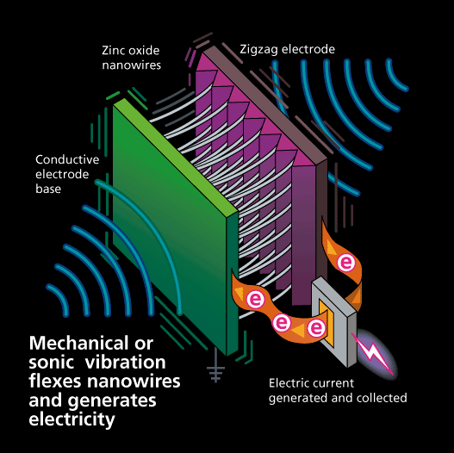Scientists from Clemson University, U.S. have developed a new tribolelectric nanogenerator that can generate over 2,000 volts just by tapping on it and also wirelessly transfer the energy produced to a nearby battery. This is the first time wireless transmission of electrical energy has been achieved and a triboelectric nanogenerator has been directly 3D printed from biodegradable materials. Polylactic acid, a plant derived polymer is an integral part of the generator which has a high electrical resistance. The scientists incorporated graphene to improve the conductivity while retaining the polymers ability to be polarized. The generator is made of graphene-polylactic acid layer on the bottom and a Teflon layer on top. When these two materials with very different electro negativity come into contact, they produce large voltage of 2000 volts with just one hand tap. The two unique frequencies at which the device produces electric field can be used to custom built an inexpensive wireless signal processing circuit with an inbuilt filter which will help avoid interference from the environment including WiFi routers, mobile phones, and AC power outlets.

Nanogenerator finds its use in innumerable applications ranging from smartphones to medicine. While the continuous finger tap can keep the screen of a smart phone charged, it could even help in organ transplants by harnessing the energy of involuntary movement like a heartbeat or lung expansion. Home security applications, control doors, burglar alarms, pacemakers and glucose-monitoring systems are few more practical applications of it.

Presented by-Ranjeetha Thakur, Rashmi Sindhe and Tressa Mathew