**AUTONOMOUS INTERIOR PLANTAION**

**INTRODUCTION:**

Plants are major source of food and they maintain a balanced ecosystem by respiring co2 and expiring o2 into atmosphere. But now it has become one of problem to grow plants due lack of space for gardening. So this is where interior plantation plays a huge role. But due to lack of maintenance of the plantation environment plants may not grow properly. So a device/monitoring system to monitor plant growth will assist the interior plantation to greater extents. Major threats for interior plantation will be proper monitoring of sunlight, water and tracking the plant health at every regular time intervals. By proper monitoring of heat, humidity, and weather conditions this interior plantation can be more productive than conventional plantation techniques.

**OBJECTIVE:**

The main aim of this project is to design an autonomous interior greenhouse which can monitor the plant 24/7 and adjust the environmental conditions around the plant accordingly.

**DESCRIPTION:**

This project has some main units:

**Sensor unit:**

In this unit, the moisture sensor, temperature sensor, and light sensor will detect the conditions like moisture of soil, temperature and humidity, light intensity in greenhouse and stores them in the microcontroller. Microcontroller will send the whole information to Personal computer time to time and it will also send commands to output components.

**Monitor/Log unit:**

In this unit, the information from all the sensors will be logged and send the whole information to the data base for further verification of the plant growth. The information is compiled in this unit and the commands will be sending to plantation accordingly to adjust the environment conditions in green house.

**Plantation control unit:**

In this unit, the changes in green house will be taken place like watering, adjusting light and temperature. The information took from sensors it send to microcontroller and it will send the appropriate outputs through the pump, grow light, heater and fan.

Mainly used components are

1. Arduino Uno 2) FC-28

3) LDR 4) Pump

5) Heater 6) Fan

7) Grow light 8) BMP180 9) DHT22

**GROW LIGHT:**

A grow light is an artificial light source which generates the electromagnetic spectrum which appropriates the photosynthesis of plant.

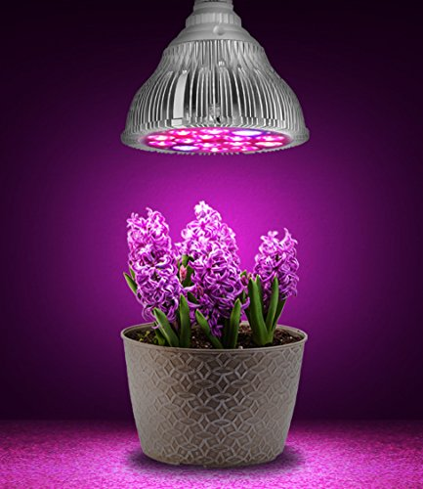

**BLOCK DIAGRAM:  
 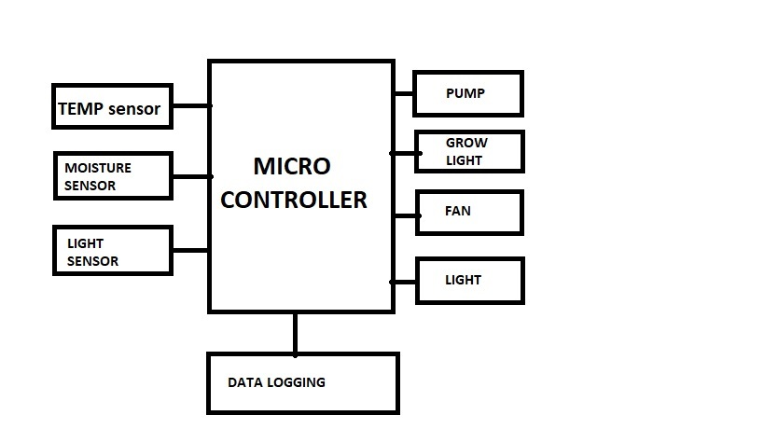**

All the sensors will send the send the information to the microcontroller and the microcontroller will execut the code which is given to it and it will make the output components to respond accordingly. The whole info will be store in database for forther check out.

**RESULTS AND CONCLUSION:**

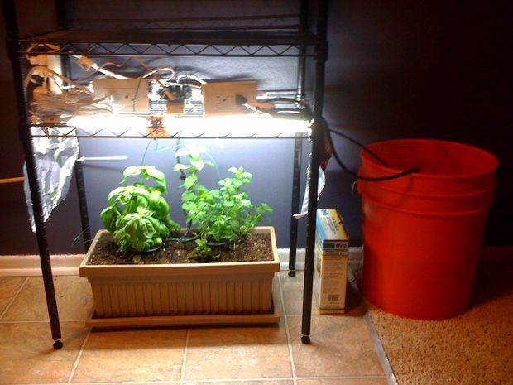

The whole setup is made into a greenhouse and all sensors are adjusted accordingly. This project can grow any type of plant with any weather conditions in home without any human care.

**FUTURE SCOPE:**

The main aim is to support the Indian farmers in advancement of technology in case of agriculture. So the future scope of this project is to make a greenhouse which can control the enviromental condition with cheaper cost in easier method that can be understanble by our farmer.

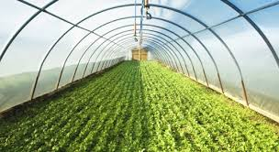

**TEAM MEMBERS:**

**G.RAGHU NANDAN**

**G.SNEHA**

**Y.KALYANI**