**SOLAR CULTIVATION : Solar cultivation is a concept of combining agricultural land with solar power plant. In india by adopting this idea we can make a solar india and can lighten the country .**

**ABSTARCT :**

**Over the past decade, large-scale solar photovoltaic projects have been commissioned in many countries. In countries such as India, where the grid-connected photovoltaic (PV) capacity has gone up from almost zero to 2,600MWp in just four years, one of the key issues that has arisen is land use as agriculture and renewable energy vy for the same resources.** Many experts have expressed that co-location of crop cultivation and solar power generation must be given serious thought, and the idea has been put to test in Japan. In simple terms, co-location sees the land allocated to solar panels used simultaneously for agricultural activities. Rainwater and water used to clean the solar panels can be collected and funnelled along the ground underneath the panels and used as irrigation for plants. Currently, many project developers and engineers in India are implementing this methodology by growing a selection of crops at utility-scale solar power generation facilities.

Solar, a solar energy-focused consulting firm based in Delhi, India, has conducted a study on solar-agriculture co-location. according, even if half of the PV installations projected by 2017 adopted co-location in India, "about 11,200 hectares of land would be brought [under cultivation](http://en.reset.org/knowledge/agroforestry-and-its-benefits)with an addition of 27,000 agriculture and project-related jobs", along with nominal increase in annual project revenue. Another benefit of co-location would be reduction in loose dust, which would improve the efficiency of the solar power plant.

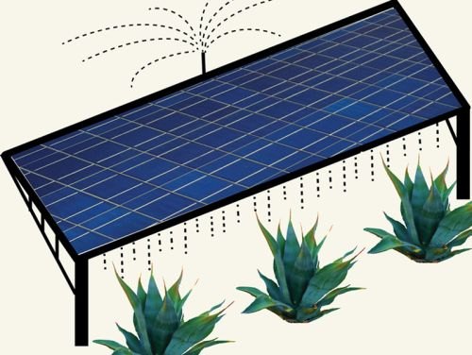 Farmers can now generate solar electricity while growing crops on the same farmland. In April, the Ministry of Agriculture, Forestry and Fisheries (MAFF) approved the installation of PV systems on existing crop-producing farmland. Previously solar generation on farmland, productive or idle, was prohibited under the Agricultural Land Act.

This co-existence or double-generation is known as “Solar Sharing” The rate of photosynthesis increases as the irradiance level is increased; however at one point, any further increase in the amount of light that strikes the plant does not cause any increase to the rate of photosynthesis.

By knowing that too much sun won’t help further growth of plants we came up with the idea to combine PV systems and farming. He devised and originally patented special structure, which is much like a pergola in a garden. He created a couple of testing fields with different shading rates and different crops. The structures he created are made of pipes and rows of PV panels, which are arranged with certain intervals to allow enough sunlight to hit the ground for photosynthesis .

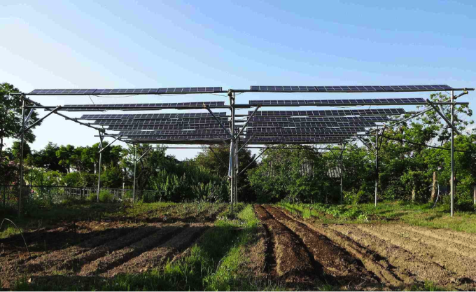

Howeversaid that the point of these guidelines are for farmers to remain “farming” and prevent farmers from fully converting productive farmland to solar facilities. Based on the tests conducted at his solar testing sites in Chiba Prefecture, he recommends about 32% shading rate for a farmland space to reach adequate growth of crops. In other words, there is twice as much empty space for each PV module installed. To ensure continuous farming, municipal agricultural committees require farmers to report annual amounts of cultivation and demand to take down the PV system from the land if the amount of crops cultivated on the solar shared farmland gets reduced by more than 20%, compared to the pre-PV installation.

Many have questioned stability and durability of the PV structure for solar shared family. stated that his systems, which are made of thin pipes without concrete footings, even withstood strong winds and earthquakes during , These systems are extremely lightweight and installation of PV panels are spaced out, allowing air to flow through between the panels. This will eliminate concern that the panels will receive wind load and be blown away, therefore, reducing the need for complicated and expensive mounting hardware.