In order to increase revenue, the Capital Bikeshare program should target specific rider types during critical times. On weekdays, an average of 3,000-4,000 registered riders use the Capital Bikes program, but less than 750 casual riders use the program (Figure 1). We also note that registered rider use peaks between 200 and 400 riders per hour during rush hour windows (0700-0900 and 1700-1900), then generally falls below 200 riders per hour between 0900-1600. During this time, only the average number of casual riders falls between 50-75 per hour, meaning that at least 125 bikes are not being used in that windows (Figure 2). Consider offering a discount to casual riders during this window, and advertising in locations such as the local airports or Amtrak station so more tourists become aware of the offerings.

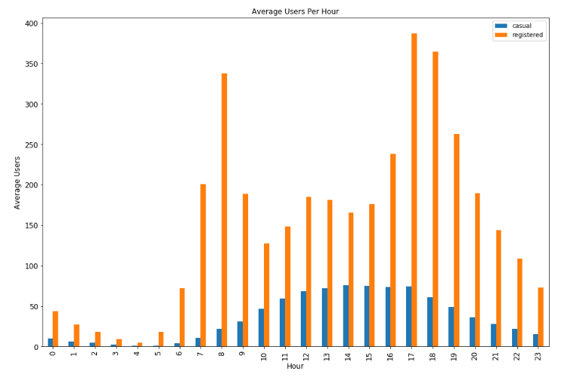 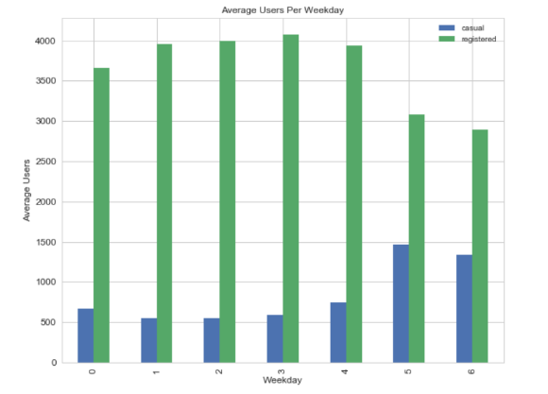

Figure 1. Average users per hour Figure 2. Average users per day

We also see an extremely high correlation to weather and ridership. Daily temperature is the top predictor of total riders per day. During the late spring, the summer, and the early fall months, the weather is generally warmer and more pleasant, and ridership increases. We believe Capital Bikeshare program should increase its product in the summer months, offering “pop-up” or temporary stations, or by augmenting key locations during those months. Conversely, we know that ridership decreases during bad weather. We want to encourage riders to continue using Capital Bike Share during more mild bad weather periods. One easy way to do this would be to add waterproof seat covers to each bike. It would enable the rider to slide the cover off and have a dry seat for his or her ride. Conversely, an advertising campaign specifically aimed at winter months would educate riders who weren’t aware that they could safely bike in the snow.