**DESAIN APLIKASI MOBILE**

**MULTI SCREEN APLIKASI WARUNG E**



**Disusun Oleh**

**Avrino Hanggoro Saputra**

**2055201032**

**PROGRAM STUDI TEKNIK INFORMATIKA**

**FAKULTAS TEKNIK**

**UNIVERSITAS MUHAMMADIYAH BENGKULU**

1. **Desain Aplikasi Mobile Multi Screen Aplikasi Warung E**
2. **Halaman Login**

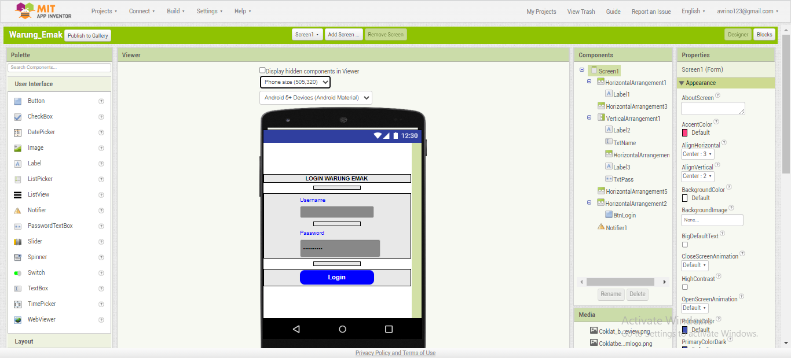

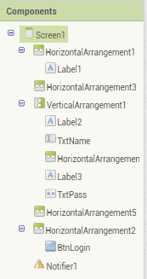

Keterangan Komponen :

1. HorizontalArragement

* Label

1. HorizontalArragement
2. VerticalArrangement

* Label
* TextBox
* HorizontalArragement
* Label
* TextBox
* HorizontalArragement

1. HorizontalArragement

* Button

1. Notifier
2. **Halaman Menu**

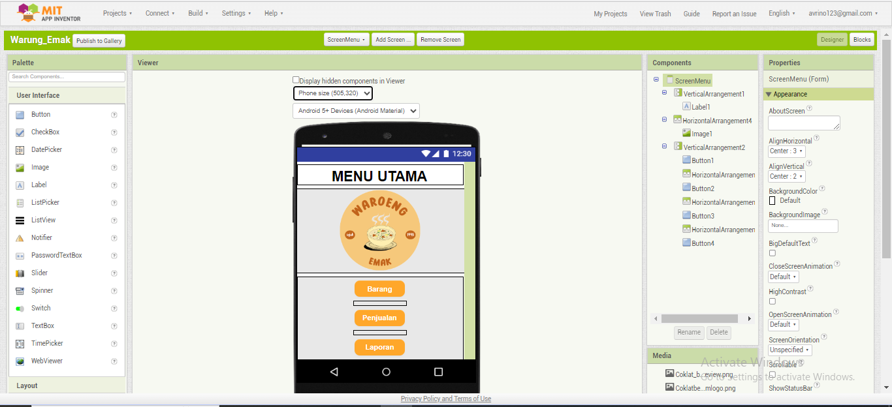

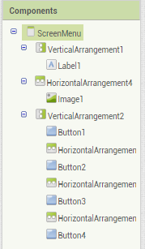

Keterangan Komponen :

1. VerticalArrangement

* Label

1. HorizontalArragement

* Iamge

1. VerticalArrangement

* Button
* HorizontalArragement
* Button
* HorizontalArragement
* Button
* HorizontalArragement
* Button

1. **Halaman Barang**

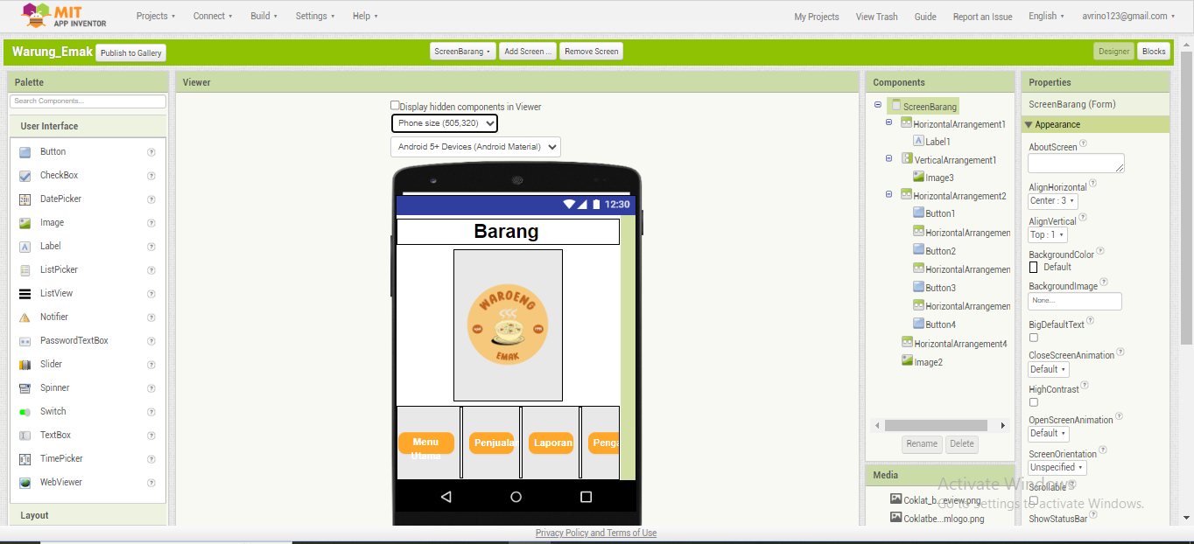

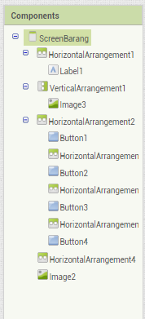

Keterangan Komponen :

1. HorizontalArragement

* Label

1. VerticalArragement

* Iamge

1. HorizontalArrangement

* Button
* HorizontalArragement
* Button
* HorizontalArragement
* Button
* HorizontalArragement
* Button

1. HorizontalArrangement

* Image

1. **Halaman Penjualan**

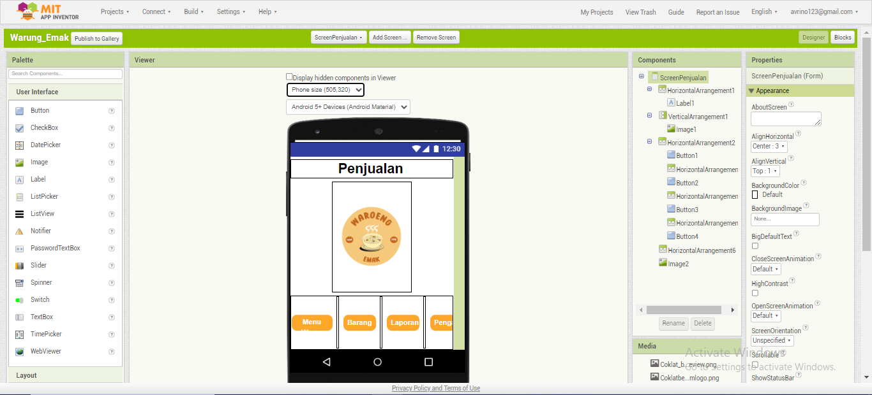

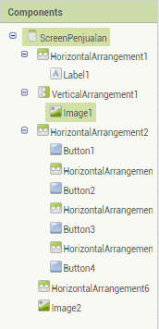

Keterangan Komponen :

1. HorizontalArragement

* Label

1. VerticalArragement

* Iamge

1. HorizontalArrangement

* Button
* HorizontalArragement
* Button
* HorizontalArragement
* Button
* HorizontalArragement
* Button

1. HorizontalArrangement

* Image

1. **Halaman Laporan**

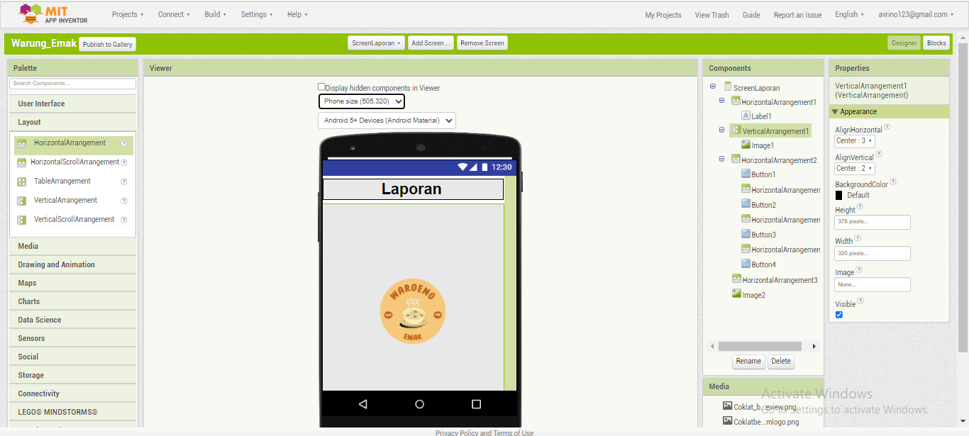

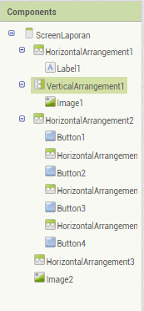

Keterangan Komponen :

1. HorizontalArragement

* Label

1. VerticalArragement

* Iamge

1. HorizontalArrangement

* Button
* HorizontalArragement
* Button
* HorizontalArragement
* Button
* HorizontalArragement
* Button

1. HorizontalArrangement

* Image

1. **Halaman Pengaturan**

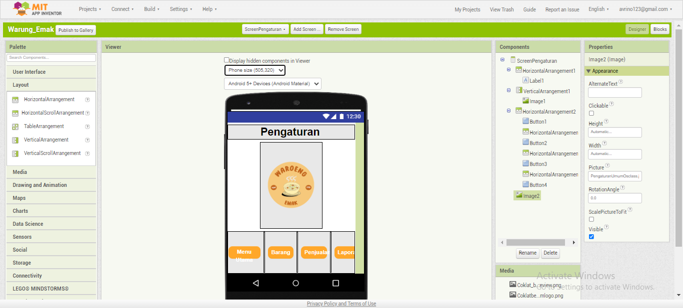

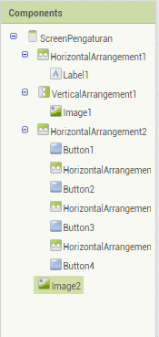

Keterangan Komponen :

1. HorizontalArragement

* Label

1. VerticalArragement

* Image

1. HorizontalArrangement

* Button
* HorizontalArragement
* Button
* HorizontalArragement
* Button
* HorizontalArragement
* Button

1. Image

Link GitHub File AIA Warung Emak :

<https://github.com/avrino/Warung_Emak_MITappInventor.git>