SC2002 Object-Oriented Design & Programming
Restaurant Rush
Group Assignment Report - Design, Diagrams and Evidence
Item | Details (fill in before submitting)
Lab group / Group | [e.g. FCS1 / Grp1]
Members | [Name 1 - Matric]  [Name 2 - Matric]  [Name 3 - Matric]  [Name 4 - Matric]
GitHub repository | [https://github.com/<team>/restaurant-rush]
Tags | stage-1, stage-2, stage-3 (stage-3 = final submission)
Language / tools | Java (compiled with JDK 21, source compatible with Java 11+), no external libraries; PlantUML for diagrams

Contents. 1 Overview and how to run - 2 Diagrams (class, sequence) - 3 Design discussion - 4 Functional evidence - 5 Stage comparisons - 6 Reflections - Appendix: interpretations of the brief.

1 Overview and how to run
Restaurant Rush is a deterministic, turn-based command-line game. The player is the manager of a restaurant with two tables and runs a Host, a Waiter and a Chef each turn (the Cashier works automatically) for 18 turns. Six customers arrive on turns 1, 4, 7, 10, 13 and 16. The game is won if, after turn 18, at least 4 customers have paid, revenue is at least $45.00 and the average recorded satisfaction of paid customers is at least 60.
The game was built in three stages, each a runnable version marked by a git tag. Every stage is a complete game; later stages add behaviour without removing earlier behaviour.
Tag | What it adds | Customers in the reproducible run
stage-1 | Regular customers, menu (Salad $9 / Burger $15 / Pasta $18), Waiter, Chef, automatic Cashier, 2 tables, queue, six-step turn loop, victory/defeat | 6 Regular
stage-2 | VIPCustomer (loses 5/turn, 10% discount) and CriticCustomer (loses 12/turn, always orders Pasta, publishes a review) | Regular, Critic, VIP, Regular, Regular, Regular
stage-3 | Host (seats one extra customer per turn), ComboMeal (two items at 90% of the combined price), Happy Hour (once per game, 2 turns, 20% off new orders, +15 satisfaction to unserved customers at turn start) | same as Stage 2

Build and run
./build.sh # Windows: build.bat (needs JDK 11 or newer)
./run.sh # Windows: run.bat - play interactively
./run.sh < runs/stage3_victory.txt # replay a saved, reproducible game

Commands are typed one line at a time: seat <C#>, order <C#>, serve <order#>, cook <order#>, wait, and in Stage 3 also happyhour. Anything the rules do not allow prints a reason and asks again without using up the staff member's task. Source is organised as rr.domain (rules and entities), rr.control (turn engine) and rr.ui (console only).

2 Diagrams

2.1 Class diagram (final design, Stage 3), annotated
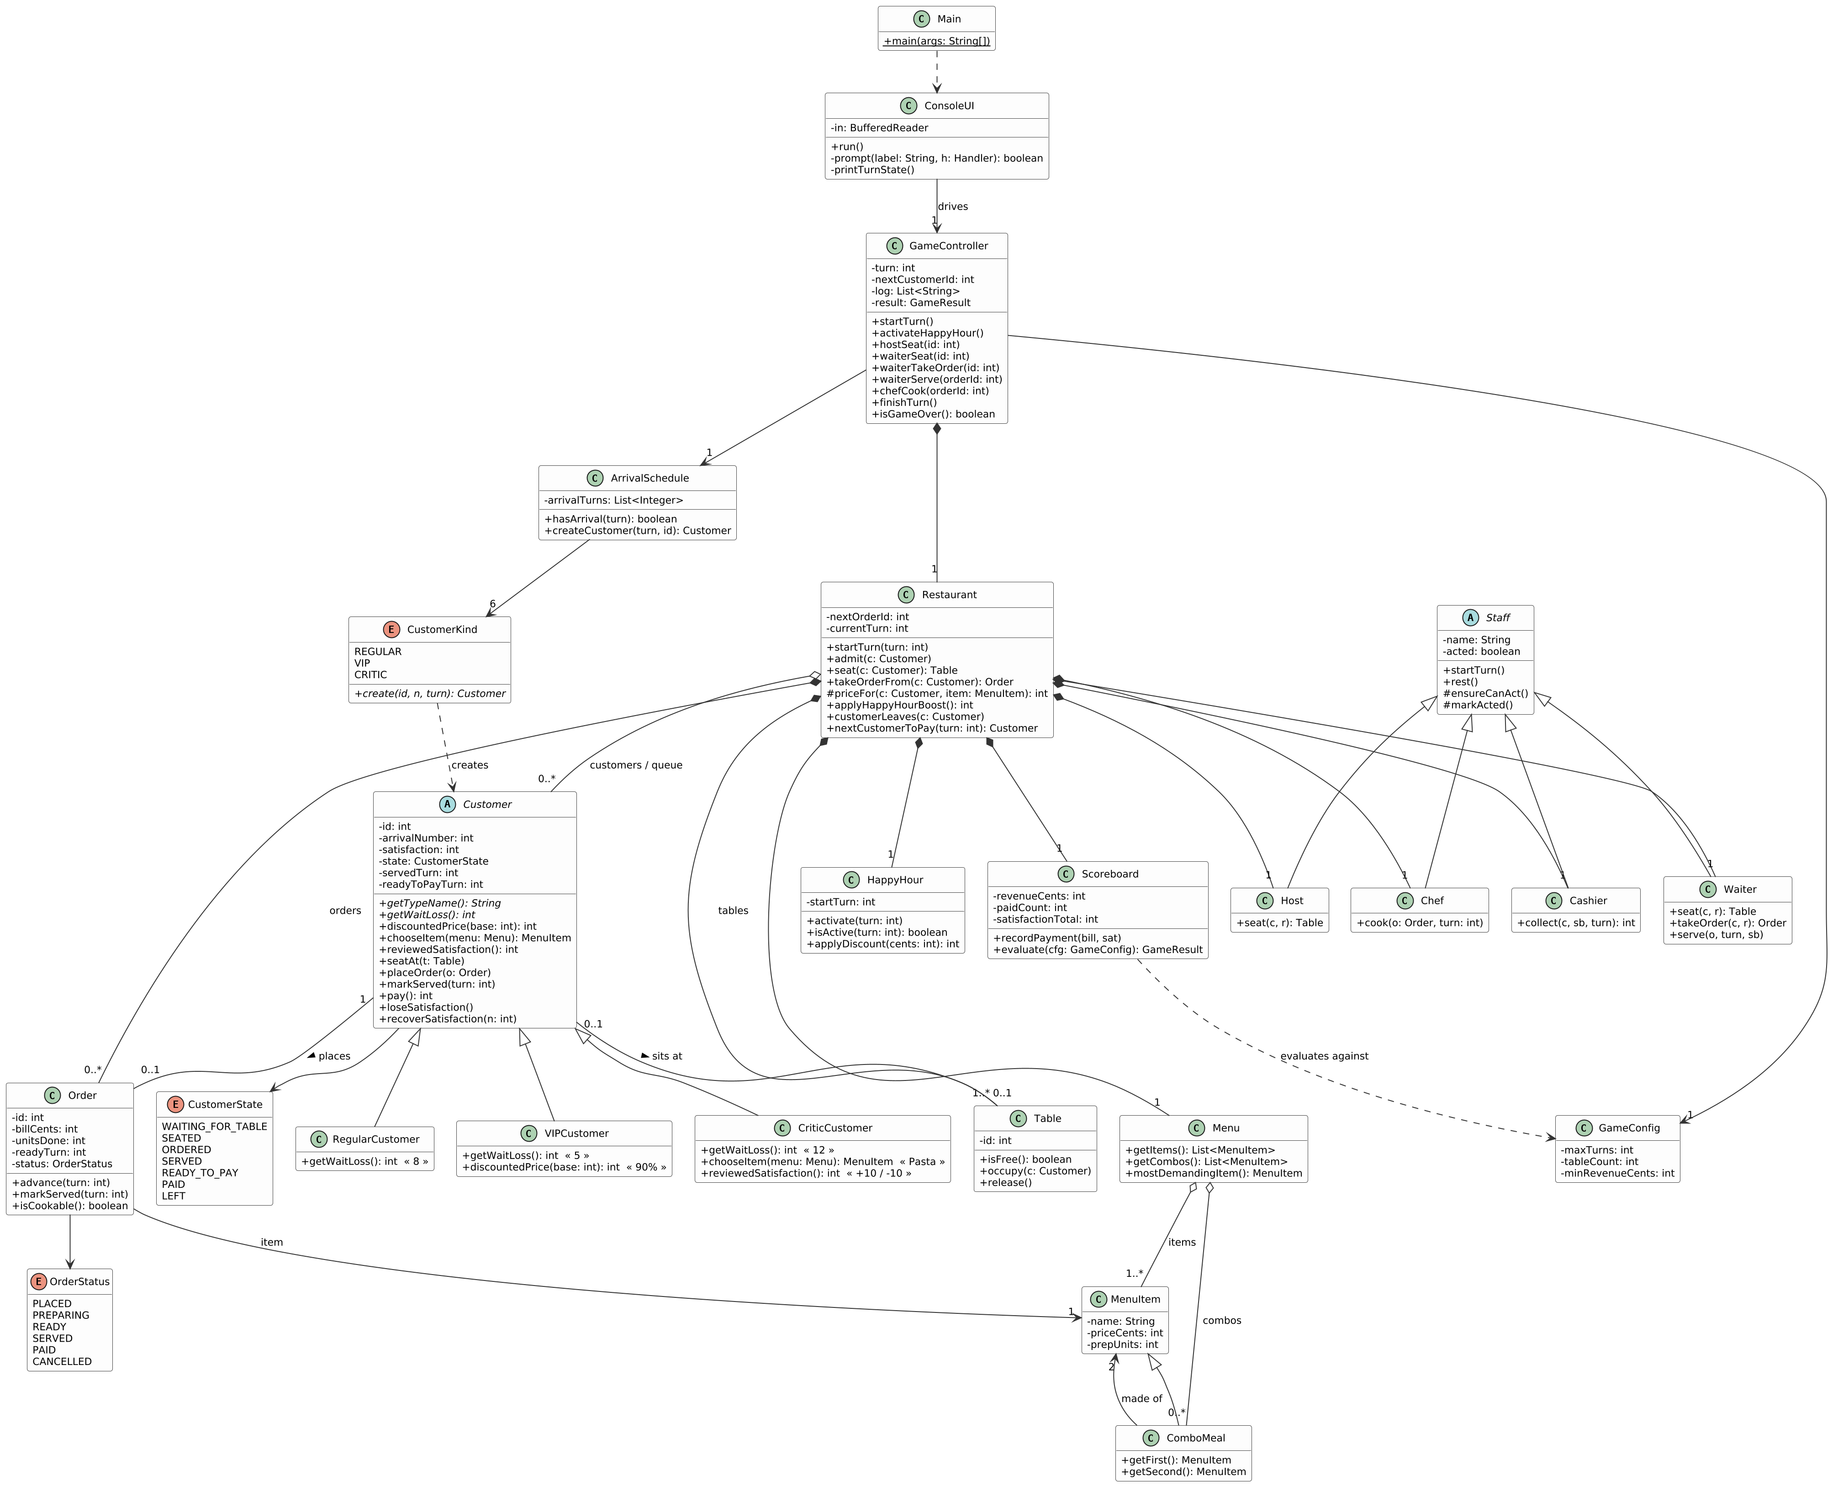  Figure 1 - Class diagram of the Stage 3 code. Visibility: + public, - private, # protected. Multiplicities are on the associations. | Encapsulation  Customer.state and satisfaction are private. The only way to change them is seatAt, placeOrder, markServed, pay, loseSatisfaction; each checks its own precondition and throws InvalidActionException (e.g. placeOrder refuses unless the customer is SEATED). Order.billCents is final, so the price is locked when the order is taken and Happy Hour can never change it afterwards. Staff.acted is private and only reachable through ensureCanAct() / markActed().  Polymorphism  GameController.finishTurn() calls loseSatisfaction(), and Restaurant.takeOrderFrom() calls chooseItem() and discountedPrice(), on a Customer without ever asking what kind it is. RegularCustomer, VIPCustomer and CriticCustomer override getWaitLoss(); VIP overrides discountedPrice(); Critic overrides chooseItem() and reviewedSatisfaction(). ComboMeal is used wherever a MenuItem is expected, so Order, Chef and the bill calculation needed no changes. Each CustomerKind constant overrides create().  Composition and aggregation  Composition (filled diamond): Restaurant creates and owns its Tables, Orders, Waiter, Host, Chef, Cashier, Menu, HappyHour and Scoreboard; GameController owns the Restaurant. Aggregation (hollow diamond): a Restaurant holds Customers that are created elsewhere (by the ArrivalSchedule); Menu holds MenuItems.  Inheritance and abstraction  Customer has 3 subclasses, Staff has 4, MenuItem has ComboMeal. Customer and Staff are abstract: Customer leaves getTypeName() and getWaitLoss() abstract, so a new kind cannot forget to say how fast it loses patience.

2.2 Sequence diagram
Scenario. Turn 7 of the Stage 3 reproducible run (runs/stage3_victory.txt): the VIP customer c3 arrives; the manager decides whether to start Happy Hour; the Host seats c3, the Waiter takes the order, the Chef cooks it over two turns; the dish becomes READY, is SERVED, c3 eats, pays, and the game ends with the result check. The manager's choice that changes the outcome is shown as the alt block: with Happy Hour the VIP's Pasta is billed $12.96 (= $18.00 x 0.9 x 0.8) and c3 recovers 15 satisfaction twice; without it the bill is $16.20 and c3 is recorded at 90 instead of 95 (see section 3.6). Behaviour from Stages 2 and 3 appears in discountedPrice() (VIP override), HappyHour.applyDiscount() and the Host.
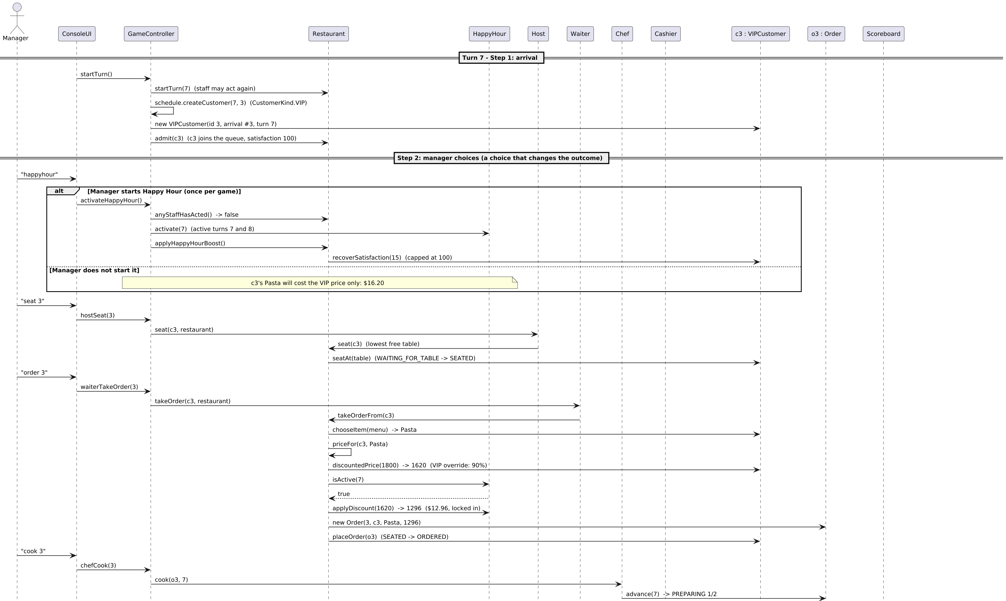
Figure 2a - Sequence diagram, part 1: turn 7, steps 1-3 (arrival, manager choices, order and cooking).

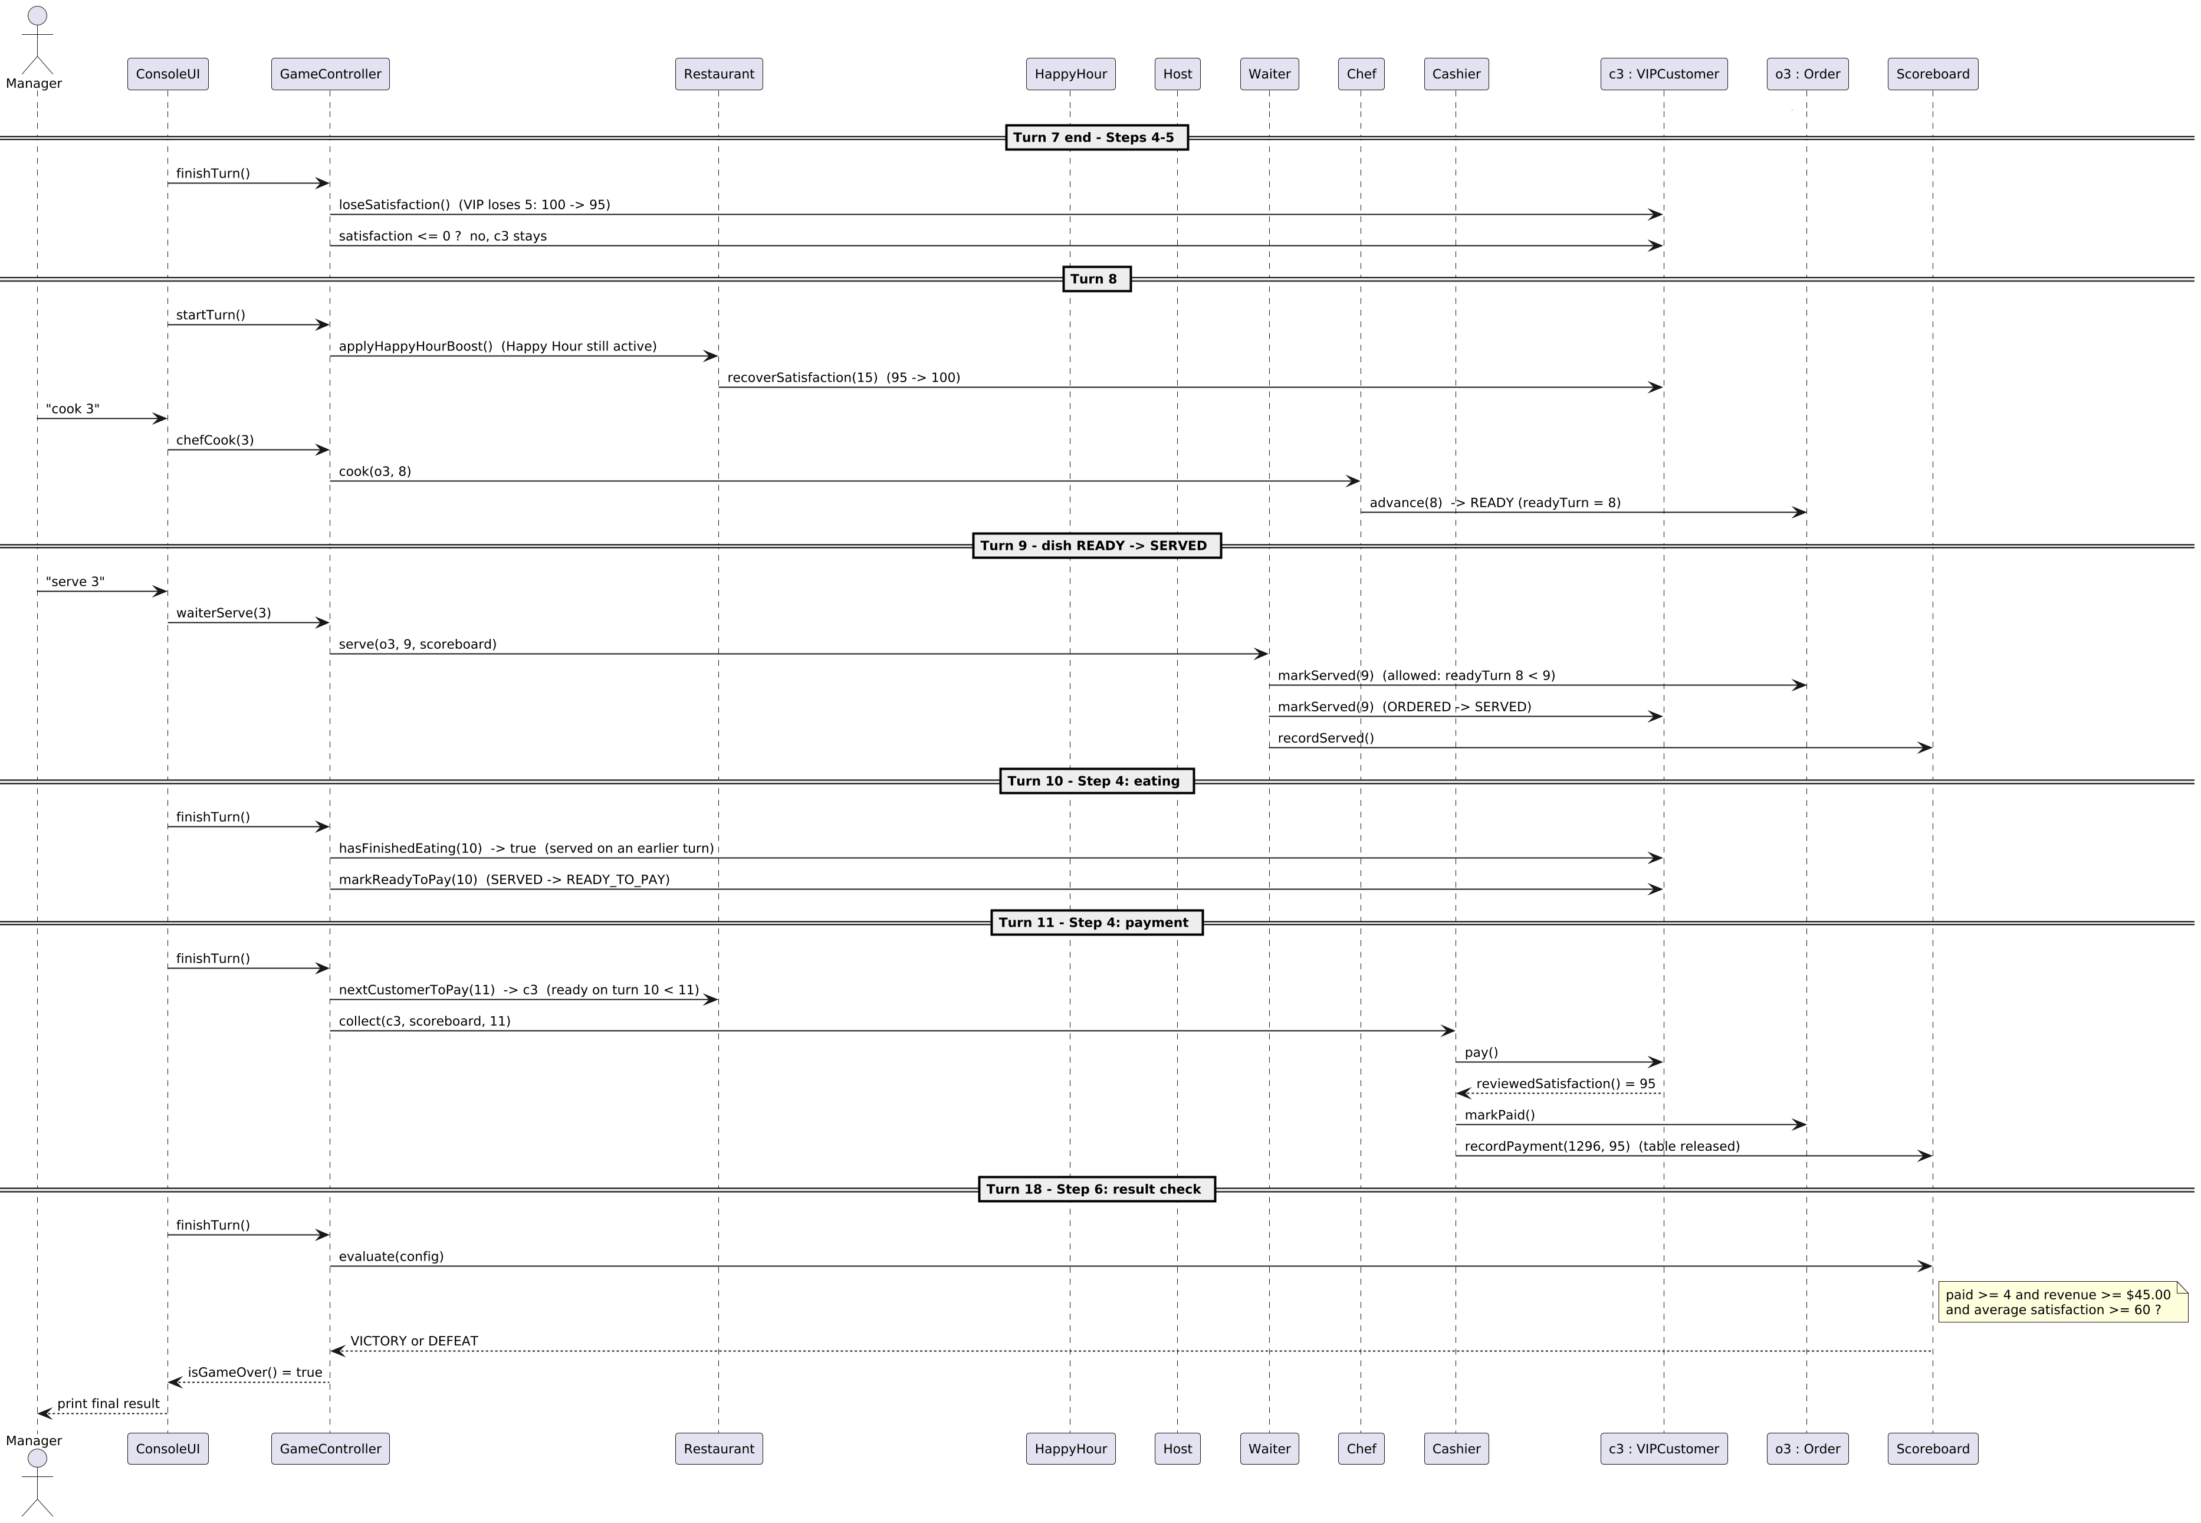
Figure 2b - Sequence diagram, part 2: turn 7 end (satisfaction loss), turn 8 (READY), turn 9 (SERVED), turn 10 (eating), turn 11 (payment), turn 18 (result check).

3 Design discussion

3.1 Abstractions and responsibilities
Class | Responsibility | Why it is its own class
ConsoleUI | Reads commands, prints state, shows rule errors. No rules. | The rules can be tested or reused with another front end.
GameController | Turn counter and the six turn steps in the required order; collects an event log for the UI. | One place that owns "what happens when".
Restaurant | Owns tables, queue, orders, staff, menu, Happy Hour, scoreboard. Seats customers, takes orders, calculates the locked bill, handles walkouts. | Aggregate root: everything that must stay consistent (table occupancy, queue, orders) lives behind one API.
Customer (+ RegularCustomer, VIPCustomer, CriticCustomer) | State of one visit and the behaviours that differ by kind: wait loss, discount, food choice, review. | The variation point of Stage 2. Subclasses override hooks, nothing else changes.
CustomerKind | Builds the right customer for each schedule entry. | Removes if/switch on kind from the schedule and controller.
Order, OrderStatus | Prep progress, status life cycle, locked bill, ready turn. | Enforces "READY this turn can only be served next turn".
Menu, MenuItem, ComboMeal | What can be ordered, price, prep units; combo = 90% of two items. | Stage 3 added ComboMeal by subclassing, not by editing Order or Chef.
Staff, Waiter, Host, Chef, Cashier | One task per turn (ensureCanAct, markActed, rest) plus the role-specific operation. | Makes staff time the scarce resource the player manages.
Table | Free/occupied. | Small, but gives seating a real object to check.
HappyHour | One-time two-turn window, discount, boost constants. | Keeps the feature self-contained and removable.
Scoreboard | Revenue, paid count, satisfaction total, walkouts; decides victory. | The win rule changes in one place.
ArrivalSchedule, GameConfig | Scenario data: who arrives when, table count, targets. | Changing the scenario does not touch game logic.
InvalidActionException, Money | Rule violations carry a player-readable message; money is integer cents with half-up rounding. | No floating-point money errors ($10.80 is exactly 1080).

3.2 SOLID: where it applies, and where it does not
Principle | Evidence in this code | Honest limits
Single responsibility | ConsoleUI only does I/O; Scoreboard only does the numbers; HappyHour only knows its window; Order only tracks one order. | Restaurant has several jobs (seating, ordering, pricing, queries). We accepted this to keep invariants in one place (see 3.4).
Open/closed | Stage 1 to 2 added three classes and changed three small files (ArrivalSchedule, Menu, Main). GameController, Restaurant, Customer, the staff and the UI were not touched. ComboMeal extends MenuItem without editing Order/Chef. | Stage 2 to 3 did modify existing classes (Restaurant, GameController, ConsoleUI, Customer, Menu) because Host and Happy Hour are new rules about the restaurant, not new kinds of an existing thing.
Liskov substitution | Every Customer subclass keeps the contract: wait loss >= 0, discounted price <= list price, reviewed satisfaction stays in 0..100. ComboMeal behaves as a MenuItem. | Host extends Staff but is not a Waiter on purpose; making it a subclass of Waiter would let it take orders.
Interface segregation | Not claimed. We created no interfaces just to tick a box; the only interface is the private one-method Handler in the UI. | With more roles the staff operations might deserve small interfaces.
Dependency inversion | Game logic depends on the abstract Customer and on MenuItem, not on concrete kinds. | The controller still depends on concrete Restaurant and staff classes. We did not add interfaces there because there is only one implementation.

3.3 Turn engine and when choices are applied
GameController maps the six required steps to code: step 1 startTurn() (new arrival, staff task counters reset, Happy Hour boost if active); steps 2-3 hostSeat/waiterXxx/chefXxx; step 4 the first half of finishTurn() (Cashier takes the oldest customer who was READY_TO_PAY on an earlier turn, then customers served on an earlier turn finish eating); step 5 the second half (unserved customers lose satisfaction, at 0 they leave, their order is cancelled and the table is freed); step 6 the result check after turn 18.
The brief separates "manager choices" (step 2) from "kitchen and serving" (step 3). We validate and apply each choice at the moment it is entered, always in the order Host, Waiter, Chef. This gives exactly the required results: the Waiter always acts before the Chef, so a dish that becomes READY this turn can never be served this turn (and Order.markServed additionally checks readyTurn < turn); the Chef can work on an order the Waiter took this turn; an order taken this turn is billed with this turn's Happy Hour status. Applying choices immediately also lets the UI reject an invalid choice on the spot and ask again without consuming the task.
Happy Hour timing. happyhour is only accepted before any staff member has acted that turn (Restaurant.anyStaffHasActed()), once per game. It is active on the turn it is started and the next one. The boost is applied on activation and again at the start of the next turn; prices are locked at order time, so Happy Hour never changes orders placed earlier.

3.4 Trade-offs we made
- Fat Restaurant class. Putting seating, ordering and pricing in the aggregate root keeps table/queue/order invariants in one place and made GameController simple, but Restaurant is the class most likely to grow. Splitting out a Pricing class would be the next refactor.
- Thin staff classes. Chef.cook is only a few lines. Their real job is modelling "one task per turn" and giving Stage 3 a natural place to add Host. We preferred that to an over-designed task framework.
- Deterministic food choice. Food is chosen by a documented rule (arrival number cycles Salad, Burger, Pasta; in Stage 3 even arrivals take a combo; Critic always Pasta) instead of random numbers, so every run is reproducible and the manager can plan. The cost is less variety.
- Enum for customer state, not the State pattern. CustomerState plus guard checks in Customer is shorter and clear enough for seven states; separate state classes would add files without removing any branching we actually have.
- Combo rule inside the customer's food choice. It is a small edit to an existing class (Stage 3) and makes Customer know that menus can have combos. We accepted it rather than add a separate "ordering policy" class for one rule.
- Integer cents. All money is int cents; the only rounding is Money.percentOf (half up), applied in the required order VIP then Happy Hour.

3.5 An alternative design we considered
We considered modelling every manager choice as a Command object (SeatCommand, TakeOrderCommand, CookCommand, ...). The UI would queue a command for each staff member and GameController would execute them in step 3 in the order Waiter then Chef. Advantages: a clean separation of step 2 (choose) from step 3 (resolve), easy logging and an undo option. We rejected it because the Chef's valid choices depend on what the Waiter does in the same turn (an order taken this turn exists only after the Waiter's command has run), so every command would need to be validated against a "projected" future state, which duplicates rules and adds many classes. Applying choices immediately in a fixed role order produced identical game outcomes with far less code. If the game grew to many simultaneous actors, the Command design would become worth it.

3.6 How the manager's choices change the result
Because the Waiter and Host have one task per turn, ordering matters. All figures below come from saved, reproducible runs (section 4):
Choice | Run A | Run B | Effect
Turn 10 (Stage 1): serve the finished Pasta first, or seat the new arrival first? | Serve first (stage1_victory)  C3 recorded 76, average 79.2 | Seat first (stage1_variant_seat_first)  C3 recorded 68, average 77.6 | The customer who has already waited longest keeps losing 8 points per turn. Seating the newcomer first gains nothing because the newcomer is not ordering until the next turn anyway.
Turn 7 (Stage 3): start Happy Hour for the VIP's order? | With (stage3_victory)  bill $12.96, C3 recorded 95  revenue $76.56, avg 89.8 | Without (stage3_no_happyhour)  bill $16.20, C3 recorded 90  revenue $79.80, avg 88.8 | Happy Hour trades $3.24 of revenue for +5 satisfaction on that customer. Both win; in a tighter game the manager would pick based on which target is at risk.
Do nothing at all | stage1_defeat, stage2_defeat, stage3_defeat | - | 0 paid; customers walk out once satisfaction hits 0 (the Critic after 9 unserved turns, a Regular after 13) -> DEFEAT.

4 Functional evidence
Every run is replayable: ./run.sh < runs/<script>.txt prints the same transcript (saved as runs/<script>.out.txt). Stage 1 and Stage 2 scripts need their own tag checked out (git checkout stage-1), because Stage 3 added the Host prompt.
Tag | Script | Result
stage-1 | stage1_victory | 5 paid, $66.00, average satisfaction 79.2 - VICTORY
stage-1 | stage1_defeat (everyone waits) | 0 paid, $0.00, 2 customers walked out - DEFEAT
stage-1 | stage1_invalid_demo | Unknown command, missing number, unknown customer, order before seating, cook with no order, serve before READY: each prints a reason and the same staff member is asked again
stage-1 | stage1_variant_seat_first | 5 paid, $66.00, average 77.6 - victory, but lower than the best line (section 3.6)
stage-2 | stage2_victory (Critic + VIP) | 5 paid, $67.20 (VIP Pasta $16.20), average 78.0 - VICTORY. Critic served at 64 is recorded as 74 (+10 review).
stage-2 | stage2_defeat | Critic leaves at the end of turn 12, a Regular at turn 13, 0 paid - DEFEAT
stage-3 | stage3_victory (Host, combo, Happy Hour) | 5 paid, $76.56, average 89.8 - VICTORY. VIP Pasta $12.96; C4 orders the combo "Burger + Salad" ($21.60, 2 prep units).
stage-3 | stage3_no_happyhour | 5 paid, $79.80, average 88.8 - VICTORY
stage-3 | stage3_defeat | 0 paid - DEFEAT

Excerpt (Stage 1, invalid choices are explained and the task is not consumed):
Waiter> serve 1
[Not allowed] There is no order #1. Choose again.
Waiter> order 1
[Not allowed] Customer C1 is not seated and waiting to order (currently WAITING_FOR_TABLE). Choose again.
Waiter> seat 1
> Waiter seated C1 (Regular) at T1.

Excerpt (Stage 3, stacked discount):
Host> happyhour
> HAPPY HOUR started (this turn and next): orders taken cost 80% of their price; 1 unserved customer(s) recover 15 satisfaction.
> Waiter took C3's order. C3 chose Pasta (order #3, bill $12.96, 2 prep unit(s)).

Requirement coverage
Requirement from the brief | Where it is met
18 turns, 2 tables, 6 scheduled arrivals | GameConfig.base(), ArrivalSchedule
One task per staff member per turn; waiting uses the task | Staff.ensureCanAct/markActed/rest
Invalid choice: explain, choose again, task not consumed | InvalidActionException thrown before markActed(); ConsoleUI.prompt loops
READY this turn can only be served next turn | Order.markServed (readyTurn < turn); Waiter acts before Chef
Eating takes a full turn; Cashier pays oldest first, one per turn, never in the turn the customer became ready | Customer.hasFinishedEating, Restaurant.nextCustomerToPay, Cashier.collect
Satisfaction loss for unserved customers; at 0 leave, cancel order, free table | GameController.finishTurn step 5, Restaurant.customerLeaves
Victory: >= 4 paid, >= $45.00, average >= 60 | Scoreboard.evaluate (integer comparison, no rounding)
Customer kinds without kind checks in the controller | getWaitLoss, discountedPrice, chooseItem, reviewedSatisfaction overrides
Pricing order VIP then Happy Hour, locked at order time | Restaurant.priceFor, Order.billCents final
Money in integer cents | Money, all *Cents fields
State, available tasks and results shown every turn | ConsoleUI.printTurnState, printScoreLine, printResult

5 Stage comparisons
Repository: [https://github.com/<team>/restaurant-rush]. Compare links (replace the placeholder with your repository): .../compare/stage-1...stage-2 and .../compare/stage-2...stage-3. The same information locally: git diff --stat stage-1 stage-2.

5.1 Stage 1 to Stage 2
Change | File | Reason
New | VIPCustomer, CriticCustomer | The two new customer kinds, overriding the existing hooks.
New | CustomerKind | Lets the schedule create any kind without if/switch.
Changed | ArrivalSchedule | Was hard-wired to Regular; now takes a list of kinds and offers base() (Stage 1) and mixed() (Stage 2).
Changed | Menu | Added mostDemandingItem() for the Critic's order rule.
Changed | Main | Uses the mixed schedule.
Deleted | none | -
Untouched | GameController, Restaurant, Customer, staff, ConsoleUI | The new behaviour arrives through overridden methods.

5.2 Stage 2 to Stage 3
Change | File | Reason
New | ComboMeal, Host, HappyHour | The three new concepts, each self-contained.
Changed | Customer | chooseItem also handles combos; recoverSatisfaction for the Happy Hour boost.
Changed | Menu | Holds a list of combos.
Changed | Restaurant | Owns the Host and Happy Hour; startTurn(turn) knows the current turn; priceFor applies VIP then Happy Hour; boost and "has any staff acted" helpers.
Changed | GameController | hostSeat, hostWait, activateHappyHour, start-of-turn Happy Hour boost.
Changed | ConsoleUI | Host prompt, happyhour command, Happy Hour status line.
Deleted | none (a few lines were replaced) | -
Local commits: b8b5561 (stage-1), 087630e (stage-2), a2f5118 (stage-3); the final commit on main adds the report, diagrams and documentation only.

6 Reflections
- What worked. Making the points where customers differ into overridable methods meant Stage 2 touched no game-flow code at all. Writing the saved input scripts early let us check each stage with exact expected numbers.
- What we would change. Restaurant grew the most in Stage 3 and is the weakest part of the design; a separate pricing class and a separate seating/queue class would be the next refactor. The Host being a distinct prompt each turn makes the UI slightly repetitive.
- Surprise. Satisfaction rules interact: the Critic's review can turn a good result into a bad one if the Critic is served late, which makes the "who do I serve first" decision more meaningful than the raw numbers suggest.
- Testing approach. All tests are deterministic replays of saved scripts compared against hand-calculated expectations (for example VIP Pasta in Happy Hour: 1800 x 0.9 x 0.8 = 1296 cents). We did not use a unit-test framework.

Appendix: interpretations of the brief
- The Waiter and Host seat the queued customer the manager names, at the lowest-numbered free table.
- The Waiter may take an order from a customer the Host seated on the same turn, mirroring "the Chef may work on an order the Waiter took this turn".
- "Waiting for food" for Happy Hour and for satisfaction loss means any customer who is queued, seated or ordered but not yet served.
- Critic special behaviour (our design): always orders the dish with most prep units (Pasta); the satisfaction recorded at payment is a review: +10 if at least 60, -10 if below 60 (kept within 0..100).
- Combo rule: even-numbered arrivals order combo number (n/2 - 1) mod 2 from [Salad + Pasta, Burger + Salad]; the Critic still orders Pasta.
- Average satisfaction is compared as total >= 60 x paid (integers), so no rounding can change the result.

