How to add code into the Cordova project

Put everything into the local www folder

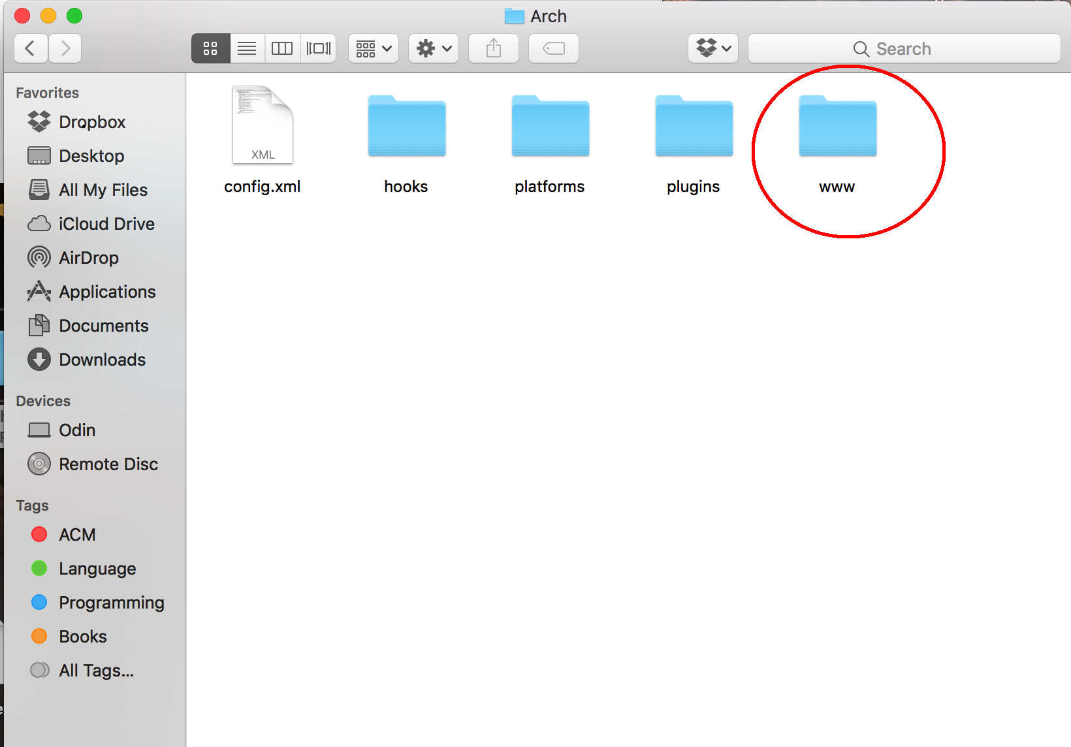

That is where the code is located, and everything should work.

Go to terminal or cmd

Switch to the directory, in this case it would be “Arch”

enter “cordova run browser” to emulate this in your browser.

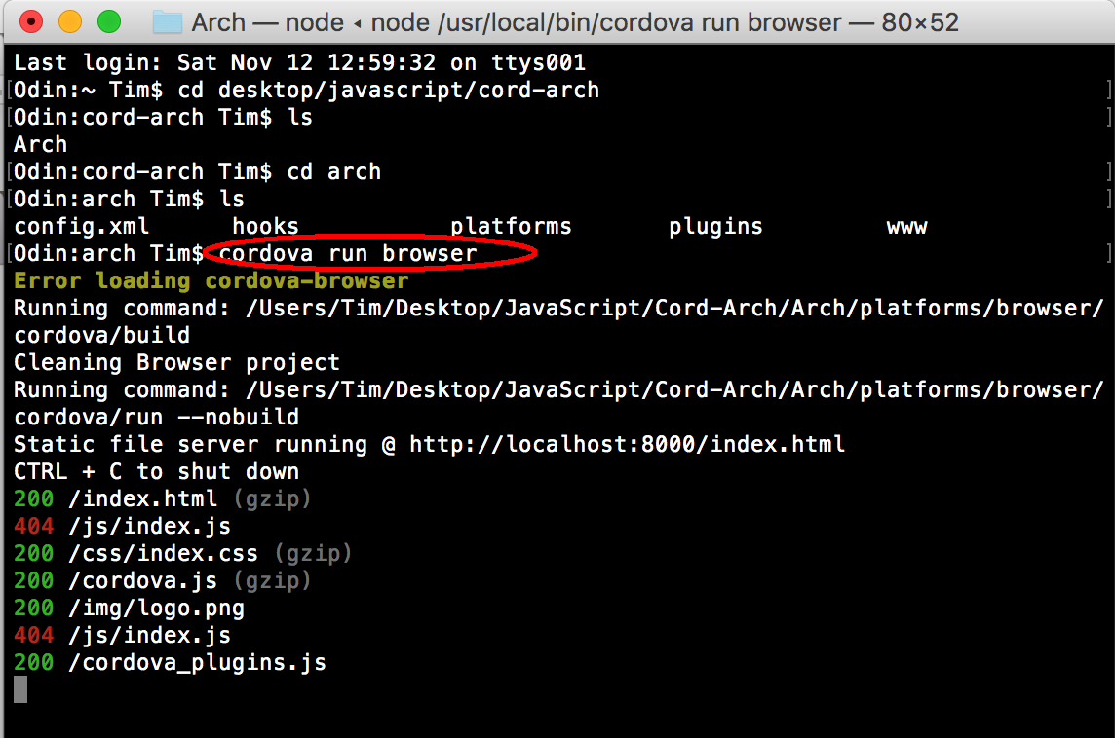

Game will be running at “localhost:8000”