|  |  |  |
| --- | --- | --- |
| **pin** | **port** | **description** |
| **1** |  | GND |
| **2** |  | 3v3 |
| **3** | 35 | ADC1_7, RTC |
| **4** | 34 | ADC1_6, RTC |
| **5** | 19 | digital |
| **6** | 1 | TX |
| **7** | 3 | RX |
| **8** | 21 | SDA |
| **9** | 22 | SCL |

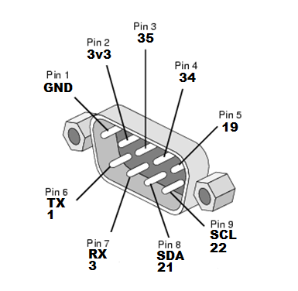

|  |  |  |
| --- | --- | --- |
| **pin** | **port** | **description** |
| **1** |  | GND |
| **2** |  | 3v3 |
| **3** | 35 | ADC1_7, RTC |
| **4** | 34 | ADC1_6, RTC |
| **5** | 19 | digital |
| **6** | 1 | TX |
| **7** | 3 | RX |
| **8** | 21 | SDA |
| **9** | 22 | SCL |

