R for Finance Report Examples
Alexandr Semenov

Libraries
library(tidyverse)
Warning: package 'ggplot2' was built under R version 4.3.3
Warning: package 'purrr' was built under R version 4.3.3
Warning: package 'lubridate' was built under R version 4.3.3
── Attaching core tidyverse packages ──────────────────────── tidyverse 2.0.0 ──
✔ dplyr 1.1.4 ✔ readr 2.1.5
✔ forcats 1.0.0 ✔ stringr 1.5.1
✔ ggplot2 3.5.2 ✔ tibble 3.2.1
✔ lubridate 1.9.4 ✔ tidyr 1.3.1
✔ purrr 1.0.4
── Conflicts ────────────────────────────────────────── tidyverse_conflicts() ──
✖ dplyr::filter() masks stats::filter()
✖ dplyr::lag() masks stats::lag()
ℹ Use the conflicted package (<http://conflicted.r-lib.org/>) to force all conflicts to become errors
library(santimentR)
library(forecast)
Warning: package 'forecast' was built under R version 4.3.3
Registered S3 method overwritten by 'quantmod':
method from
as.zoo.data.frame zoo

API-Key Management
The “Golden Rule” of API keys is: Never hardcode credentials directly into your script.
If you type api_key <- “abc12345” in your code, you risk accidentally committing it to GitHub or sharing it with a colleague, which compromises your security.
The easiest solution is to add it to .Renviron, which works the same way as .env file in Python. You store variables in a hidden text file that R loads automatically when it starts.
1. Setup your key
The easiest way to edit this file is using the usethis package:
# install.packages("usethis")
usethis::edit_r_environ()
☐ Edit '/Users/semenoffalex/.Renviron'.
☐ Restart R for changes to take effect.
This opens a file called .Renviron. Add your key there on a new line:
MY_API_KEY="12345-secret-key"
2. Restart R
Important: You must restart your R session for these changes to take effect (Session -> Restart R).
3. Use the key in your code
Now, you can access the key using Sys.getenv():
my_key <- Sys.getenv("MY_API_KEY")
# Check if it loaded correctly
if (my_key == "") stop("API Key not found! Check .Renviron")
4. Safety Check
Ensure your .gitignore file includes .Renviron so git does not track it.

Getting crypto assets data via Santiment API
Initialize Santiment client

Get Data via SantimentR
We will fetch daily USD price data for four major coins: Bitcoin, Ethereum, Cardano, and Solana.
slugs <- c("bitcoin", "ethereum", "cardano", "solana")
from_date <- "2025-01-01T00:00:00Z"
to_date <- "2026-01-15T00:00:00Z"
interval <- "1d"

Fetching metrics for all slugs at once.
Sometimes it doesn’t work (LoL) for long intervals ~1 year.
raw_data <- map_df(slugs, function(s) {
get_metrics(client, metric = "price_usd", slug = s,
from_date = from_date, to_date = to_date,
interval = interval) %>%
mutate(slug = s)
})

Alternative way: getting time series for each slug separately
btc <- get_metric(client, metric = 'price_usd',
slug = "bitcoin", from_date = from_date,
to_date = to_date,
interval = interval)
eth <- get_metric(client, metric = 'price_usd',
slug = "ethereum", from_date = from_date,
to_date = to_date,
interval = interval)
ada <- get_metric(client, metric = 'price_usd',
slug = "cardano", from_date = from_date,
to_date = to_date,
interval = interval)
sol <- get_metric(client, metric = 'price_usd',
slug = "solana", from_date = from_date,
to_date = to_date,
interval = interval)
# Combine 4 dataframes into 1 dataframe
raw_data <- bind_rows("btc"=btc,
"eth"=eth,
"ada"=ada,
"sol"=sol,
.id = "slug")

Another way to have some overview of the data
glimpse(raw_data)
Rows: 1,516
Columns: 3
$ slug <chr> "btc", "btc", "btc", "btc", "btc", "btc", "btc", "btc", "btc"…
$ datetime <dttm> 2025-01-01, 2025-01-02, 2025-01-03, 2025-01-04, 2025-01-05, …
$ value <dbl> 94416.29, 96876.24, 98101.70, 98236.74, 98319.67, 102255.22, …

Visualization

Separate graphs for the prices
ggplot(raw_data, aes(x = datetime, y = value, color = slug)) +
geom_line(linewidth = 1) +
facet_wrap(~ slug, scales = "free_y") + # Facet to see individual scales
theme_minimal() +
labs(title = "Cryptocurrency Price Trends (2025-2025)",
x = "Date", y = "Price (USD)", color = "Asset")
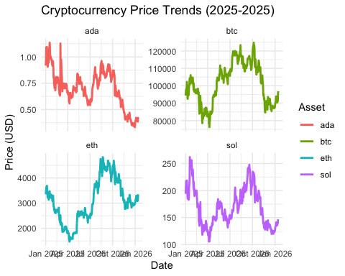

Pivot data from long to wide format for convenience
wide_data <- raw_data %>%
pivot_wider(names_from = slug, values_from = value) %>%
drop_na()

Making correlation matrix the tidy way
wide_data %>%
select(-datetime) %>%
cor() -> cor_matrix
cor_matrix
btc eth ada sol
btc 1.0000000 0.7385131 0.4638825 0.6955089
eth 0.7385131 1.0000000 0.3219278 0.7033782
ada 0.4638825 0.3219278 1.0000000 0.7541814
sol 0.6955089 0.7033782 0.7541814 1.0000000

Simple correlation visualization from correlation matrix
corrplot::corrplot(cor_matrix, method = 'number', type = 'upper',
title = "Price Correlation Matrix")
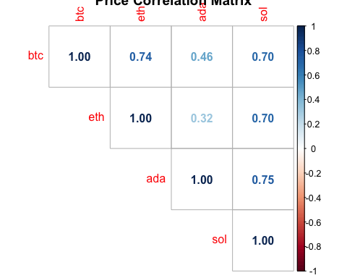

Fancy correlation visualization from the data in wide format
GGally::ggpairs(
data = wide_data,
columns = 2:5
) +
tidyquant::scale_fill_tq() +
tidyquant::scale_color_tq()
Registered S3 method overwritten by 'GGally':
method from
+.gg ggplot2
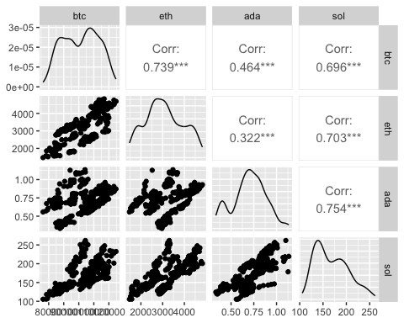

Forecasting
Let’s use BTC as an example

Getting the data
We did it already in this notebook, but just for a reminder:
btc <- get_metrics(client, metric = 'price_usd',
slug = "bitcoin",
from_date = from_date,
to_date = to_date,
interval = interval)

Create target variable
btc_data <- btc %>%
arrange(datetime) %>%
mutate(next_day_price = lead(price_usd)) %>% # Our target variable
drop_na()

Linear regression model
lm_model <- lm(next_day_price ~ price_usd, data = btc_data)
summary(lm_model)
Call:
lm(formula = next_day_price ~ price_usd, data = btc_data)
Residuals:
Min 1Q Median 3Q Max
-8355.3 -1133.8 45.9 1137.1 8042.4
Coefficients:
Estimate Std. Error t value Pr(>|t|)
(Intercept) 1.703e+03 9.503e+02 1.792 0.074 .
price_usd 9.833e-01 9.320e-03 105.501 <2e-16 ***
---
Signif. codes: 0 '***' 0.001 '**' 0.01 '*' 0.05 '.' 0.1 ' ' 1
Residual standard error: 2118 on 376 degrees of freedom
Multiple R-squared: 0.9673, Adjusted R-squared: 0.9672
F-statistic: 1.113e+04 on 1 and 376 DF, p-value: < 2.2e-16

Plotting some model quality graphs
par(mfrow = c(1, 2))
plot(lm_model, which = 1:2)
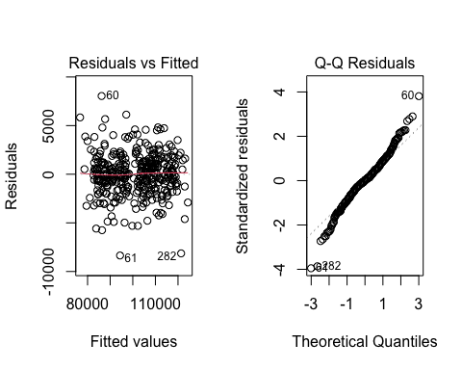

ARIMA model with Auto.ARIMA
btc_ts <- ts(btc_data$price_usd, frequency = 365)
arima_model <- auto.arima(btc_ts)
summary(arima_model)
Series: btc_ts
ARIMA(0,1,0)
sigma^2 = 4505747: log likelihood = -3422.92
AIC=6847.84 AICc=6847.85 BIC=6851.78
Training set error measures:
ME RMSE MAE MPE MAPE MASE
Training set 2.730626 2119.865 1546.494 -0.02077464 1.558181 0.3154826
ACF1
Training set -0.05463296

Plotting forcast from ARIMA model
arima_forecast <- forecast(arima_model, h = 1)
plot(arima_forecast)
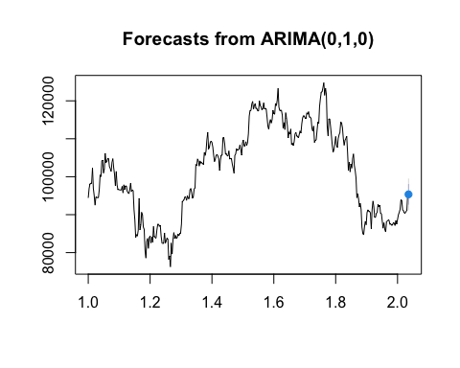

Comparing forecast accuracy
lm_preds <- predict(lm_model, btc_data)
arima_preds <- fitted(arima_model)
rmse_lm <- sqrt(mean((btc_data$next_day_price - lm_preds)^2))
rmse_arima <- sqrt(mean((btc_data$price_usd - arima_preds)^2))
performance_comparison <- tibble(
Model = c("Linear Regression", "ARIMA"),
RMSE = c(rmse_lm, rmse_arima)
)
print(performance_comparison)
# A tibble: 2 × 2
Model RMSE
<chr> <dbl>
1 Linear Regression 2112.
2 ARIMA 2120.

Conclusion
This notebook successfully integrated Santiment data with Tidyverse tools to analyze and predict cryptocurrency movements via linear regression and ARIMA.

Key Considerations from the Sources:
- Data Structure: The code prioritizes the long format for visualization with ggplot2 and the wide format for calculating correlations.
- Modeling Assumptions: When reviewing the Linear Regression results, pay attention to the Residuals vs Fitted plot to check for homoscedasticity and the Normal Q-Q plot for normality of residuals.
- Tooling: The use of pivot_longer() and pivot_wider() ensures the data is “tidy” before it enters the analytical pipeline.

