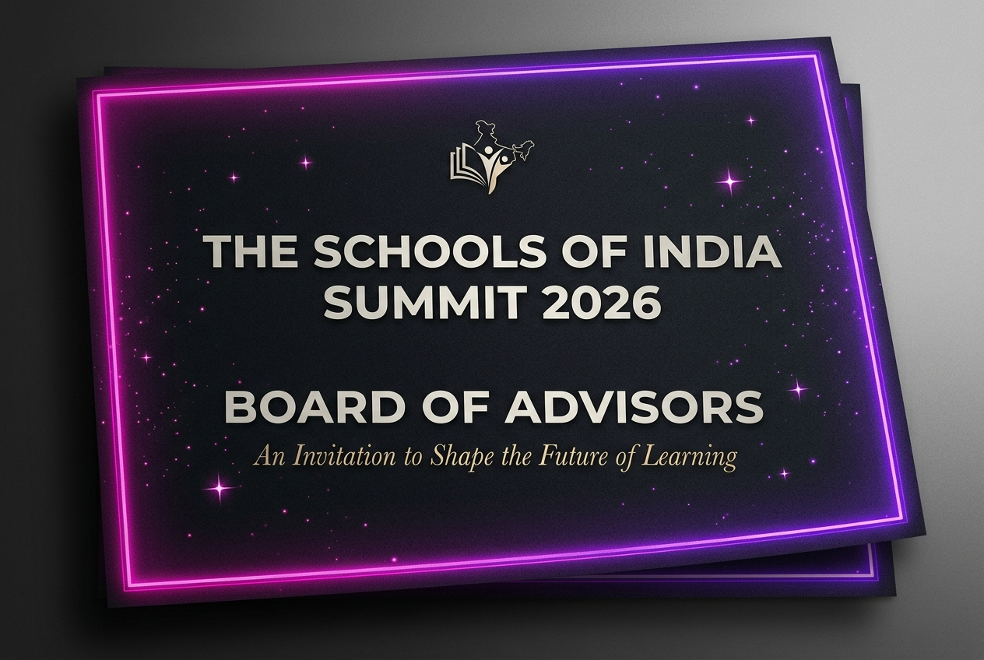

THE SCHOOLS OF INDIA SUMMIT 2026

Founding Advisory Council Charter
**Theme:** Where Education Leaders Shape the Future
**Summit Dates:** 30 & 31 October • 1 November 2026
**Venue:** Novotel Imagicaa Khopoli, India
**Objective:** Establishing the operational policy, responsibilities, and incentives for the summit’s guiding board.

1. Mandate & Purpose
The Schools of India Summit 2026 is the definitive annual convergence for the architects of Indian K-12 and Higher Education. To ensure the curriculum remains forward-looking, academically rigorous, and operationally practical, we are establishing the Founding Advisory Council.
The Council serves as the strategic brain trust of the summit. Comprising 20 to 30 distinguished school founders, trustees, academic directors, policy makers, and innovators, the Council guides the thematic framework and coordinates the collective intelligence of the community.

2. Term & Composition
- Council Size: Restricting active membership to 20–30 seats to maintain intimate, high-impact collaboration.
- Term: A one-year honorary tenure (covering the planning, execution, and post-summit evaluation cycle for the 2026 edition).
- Profile:
- 40% School Founders & Trustees (Capital, Scale, Governance)
- 30% School Principals & Directors (Culture, Academics, Parents)
- 20% EdTech Pioneers & Educational Authors (Innovation, Platforms)
- 10% Government, Policy, & Association Representatives (Regulations, Compliance)

3. Core Responsibilities of Advisors
Advisors are expected to contribute strategic inputs to shape the summit’s direction:
1. Curriculum & Theme Review:
Review and guide the core tracks across our three days: Day 1 (Vision), Day 2 (Systems & SOPs), and Day 3 (Growth & Branding).
2. Speaker & Innovator Nominations:
Recommend and introduce leading education practitioners, athletes, child psychologists, and global tech experts.
3. Session Leadership:
Lead or moderate closed-door roundtable discussions, principal war room drills, or masterclasses.
4. Community Ambassador:
Act as TSOI Ambassadors in your regional hubs (Mumbai, Delhi, Pune, Bangalore, etc.), inviting peer school leaders who will benefit from the summit.

4. Incentives & Advisory Board Privileges
To recognize your invaluable leadership, Founding Advisors receive exclusive privileges:
- Complimentary VIP Pass: Two complimentary VIP All-Access passes to the summit for you and a co-trustee/principal.
- Closed-Door VIP Dinner: Exclusive invitation to the Advisory Board Networking Dinner on Day 0 (October 30) at Novotel Imagicaa Khopoli.
- Prestige Recognition:
- Prominent placement of your name, portrait, and school logo on the summit portal, print brochures, and marketing newsletters.
- Dedicated acknowledgement during the Opening Ceremony and featured listing on the main stage backdrop.
- Benchmarking Access: First-priority access to the summit's post-event Benchmarking Reports on operations, salaries, and parent satisfaction.

5. Council Engagement Timeline
To respect your schedule, we have designed a streamlined engagement timeline:
- Stage 1: Council Onboarding (July 2026)
Confirming board seats and conducting a brief 1-on-1 alignment call with the convener.
- Stage 2: Agenda Review (August 2026)
A 60-minute virtual roundtable to review the draft curriculum, speaker roster, and focus tracks.
- Stage 3: Outreach & Finalization (September 2026)
Nominating regional leaders and locking down panel moderator assignments.
- Stage 4: Flagship Summit (October 30 – November 1, 2026)
Attending the closed-door board dinner on Day 0, leading sessions, and guiding panels.

