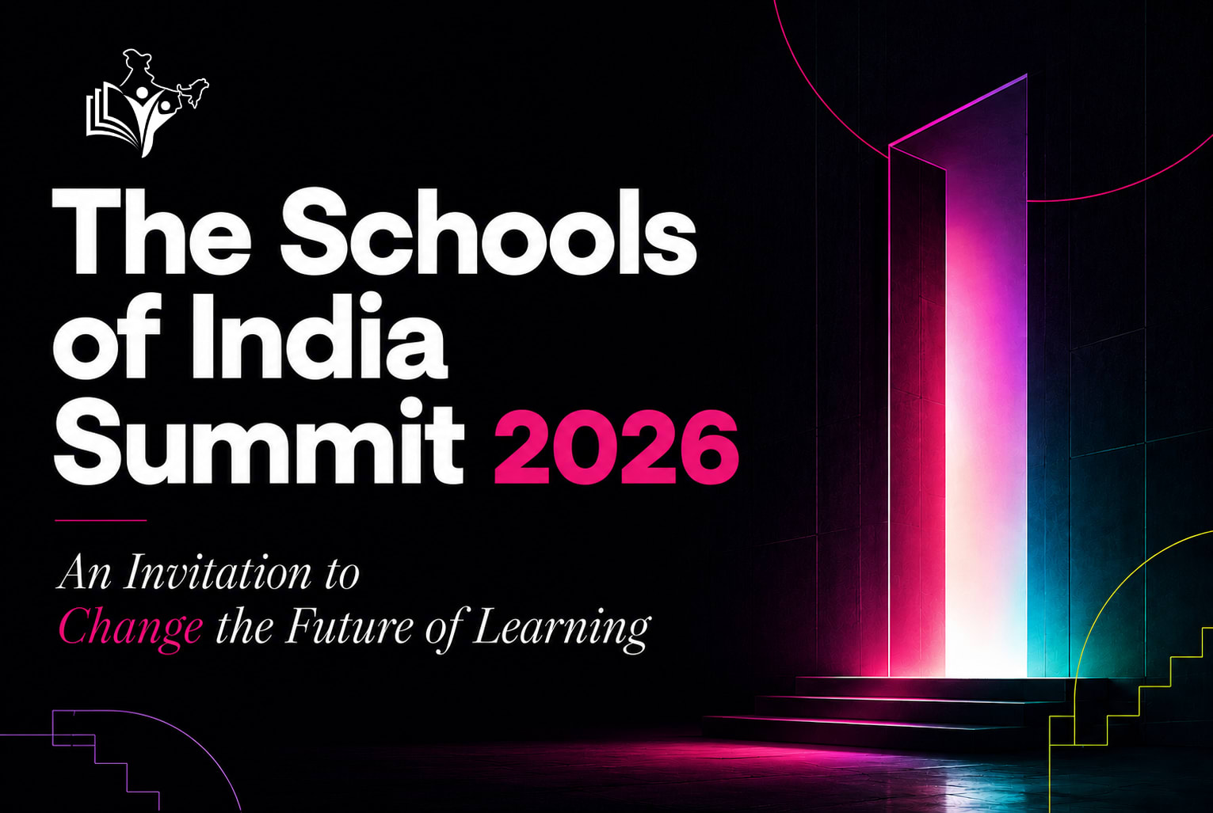

THE SCHOOLS OF INDIA SUMMIT 2026

Board of Advisors — Invitation & Vision Document
**Theme:** Where Education Leaders Shape the Future
**Dates:** 30 & 31 October • 1 November 2026
**Venue:** Novotel Imagicaa Khopoli, India
**Hosts:** The Schools of India founding committee in association with SPS, EduMojo, and UltraHire

1. The Invitation: A Call to Visionaries
Education is evolving faster than ever. The rise of generative AI, shifts in parental and administrative structures, new national frameworks, and changing school models require leadership that is proactive and collaborative.
To guide this transformation, The Schools of India Summit 2026 is establishing its Founding Board of Advisors.
We invite you—as a distinguished school founder, trustee, principal, or educational pioneer—to join this council. Your vision, experience, and leadership will help shape the agenda of India's premier education gathering, mapping out the future of K-12 and Higher Education.

2. The Summit Vision & Purpose
The Schools of India Summit 2026 is designed as a high-density, collaborative forum that convenes over 500+ of the nation’s brightest minds. Our goal is to shift educational gatherings away from passive vendor expos and sales-driven seminars, turning them into active incubators for school building.

Core Value Proposition:
- Collective Intelligence: We believe that every school has discovered something valuable, and every educator has a system or experiment that can help another. Curation and open collaboration are our core drivers.
- Systems over Speeches: We move beyond generic, surface-level panels. The summit provides concrete operational blueprints, SOPs, and actionable toolkits that leaders can deploy directly on their campuses.

3. Core Thematic Pillars
The summit curriculum runs across three progressive days of learning, strategy, and partnership:

Pillar 1: Vision & Strategy (Day 1)
*Anticipating shifts in technology, pedagogy, regulations, and institutional culture.*
Deep-diving into future school models, Generative AI policies, curriculum redesign, student wellbeing, and leadership structures.

Pillar 2: Systems & Implementation (Day 2)
*Translating vision into concrete, operational systems.*
Interactive workshops focusing on standard operating procedures (SOPs), academic quality audits, parent-school relationship management, and administrative efficiency.

Pillar 3: Growth & Partnerships (Day 3)
*Building scale, admissions, branding, and community.*
Exploring admissions marketing strategies, branding school identities, securing infrastructure scale, and building collaborative cross-institutional networks.

4. Advisory Board Roles & Privileges
As a member of the Founding Board of Advisors, you will help co-create the soul of the summit:
- Curriculum Curation: Provide strategic inputs on session tracks, panel themes, and masterclass formats.
- Speaker Nominations: Help identify and invite leading experts, practitioners, and change-makers.
- Panel Moderation & Leadership: Lead closed-door roundtables or moderate key panel discussions during the summit.
- Board Privileges:
- Exclusive invitation to the Advisory Board Closed-Door Dinner & Mixer on Day 0.
- Complimentary VIP All-Access passes to the summit.
- Honorary visual recognition across all print, digital, and stage backdrops as a Founding Advisor.

5. Next Steps
This is not an invitation to attend an event. It is an invitation to help build an institution. We would be privileged to have your leadership help architect this milestone event. If this is a cause you want your name attached to from day one, we would love to hear from you.
RSVP / Contact the Convener at:
[board@theschoolsofindiasummit.com](mailto:board@theschoolsofindiasummit.com) • [www.theschoolsofindiasummit.com](http://www.theschoolsofindiasummit.com)
Warm Regards,
Ankit Verma
Founder, TSOI - The School of India

