**Learning Python**

Chapter 0 – Python Setup

**Objective:**

Setup the necessary tools for python development and run simple sanity checks to make sure that setup process was done correctly (Note: install PyCharm **community** edition).

**Relevant material:**

[Learn Python – Full Course for Beginners](https://www.youtube.com/watch?v=rfscVS0vtbw&t=1470s) sections 1-3 (Introduction to Setup & Hello World).

*See also:* [*PyCharm*](https://www.jetbrains.com/pycharm/download/#section=windows)[*Python*](https://www.python.org/downloads/)[*print()*](https://docs.python.org/3/library/functions.html#print)

**Assignment:**

1. Attach a print-screen of PyCharm window with "Hello World!" printed in the terminal.
2. **Challenge**: print the version of the installed and used python. Attach a print-screen of PyCharm showing both the code and the terminal.

**Solutions**:

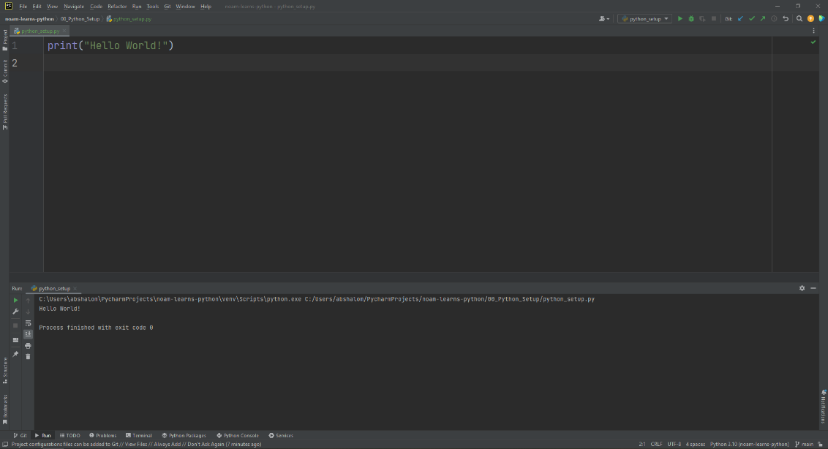1.

*Attach solution here*

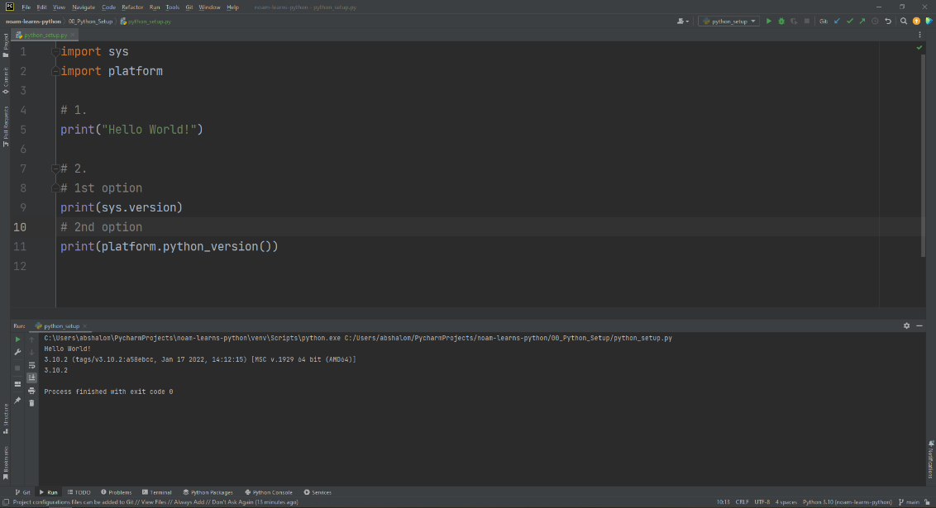2.

*Attach solution here*