

Safety Plan Lane Assistance

**Document Version: [Version]**

**Template Version 1.0, Released on 2017-06-21**



# Document history

**[Instructions: Fill in the date, version and description fields. You can fill out the Editor field with your name if you want to do so. Keep track of your editing as if this were a real world project.**

**For example, if this were your first draft or first submission, you might say version 1.0. If this is a second submission attempt, then you'd add a second line with a new date and version 2.0]**

|  |  |  |  |
| --- | --- | --- | --- |
| Date | Version | Editor | Description |
| 10/15/2017 | 1.0 | A.Shepelev |  |
|  |  |  |  |
|  |  |  |  |
|  |  |  |  |
|  |  |  |  |

# Table of Contents

**[Instructions: We have provided a table of contents. If the table of contents is not showing up correctly in your word processor of choice, please update it. The table of contents should show each section of the document and page numbers or links. Most word processors can do this for you. In** [**Google Docs**](https://support.google.com/docs/answer/116338?co=GENIE.Platform%3DDesktop&hl=en)**, you can use headings for each section and then go to Insert > Table of Contents.** [**Microsoft Word**](https://support.microsoft.com/en-us/help/285059/how-to-create-a-table-of-contents-by-marking-text-in-word) **has similar capabilities]**

Document history

Table of Contents

Introduction

Purpose of the Safety Plan

Scope of the Project

Deliverables of the Project

Item Definition

Goals and Measures

Goals

Measures

Safety Culture

Safety Lifecycle Tailoring

Roles

Development Interface Agreement

Confirmation Measures

# Introduction

## Purpose of the Safety Plan

**[Instructions: Answer what is the purpose of a safety plan?]**

This safety plan outlines the steps that will be undertaken to achieve functional safety for the Lane Assistance System by:

* Introducing the Lane Assistance system and the functional safety work supporting the project
* Defining roles and responsibilities on the project
* Documenting the Development Interface Agreement

The Safety Plan provides an overall framework for the project. It does not list project schedules or deadlines.

## Scope of the Project

**[Instructions: Nothing to do here. This is for your information.]**

For the lane assistance project, the following safety lifecycle phases are in scope:

Concept phase

Product Development at the System Level

Product Development at the Software Level

The following phases are out of scope:

Product Development at the Hardware Level

Production and Operation

## Deliverables of the Project

**[Instructions: Nothing to do here. This is for your information.]**

The deliverables of the project are:

Safety Plan

Hazard Analysis and Risk Assessment

Functional Safety Concept

Technical Safety Concept

Software Safety Requirements and Architecture

# Item Definition

**[Instructions:**

**REQUIRED**

**Discuss these key points about the system:**

**What is the item in question, and what does the item do?**

The item considered in this document is the Lane Assistance System. The Lane Assistance System consists of a Lane Departure Warning and a Lake Keeping function.

**What are its two main functions? How do they work?**

Lane Departure Warning alerts the driver when the vehicle drifts too close to a lane line by vibrating the steering wheel in a manner that mimics the vibration from running over a rumble strip.

The Lane Keeping functionality provides a steering torque to help steer a vehicle back into a lane after the vehicle drifts too close to the lane markings.

**Which subsystems are responsible for each function?**

The Lane Assistance System relies on the following subsystems for operation:

* Forward-facing Camera system
  + Camera lens, sensor, housing and wiring
  + Camera ECU
* Electronic Power Steering (EPS) system
  + EPS ECU
  + Steering torque sensor
  + Power steering motor
* In-vehicle Display system
  + Display ECU
  + Car display

**What are the boundaries of the item? What subsystems are inside the item? What elements or subsystems are outside of the item?**

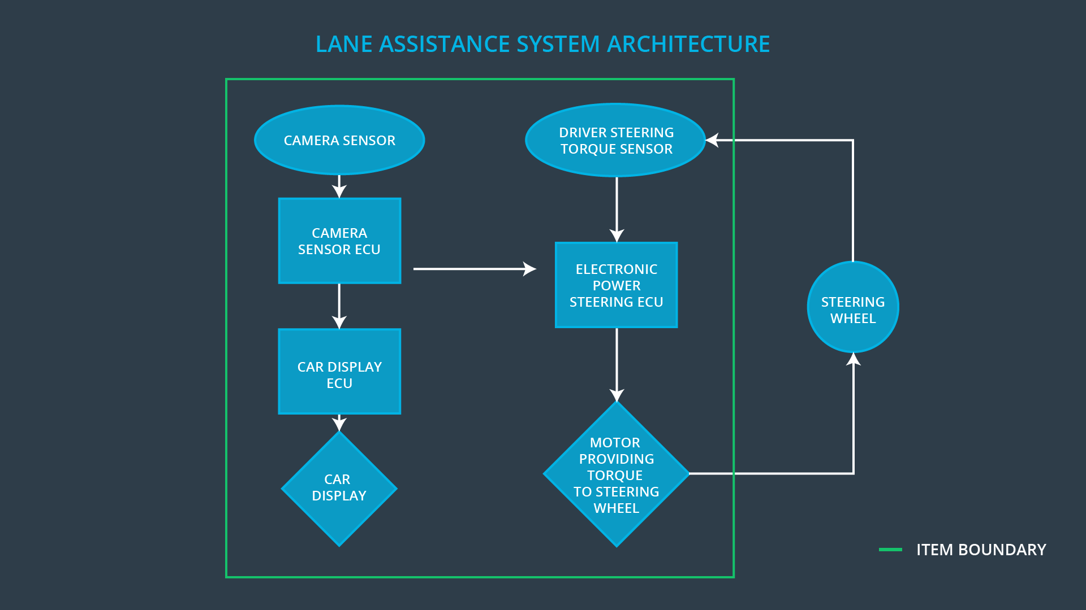

**OPTIONAL**

**Optionally, include information about these points as well. These were not included in the lectures, but you might be able to find this information online:**

* **Operational and Environmental Constraints. This could especially be limited to camera performance; lane lines are difficult to detect in snow, fog, etc**
* **Legal requirements in your country for lane assistance technology**
* **National and International Standards Related to the Item**
* **Records of previously known safety-related incidents or behavioral shortfalls**

**]**

# Goals and Measures

## Goals

**[Instructions:**

**Describe the major goal of this project; what are we trying to accomplish by analyzing the lane assistance functions with ISO 26262?]**

This project aims to design a lane assistance system with acceptably low levels of risk in operation. By applying ISO 26262 to the design of the system, we aim to achieve functional safety for the Lane Assistance system.

## Measures

**[Instructions:**

**Fill in who will be responsible for each measure or activity. Hint: The lesson on Safety Management Roles and Responsibilities.**

**The options are:**

**All Team Members**

**Safety Manager**

**Project Manager**

**Safety Auditor**

**Safety Assessor**

**]**

|  |  |  |
| --- | --- | --- |
| Measures and Activities | Responsibility | Timeline |
| Follow safety processes | All Team Members | Constantly |
| Create and sustain a safety culture | Project Manager, Safety Manager, All Team Members | Constantly |
| Coordinate and document the planned safety activities | Safety Manager | Constantly |
| Allocate resources with adequate functional safety competency | Project Manager | Within 2 weeks of start of project |
| Tailor the safety lifecycle | Safety Manager | Within 4 weeks of start of project |
| Plan the safety activities of the safety lifecycle | Safety Manager | Within 4 weeks of start of project |
| Perform regular functional safety audits | Safety Auditor | Once every 2 months |
| Perform functional safety pre-assessment prior to audit by external functional safety assessor | Safety Manager | 3 months prior to main assessment |
| Perform functional safety assessment | Safety Assessor | Conclusion of functional safety activities |

# Safety Culture

**[Instructions:**

**Describe the characteristics of your company’s safety culture. How do these characteristics help maintain your safety culture. Hint: See the lesson about Safety Culture**

**]**

* Safety is our highest priority. Everyone from the senior leadership of the company to every engineer understands the value of safety and puts safety first.
* Well-defined process.
* Independence of design and audit teams.
* Accountability. Design decisions are documented and traceable.
* Recognition. The organization promotes safety achievements in general and functional safety in particular with its Semi-Annual Safety Awards
* Discipline. Safety is a condition of employment at our company. Leading or supporting delivery of functional safety is on every employee’s annual objectives. The management reviews every employee’s contribution to the functional safety of our products.

# Safety Lifecycle Tailoring

**[Instructions:**

**Describe which phases of the safety lifecycle are in scope and which are out of scope for this particular project. Hint: See the** **Intro section** **of this document**

**]**

As mentioned in the Introduction section, the Concept phase, Product Development at the System Level, and Product Development at the Software Level are within the scope of this project and will be covered in this Functional Safety analysis.

# Roles

**[Instructions:**

**This section is here for your reference. You do not need to do anything here. It is provided to help with filling out the development interface agreement section.**

**]**

|  |  |
| --- | --- |
| Role | Org |
| Functional Safety Manager- Item Level | OEM |
| Functional Safety Engineer- Item Level | OEM |
| Project Manager - Item Level | OEM |
| Functional Safety Manager- Component Level | Tier-1 |
| Functional Safety Engineer- Component Level | Tier-1 |
| Functional Safety Auditor | OEM or external |
| Functional Safety Assessor | OEM or external |

# Development Interface Agreement

**[Instructions:**

**Assume in this project that you work for the tier-1 organization as described in the above roles table. You are taking on the role of both the functional safety manager and functional safety engineer.**

**Please answer the following questions:**

1. **What is the purpose of a development interface agreement?**
2. **What will be the responsibilities of your company versus the responsibilities of the OEM? Hint: In this project, the OEM is supplying a functioning lane assistance system. Your company needs to analyze and modify the various sub-systems from a functional safety viewpoint.**

**]**

The development interface agreement defines the roles and responsibilities between the OEM, Tier I, and Tier II suppliers

|  |  |
| --- | --- |
| **Task** | **Responsibility** |
| Component-level software safety requirements | Tier I |
| Software component verification per requirements | Tier I |
| Technical safety requirements | Tier I |
| System verification per technical safety requirements | Tier I |
| System-level functional requirements | OEM |
| Functional safety requirements | Tier I |
| Functional safety analysis, including safety goals and safety plan | Tier I |

# Confirmation Measures

**[Instructions:**

**Please answer the following questions:**

1. **What is the main purpose of confirmation measures?**
2. **What is a confirmation review?**
3. **What is a functional safety audit?**
4. **What is a functional safety assessment?**

**]**

A safety plan could have other sections that we are not including here. For example, a safety plan would probably contain a complete project schedule.

There might also be a "Supporting Process Management" section that would cover "Part 8: Supporting Processes" of the ISO 26262 functional safety standard. This would include descriptions of how the company handles requirements management, change management, configuration management, documentation management, and software tool usage and confidence.

Similarly, a confirmation measures section would go into more detail about how each confirmation will be carried out.