Practice-8
Rollno:2520030022 name:AVSNR Akhila
Query 1: -CREATE DATABASE
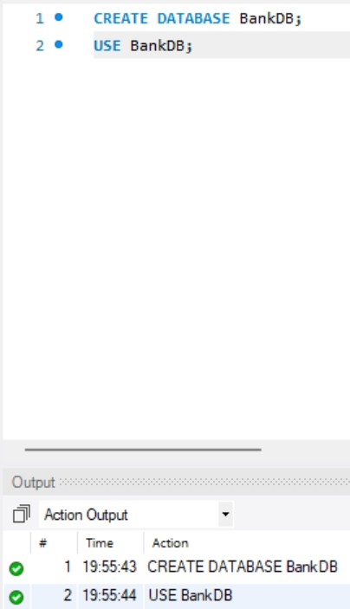
Query 2: - CREATE CUSTOMER TABLE
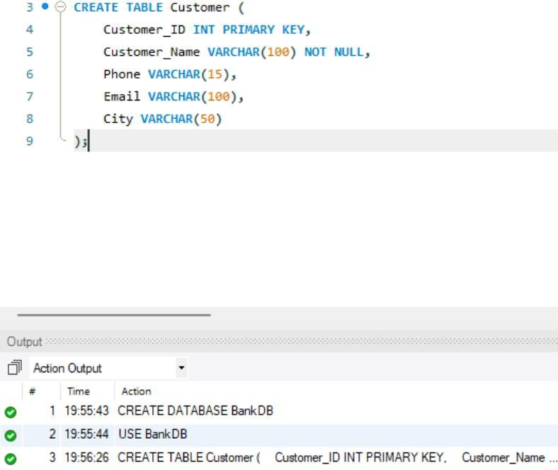

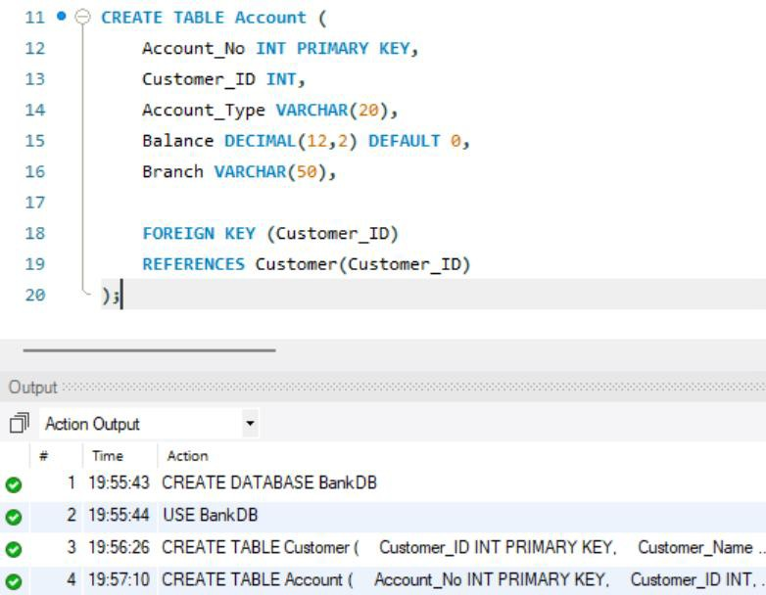

Query 4: - CREATE TRANSACTION TABLE
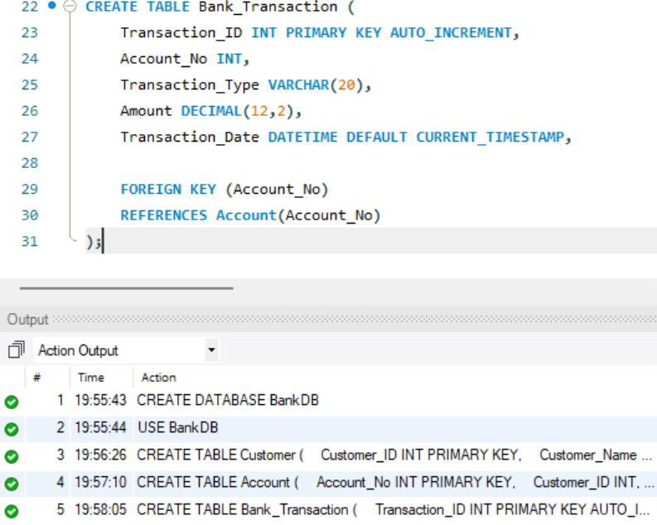

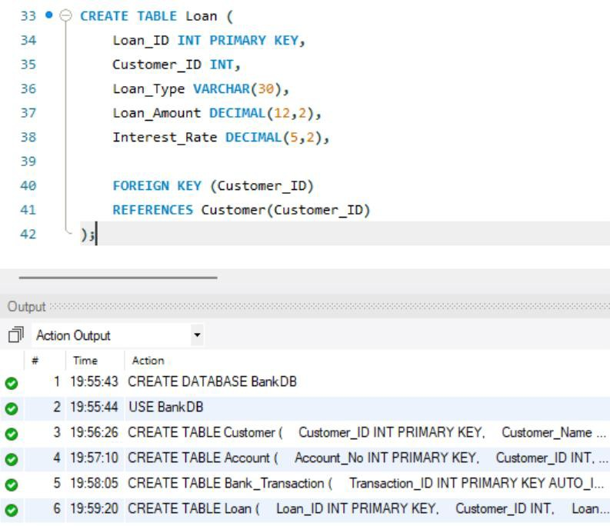

Query 6: - INSERT CUSTOMER DATA
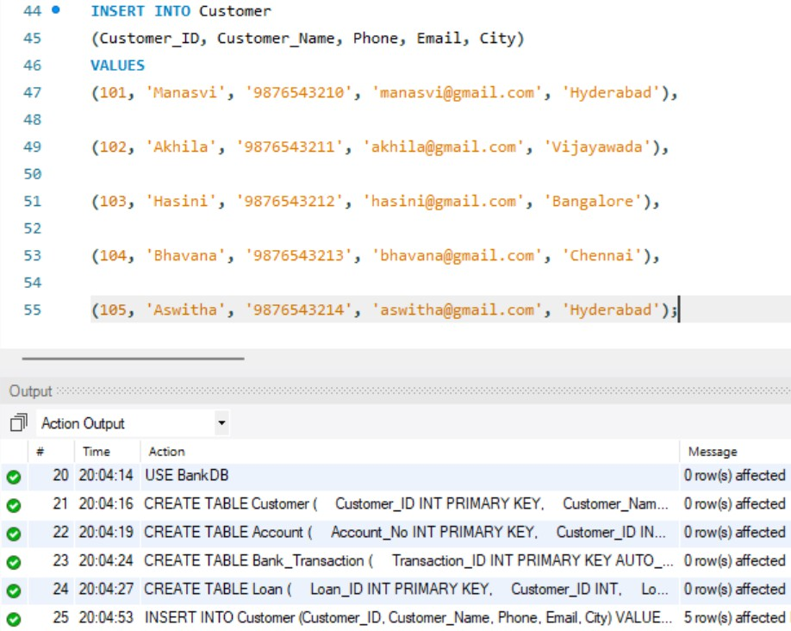

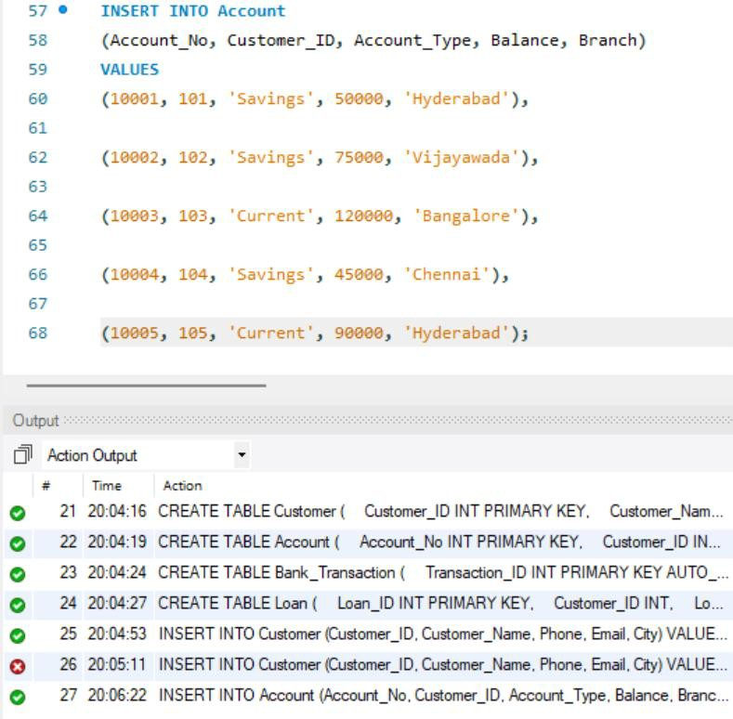

Query 8:- INSERT TRANSACTION DATA
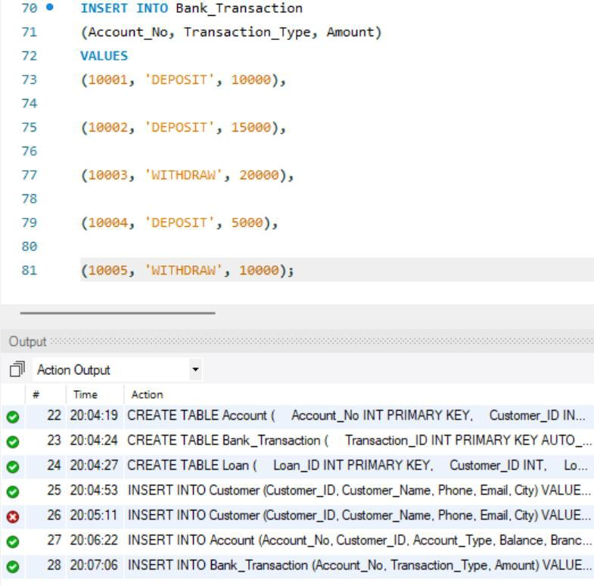

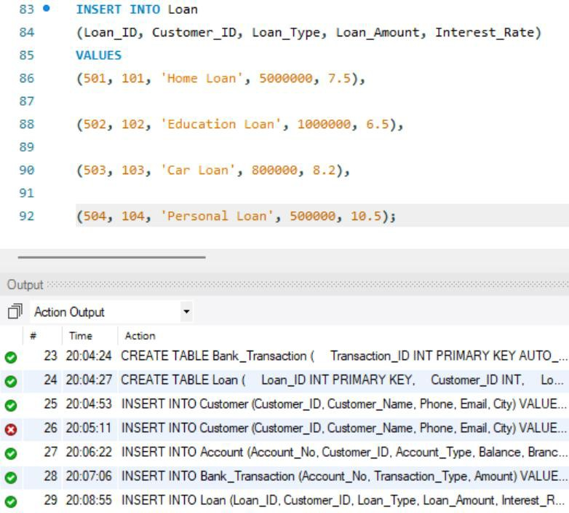

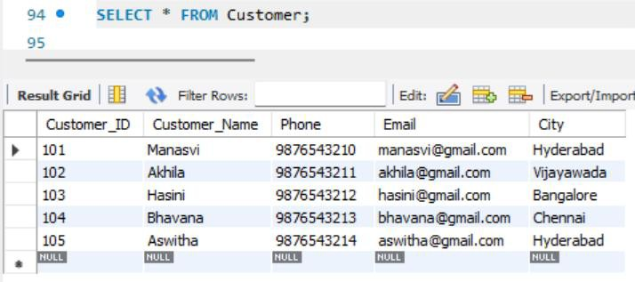
Query 10: - DISPLAY TABLE DATA

6 • L T cc:o
7

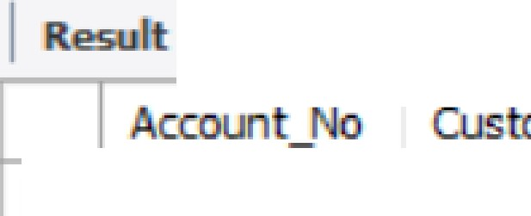



₆ - I . r
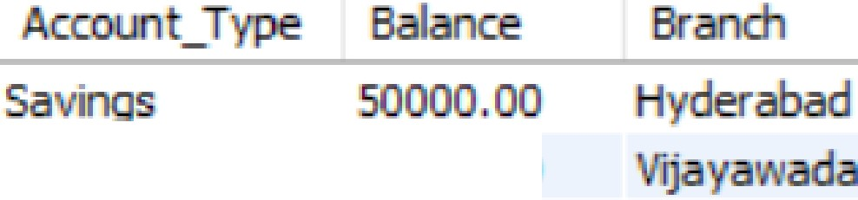
,mer_ID1
Saving
cw-rent
Savings
75000.00
120000.00 ,al! e
-5000 00 ch-nnai
►
10

10 •·3

10-
105 CUrrel' 90000 00 derabad


8 •  • B n T ns c on
99




T� nsaction_ID
,
10 1
Transac.tion_Typ
DBJO,SIT
- 1
2 10 02.


oe,;osrr 1so o.oo 2026�a..lfi 20=07:06

3 lJ 03
10
5 5


0 • L
- ITHDRA
,, OSIT




0, 0
2.026-08- .. 20:07:D .
2026�8 16.20:0 :06
.2026-08- 6 0�07.06


..:.r Ro :
1�
►
Loan- D
§011
50
Cu
102
03
10
Edu
Lo
ca
Oiffl
p rso
LO
5000000 00
1000000.00
00000 00
500000 00
7.50
6.5
..20
10.50

ACCOUNTS
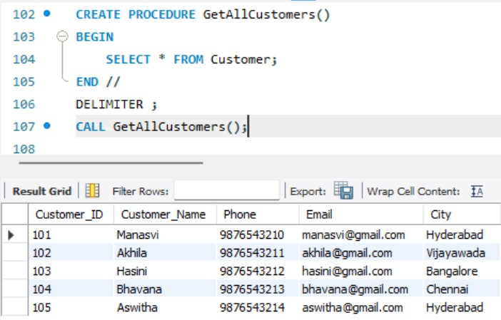

Query 12: - PROCEDURE TO DEPOSIT MONEY
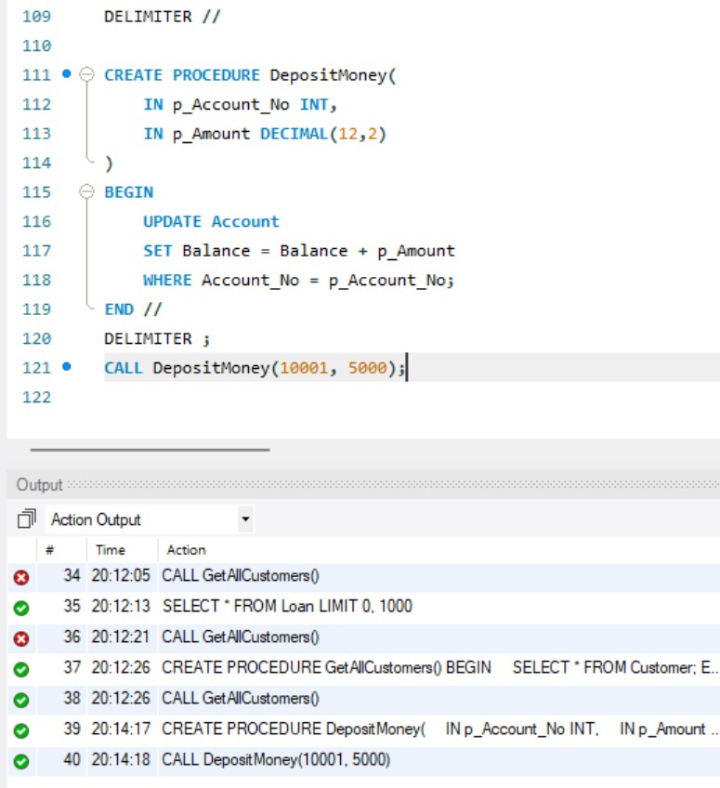

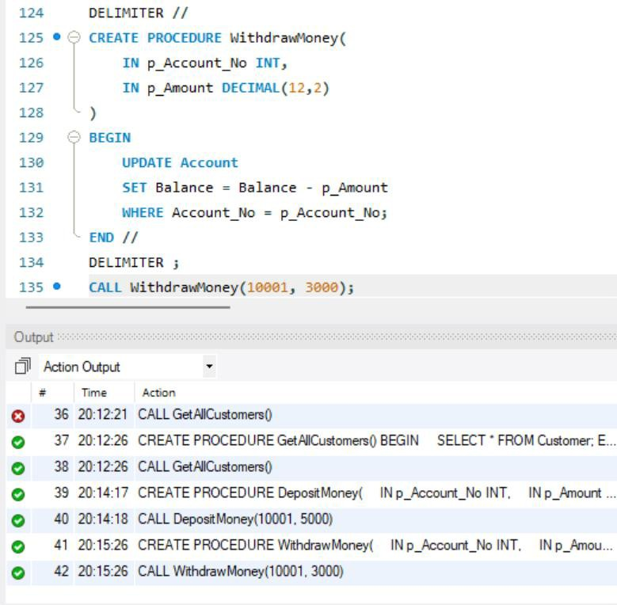

Query 14: - TRIGGER – PREVENT NEGATIVE BALANCE
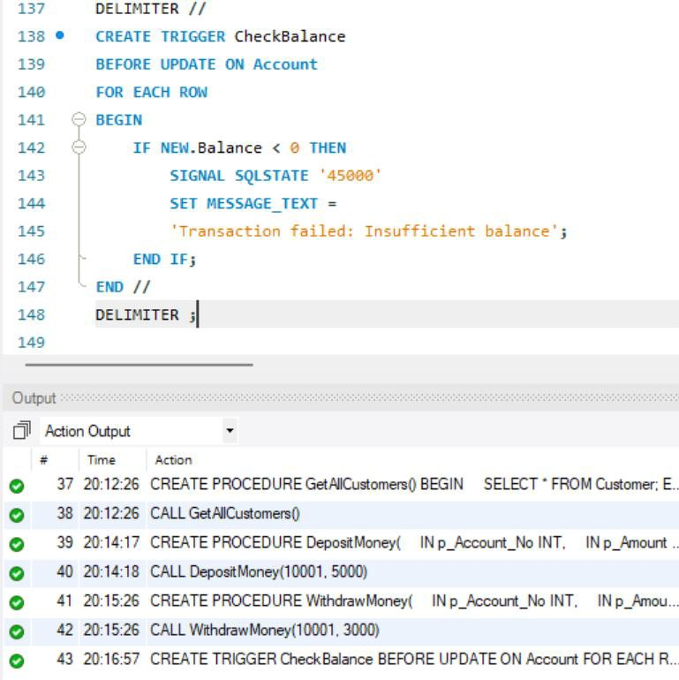

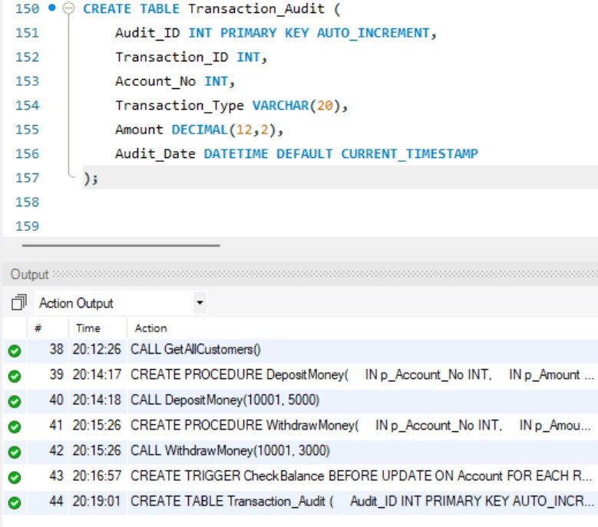
Query 16: - TRIGGER – TRANSACTION AUDIT
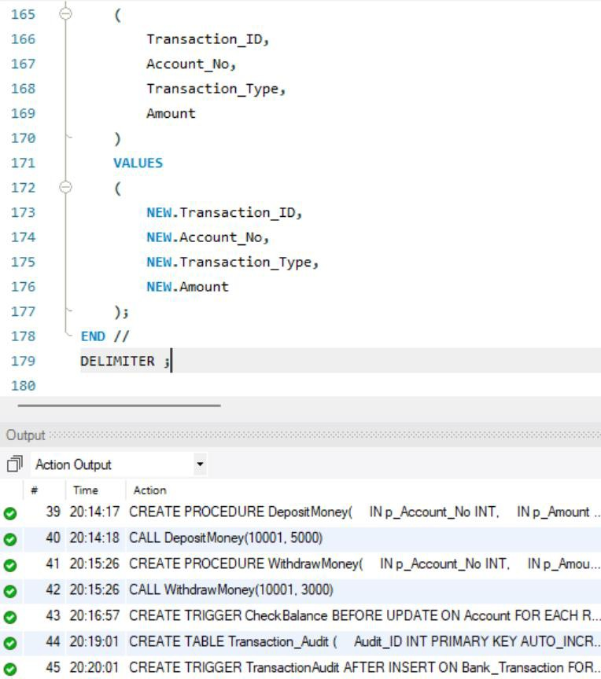

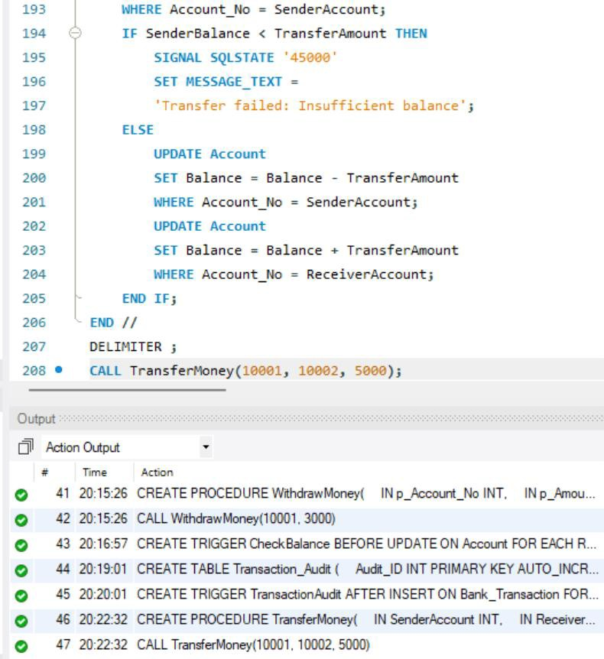

CHECK:
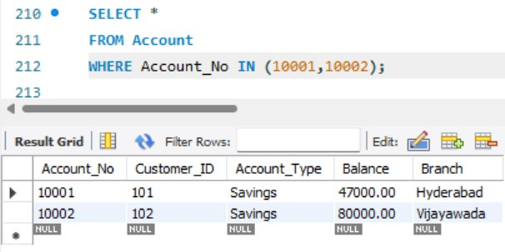

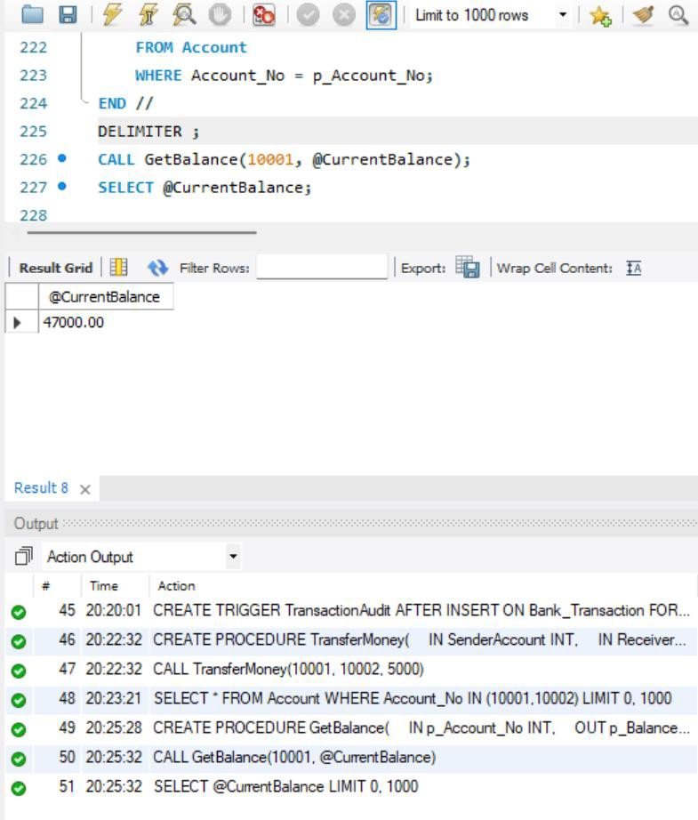

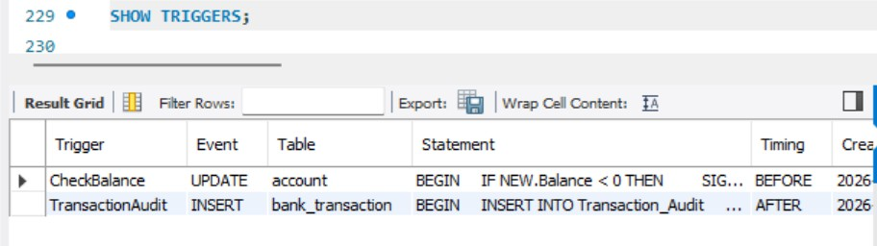
Query 19: -TRIGGER COMMANDS

