Name:AVSNR Akhila
Rollno:2520030022
moongoDB-1
VERIFY INSERTED DOCUMENTS
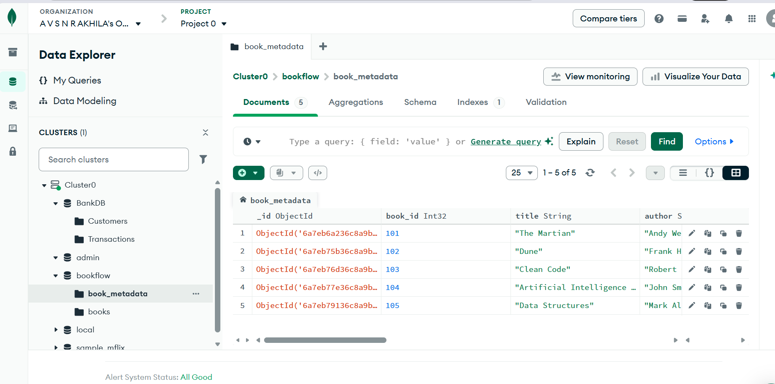
COMPARISON OPERATOR $gt
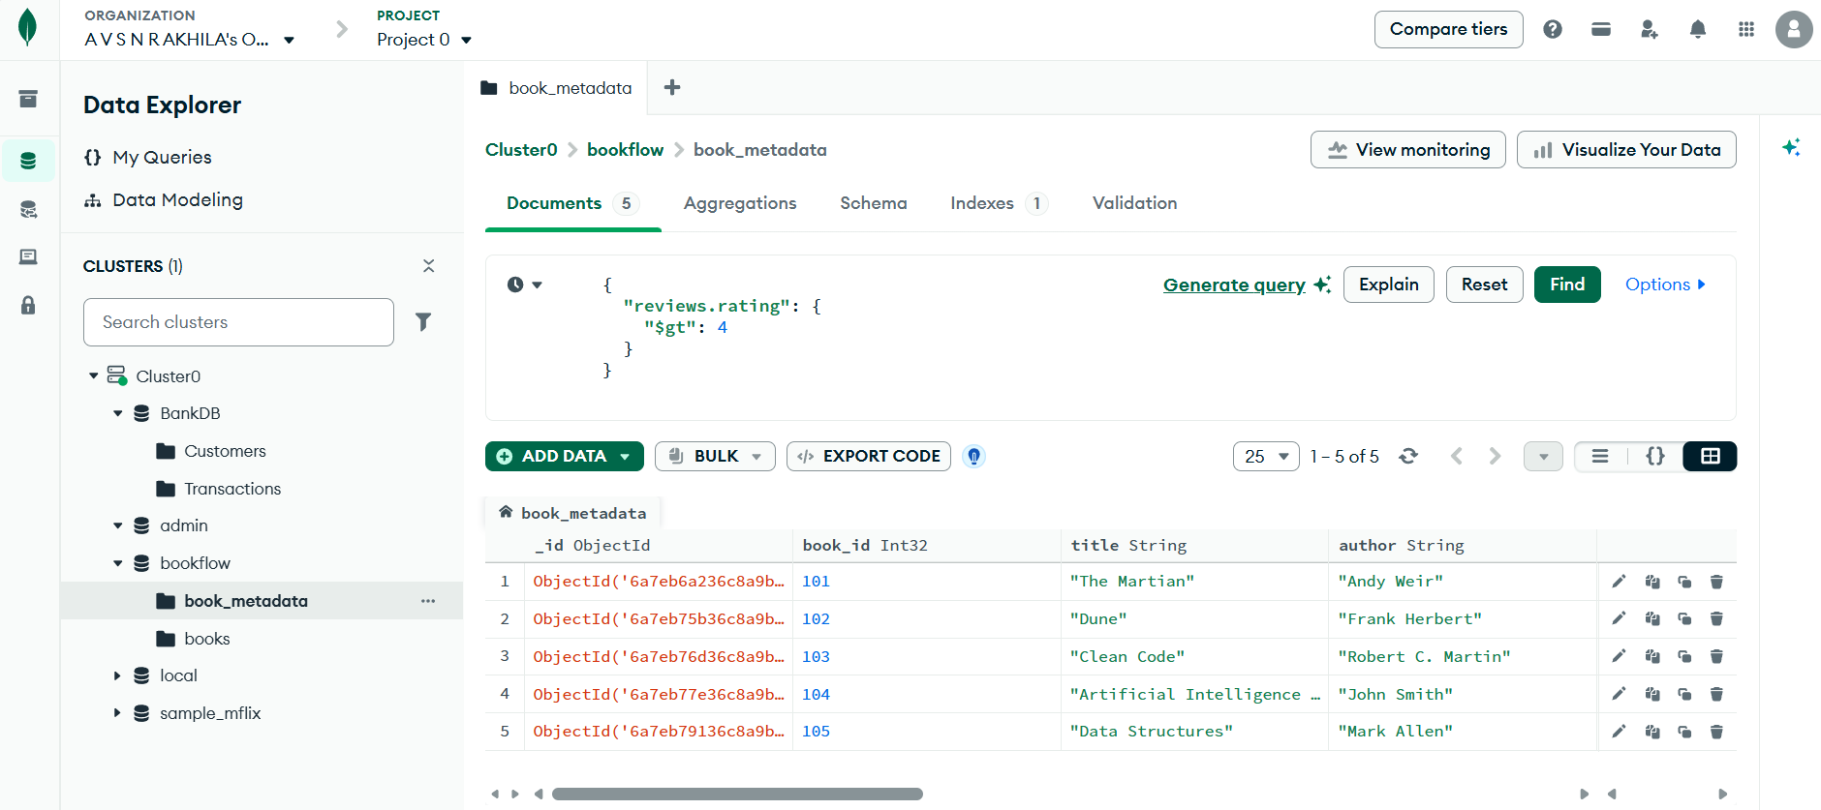
USING $IN
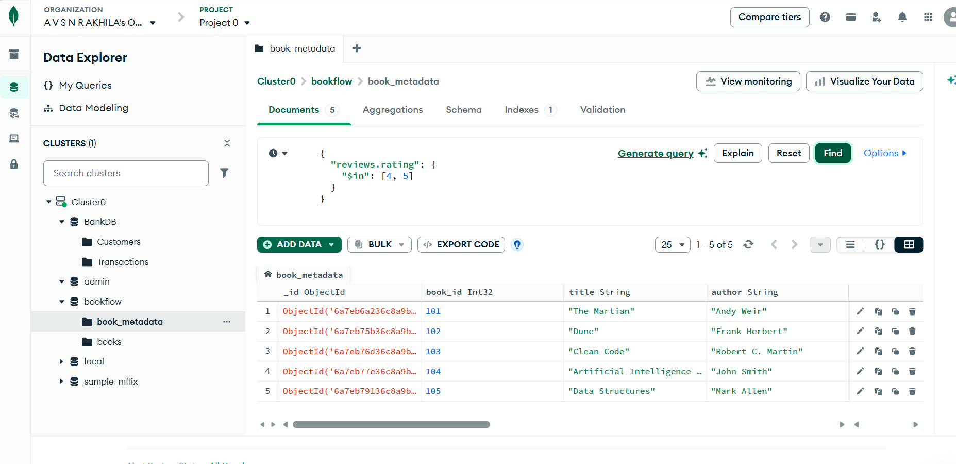
REGEX QUERY
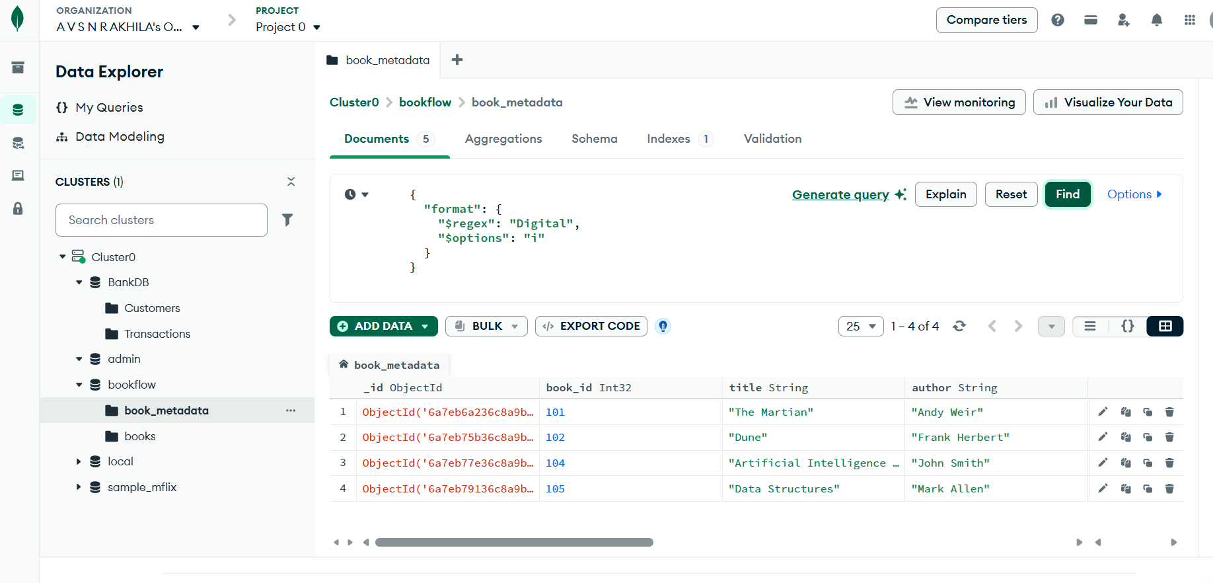AGGREGATION PIPELINE
STEP 1: $MATCH
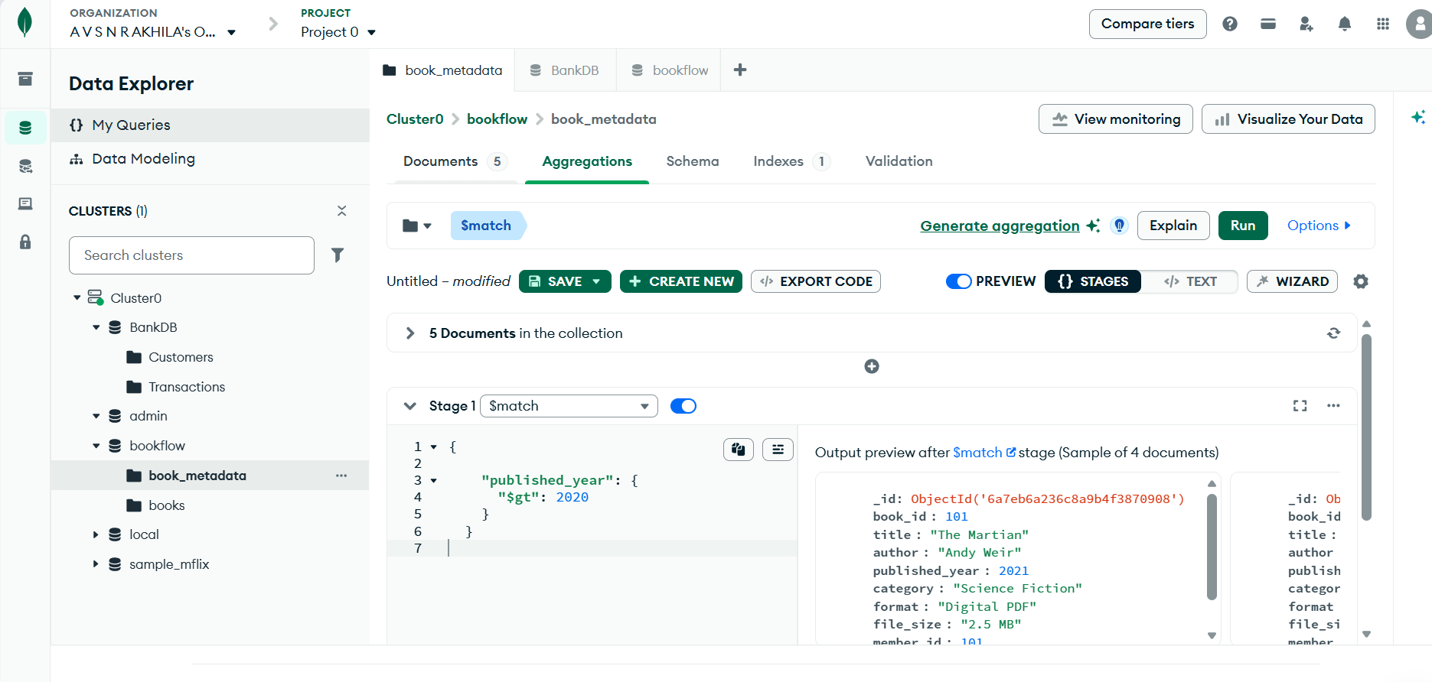
STEP 2: $UNWIND
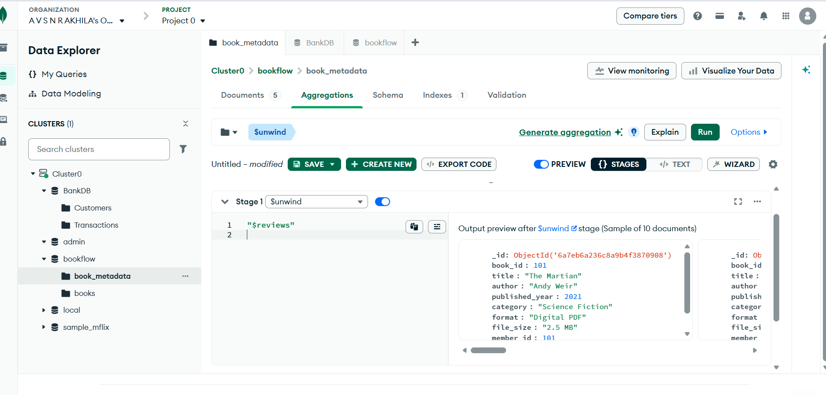
STEP 3: $GROUP
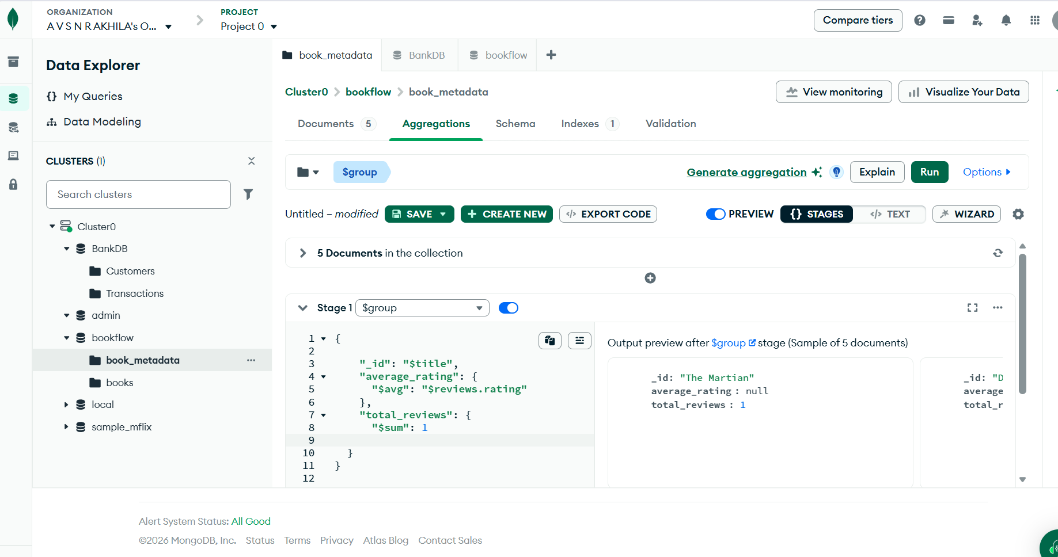
STEP 4: $SORT
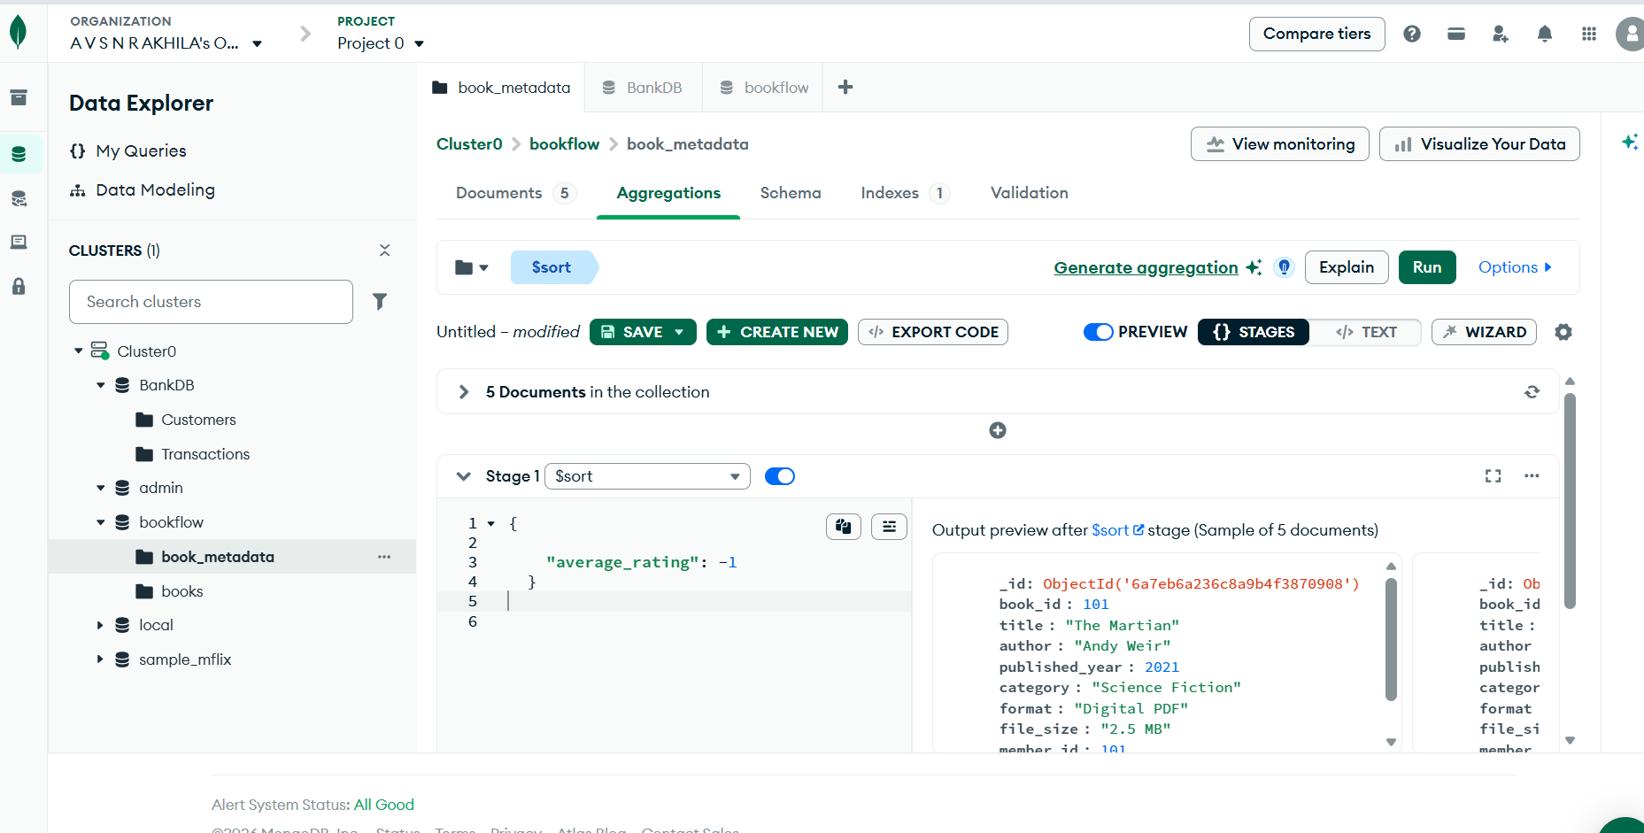
CREATE TEXT INDEX
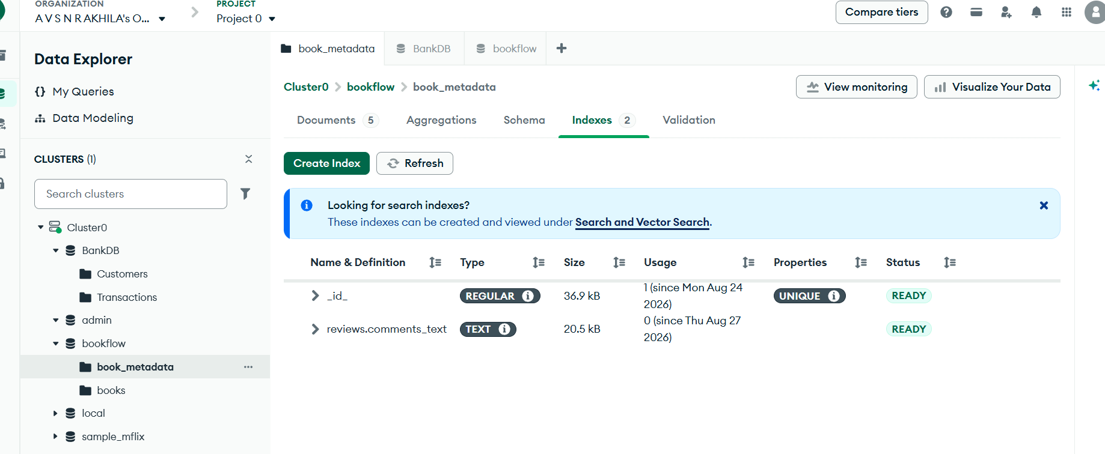
SEARCH USING TEXT INDEX
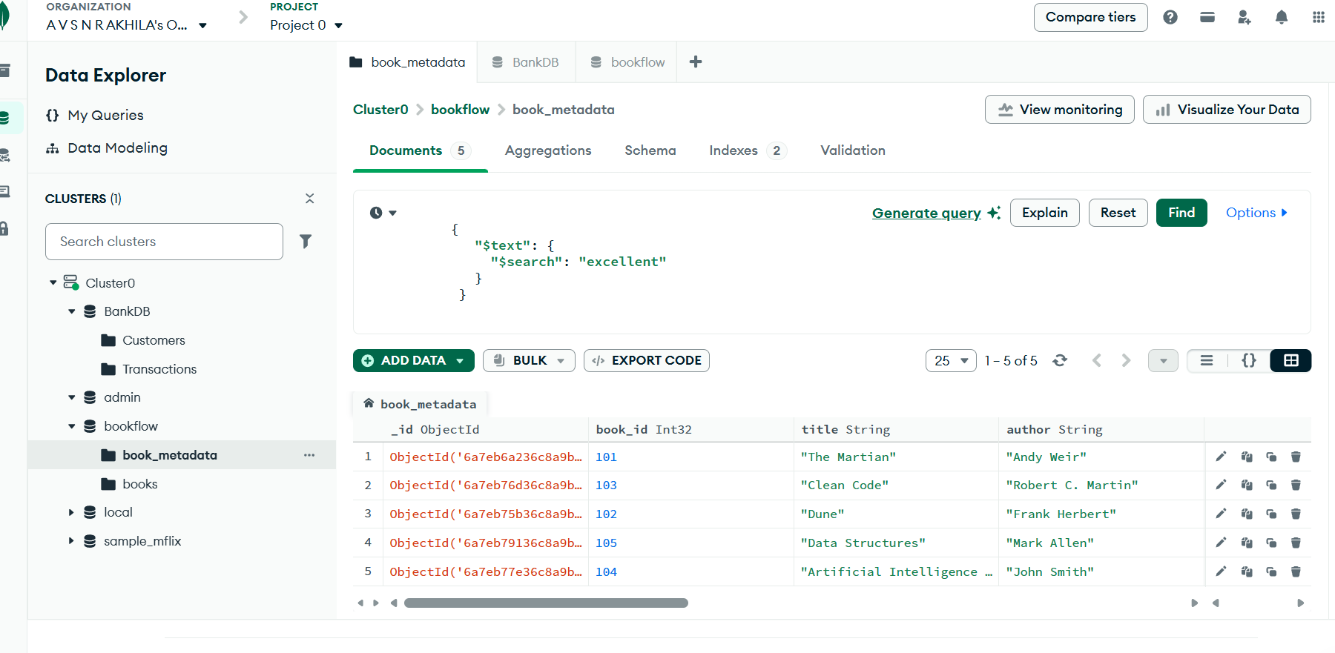
SEARCH FOR A SPECIFIC KEYWORD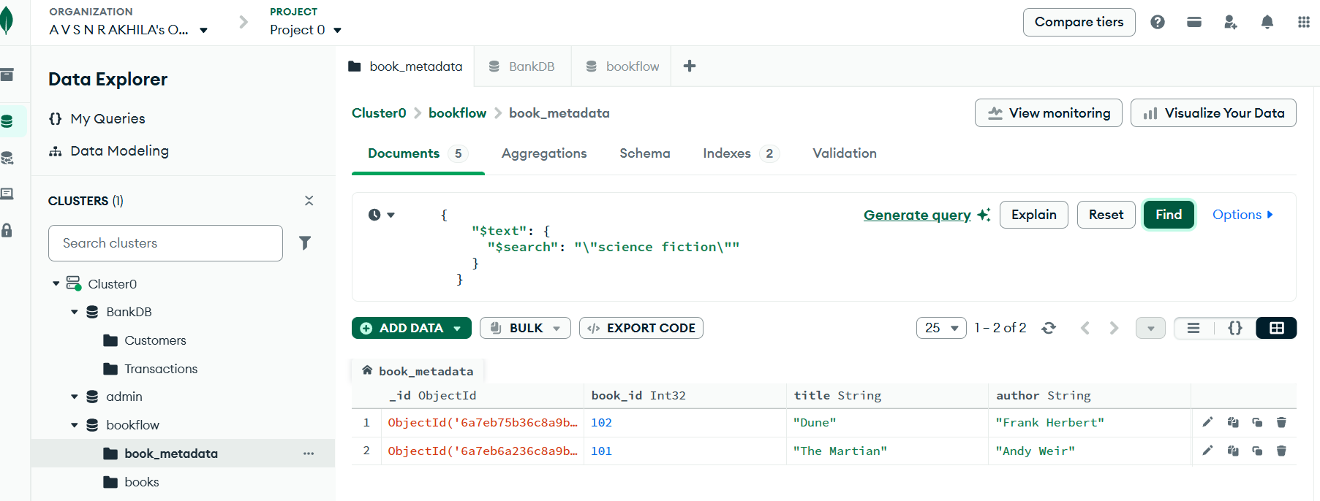
USE explain()
