Name:AVSNR Akhila
Rollno:2520030022
MoongoDB-2&3
QUERY 1: DISPLAY ALL CUSTOMERS
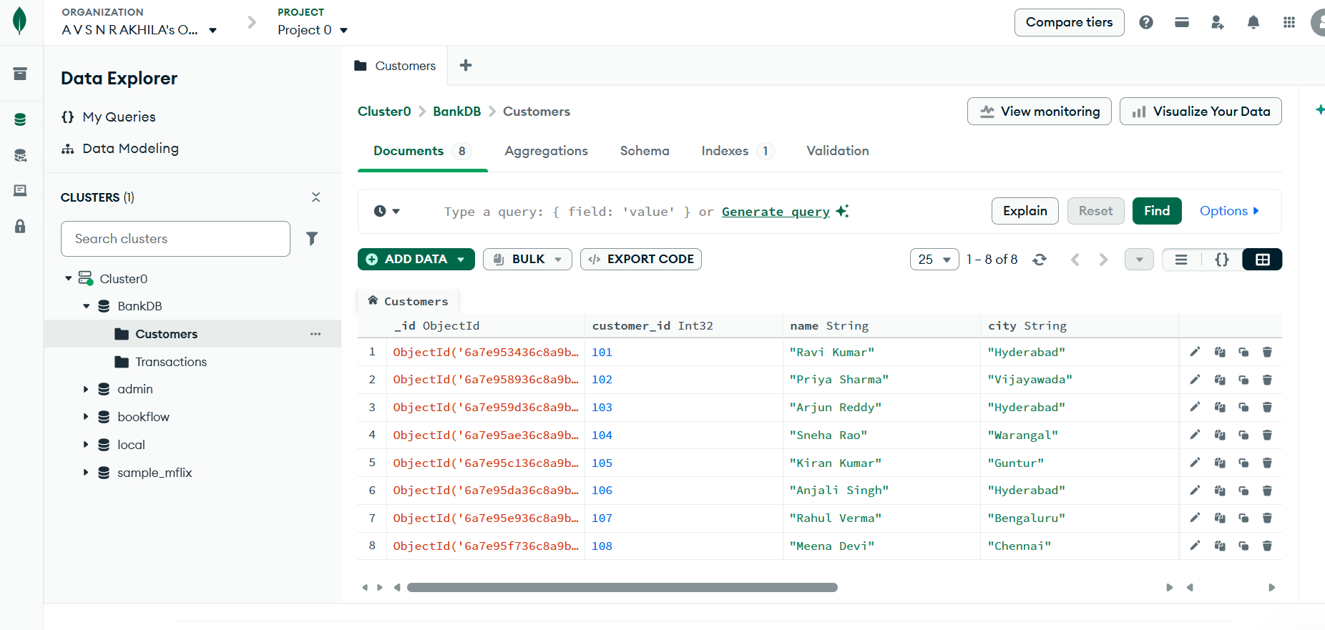
QUERY 2: FIND ACTIVE CUSTOMERS
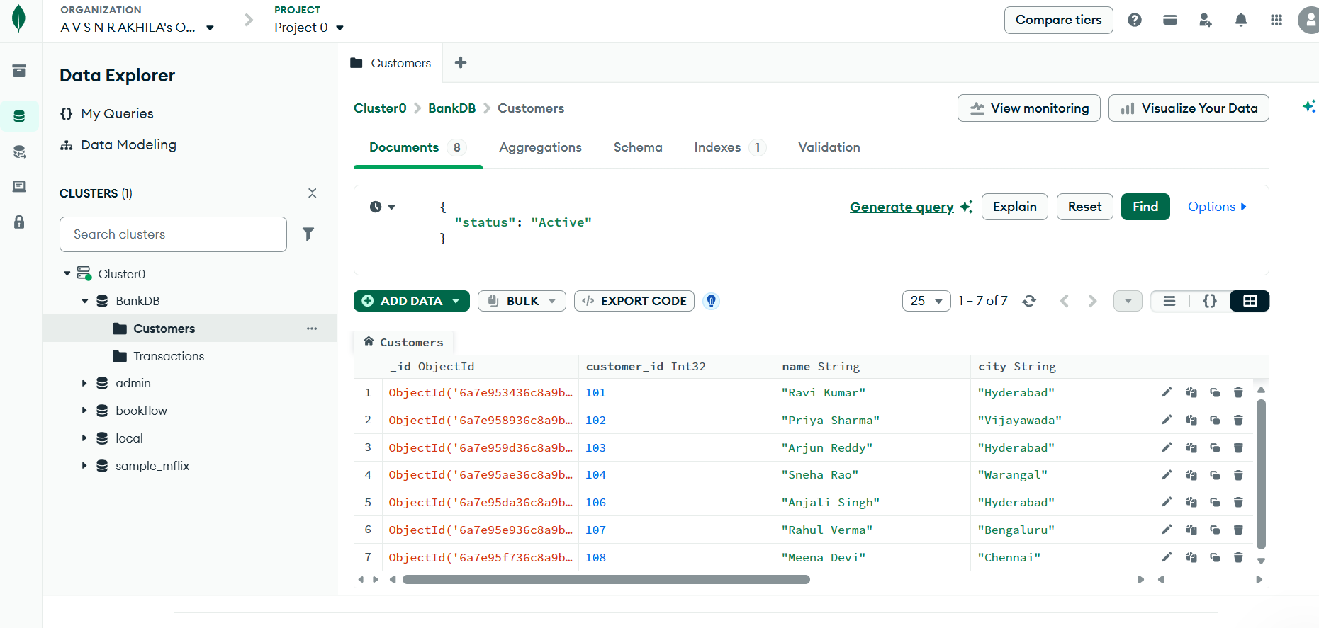
QUERY 3: FIND CUSTOMERS WITH BALANCE GREATER THAN 100000
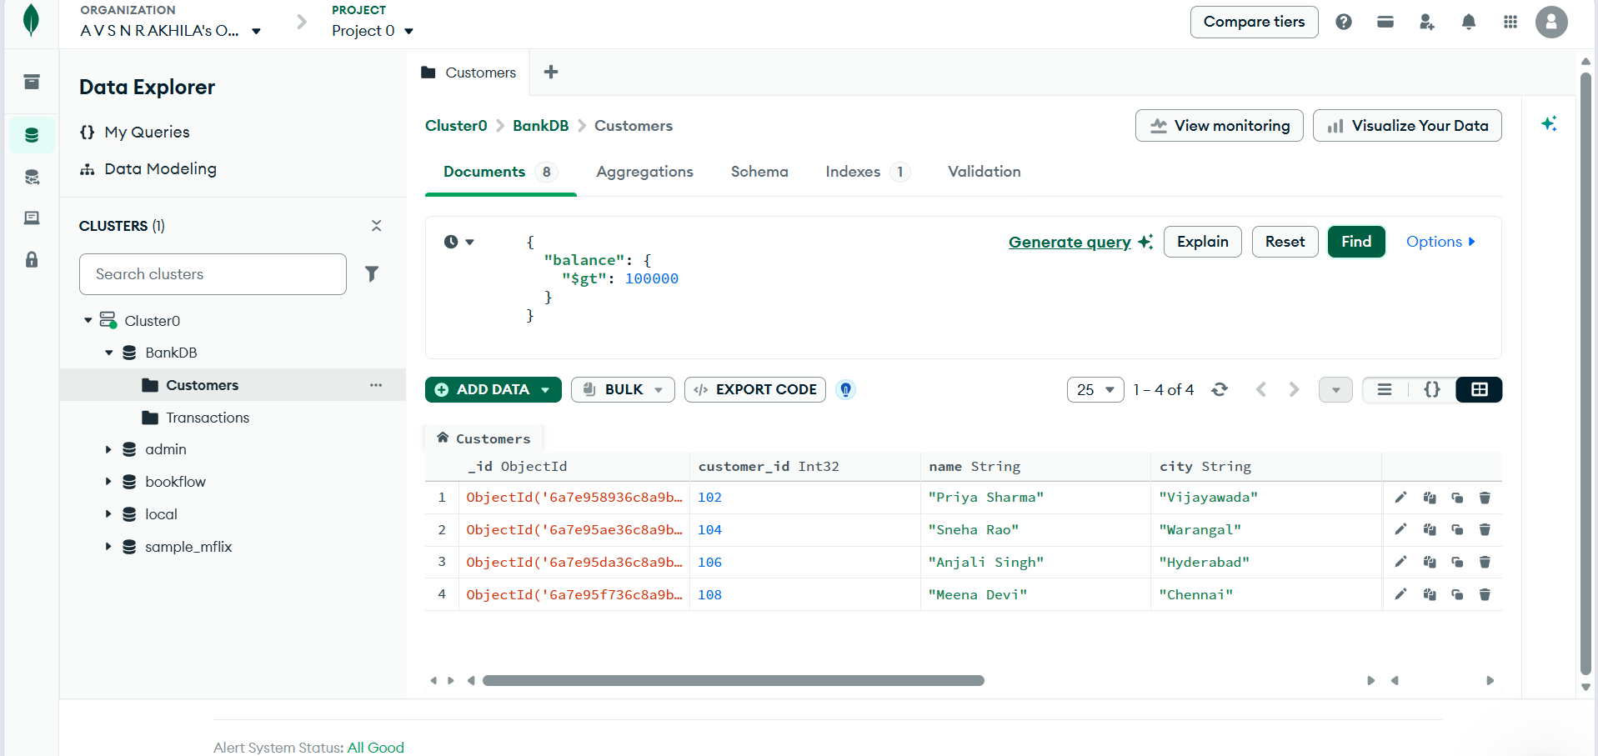
QUERY 4: FIND HYDERABAD CUSTOMERS
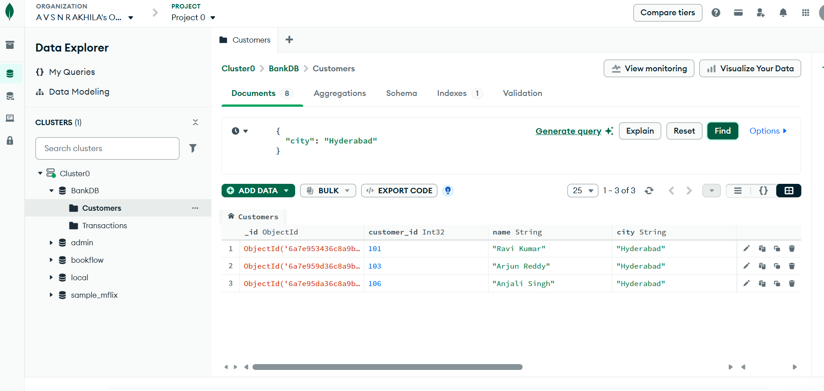
QUERY 5: FIND SAVINGS ACCOUNT CUSTOMERS
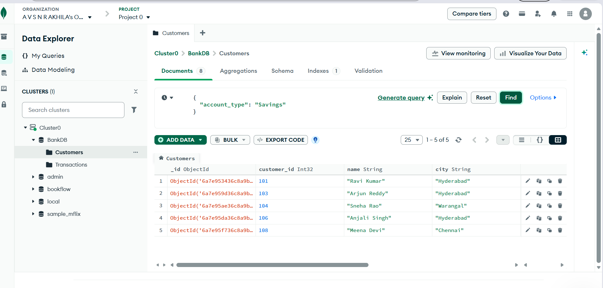
QUERY 6: FIND TRANSACTIONS GREATER THAN 20000
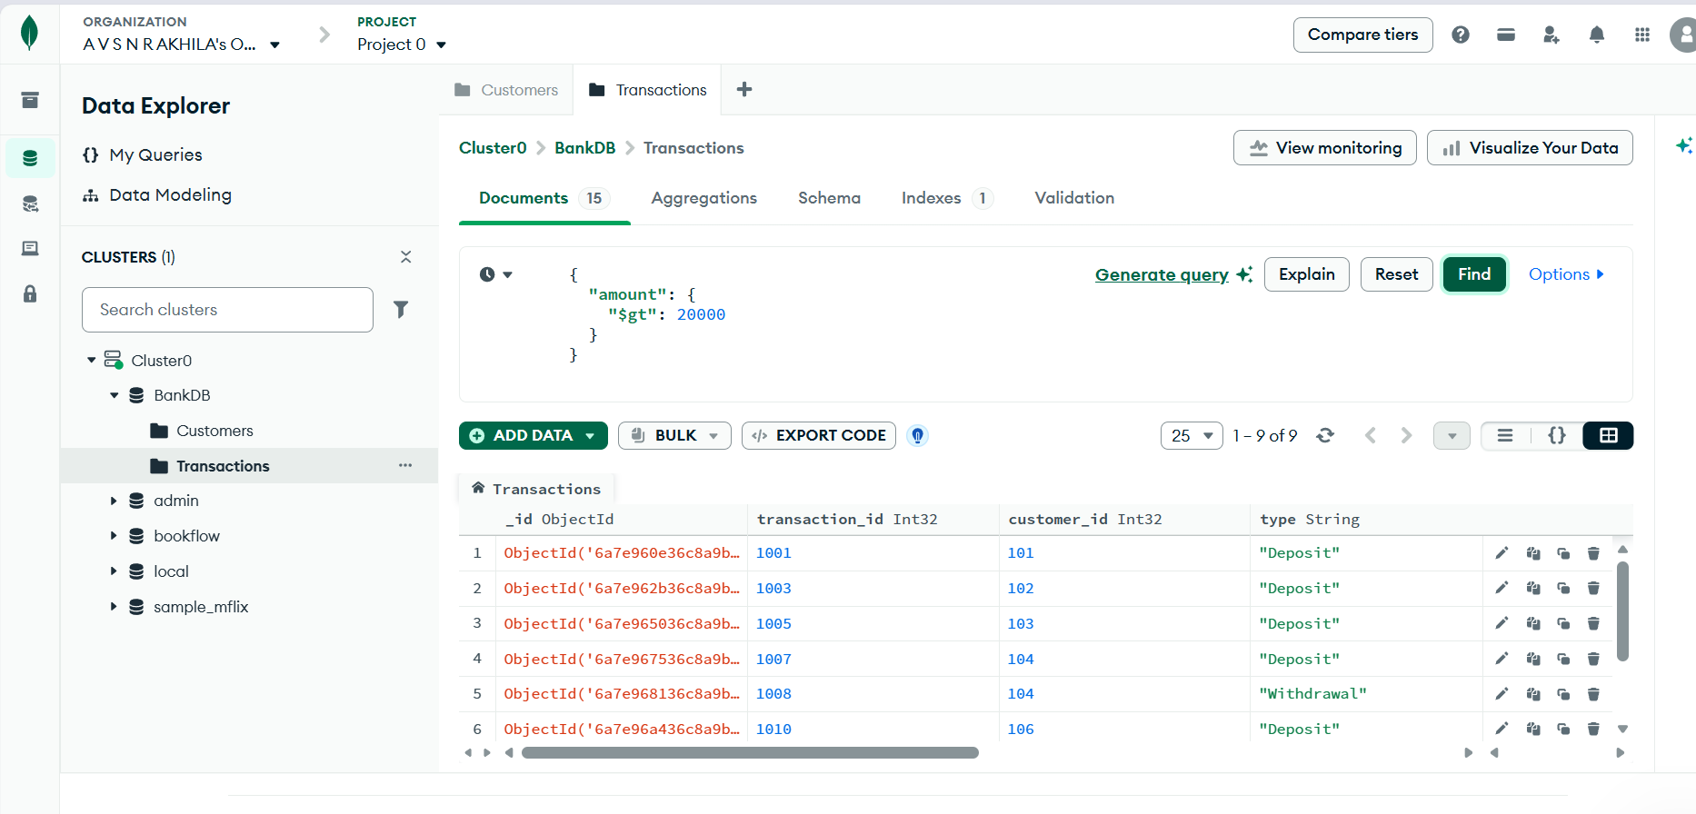
QUERY 7: FIND DEPOSITS
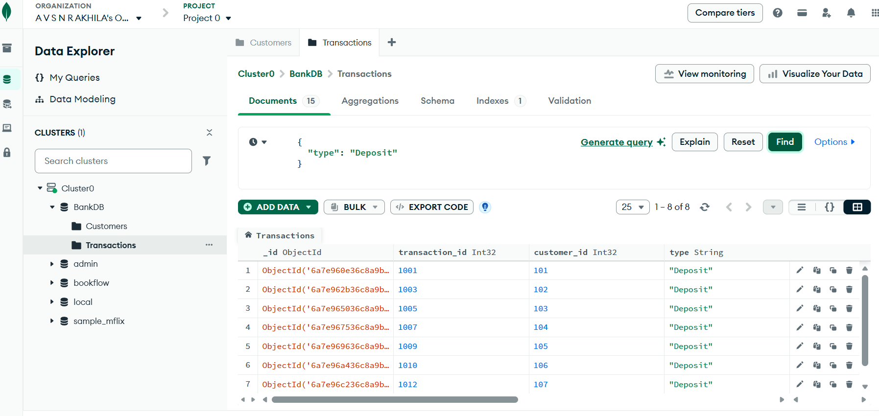QUERY 8: FIND ATM TRANSACTIONS
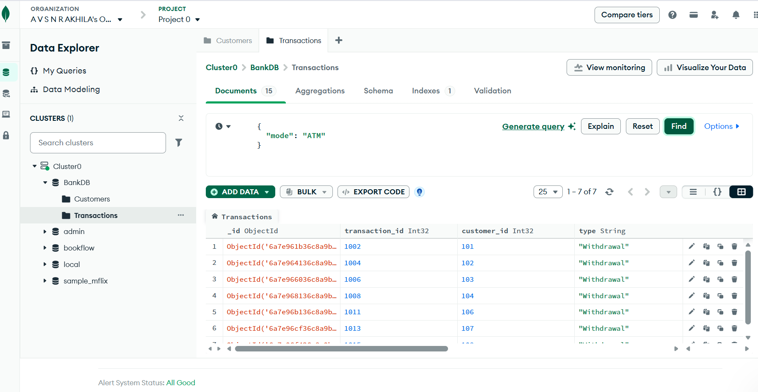
QUERY 9: FIND DEPOSITS GREATER THAN 50000
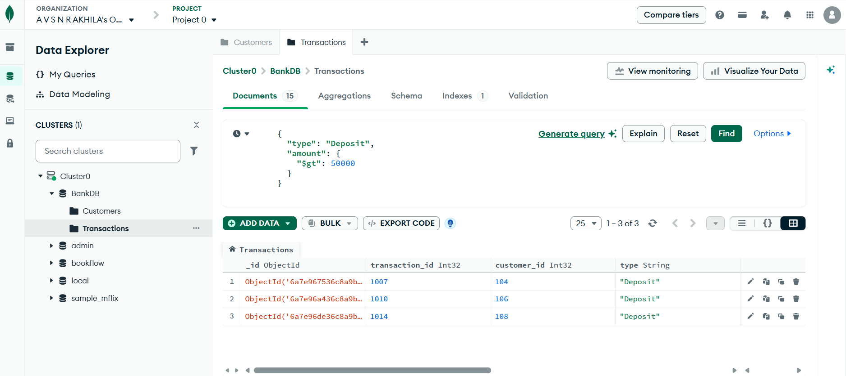
QUERY 10: FIND HYDERABAD CUSTOMERS WITH HIGH BALANCE
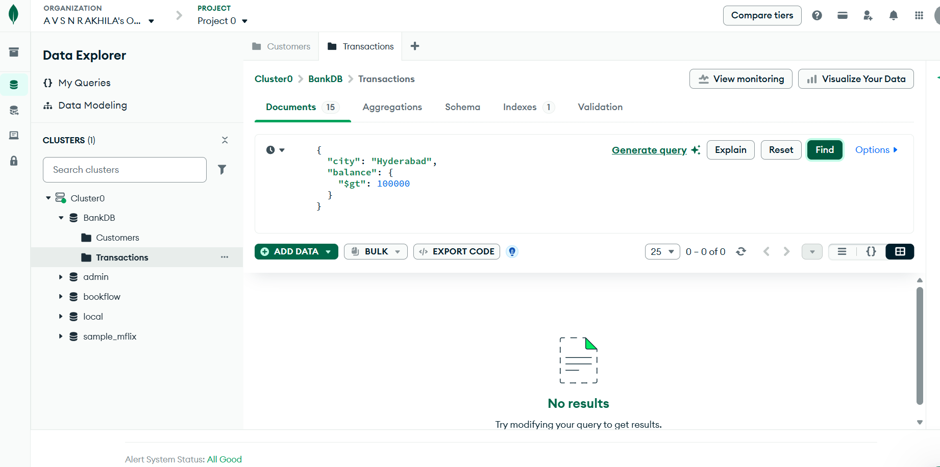
QUERY 11: FIND CUSTOMERS IN MULTIPLE CITIES
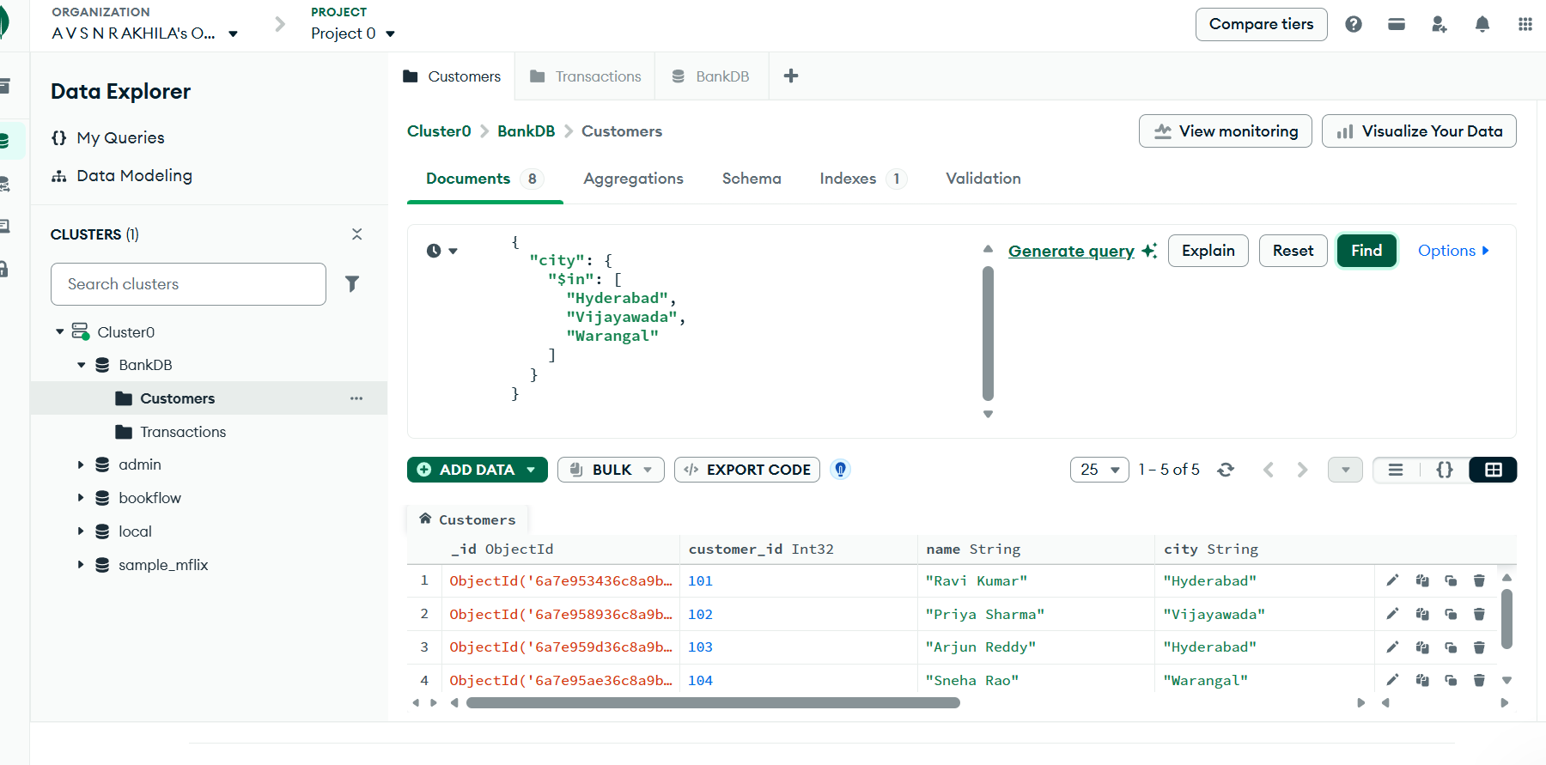
QUERY 12: SORT CUSTOMERS BY BALANCE
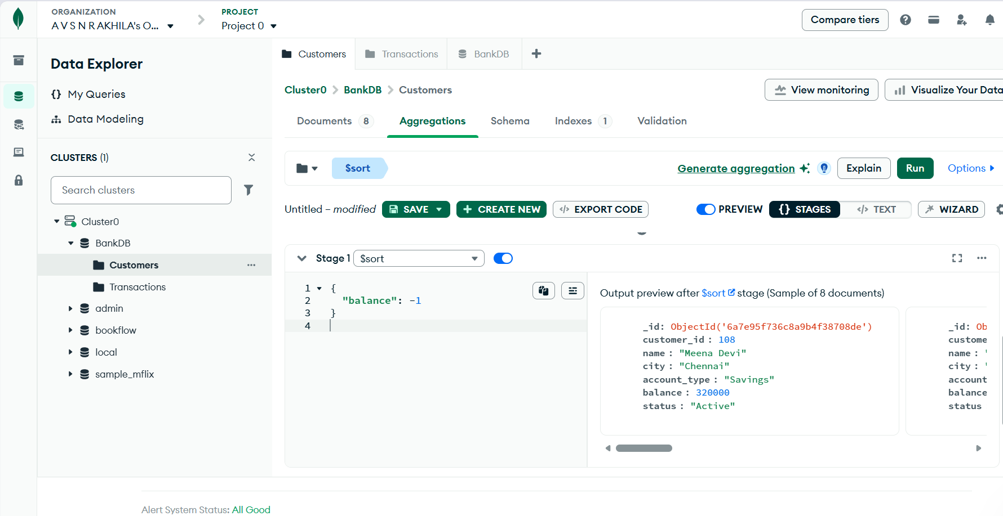
QUERY 13: CALCULATE TOTAL TRANSACTION AMOUNT
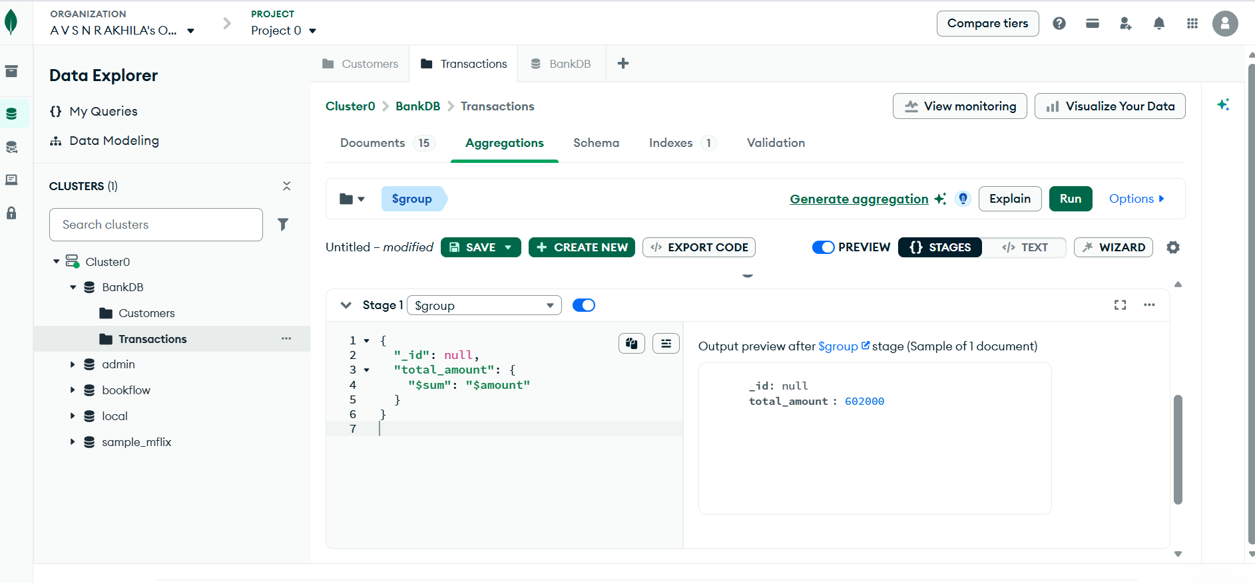
QUERY 14: CALCULATE AVERAGE TRANSACTION AMOUNT
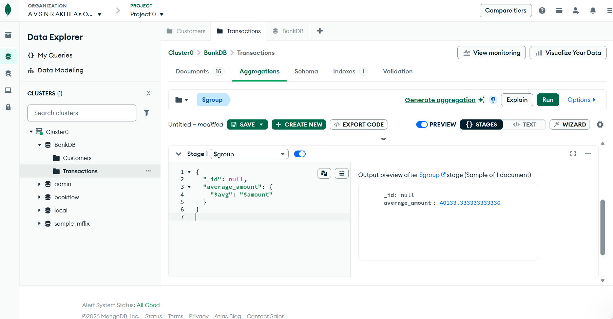
QUERY 15: TOTAL TRANSACTION AMOUNT BY TYPE
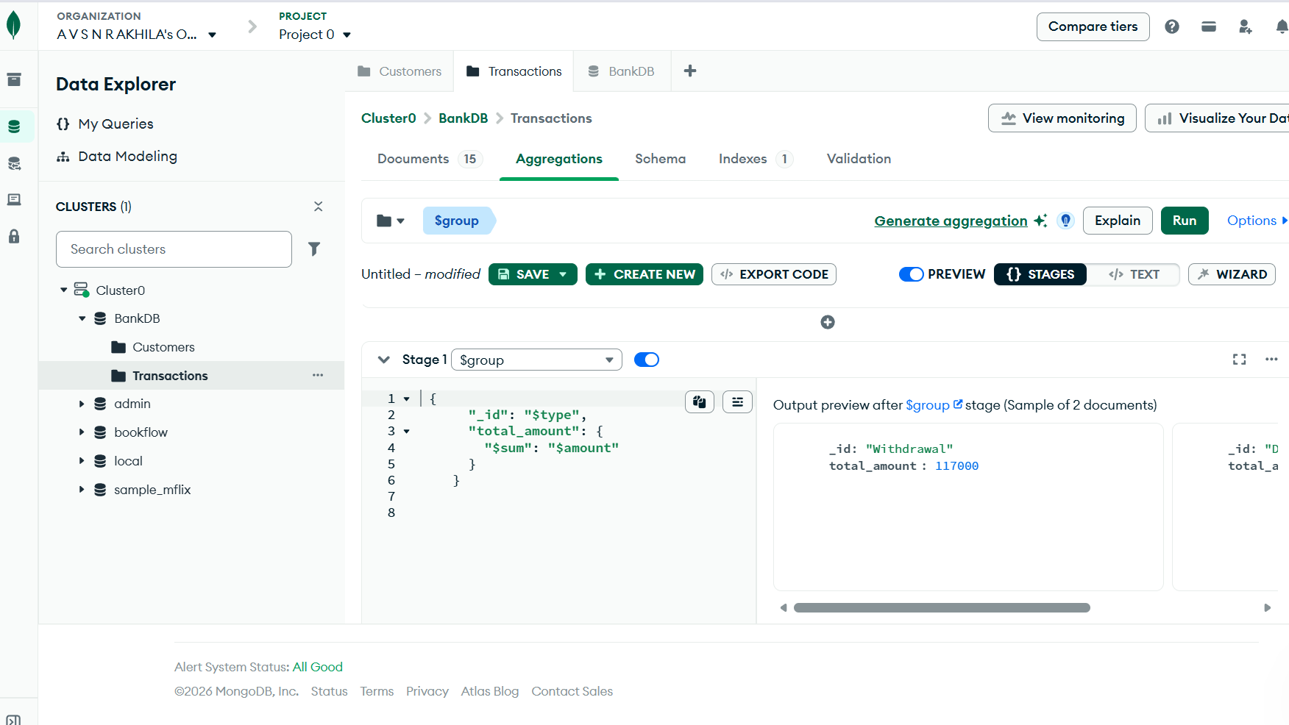
QUERY 16: CUSTOMER + TRANSACTION JOIN
