**Problem 1:**

Contour plots are very popular for depicting continuous density on any 2D surface. Generally, when we use contour plot over any two dimensional spatial surface it depicts density in form of high peaks or low valleys and gives a vibe of 3 dimensional space.

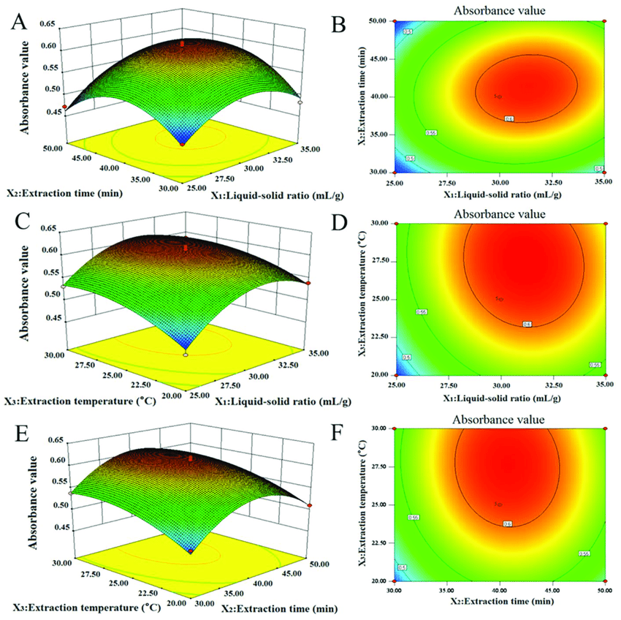

**Figure 1: Example contour plot and its 3 dimensional view**

This problem is to think contour plot one step ahead, in a 3D surface. For example, if we think a spatial surface such as any area on earth as two dimensional space and time as the third dimension and want to create a contour plot over this three dimensional space the representation becomes problematic if we want to represent that on any two dimensional media such as paper. Any two dimensional media can only give vibe of 3D visualization. But the above problem requires a four dimensional representation (e.g. 2D space with latitude & longitude, 3rd dimensional time and 4th dimensional density) on a two dimensional media. The challenging part of this task is depicting the continuity of the density in all three spatio-temporal domains as continuously and flawlessly as possible.

**Dataset**:

Any sample point dataset can be used. One example dataset can be New York crime dataset. <https://data.cityofnewyork.us/Public-Safety/NYC-crime/qb7u-rbmr>

The dataset contains latitude and longitude and different crime types. Density of any types of crimes can be used for analysis.

**Density Estimation Technique**:

1. First you need to think a hypothetical grid over the observation area
2. In each grid point you can calculate density of any crime such as robbery using Kernel Density Estimation
3. You can follow this tutorial: https://pro.arcgis.com/en/pro-app/latest/tool-reference/spatial-analyst/how-kernel-density-works.htm

**Problem 2:**

To depict contour on any spatial surface we try to plot contour plot over any map or polygon plots.

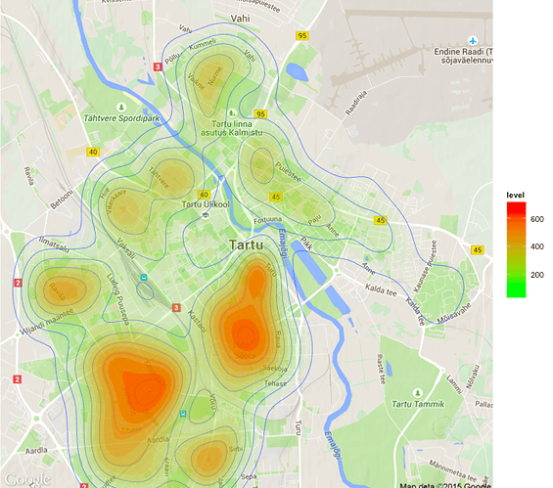

Figure: 2- Contour plot over map

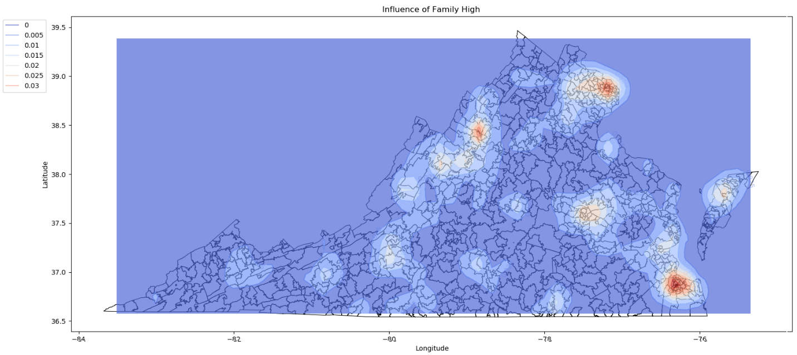

Figure: 3- Contour plot over shapely geometry polygons.

Sometimes we need to stack several 2D contour surface in 3D visualization like below:

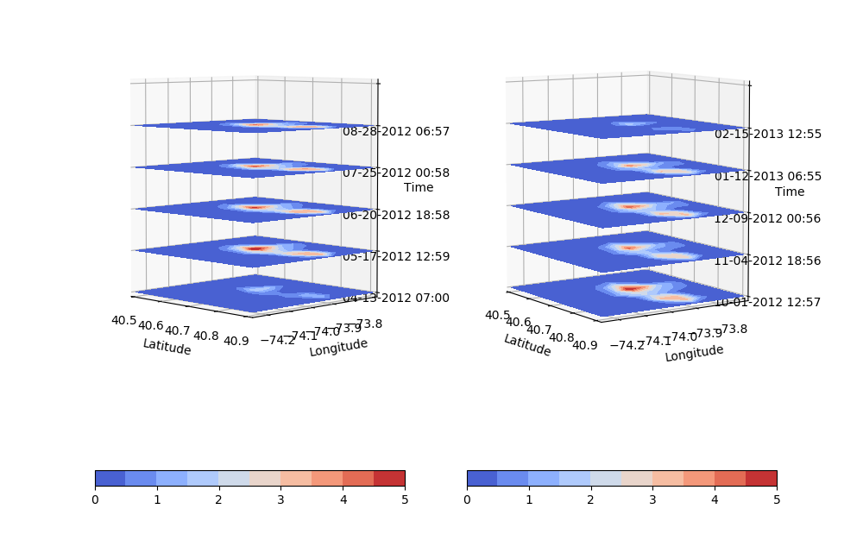Figure 4: Stacked contour plot

The problem of these kind of plot is adding multiple map or geometry polygons over each sub stack plot as all plots are plotted in a single plot surface. Tools do not support this addition to best our knowledge.

**Dataset**:

Any sample point dataset can be used. One example dataset can be New York crime dataset. <https://data.cityofnewyork.us/Public-Safety/NYC-crime/qb7u-rbmr>

The dataset contains latitude and longitude and different crime types. Density of any types of crimes can be used for analysis.

**Density Estimation Technique**:

1. First you need to think a hypothetical grid over the observation area
2. In each grid point you can calculate density of any crime such as robbery using Kernel Density Estimation
3. You can follow this tutorial: <https://pro.arcgis.com/en/pro-app/latest/tool-reference/spatial-analyst/how-kernel-density-works.htm>
4. You can calculate density for different crimes or calculate density at different time interval and try to plot them in a single graph