**Abstract:**

As we all know now a days many people are showing up interest and taking step towards investing in shares of many companies and this is also familer to us as stock market because every day we use to see it in news, stock market is a equity market or share market is the aggregation of buyers and sellers of stocks, which represent ownership claims on businesses, in which some of them are highly profited and some of them are lost in them. The main fault many of them do in trading is not having good analysis and not concentrating on trend changing part and also not checking the trading cyclicality part and this is what where we concentrate and want to build a process which helps the investors or stack holders for buying or selling shares or nothing but investing ,

As we can see daily in news that the stock market price is increased or decreased in an unpredictable way, basically it is concluded on the open price and closed price of the shares in the hole day ,and many of them think it is very difficult but if we can catch up the loop of the trading cyclicality then it will be really easy and help full for us to analysis the market changes, for this we divided our project into 3 modules as trend changing part, trading cyclicality part, final candles and we also use some of the techniques like smoothing , **e.c.d.f.** (empirical cumulative distribution function) ,quantile which will be discussed in detailed below.

**Introduction:**

The main motive of the project is to analyze the trade in such a way that you can make the investors to buy the shares at the profitable time based on the previous year’s data. For this we are going to take the trade dataset (EURUSD) of previous years and make the data familiar by plotting graphs and get the inference from it which we require, Basicallyt our dataset(EURUSD) consist 28498 rows and 5 columes namely like date, open, high, low, close which says like open is the price of trading (share market price) in a particular day at particular hour when it is sarted and close is the price of trading (share market price) when it is closed and coming to high and low they indicates the peak price of trading in a hour and the least price of trading in the same hour, and as said we plot the graphs and get the required inference which will be very much helpfull in future part of the code.

Then coming to main part of the project first we will change the date format as required and some pre required function like shif which will shift the cells this is very important in all modules,then we start the next part which is the “ trend change” this can be achieved by considering the bullish (1) and bearish (0) values and then based on it make count column of them , then using profit formula calculate the values of them that gives you the trend change. Then find the trading cyclicality which is nothing but the flow of profit and loss which helps for future step, this consists the step like smoothing the row values and trade close values, then by the smoothing values check the cyclicality, use the plot to decide how to trade this thing from that plot we can deduce what is / is not tradable and finally by taking certain trade open and close values analyzing get some candles of future, so that investors can decide when to not and when to trade the shares on a particular time.

**Literature Survey / Requirements**

**Libraries used:**

library(ggplot2): # ggplot2 is a system for declaratively creating graphics, based on The Grammar of Graphics. You provide the data, tell ggplot2 how to map variables to aesthetics, what graphical primitives to use, and it takes care of the details.

library(tidyverse): #idyverse. The tidyverse is an opinionated collection of R packages designed for data science. All packages share an underlying design philosophy, grammar, and data structures. See how the tidyverse makes data science faster, easier and more fun with “R for Data Science”.

library(dplyr): # dplyr is a grammar of data manipulation, providing a consistent set of verbs that help you solve the most common data manipulation challenges: mutate() adds new variables that are functions of existing variables. select() picks variables based on their names. filter() picks cases based on their values.

library(caret): #The caret package (short for Classification And REgression Training) contains functions to streamline the model training process for complex regression and classification problems.

library(lattice): #The lattice add-on package is an implementation of Trellis graphics for R. It is a powerful and elegant high-level data visualization system with an emphasis on multivariate data

**Dataset Description:**

The data set used in our project has taken from kaggle which is named as EURUSD. It consist of 28498 rows and 5 columes namely like date, open, high, low, close which says like open is the price of trading (share market price) in a particular day at particular hour when it is sarted and close is the price of trading (share market price) when it is closed and coming to high and low they indicates the peak price of trading in a hour and the least price of trading in the same hour, and as said we plot the graphs and get the required inference which will be very much helpful in future part of the code.

The format of dataset that we have dicussed above is as shown below and an important graph to get inference of the dataset.

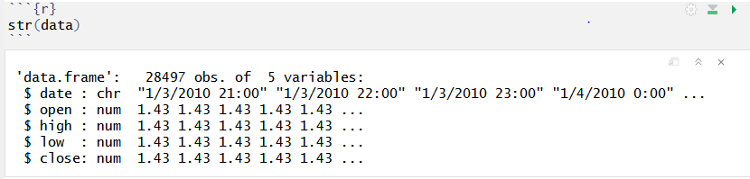

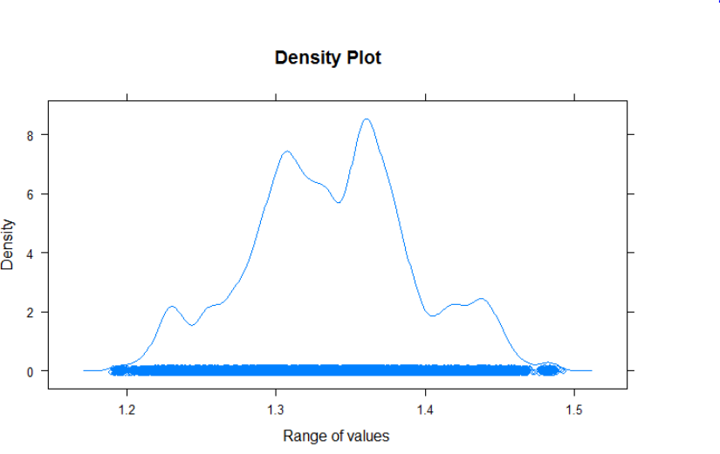

**Proposed System / Module(s) description**

We can find many trading prediction project in other langues like deep learning python etc.., but there are very less papers of trading in r, and as we are not following any particular, papers but we have taken the knowledge from them about the present trading project and we want find a our own way from the knowledge that we have . we have divide our project in to 3 modules as follows.

1. **trend changing part:**

* As said first change the date format as require using **posixct** as it is in an un practicable way in dataset then, Crate a shift function which will move the cells as required.Then by considering the bullish (1) and bearish (0) values which can be get by the open and close price values and create a bull column if open is less the close it is bullish (1) and vice versa.
* Then crate a other data called count which count the number of zero’s and ones, which helps to find the change rate probability. now create a nextcount attribute with one shift to know the bullish (“1")/ bearish("0") in count and for calculation purpose.Now create a table that contains the number of events, for example, after 3 consecutive candles(candles are more like bullish (1) and bearish (0)), how many times did the trend continue vs how many times did the trend change
* Then to the know the highest loss and gain of profit from above data by considering a subset with count values grater than 7 and give the trade directions . finally set different trade cost and by formula (eg : trades$profit <- trades$direction*(trades$nextclose - trades$nextopen) - trades$cost) get the trade profit values and plot a graph and compare , to see trade change as below.

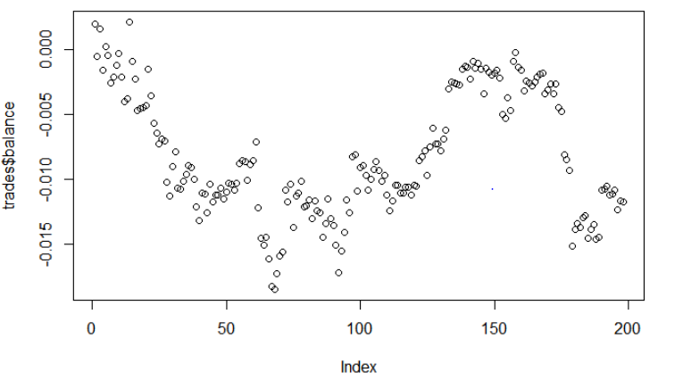

As you can clearly see from the graph there are continuous profit and loss in the balance profit that we have calculated then moving to trading cyclicality classification which tends to give more information.

1. **trading cyclicality part**

* After analyzing the trade change we are concentrating on trade cycle like how it is.
* add a row number - why? so that we can smooth without taking into account a non-uniform time axis (weekends / holidays)
* for that we are giving a row numbering and smoothing the values by function
* Then crate a plot with data and curve with 200 tuples to extract the data then plot a graph by which a line passes through the smoothing values as follows

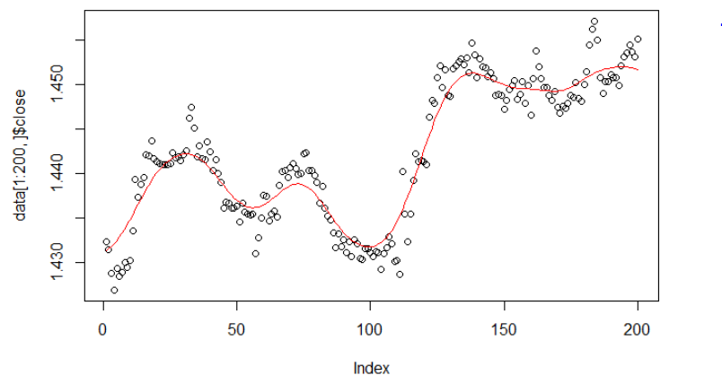

* Then for more clarification find the peaks and troughs from that graph as follows 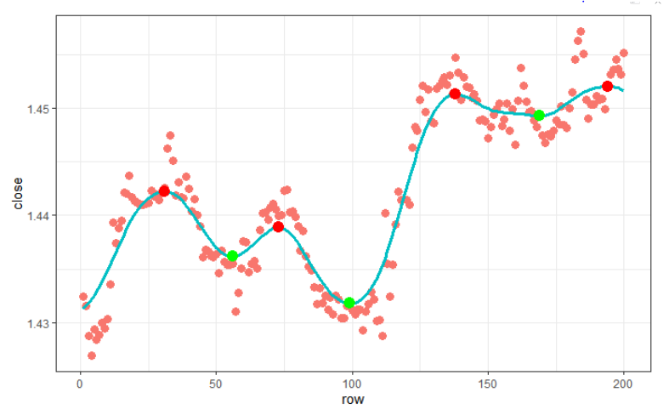

After adding peaks and troughs

* Now we want to know how the cyclicality looks like for that want to crate a other subset with the minmax column which has creted by peaks and troughs . and for smoothing values apply abs function and store in pricedifference for row values use diff function and store in candledifference then plot price a graph for pricedifference vs candledifference as follows

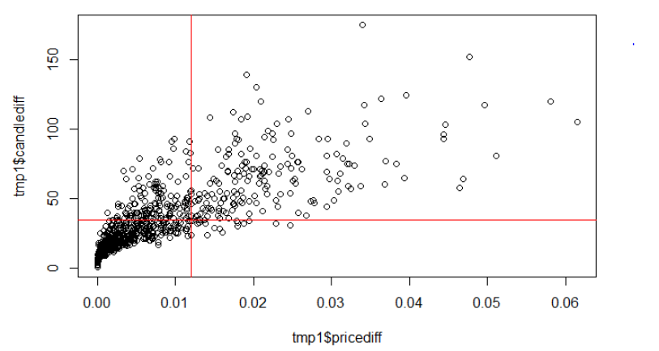

1. **Final positive balance**

* Then apply ecdf(Empirical cumulative distribution function) to candledifference then apply quantile to the candledifferen
* Then filter for the trading opportunities get the prices 15 candles in the futures. Why "10"? Not sure, seems like as good a number as any. but it does kind of helps to fit into the most dense part of the scatterplot
* Then create a subset with original datasetrow column and above created datset then set cost to 0 and 0.0002 and as before, calculate the profit/loss per trade, and the running balance

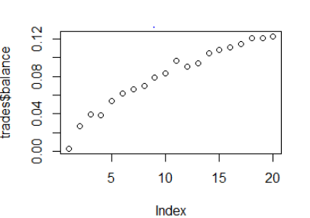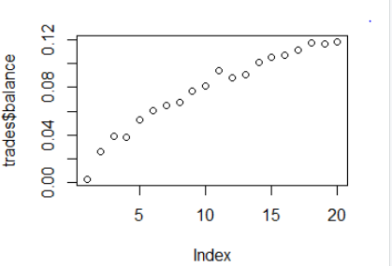

* Now you can see our final result , our graphs says that our analysis has the more accuracy of being correct which make investors to be in a profit way

The methodologies used in our project are like

1. Smoothing techniques

2. Quartile

**Advantages of your method:**

* investor can invest on the trade based on our analysis graph and have the chances of getting high profit
* users can make more accurate predictions
* easy to estimate and high change of getting profits in a always a positive way.

**Conclusion:**

As we can see now days people are showing intrest in trading and many of them were losing money while buying shares and this is a big issues .Many investors are also confused and they are lack of confidence made them to take wrong step and all this issues can be retified by our technique.

**Reference:**

https://in.tradingview.com/symbols/EURUSD/,https://admiralmarkets.com/education/articles/general-trading/trading-euro-dollar ,https://www.youtube.com/watch?v=Vw4m7pXmh2A,https://www.sciencedirect.com/science/article/pii/S1822801115300096