**ASSIGNMENT NO :2**

**User login with password verification**

**Step 1: user login page**

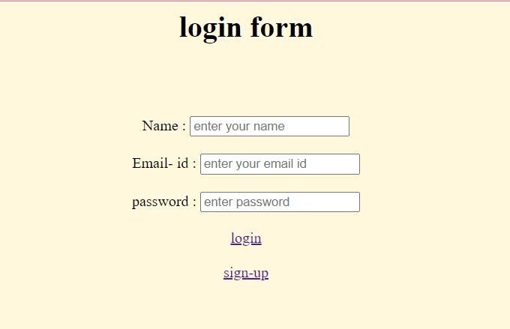

**Step2: sign-up page**

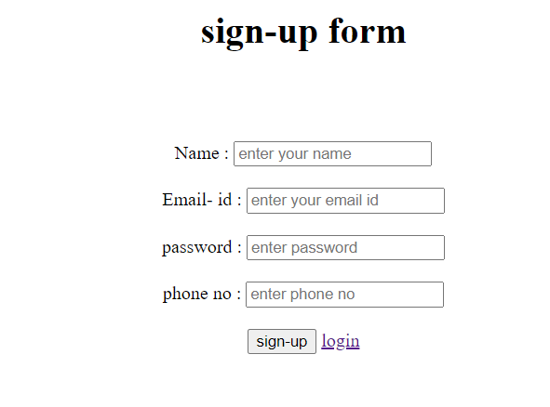

**Step3: home page, when user click logout button, take the user back to login**

