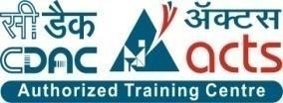

**INSTITUTE FOR**

**ADVANCED COMPUTING**

**AND SOFTWARE DEVELOPMENT**

**AKURDI, PUNE**

Documentation On

**“COLLEGE MANAGEMENT SYSTEM”**

PG-DAC SEPT 20201

*Submitted By:*

Group No: 09

Amey Teware (219018)

Tanuja Sawai (219213)

**Mr. Prashant Karhale** **Mr. Chetan Pardeshi** **Center Coordinator Project Guide**

**Table of Contents**

**1.Introduction..........................................................................................................4**

Problem Statement............................................................................................... 4

Aim & Objectives................................................................................................... 4

**2. Overall Description.............................................................................................5**

Proposed Methodology......................................................................................... 5

Operating Environment..........................................................................................5

Design and Implementation Constraints................................................................6

**3. Requirements Specification..............................................................................7**

External Interface Requirements........................................................................... 7

**4. System Diagram...................................................................................................8**

Activity Diagram......................................................................................................8

Data Flow Diagram............................................................................................... 11

Class Diagram....................................................................................................... 14

Use Case Diagram ................................................................................................ 15

ER Diagram ........................................................................................................... 18

**5. Table Structure** **...................................................................................................18**

Student ..................................................................................................................18

Faculty ................................................................................................................... 18

Course ................................................................................................................... 19

Subject .................................................................................................................. 19

Attendance............................................................................................................ 19

Exam ......................................................................................................................19

Report Card………………………………………………………………………………………………………..20

**6. Conclusion** **...........................................................................................................21**

Future Scope .........................................................................................................22

**7.References............................................................................................................22**

**List of Figures**

Figure1 Admin Activity Diagram .......................................................................8

Figure 2 Student Activity Diagram......................................................................9

Figure 3 Faculty Activity Diagram......................................................................10

Figure 4 Level 0 Data Flow Diagram..................................................................11

Figure 5 Level 1 Data Flow Diagram.................................................................. 11

Figure 6 Level 2 Data Flow Diagram for Admin ................................................ 12

Figure 7 Level 2 Data Flow Diagram Course ..................................................... 12

Figure 8 Class Diagram...................................................................................... 13

Figure 9 Use Case Diagram for Student............................................................ 14

Figure 10 Use Case Diagram for Faculty........................................................... 15

Figure 11 Use Case Diagram for Admin............................................................ 16

Figure 13 ER Diagram ........................................................................................17

1. **INTRODUCTION.**

**Introduction:**

Portal is a web system that provides the function and features to authenticate and identify the users and provide then with easy, intuitive, personalized and user-customizable web-interface for facilitating access to information and services that are of primary relevance and interests to the users. Student Portal is nothing but a portal which thinks students as the main target users & provides so many useful services to students at a single place & through a single interface but in customized form.

**Problem Statement:**

There are many problems found in the todays portal system. The problems created in the existing system enforced us to develop the new system which minimize the problem of the existing system. These problems are Now a days the system in college like entering papers details in only department level of papers data is done manually which consumes lots of time. Its application depends works on minimum peoples that is department level.

**Aims and Objective:**

The main purpose of this system, is to reduce the consumption of time during maintaining the records of college. Separate divisions are providing to maintain the records of teachers, students. Our System also procure an easy way not only to automate all functionalities of a college, but also to procure full functional reports to top management of college with the finest of details about any phase of college. In other words, our college portal has, following objectives:

* Simple database is maintained.
* Easy operations for the operator of the system.
* User interfaces are user accommodating and attractive; it takes very less time for the operator to use the system.
* The aim is to design a college website which implant update information of the college that should improve expertness of college record management.

1. **OVERALL DESCRIPTION.**

**Proposed Methodology:**

The objective of Student Portal is to provide an online web-based solution for academic use. In this application all data will be available such as student details, faculty details, course details, exam details, report card etc. It is Easy to use. In future it helps our students and staff to organize and access information about all aspects. This website provides a way for student and faculty to communicate to each other, this will solve all drawbacks of manual process, increase the efficiency and speed up all works to be completed. At college managements side a person can view the most important student and staff data. Every student and staff will provide with unique login id and password. All the data will be at least once the validated from the college database. Hence this process also helps in maintaining consistency and integrity. The student and staff acquaintance system that helps to users can readily store the students and staff information through online. The user can readily store and retrieve the data through online. This system helps the user to generate the dynamic legwork. Thus the user can convenient to interact with the system to readily and accessibility the resources through internet or intranet.

**Operating Environment:**

Server Side:

**Processor :** Intel® Xeon® processor 3500 series

**HDD :** Minimum 500GB Disk Space

**RAM :** Minimum 4GB

**OS :** Windows 10, Linux 6

**Database :** MySQL

Client Side (minimum requirement):

**Processor :** Intel Dual Core

**HDD :** Minimum 80GB Disk Space

**RAM :** Minimum 2GB

**OS :** Windows 7, Linux

**Design and Implementation Constraints:**

* The application will use JavaScript, jQuery and CSS as main web technologies.
* HTTP and FTP protocols are used as communication protocols. FTP is used to upload the web application in live domain and the client can access it via HTTP protocol.
* SMTP protocol is used for Email communication.
* Several types of validations make this web application a secured one and SQL Injections can also be prevented.
* Since Student’s Online Portal is a web-based application, internet connection must be established.
* The Student’s Online Portal will be used on PCs and will function via internet or intranet in any web browser.

1. **Requirements Specification.**

**External Interface Requirements:**

User Interfaces:

* All the users will see the same page when they enter in this website. This page asks the users a username and a password.
* After being authenticated by correct username and password, user will be redirect to their corresponding profile where they can do various activities.
* The user interface will be simple and consistence, using terminology commonly understood by intended users of the system. The system will have simple interface, consistence with standard interface, to eliminate need for user training of infrequent users.

Hardware Interfaces:

* + No extra hardware interfaces are needed.
  + The system will use the standard hardware and data communication resources.

This includes, but not limited to, general network connection at the server/hosting site, network server and network management tools.

Application Interfaces:

**Web Browser:**

The system is a web-based application; clients need a modern web browser such as Mozilla Firebox, Internet Explorer, Opera, and Chrome. The computer must have an Internet connection in order to be able to access the system.

Communications Interfaces:

* This system uses communication resources which includes but not limited to, HTTP protocol for communication with the web browser and web server and TCP/IP network protocol with HTTP protocol.
* This application will communicate with the database that holds all the booking information. Users can contact with server side through HTTP protocol by means of a function that is called HTTP Service. This function allows the application to use the data retrieved by server to fulfil the request fired by the user.

1. **System Diagrams.**

**• Activity Diagram:**

* Admin Activity:

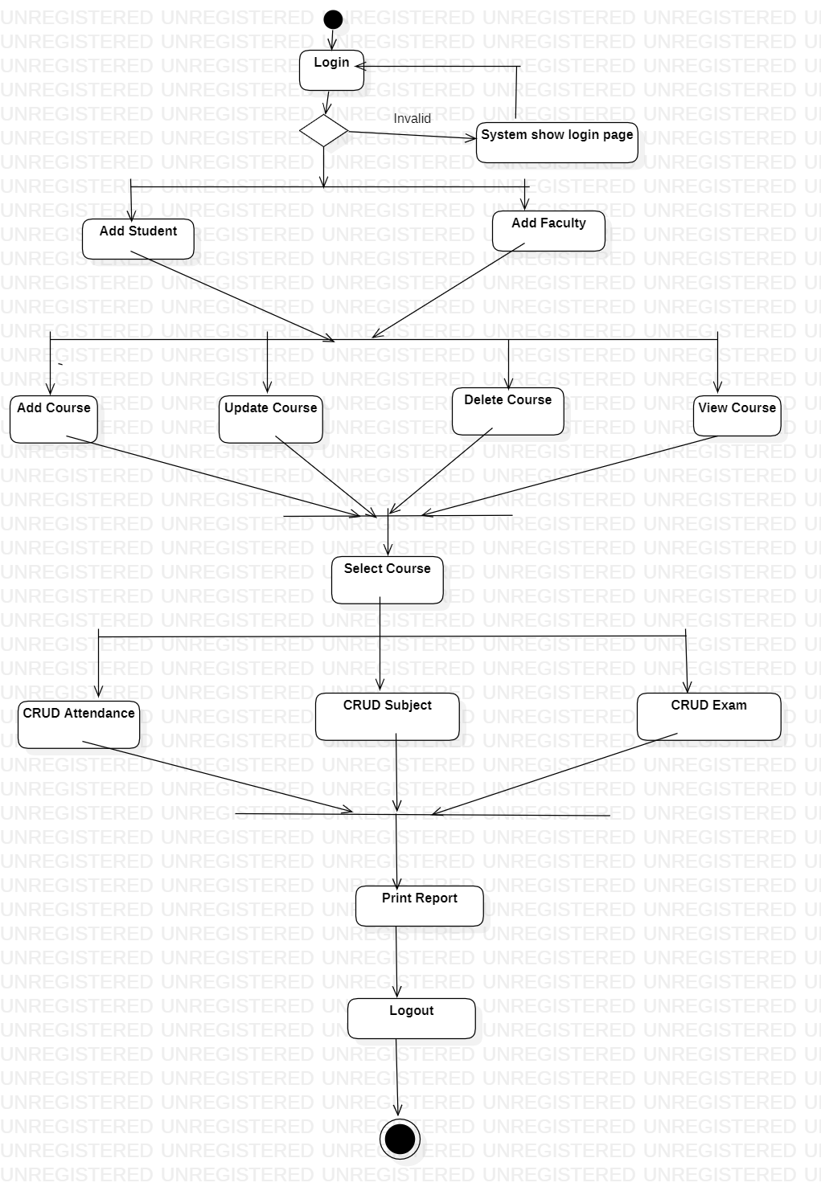

* Student Activity:

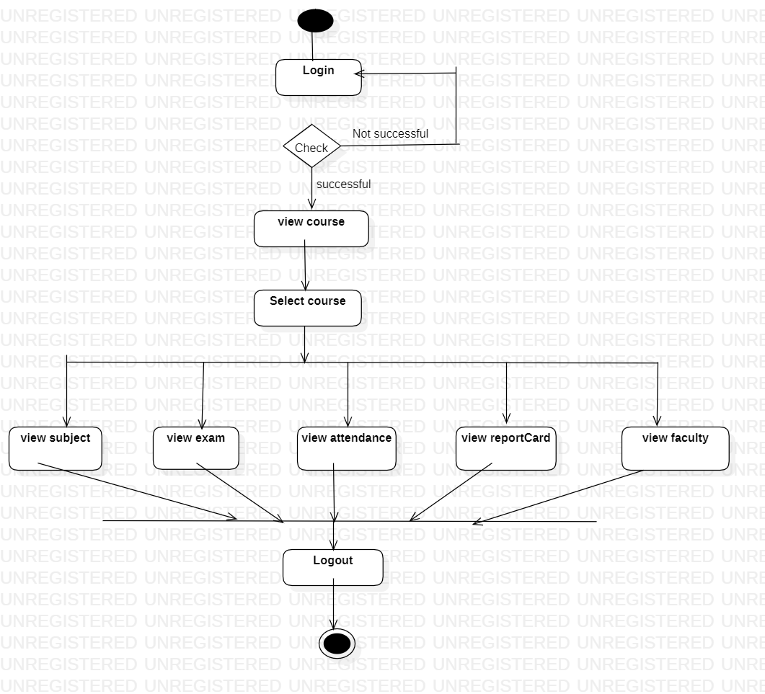

* Faculty Activity:



**• Data Flow diagram:**

**Zero level DFD**

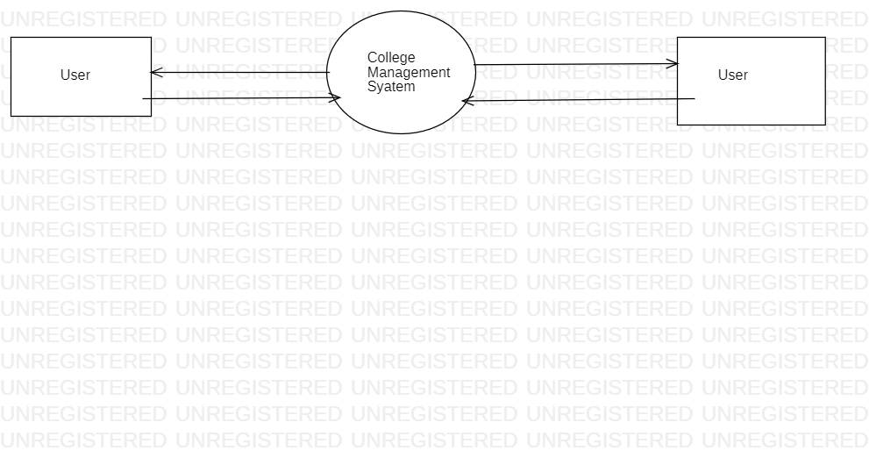

**First level DFD**

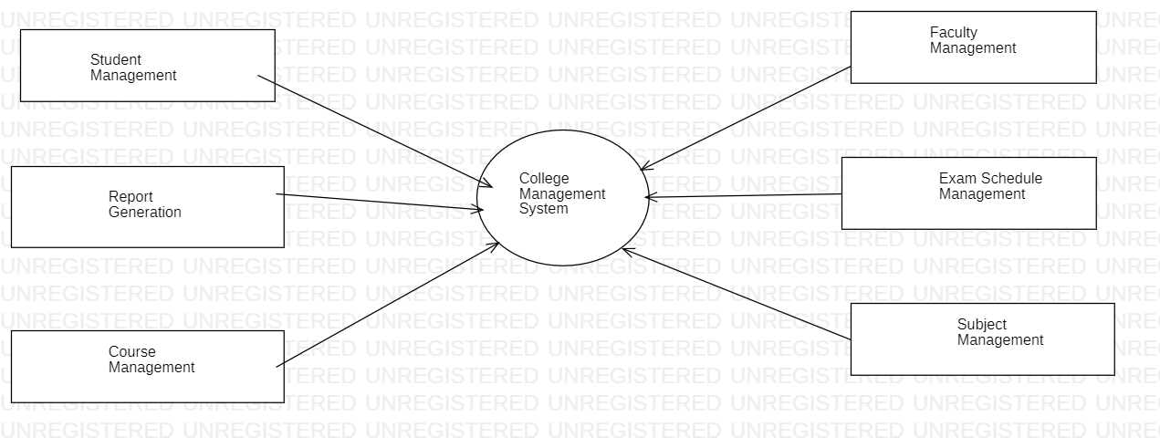

**Second level DFD**

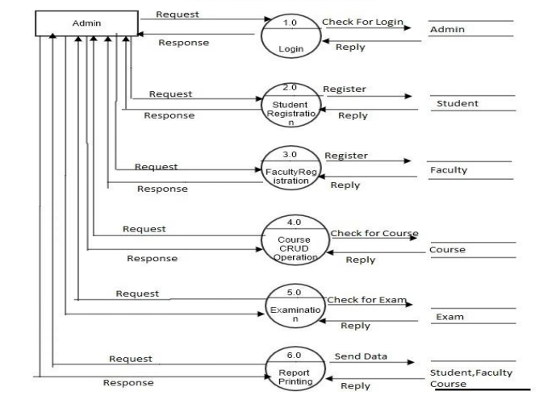

**Course DFD**

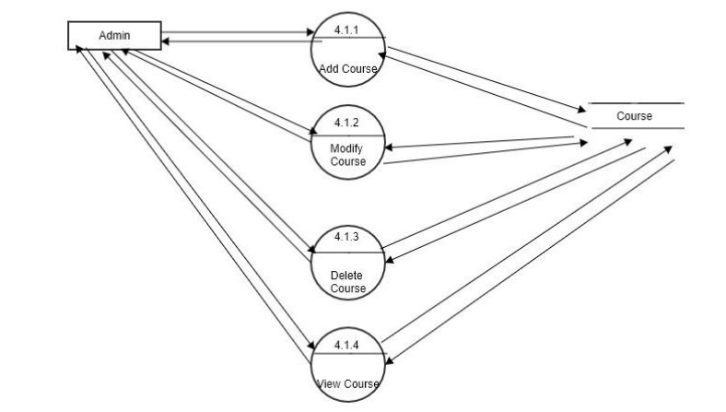

**• Class Diagram:**

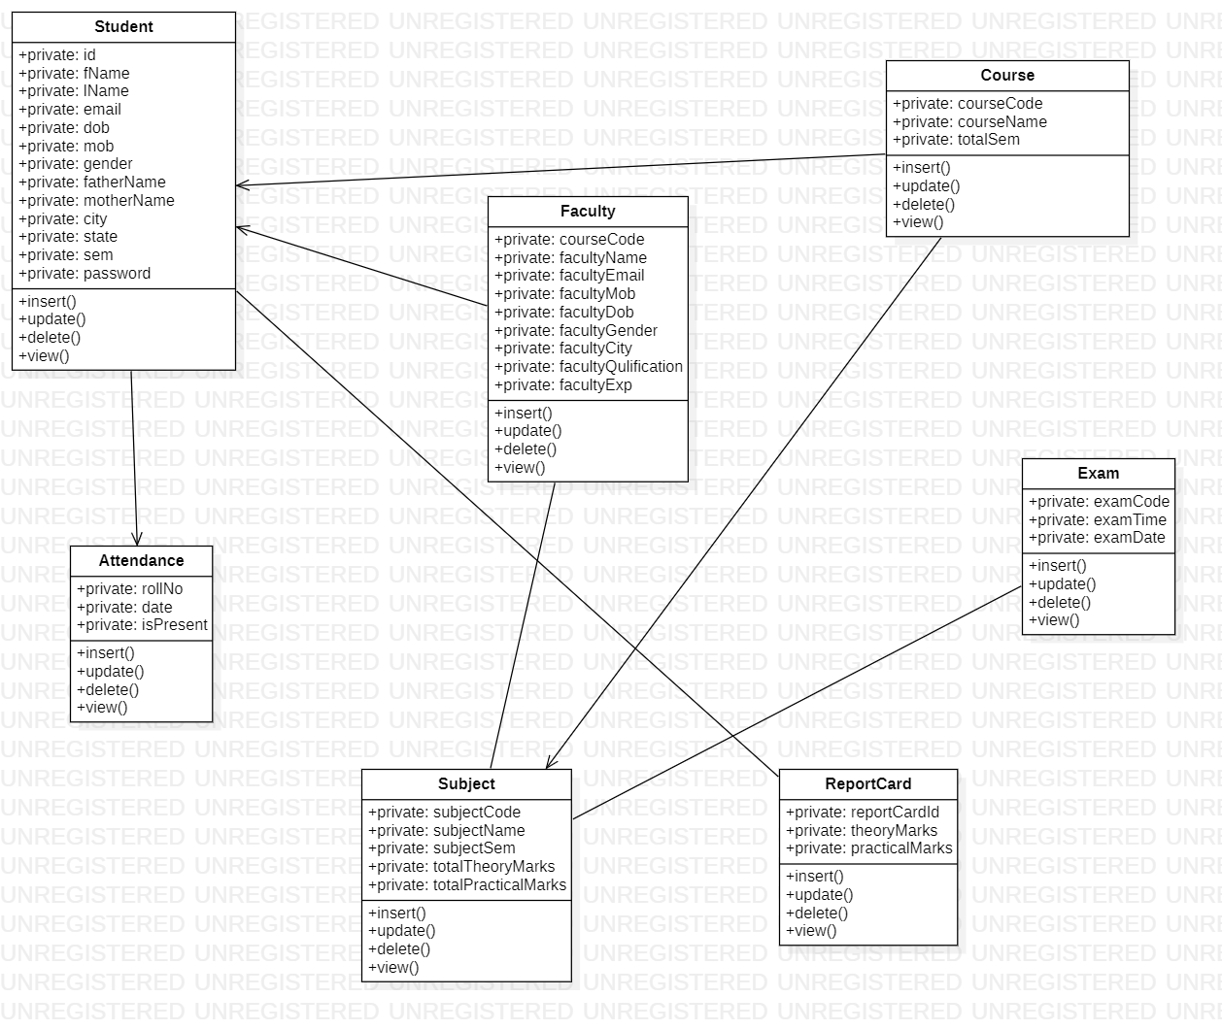

**• Use Case Diagram:**

* Student Use-case:

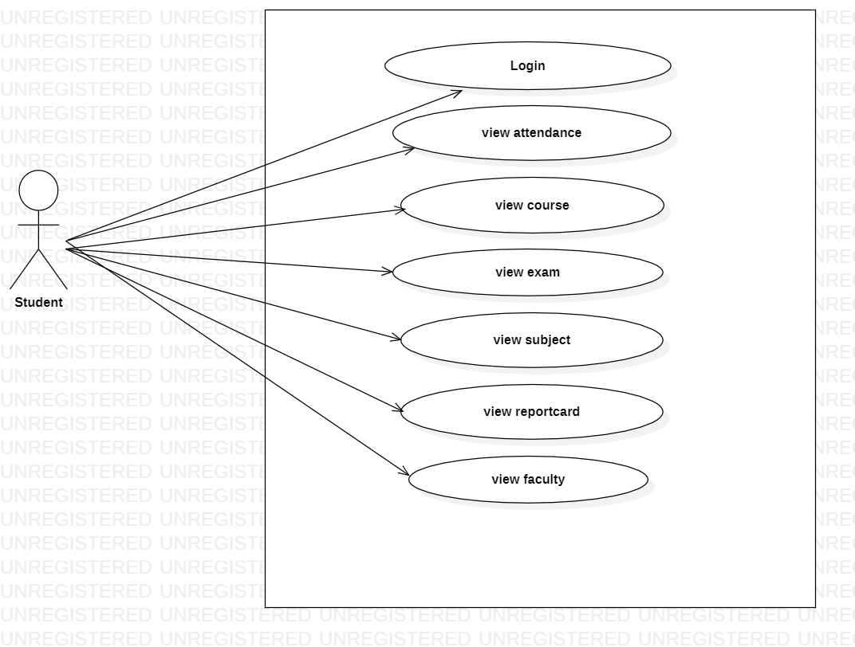

* Faculty Use-case:

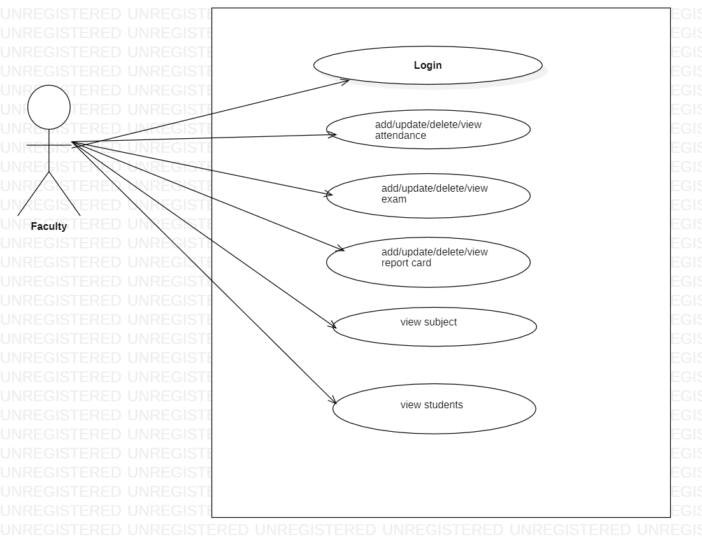

* Admin Use-case:

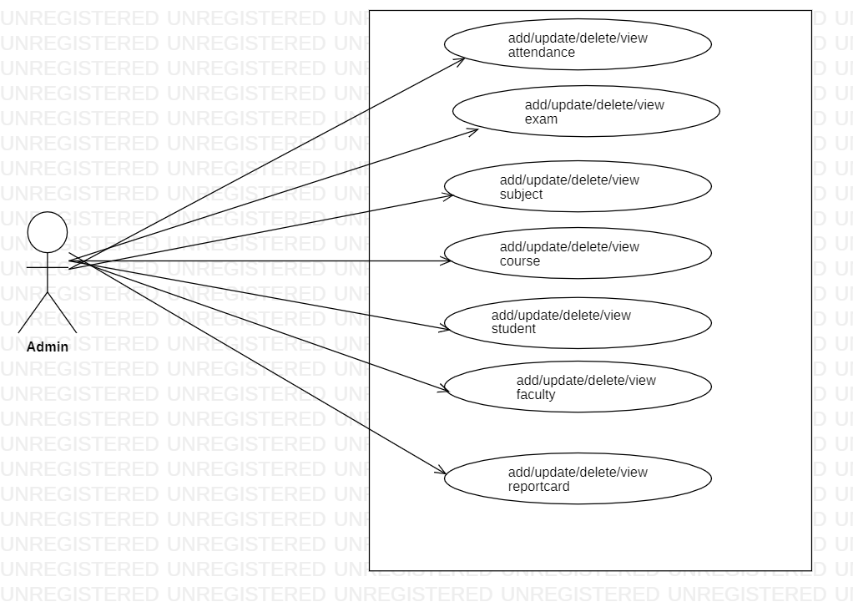

**• ER Diagram:**

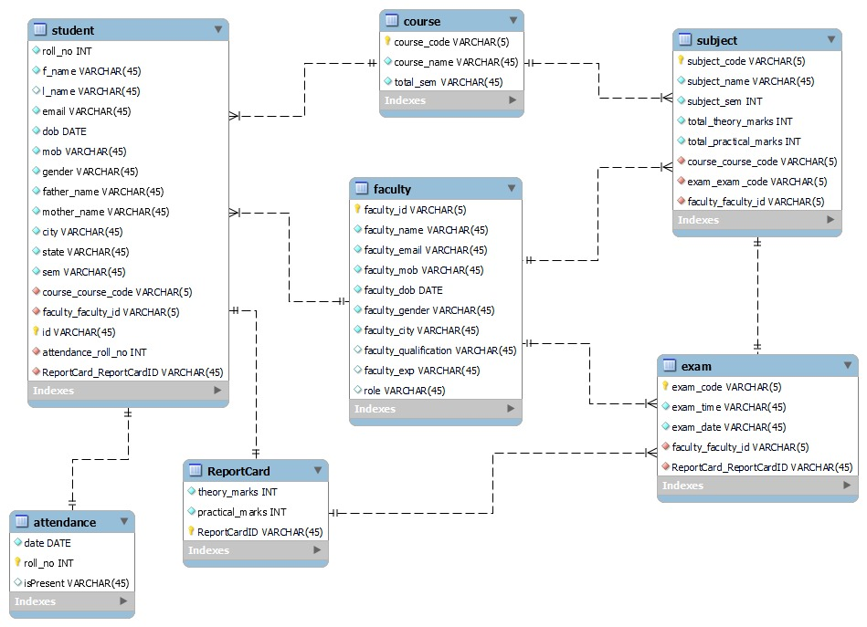

1. **Table Structure.**

* Student:

|  |  |  |  |  |  |
| --- | --- | --- | --- | --- | --- |
| **Field** | **Type** | **Null** | **Key** | **Default** | **Extra** |
| Id | int | NO | PRI | NULL | auto_increment |
| city | varchar(255) | YES |  | NULL |  |
| dob | date | YES |  | NULL |  |
| email | varchar(255) | YES | UNI | NULL |  |
| f_name | varchar(255) | YES |  | NULL |  |
| father_name | varchar(255) | YES |  | NULL |  |
| l_name | varchar(255) | YES |  | NULL |  |
| mob | varchar(255) | YES |  | NULL |  |
| mother_name | varchar(255) | YES |  | NULL |  |
| password | varchar(255) | YES |  | NULL |  |
| sem | varchar(255) | YES |  | NULL |  |
| state | varchar(255) | YES |  | NULL |  |
| course_code_course_code | int | YES | MUL | NULL |  |
| faculty_id_faculty_id | int | YES | MUL | NULL |  |
| report_card_id_report_card_id | int | YES | MUL | NULL |  |

* Faculty:

|  |  |  |  |  |  |
| --- | --- | --- | --- | --- | --- |
| **Field** | **Type** | **Null** | **Key** | **Default** | **Extra** |
| faculty_id | int | NO | PRI | NULL | auto_increment |
| faculty_city | varchar(255) | YES |  | NULL |  |
| faculty_dob | datetime(6) | YES |  | NULL |  |
| faculty_email | varchar(255) | NO | UNI | NULL |  |
| faculty_exp | varchar(255) | YES |  | NULL |  |
| faculty_gender | varchar(255) | YES |  | NULL |  |
| faculty_mob | varchar(255) | YES |  | NULL |  |
| faculty_name | varchar(255) | YES |  | NULL |  |
| faculty_qulification | varchar(255) | YES |  | NULL |  |
| role | varchar(255) | YES |  | NULL |  |

* Course

|  |  |  |  |  |  |
| --- | --- | --- | --- | --- | --- |
| **Field** | **Type** | **Null** | **Key** | **Default** | **Extra** |
| course_code | int | NO | PRI | NULL | auto_increment |
| course_name | varchar(255) | YES |  | NULL |  |
| total_sem | int | NO |  | NULL |  |

* Subject

|  |  |  |  |  |  |
| --- | --- | --- | --- | --- | --- |
| **Field** | **Type** | **Null** | **Key** | **Default** | **Extra** |
| subject_code | int | NO | PRI | NULL | auto_increment |
| subject_name | varchar(255) | YES |  | NULL |  |
| subject_sem | varchar(255) | YES |  | NULL |  |
| total_practical_marks | varchar(255) | YES |  | NULL |  |
| total_theory_marks | varchar(255) | YES |  | NULL |  |
| course_code_course_code | int | YES | MUL | NULL |  |
| exam_code_exam_code | int | YES | MUL | NULL |  |
| faculty_id_faculty_id | int | YES | MUL | NULL |  |

* Attendance

|  |  |  |  |  |  |
| --- | --- | --- | --- | --- | --- |
| **Field** | **Type** | **Null** | **Key** | **Default** | **Extra** |
| roll_no | int | NO | PRI | NULL | auto_increment |
| date | varchar(255) | YES |  | NULL |  |
| is_present | varchar(255) | YES |  | NULL |  |
| id_id | int | YES | MUL | NULL |  |

* Exam

|  |  |  |  |  |  |
| --- | --- | --- | --- | --- | --- |
| **Field** | **Type** | **Null** | **Key** | **Default** | **Extra** |
| exam_code | int | NO | PRI | NULL | auto_increment |
| exam_date | varchar(255) | YES |  | NULL |  |
| exam_time | varchar(255) | YES |  | NULL |  |
| faculty_id_faculty_id | int | YES | MUL | NULL |  |
| report_card_id_report_card_id | int | YES | MUL | NULL |  |
| subject_code_subject_code | int | YES | MUL | NULL |  |

* Report Card

|  |  |  |  |  |  |
| --- | --- | --- | --- | --- | --- |
| **Field** | **Type** | **Null** | **Key** | **Default** | **Extra** |
| report_card_id | int | NO | PRI | NULL | auto_increment |
| practical_marks | varchar(255) | YES |  | NULL |  |
| theory_marks | varchar(255) | YES |  | NULL |  |
| id_id | int | YES | MUL | NULL |  |

1. **CONCLUSION**

**• Conclusion:**

This project aid in automating the existing manual system. This is a paperless work. It can be monitored and guarded remotely. It cut down the man power required and provides accurate information. All years together huddled information can be saved and can be accessed at any time. For this reason, the data stored in the repository helps in taking decision by management. So, it is improved to have a Web Based system. All the stakeholders, faculty and authority can get the required information without delay. This system is crucial in the colleges and universities.

**• Future Scope:**

This project can be enhanced further by adding payable additional courses, online feedback system, online payment facility for the members to reduce the extra work of the admin. The software is flexible enough to be modified and implemented as per future requirements. We have tried our best to present this free and user–friendly website to Institutes.

1. **REFERENCES**

**•References:**

* <http://www.ijcstjournal.org/volume-7/issue-1/IJCST-V7I1P4.pdf>
* <https://bootstrapmade.com/mentor-free-education-bootstrap-theme/>
* <https://www.javatpoint.com/java-mail-api-tutorial>
* <https://angular.io/docs>
* <https://javaee.github.io/javaee-spec/javadocs/>
* <https://www.w3schools.com/>