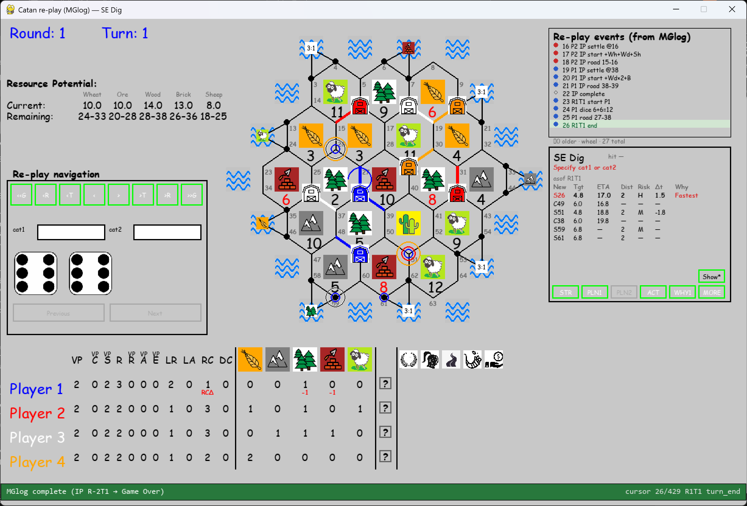
R1T1: Missing S58, S62.
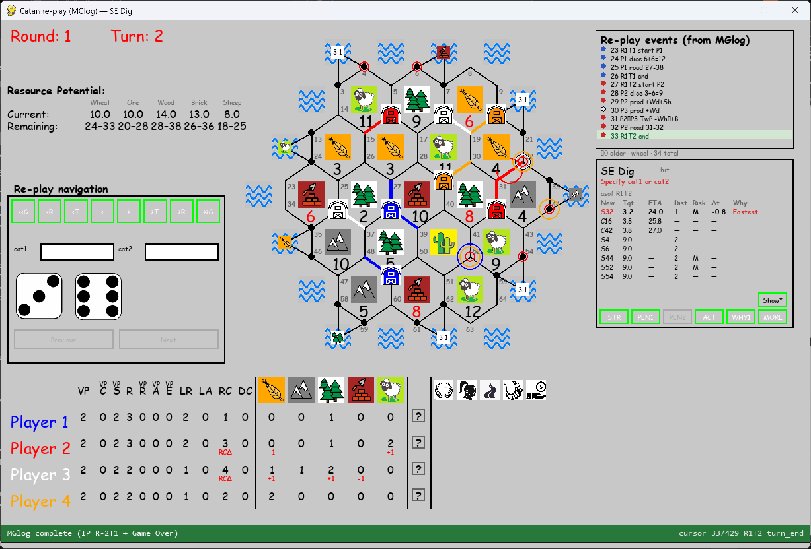
R1T2: Missing S3, S13, S26, S53.
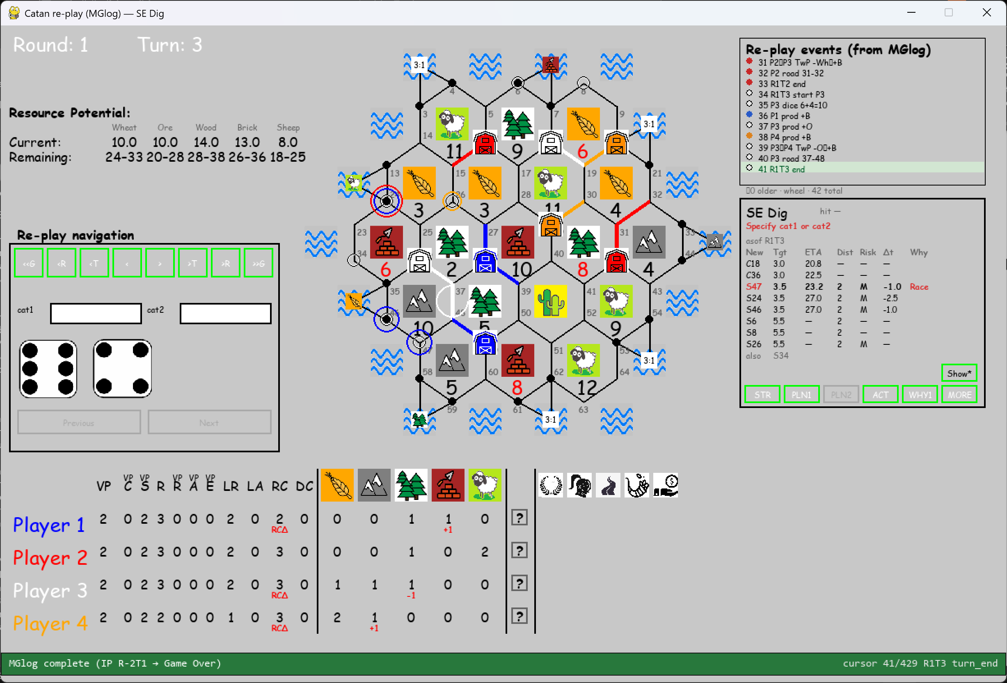
R1T3: Missing S13, S23.
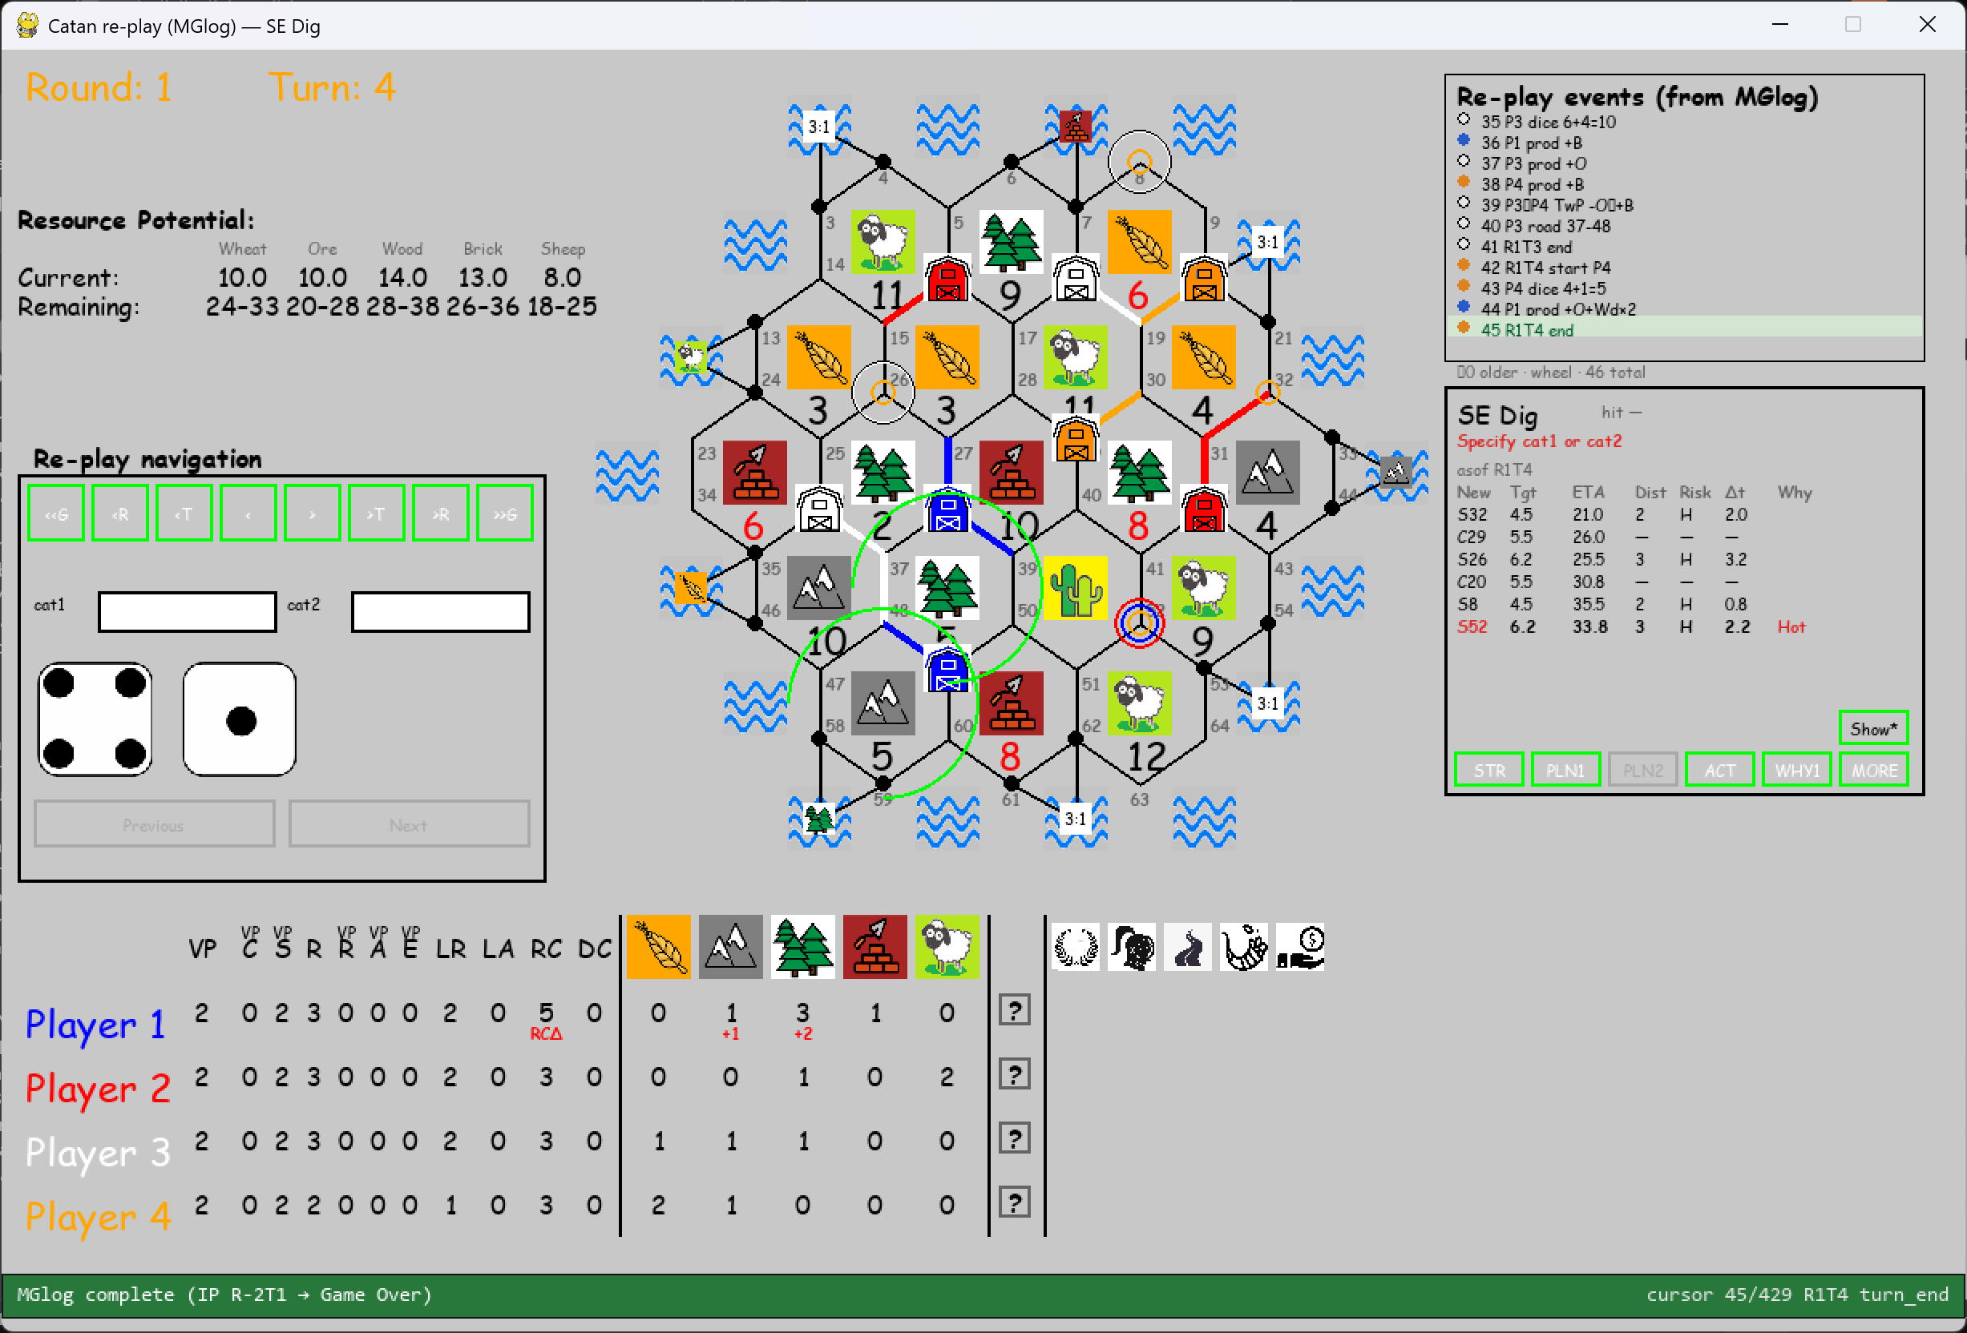
R1T4: Missing S33!
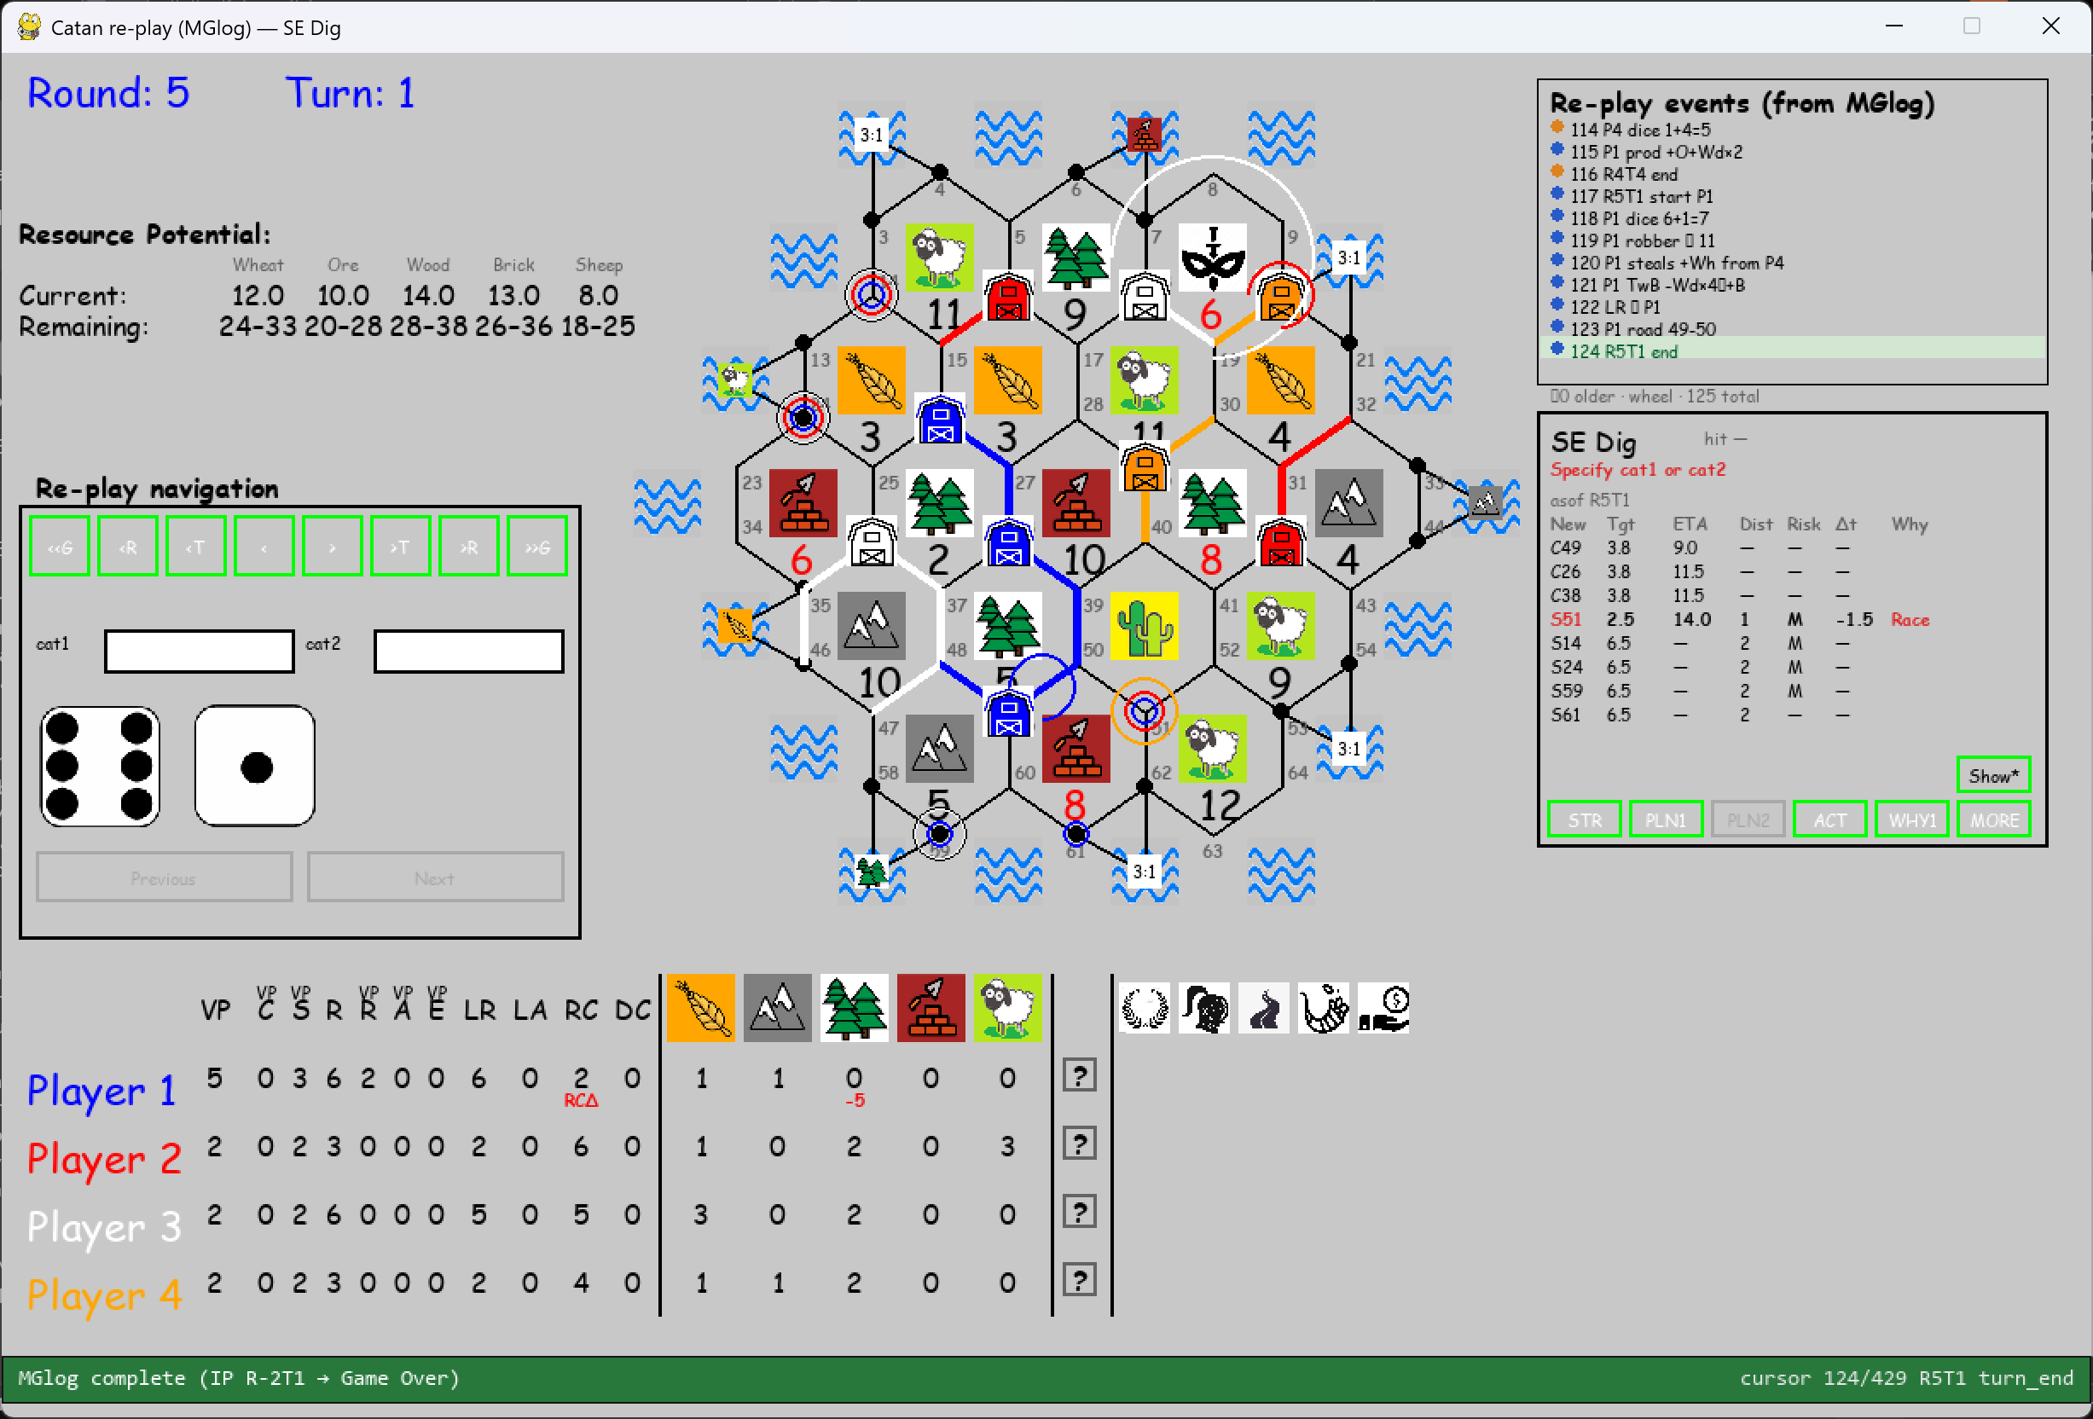
R5T1: Missing S3, S13, S23, S58, S62.
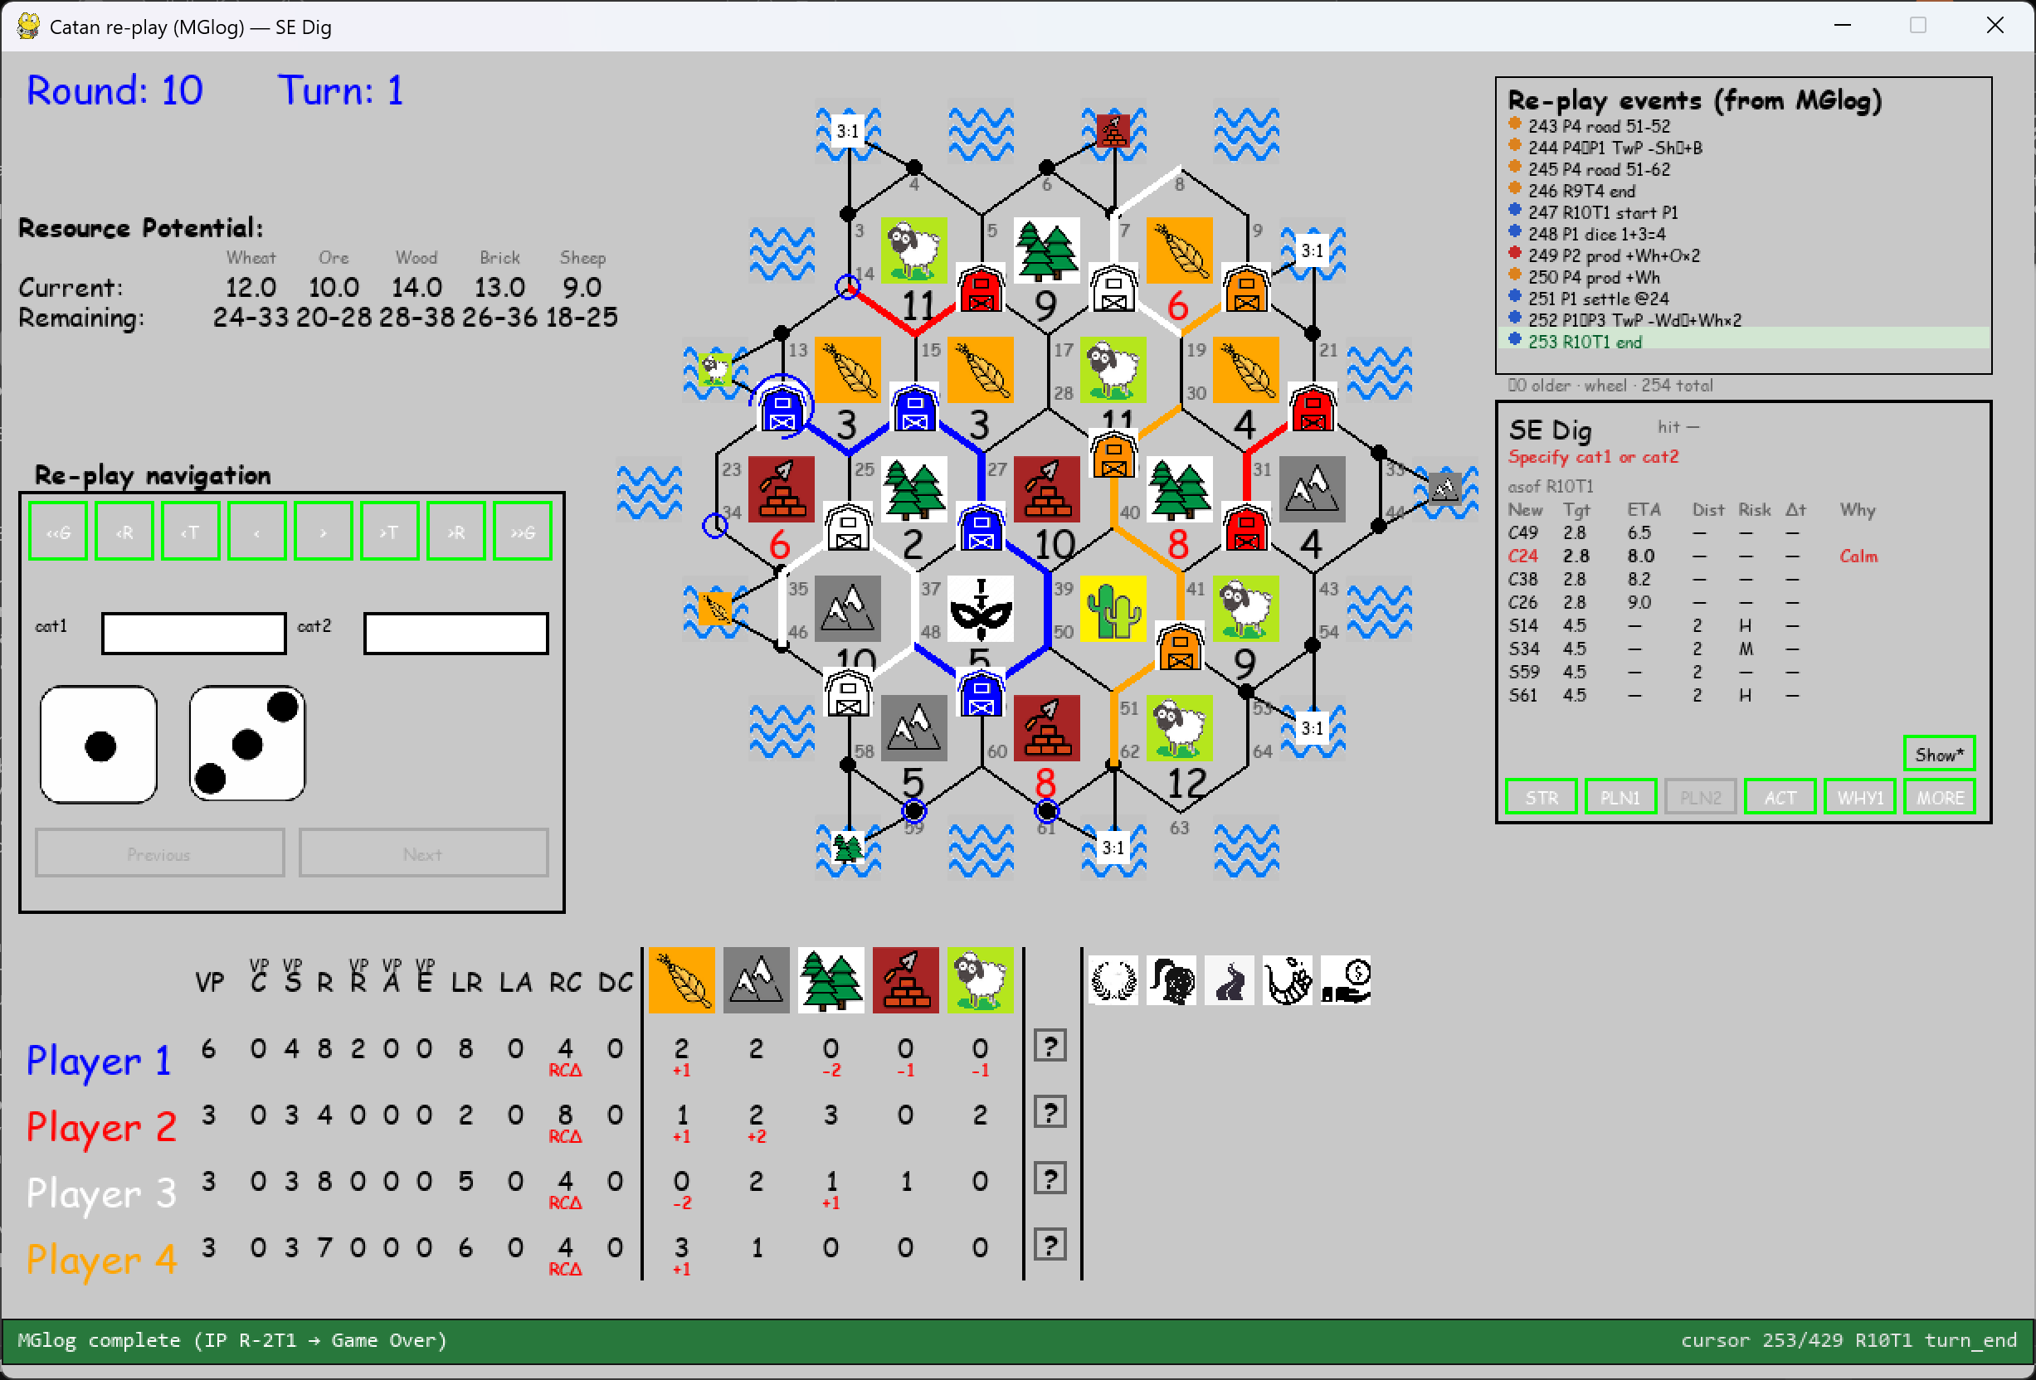
R10T1: Missing S3, S62.
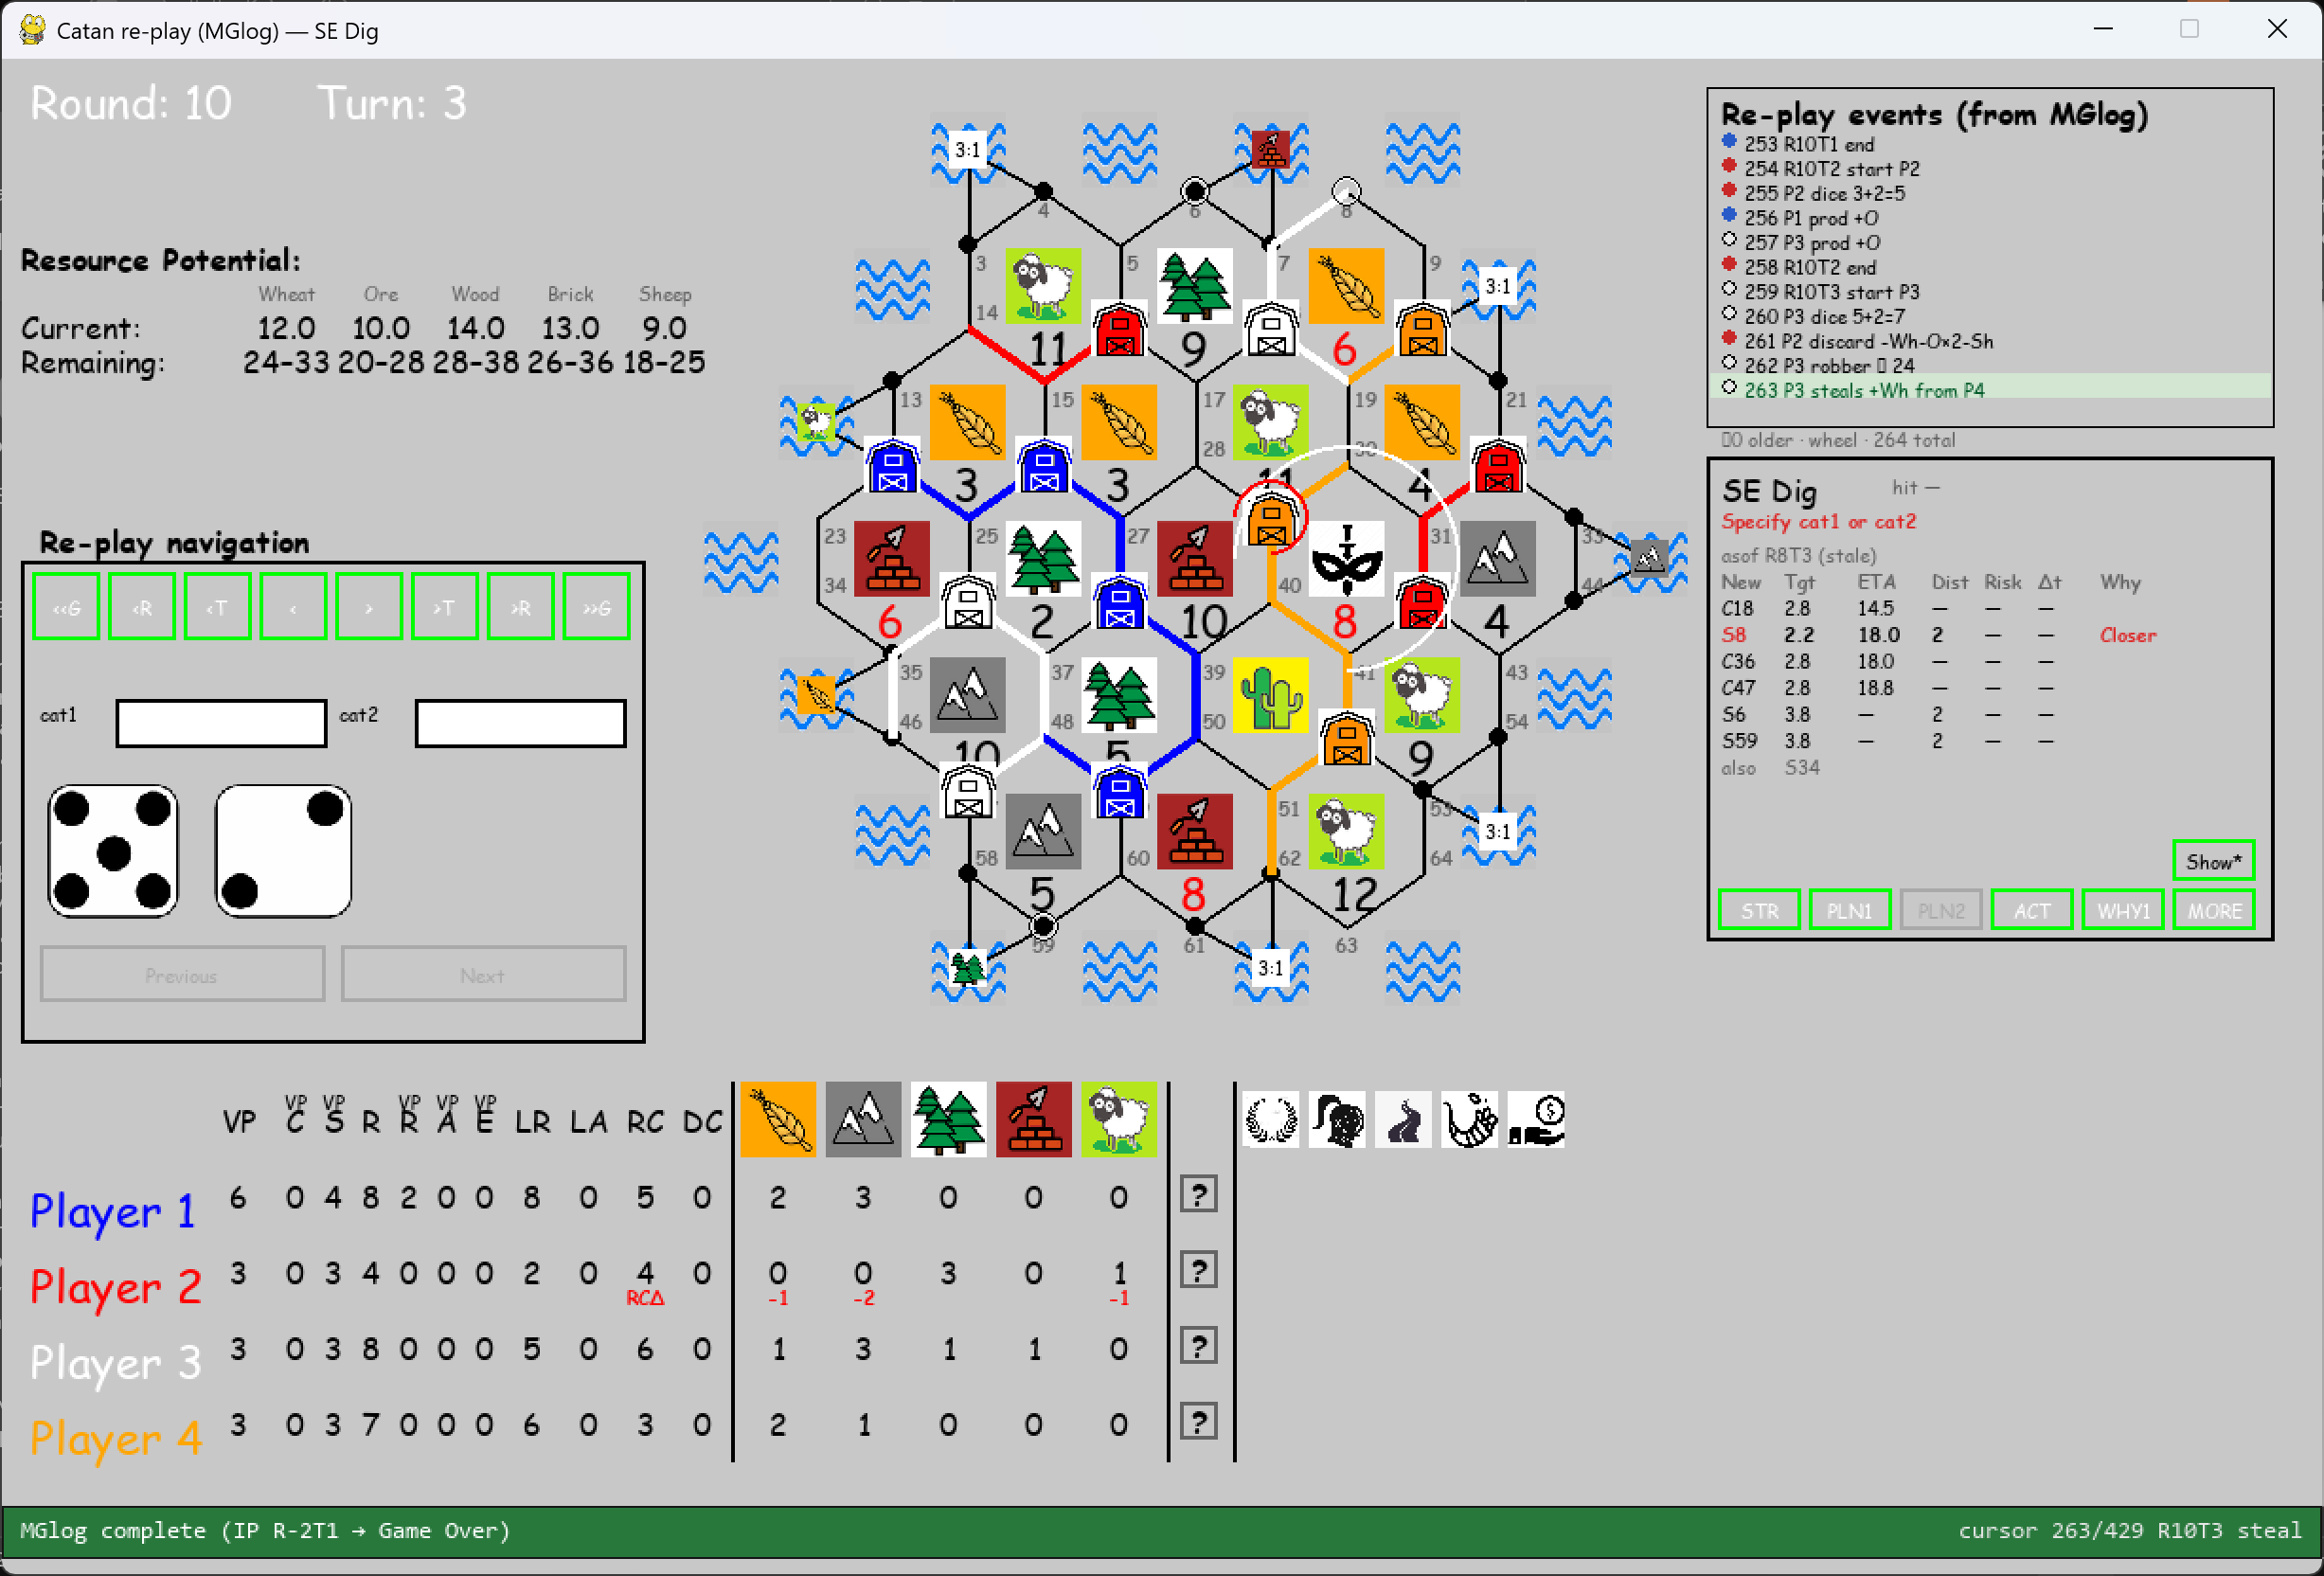
R10T3: Missing S34.
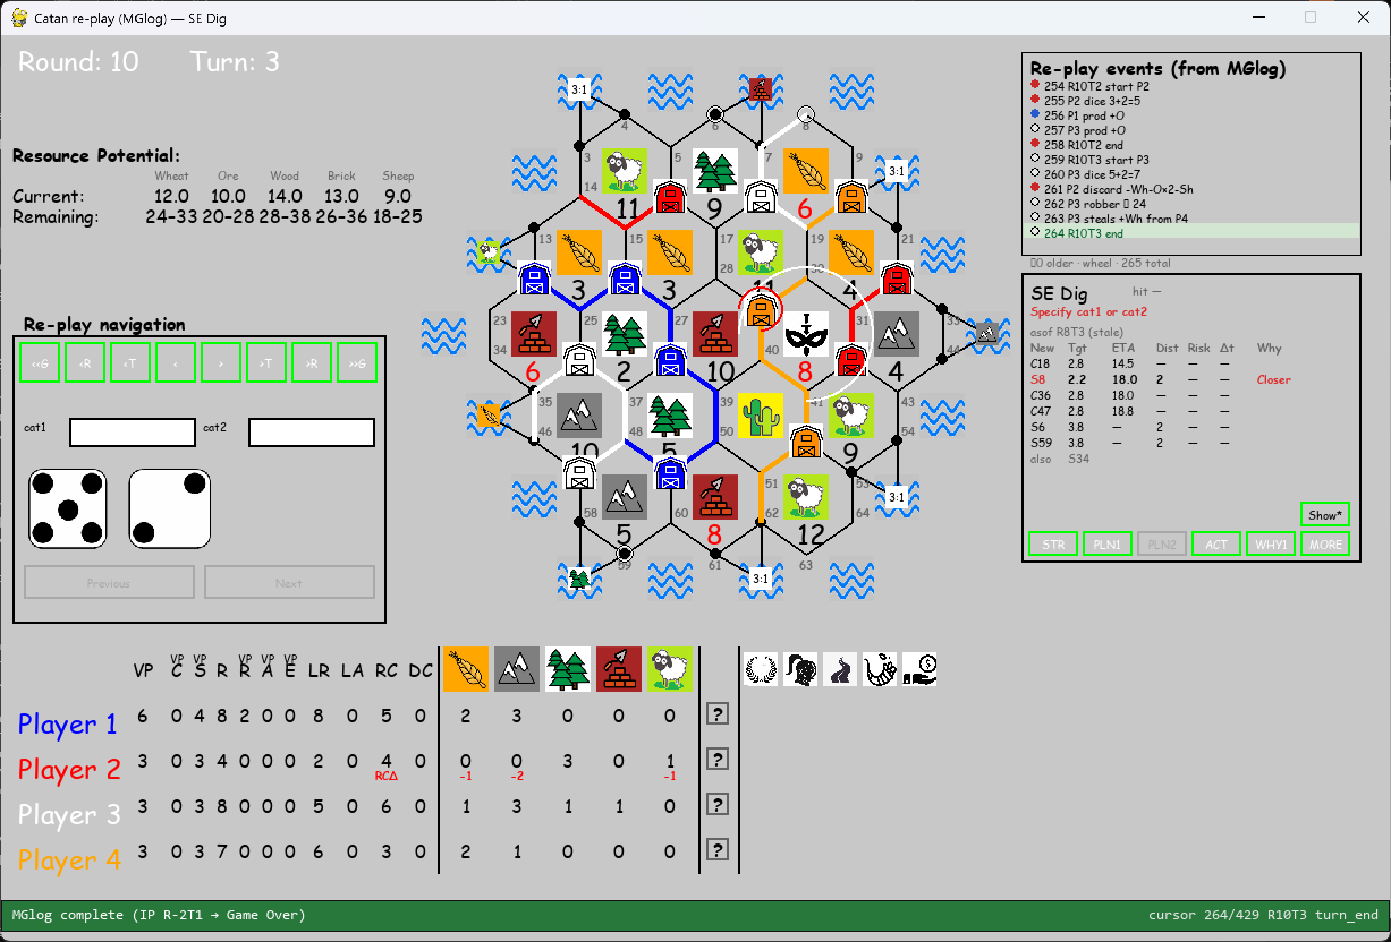
R10T4: Missing S54, S61, S63, S64.

