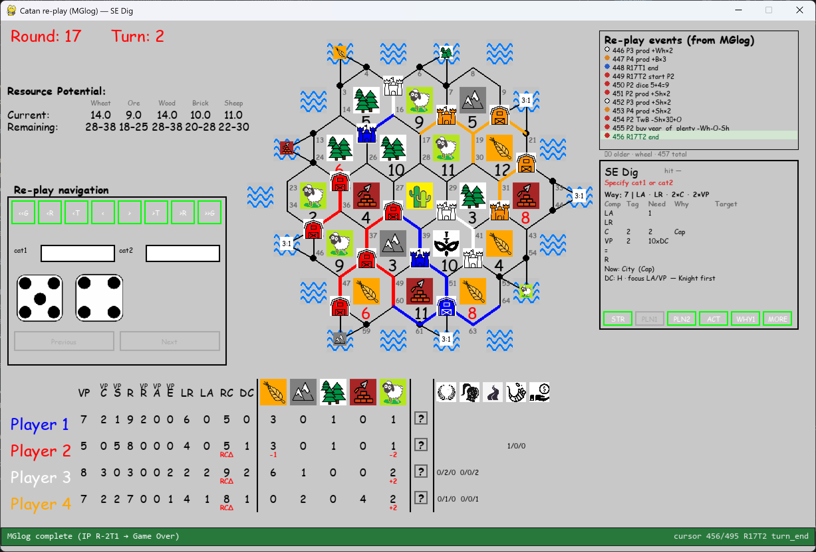
I am in shock: way_id 7 deviates from playboard; way_id must have a sum of 5x(C+S) or more, given the 5xS on playboard right now!
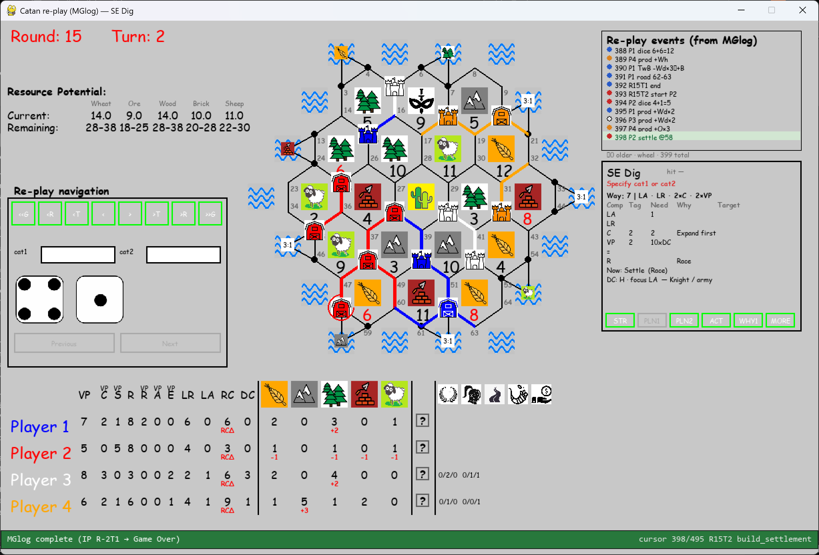
Apparently things went wrong event_index=398.

