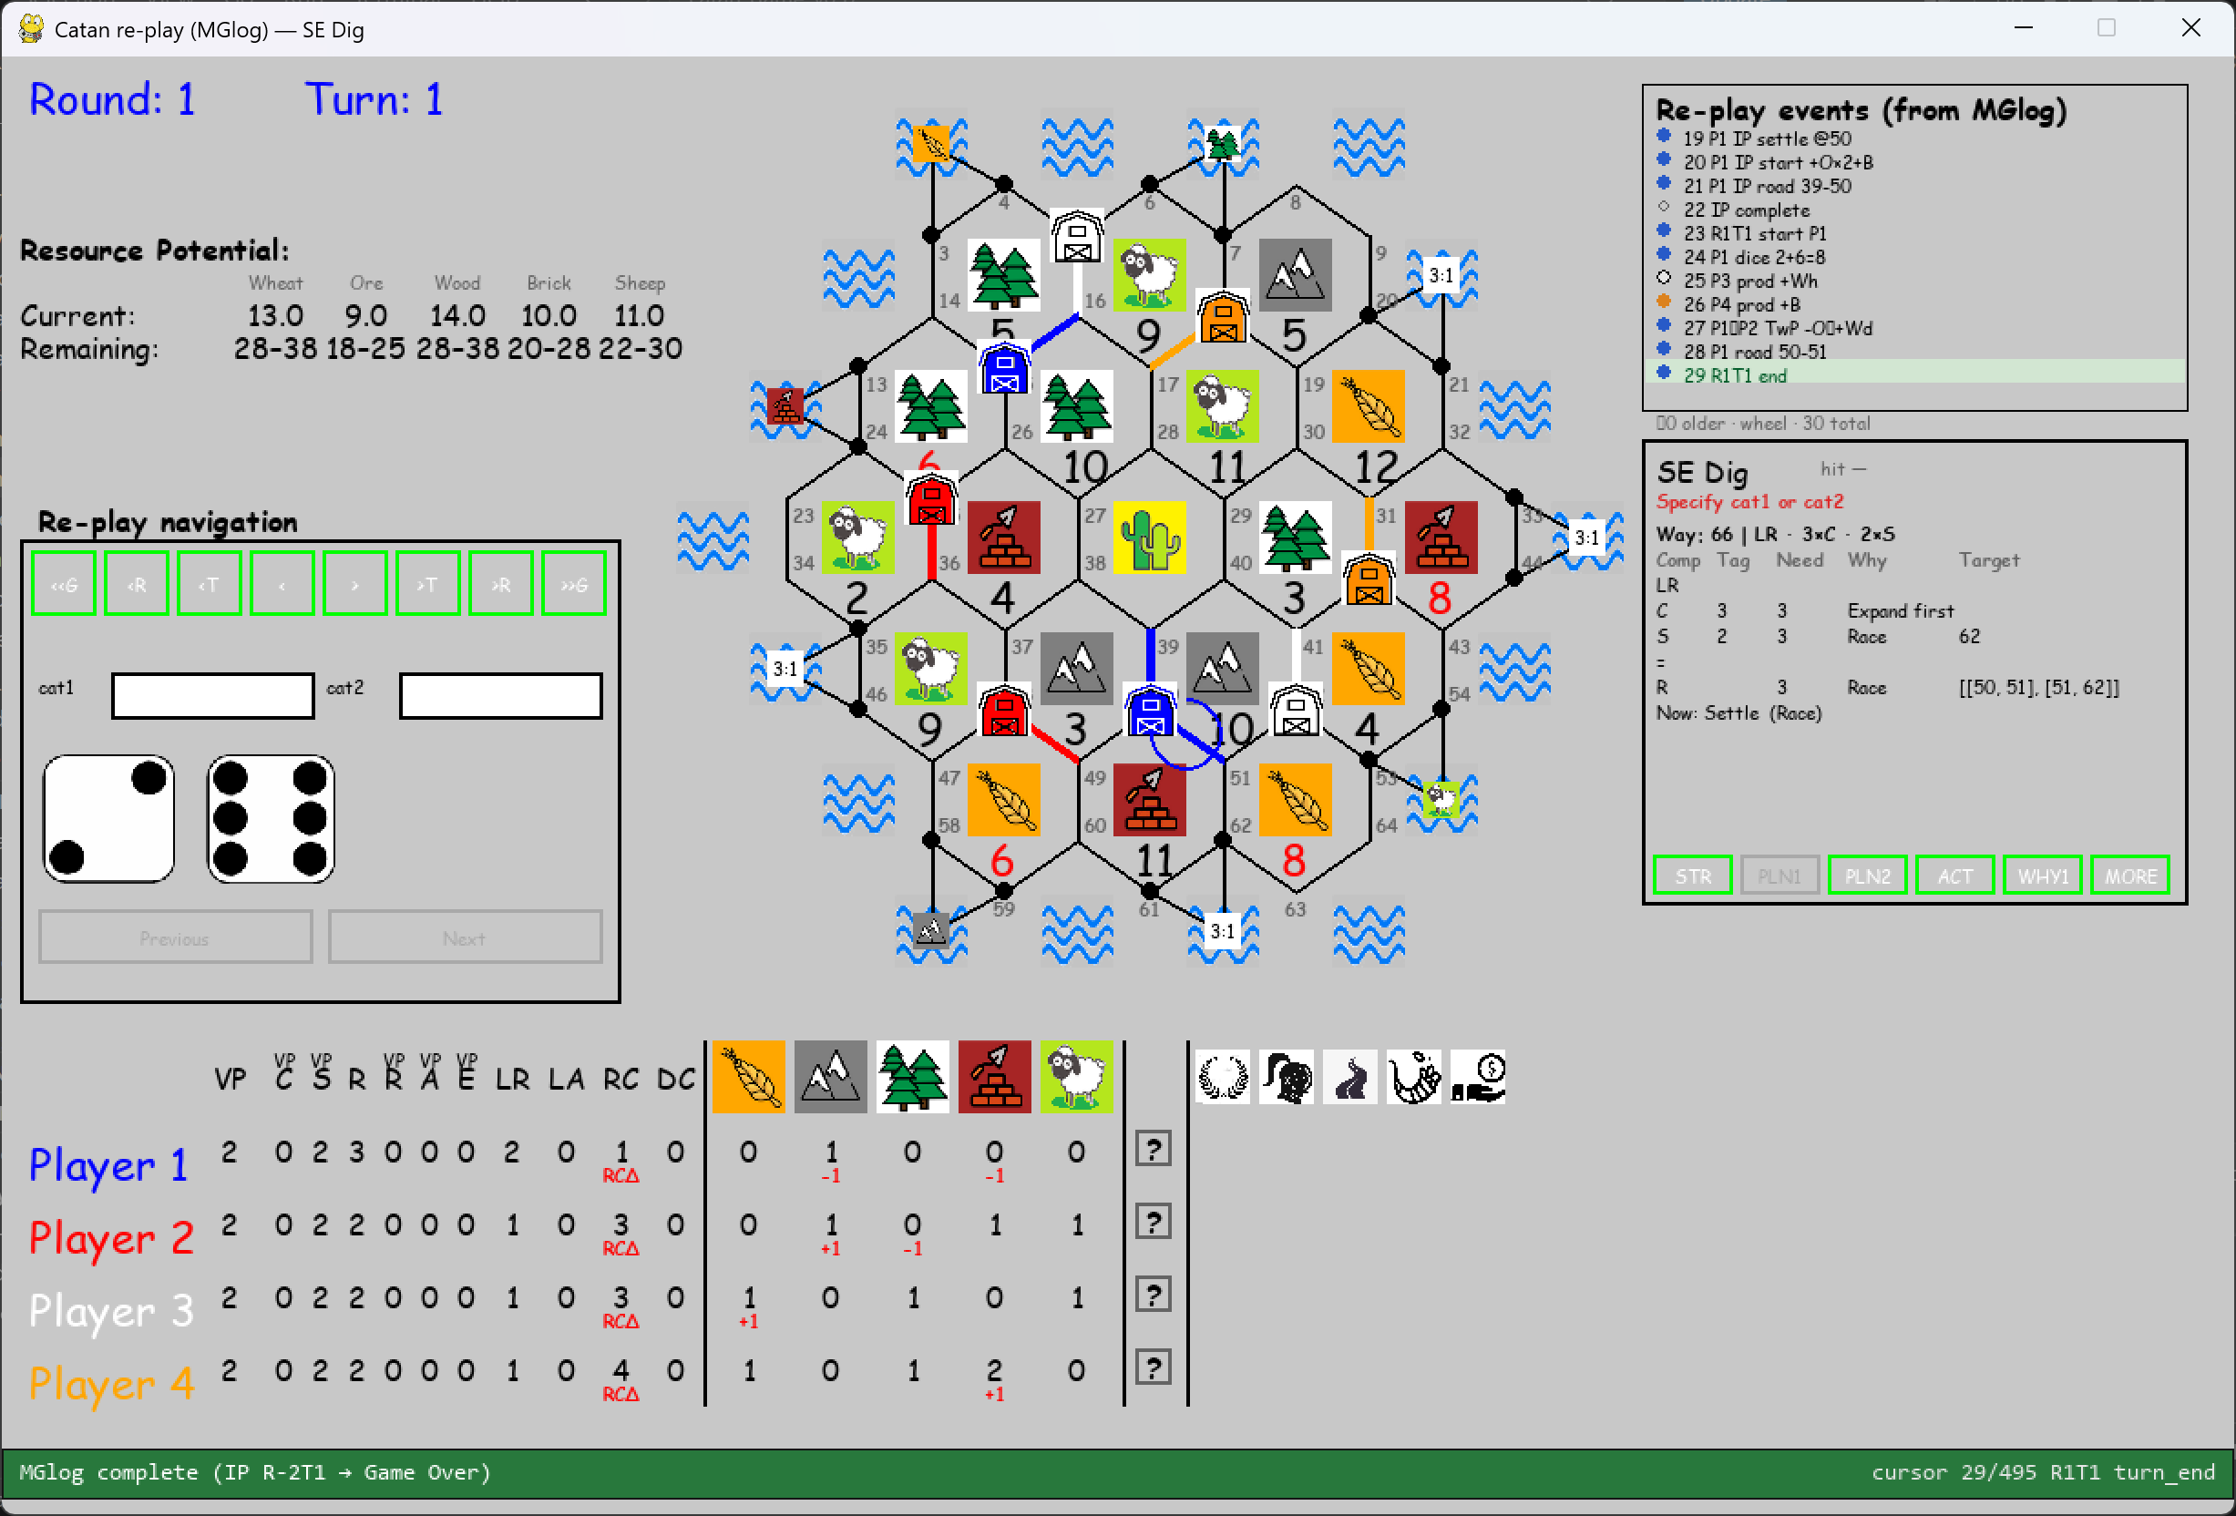
PLN1 should show in row LR a) in column Need “3/5” (meaning still need to build 3 road to get to longest path_length of 5 which claims for LR) and b) in colum Why: “Calm” (meaning we are already heading for S62, which increases longest_path to 3; plenty of options to expand futher (= beyond [50, 39] and [51, 62]. I am sure we will find new words (like “Calm”) and new rules, so find a place to organize and wire this logic.
PLN1 should show in row R in column Need “2/3” (meaning still need to build 2 roads/ total distance=4) ), however since there is Low risk for S62 we should remove Why=Race, perhaps Why=Prio (perhaps you have a better word) and column Target should be 50-51, 51-62. Note: path length can easily be 3 and this format takes the least amount of space.
PLN1 -> add an empty row between R and New: Settle (Race) and change to “New: Settle” skip (Race), sinve risk=L and make this line red. This line might overlap Best-Action. This line ignores TwB and TwP and addresses first buy or build.
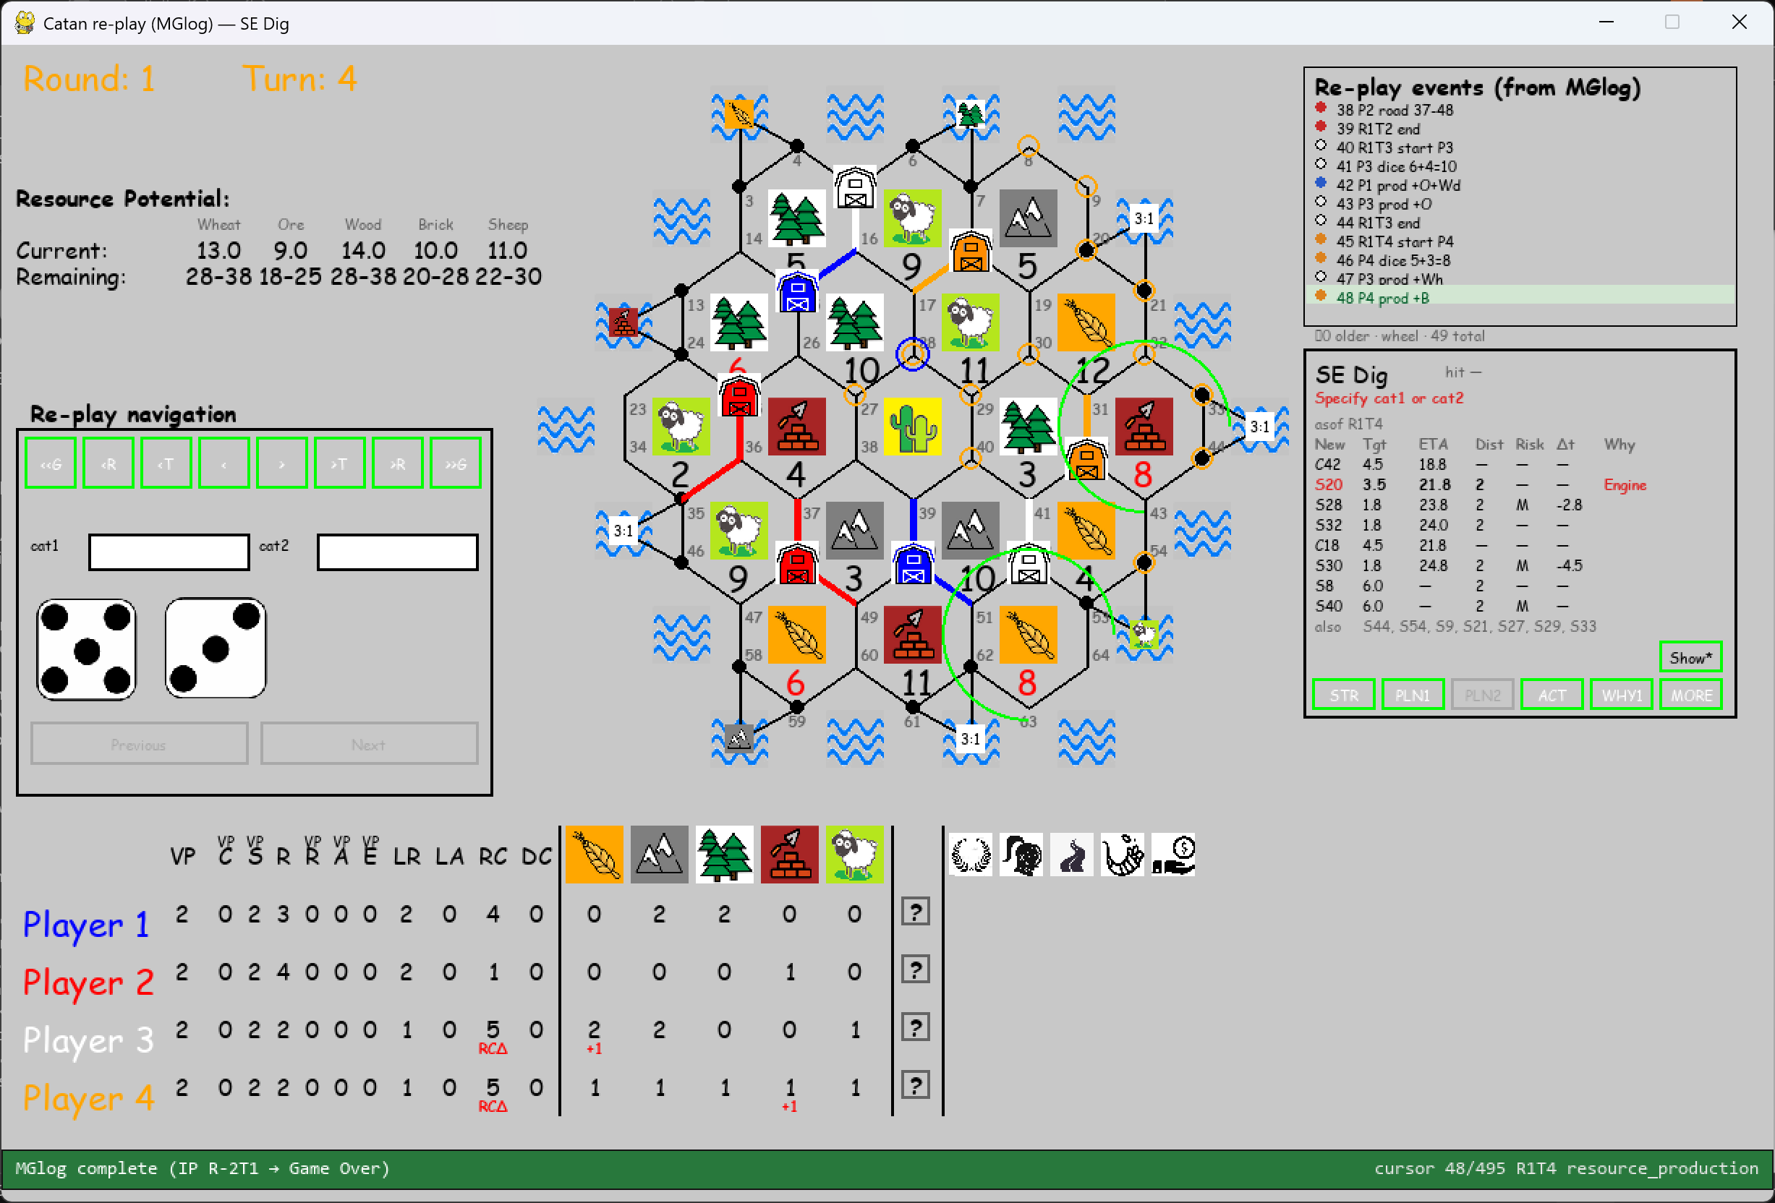
Why no ETA for S8 and S40? Don’t fix yet, explain restrictions if applicable.
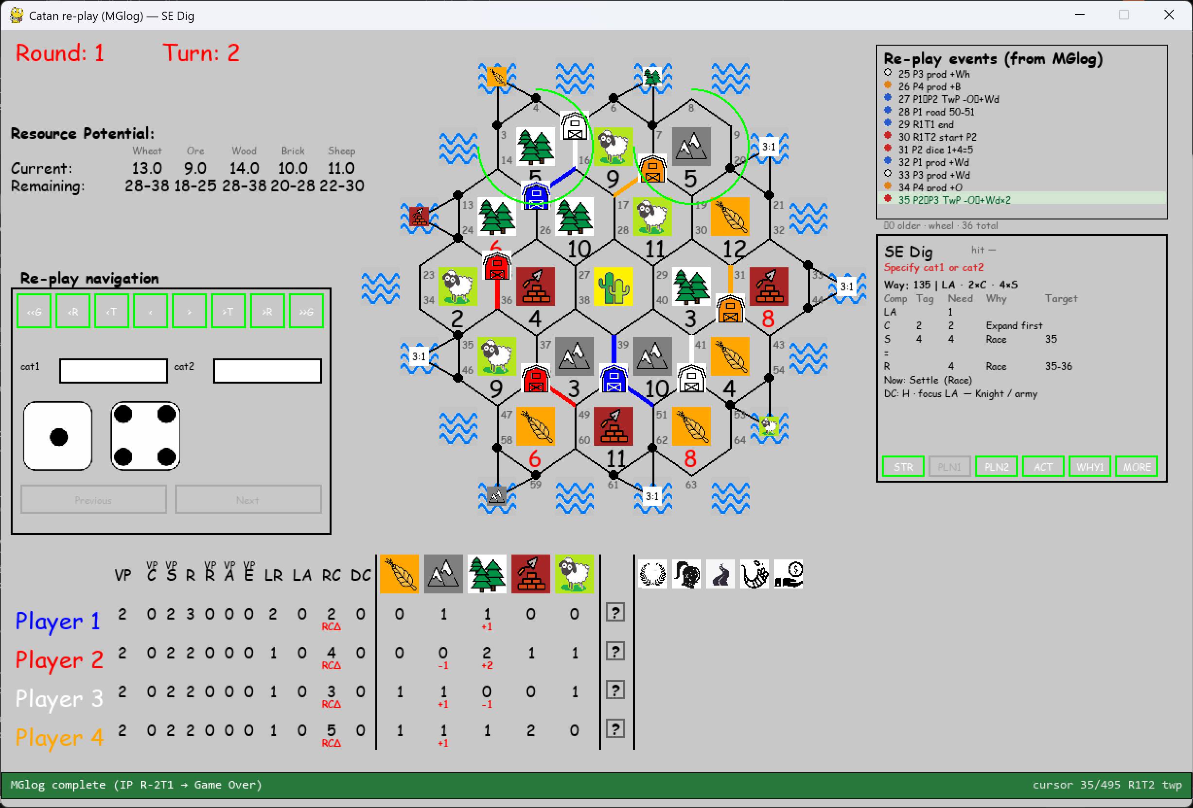
PLN1 should show in row LA a) in column Need “6xDC” (meaning still need to buy 6x DCard to statistacally acquire 3x Knight to get to LA and b) in column Why: “Calm” (meaning we no opponent is has played a Knight yet. I am sure we will find new words (like “Calm”) and new rules, so find a place to organize and wire this logic.
PLN1 should show in row R in column Need “1/2” (meaning still need to build 1 roads/ total distance=2).
PLN1 should have an extra line below R: Comp=DC, Tag=LA, Need=3/3 (meaning still need to play 3x Knight to get to LA), Target=LA
PLN1 -> add an empty row between R and New: Settle (Race) and make this line red. This line might overlap Best-Action. This line ignores TwB and TwP and addresses first buy or build.
PLN1 -> Skip line “DC: H – focus _ Knight/ army”
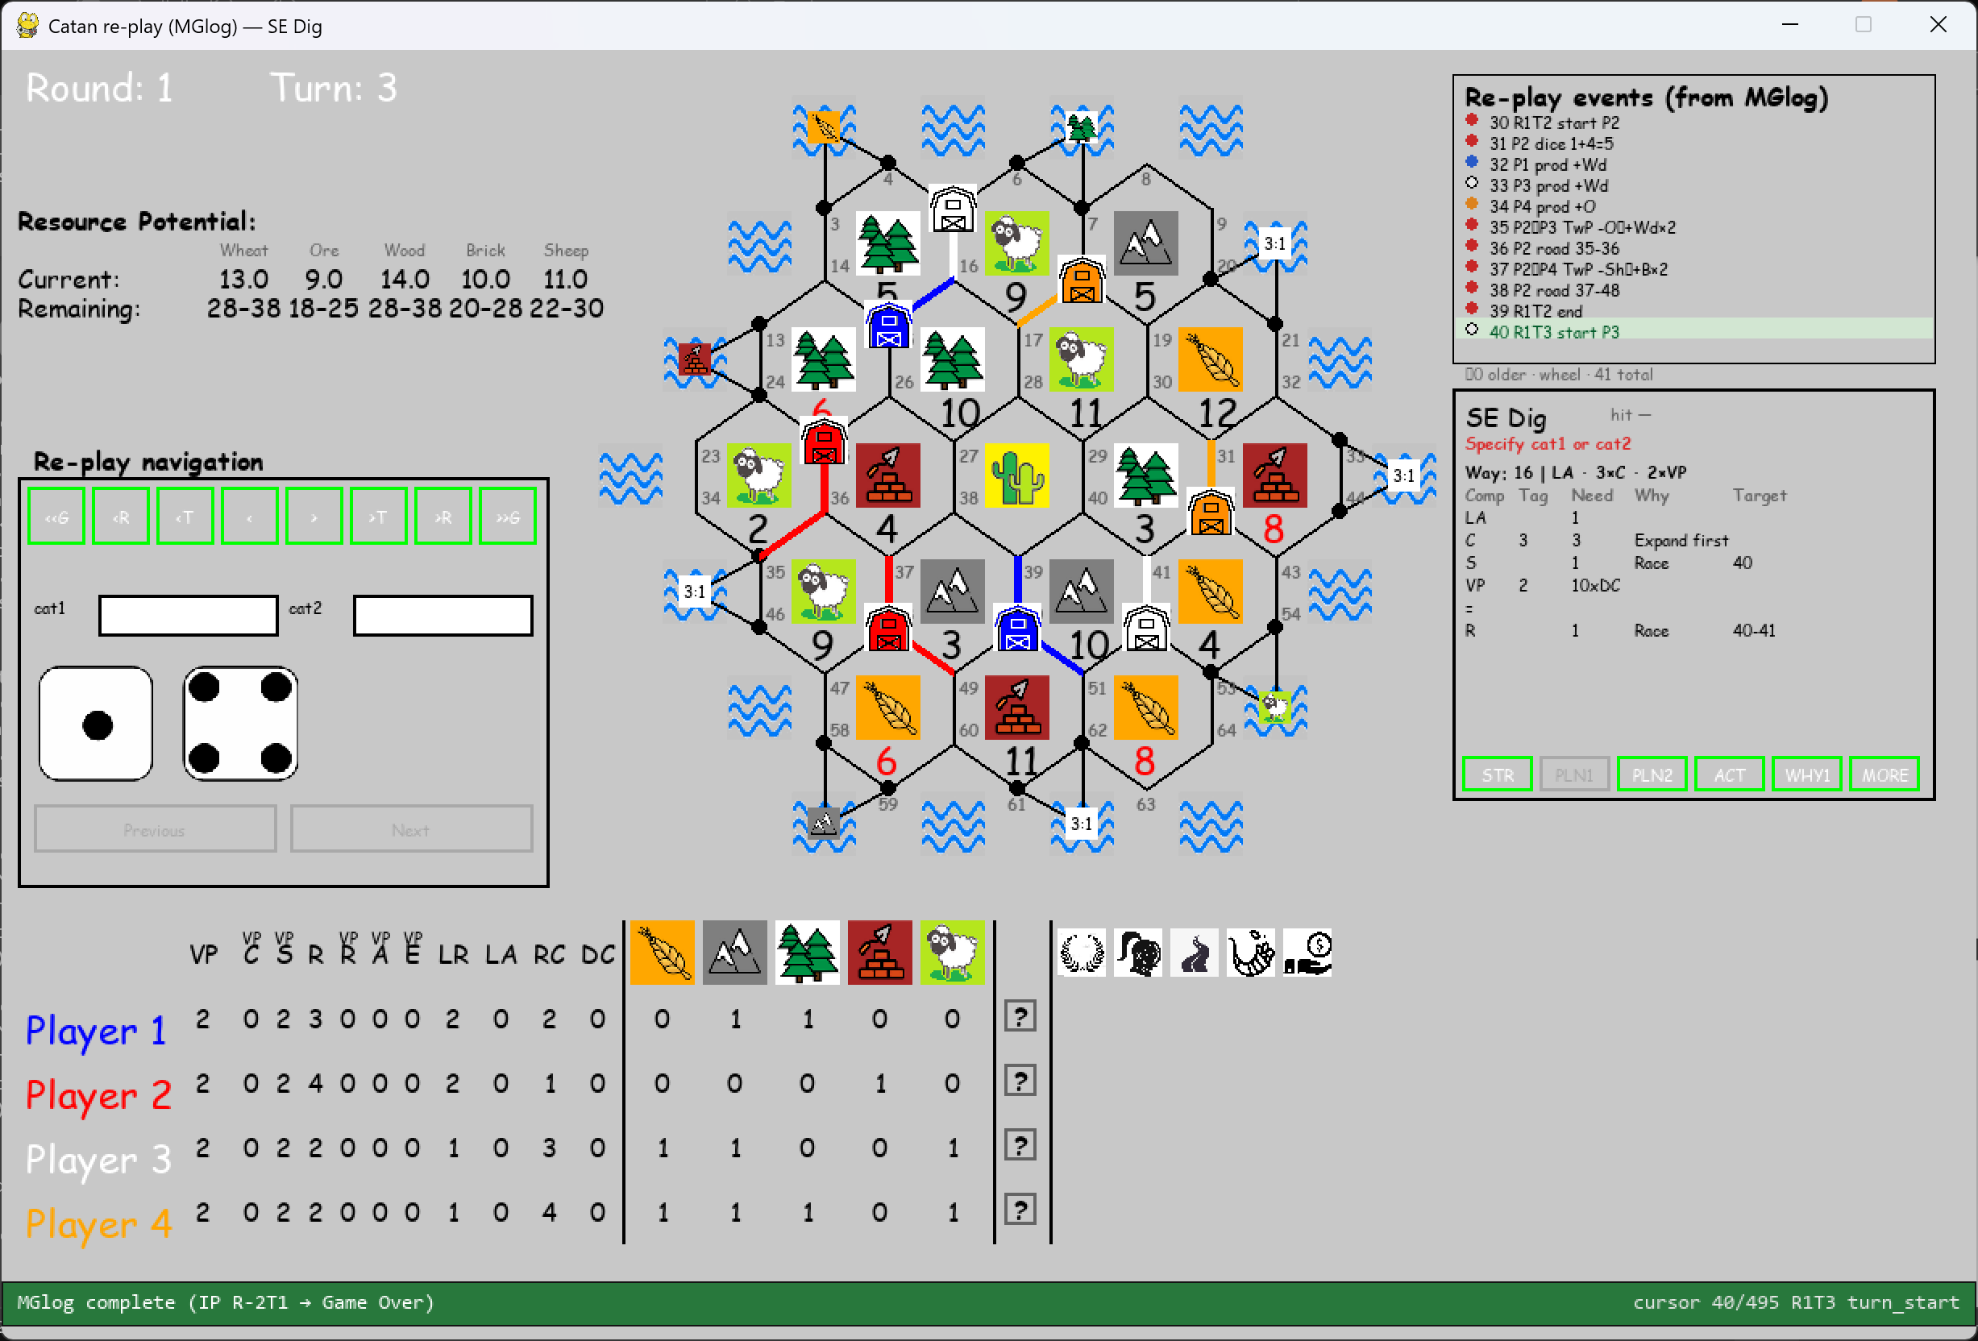
PLN1 should show in row LA a) in column Need “6xDC” (meaning still need to buy 6x DCard to statistacally acquire 3x Knight to get to LA and b) in column Why: “Calm” (meaning we no opponent is has played a Knight yet. I am sure we will find new words (like “Calm”) and new rules, so find a place to organize and wire this logic.
PLN1 should show in row R in column Need “1/2” (meaning still need to build 1 roads/ total distance=2).
PLN1 should have an extra line below R: Comp=DC, Tag=LA+VP, Need=10xDC3/3 (meaning still need to play 3x Knight to get to LA). Target=VP (in case Tag=LA+VP start with target=VP, since these a harder to pick from the DCard stack. I am sure we will find new targets and correponding rules, so find a place to organize and wire this logic.
PLN1 -> add an empty row below R and add the line “New: Settle (Race)” and make this line red. This line might overlap Best-Action. This line ignores TwB and TwP and addresses first buy or build.

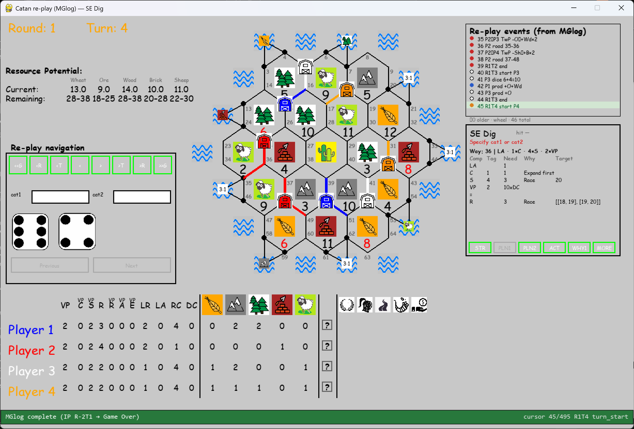
PLN1 should show in row LA a) in column Need “6xDC” (meaning still need to buy 6x DCard to statistacally acquire 3x Knight to get to LA and b) in column Why: “Calm” (meaning we no opponent is has played a Knight yet. I am sure we will find new words (like “Calm”) and new rules, so find a place to organize and wire this logic.
PLN1 should show in row R in column Need “2/2” (meaning still need to build 2 roads/ total distance=2), however since there is Low risk for S20 we should remove Why=Race, perhaps Why=Prio (perhaps you have a better word.
PLN1 should have an extra line below R: Comp=DC, Tag=LA+VP, Need=10xDC3/3 (meaning still need to play 3x Knight to get to LA). Why=Prio, Target=VP (in case Tag=LA+VP start with target=VP, since these a harder to pick from the DCard stack. I am sure we will find new targets and correponding rules, so find a place to organize and wire this logic.
PLN1 -> add an empty row below R and add the line “Build road or buy DCard”. Both have equal priority. This line might overlap Best-Action. This line ignores TwB and TwP and addresses first buy or build.
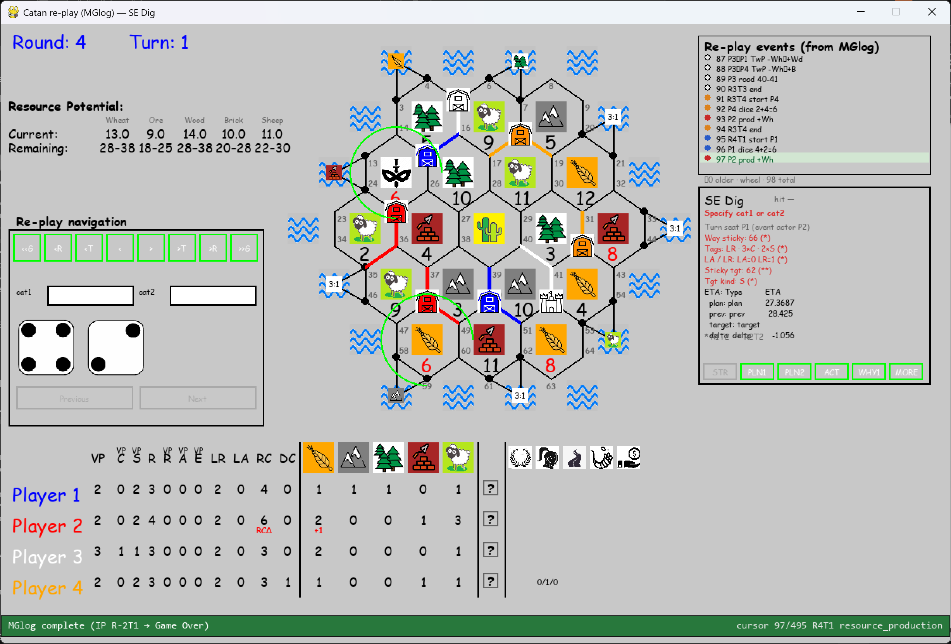
In STR skip line where ETA=target and Type=target.

Replace lines below “Sticky tgt” and “Tgt kind” with a table:
Type ETA-old ETA-update Dt
Plan 19.7 19.7 -
Previous 28.4 27.4 -1.0

For type=plan, ETA shoud be target + ETA as shown in PLN2 for the line in sync with “Sticky tgt” and “Tgt kind”. Dt should show value in either green or red; in green if delta is in favour of player in red deteriorating.
All
In STR change the line LA/LR in “Given up”. Should only display LA and or LR is actually given up. Add as “to do” or wire if this is pretty straigh forward.
In STR combine lines “Sticky tgt” and “Tgt kind”, for example S62 or C62.
In PLN2 for column Dt show value in either green or red; in green if delta is in favour of player in red if in favour of best opponent.

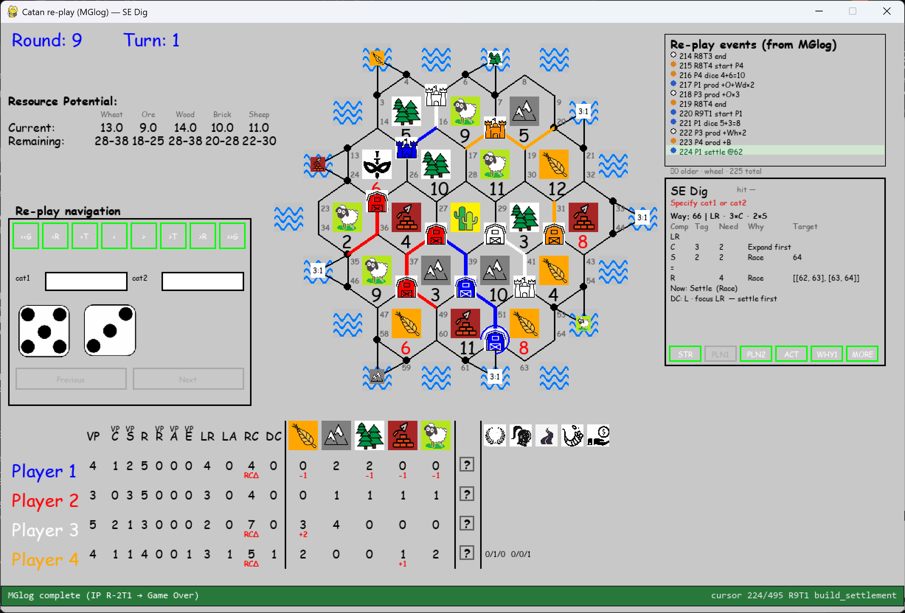
PLN1 for row LR, change why=Engine, because S64 will automatically lead to taking LR.
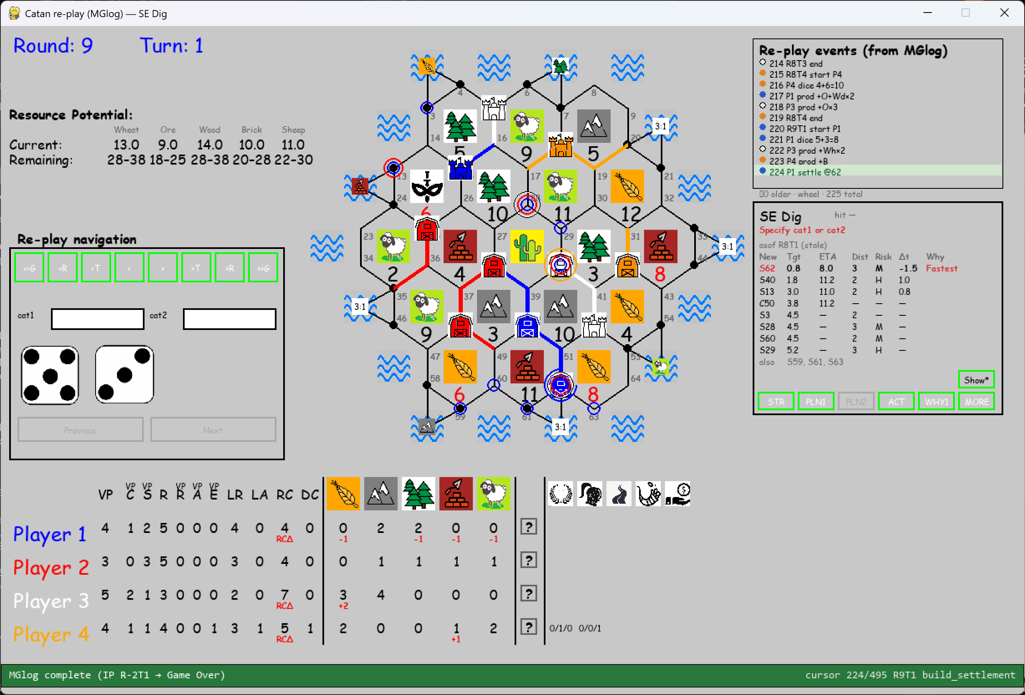
Why is S40 listed and getting circles when toggeling “Show”? Same for S62 (just built). These intersections already have a settlement -> illegal target.
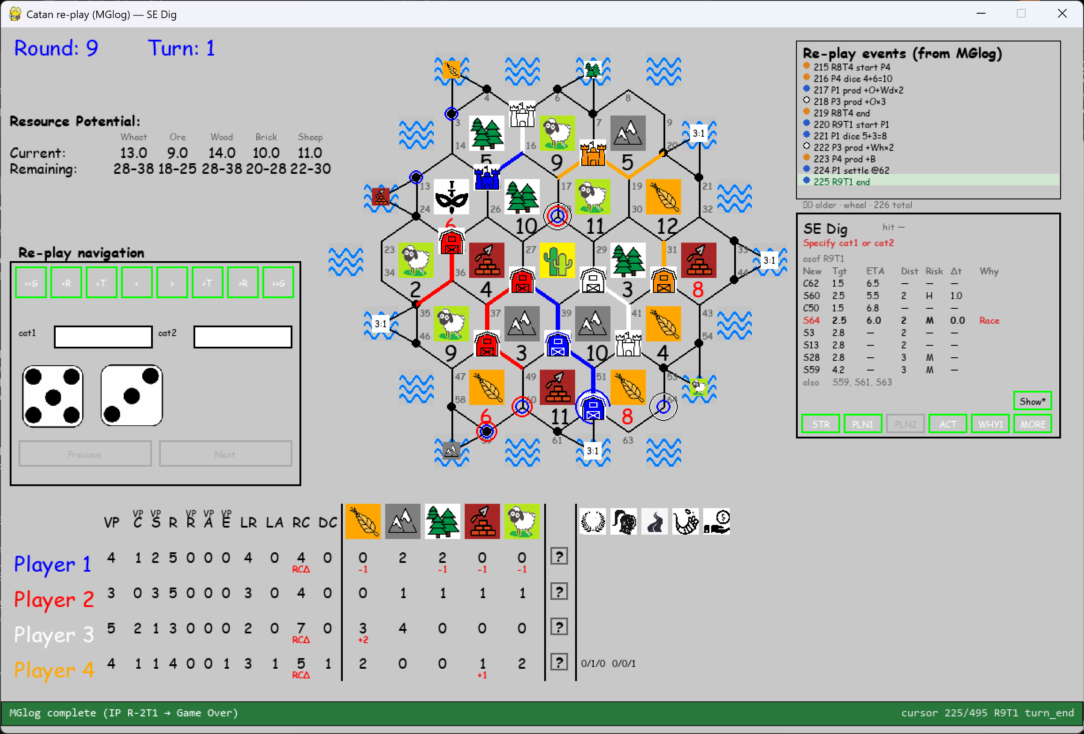
S62 triggers L2, however Sticky Target is not updated to S60, see next screenshot. This generates issues in R11 (see screenshots below).
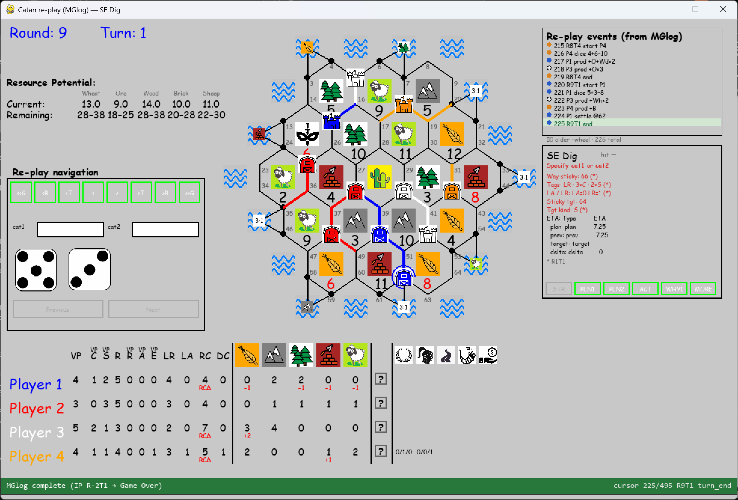
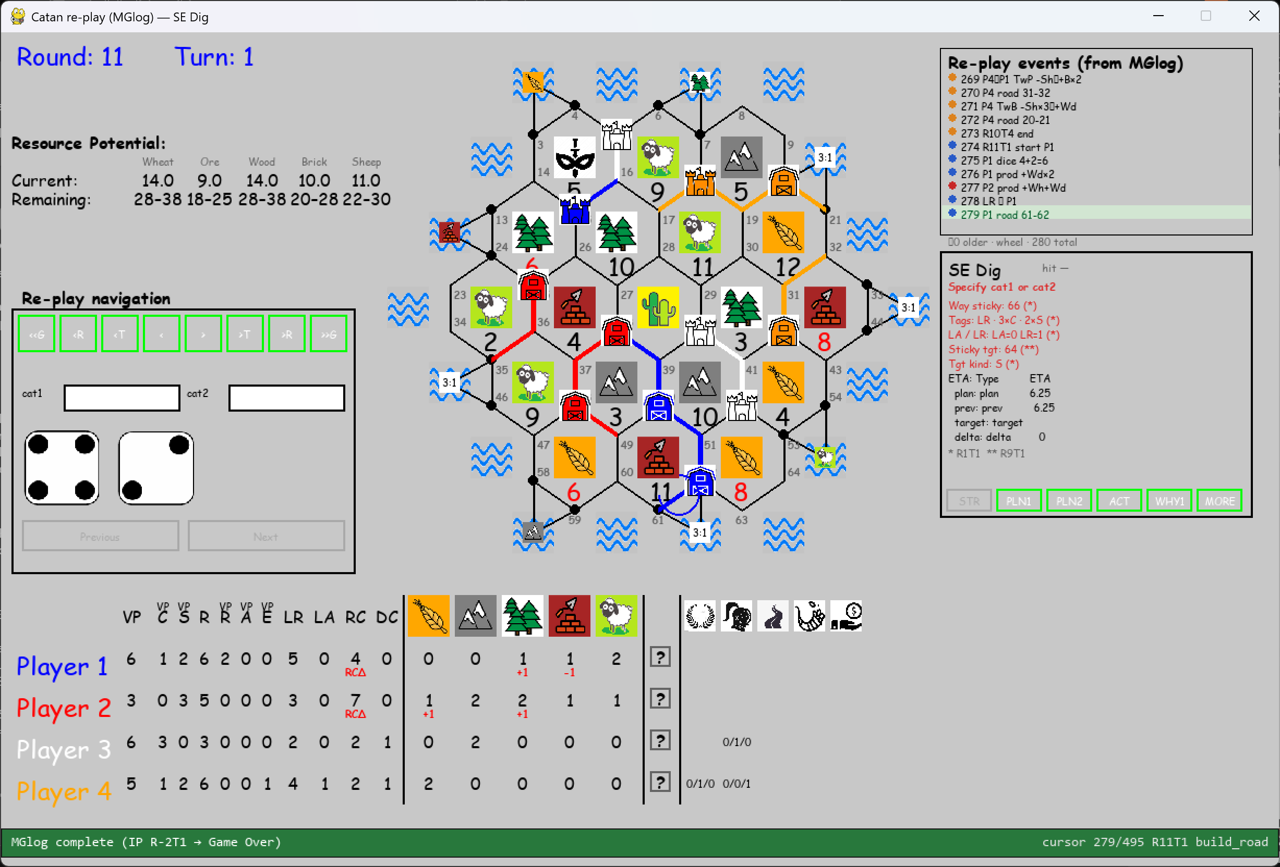
Sticky target S64.
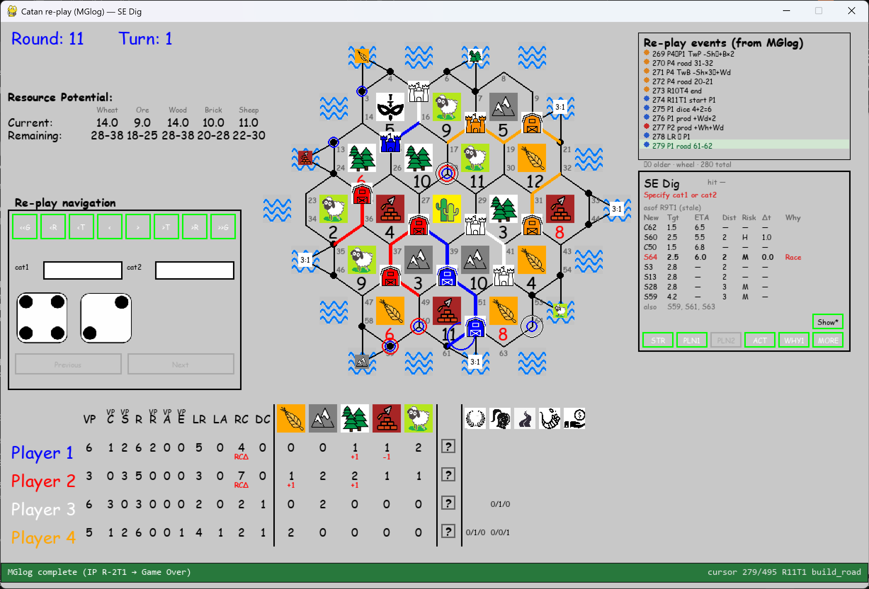
Why go for 60, since Sticky target is 64?
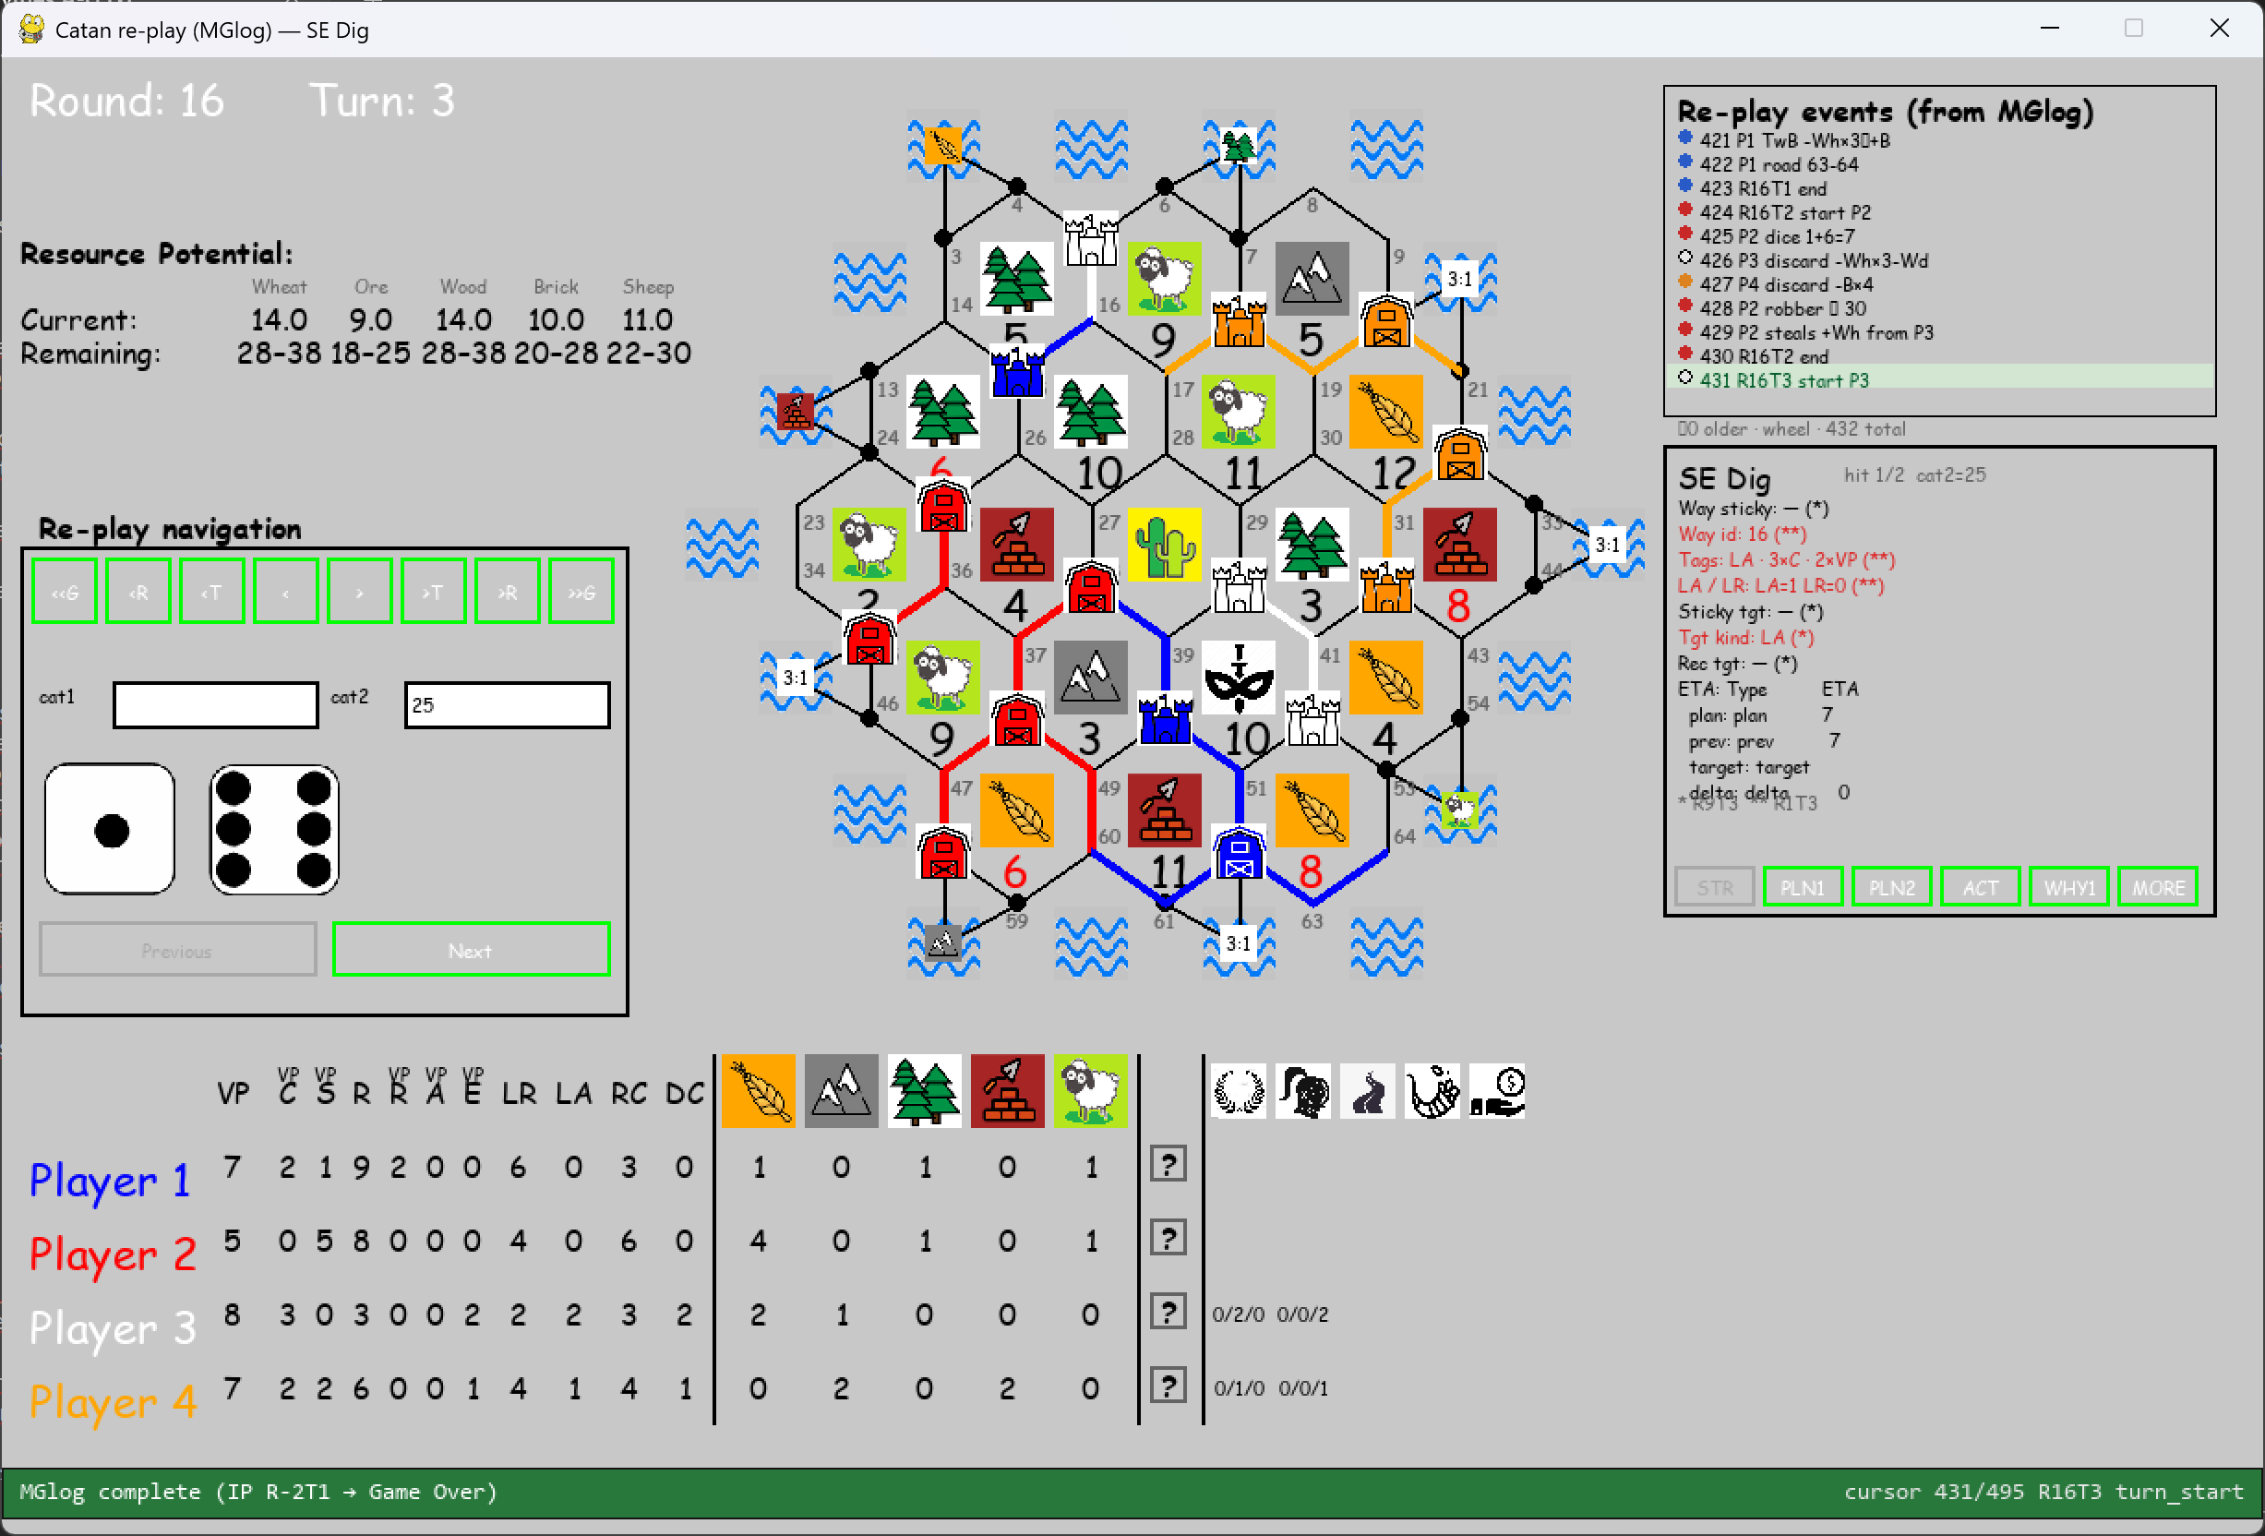

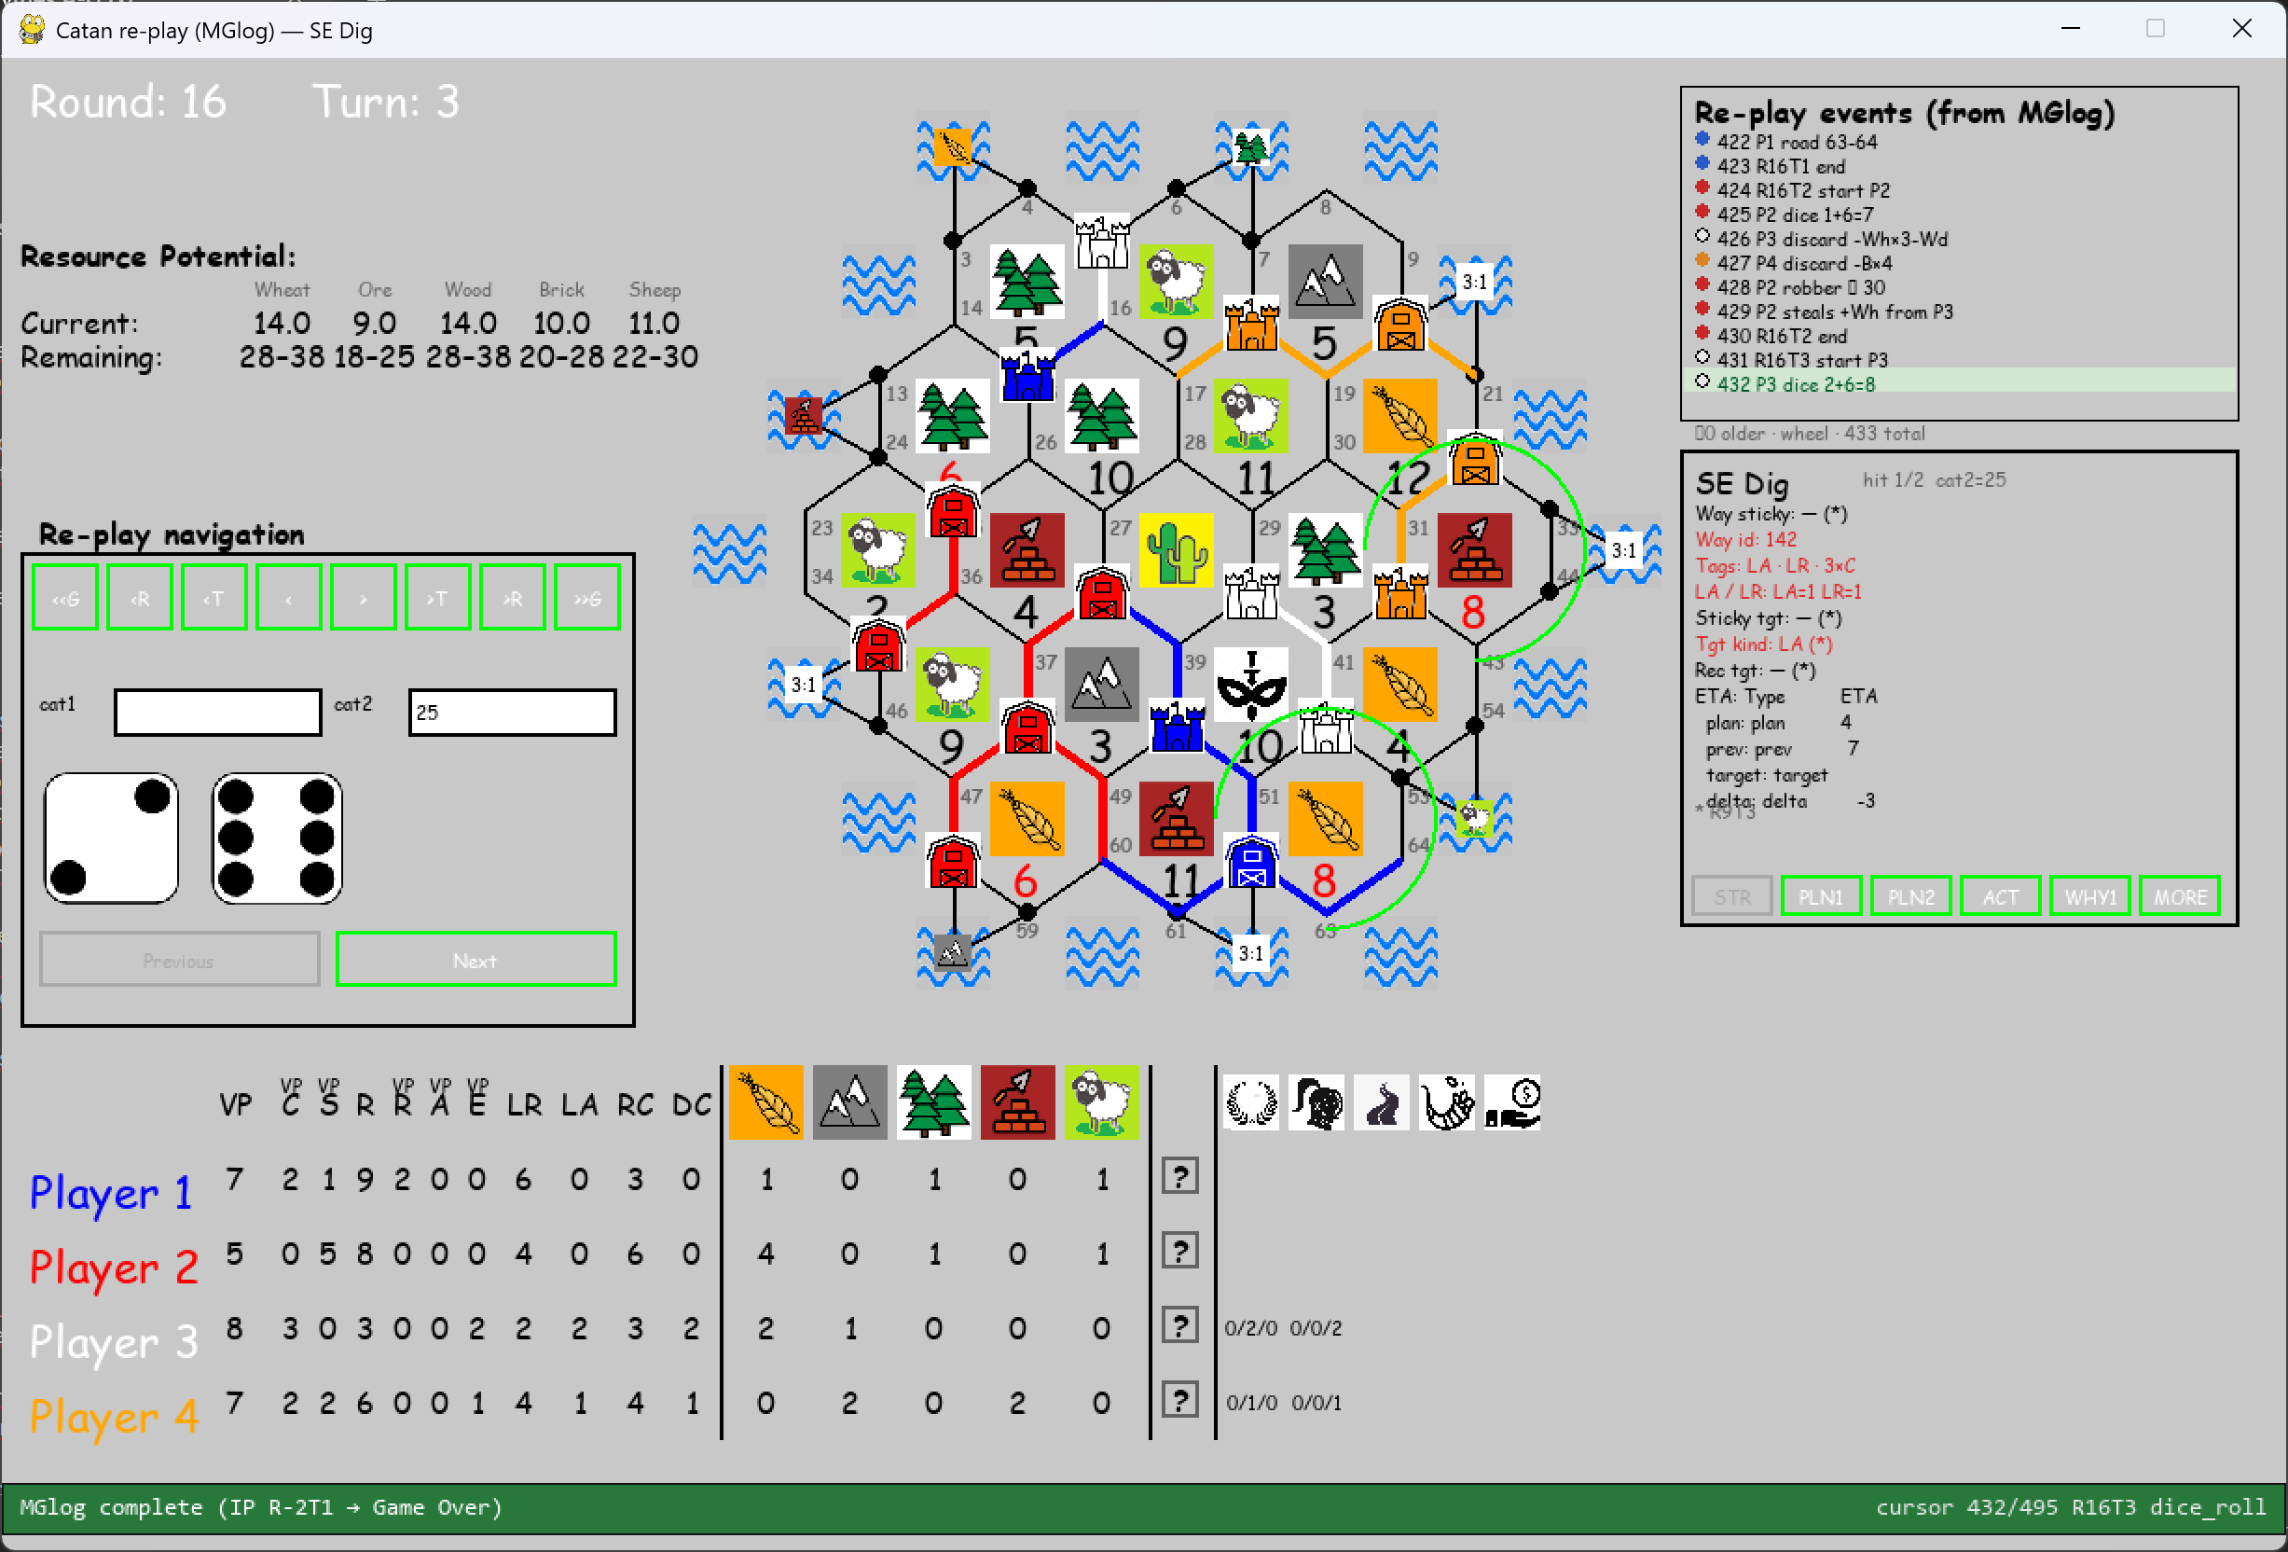
See this and previous screenshot:
1) White has no idea Orange has 2 VP (these are hidden) so changing way_id from 16 to 142 is based on info player is not supposed to know (based on cat2=25).
2) Switching to way_id 142 is not in sync with playboard (already 4 buildings)!

