Alvin, ART385, Code Self-Portrait, 2/6/20

Statement: Draw a self-portrait on paper using colored pencils and your sketchbook. Spend no more than one hour on this. You can draw yourself as you like — straight on, include neck, shoulders, headwear.
Then, take your hand drawn portrait and reinterpret it using Processing code. The idea is to capture the essence of the portrait. You can do a simple recreation, work with reinterpretation using code tools, play with asymmetry, randomness or other aspects that may not be conveyed in an analog mode.

Hand Drawn Sketches:
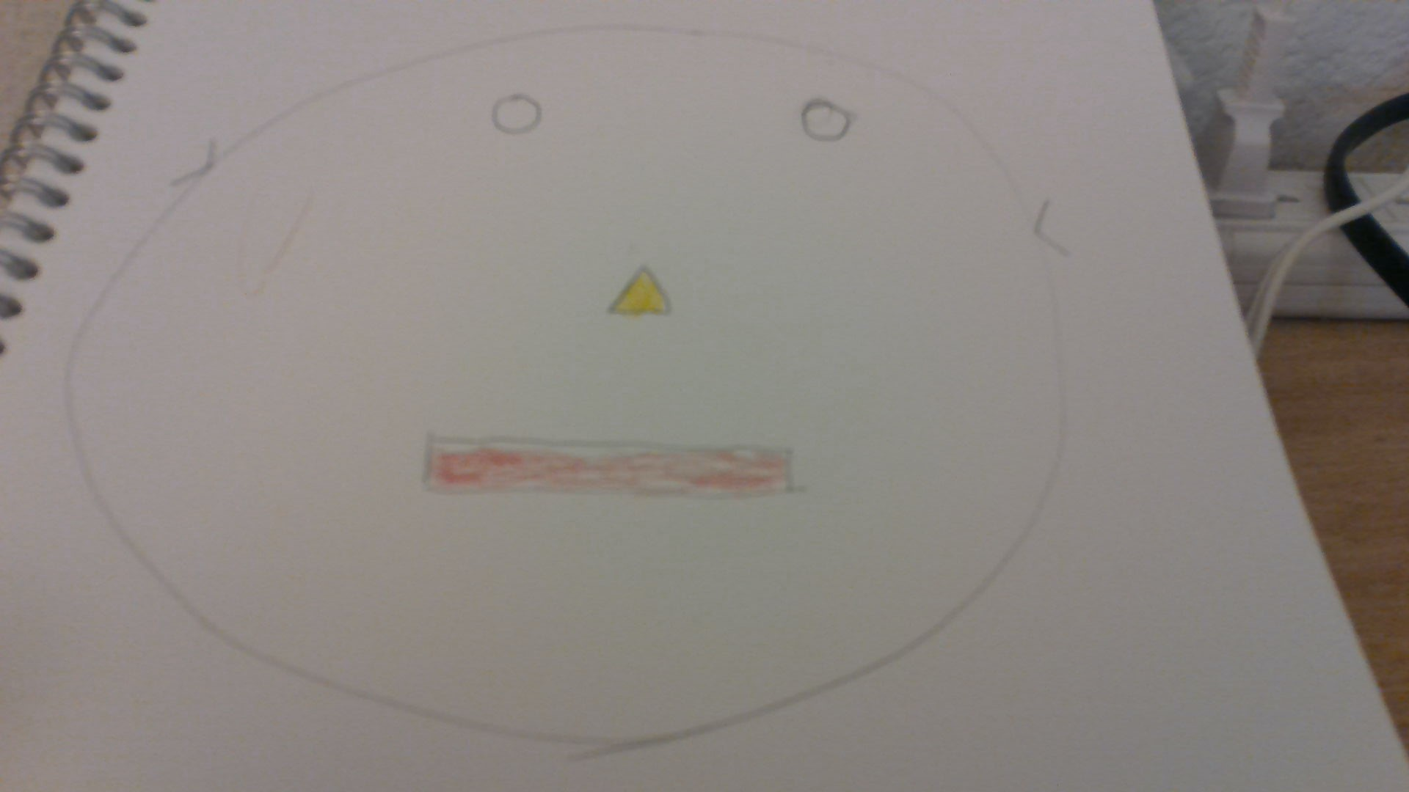

Reflections: I am a lot of things when it comes to programming. However, even though my coding skills are passable, I am not an artist. My final product looks way better, simply because it has ears, glasses, and color. However, this did not prevent my portrait from looking like Pinocchio. It might not be my face, but it does describe my self-image well; a boring man who still gets the job done. And that is the truth, because my nose is not growing.

