Alvin, ART385, Code Self-Portrait to P5.js with Feelings, 2/13/20

Statement: Port your Code Self-Portrait to p5.js and Make Emotions.

First, make it run as it did in Processing, solving syntax problems.

Then, add interactive effects for animation or changing emotions:
** Trap keyboard commands, mouse pressed, mouseX and Y

** Move eyebrows/eyes/mouth to generate at least 3 basic emotions: surprised, angry, sad, happy, disgust — you can define your own emotions

** Use global variable to make a “state machine” for these emotions, follow the BallLoop.pde example

** Put at least one for…loop in there, drawing freckles or features on the face or doing an animated effect

Hand Drawn Sketches:
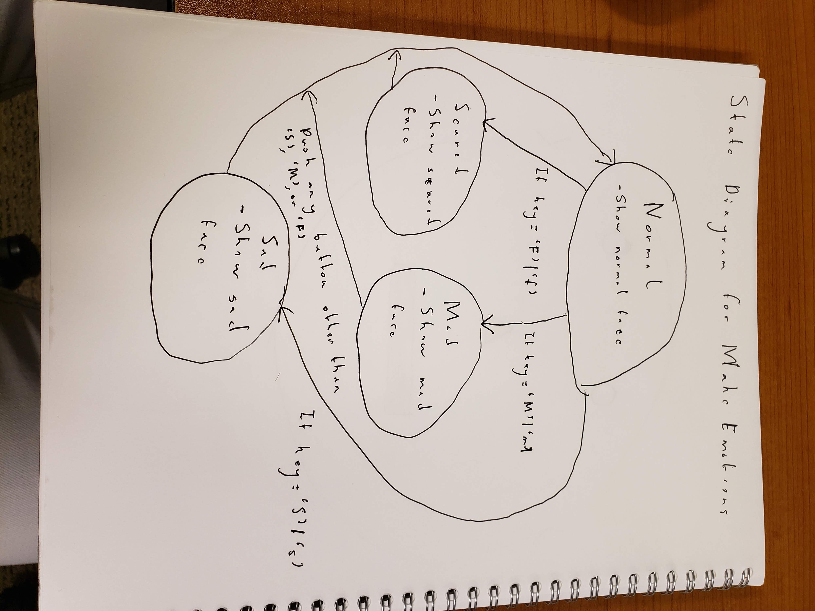

Reflections: Resizing the canvas was a lot more difficult than I thought it would be. While the actual dimensions were easy enough to manipulate, the various variables required a load of calculator work. Thankfully, once I figured out the proportions, getting everything to grow or shrink with the canvas proved to be easy. Another thing I will have to look out for are global variables. While Processing can work with global variables, p5 cannot. As a result, I had to rewrite the placement of my global variables when translating from Processing to p5. Also, Github continues to be a pain in the back. I will need to refine how I use it by the end of the semester.

