Alvin, ART385, Timers, 4/24/20

Statement: For this assignment, we will work with the Timer class to encapsulate millis() and do asynchronous timing.

Using our potentiometer and switch, we will run two timers to do a simple interaction.

Timer #1 should respond to the potentiometer and display some graphics such as a slide show

Timer #2 should be some other display such as flickering shapes that respond to something such as sliders, mouse interaction or keyboard interaction

Your repository should be called CodeTimers and have two subdirectories: Processing, which contains your .pde file and any related images and Arduino, which contains your .ino sketch.

** You will have unique code, running off the class templates for Serial Communication is okay

** in the README.md file, describe what you are doing in 4 sentences or less

** Potentiometer is on pin A2

** Switch is on pin 12

** LED for startup or power indication on pin 15

Please include a simple ART385 Design Document, which should be saved as a PDF and include the following sections:

Document Info
Restate the Assignment
Reflections

You will be assessed on code legibility (specifically the comments), working code (we will all use the same hardware pins), GitHub management, and following all the instructions.

The GitHub repo should be Called “CodeTimers”. And should include a README.md and the Art385 Design Document (called DesignDocument.pdf). Finally, please include a video of the circuit in action, you pressing the button and turning the potentiometer and the results on the screen. This can either be as a .mp4 file in your repository or Vimeo/YouTube link in the ReadMe file.

Note: no need to do the LICENSE file for any of the Weekly assignments from here on out.

Sketch:
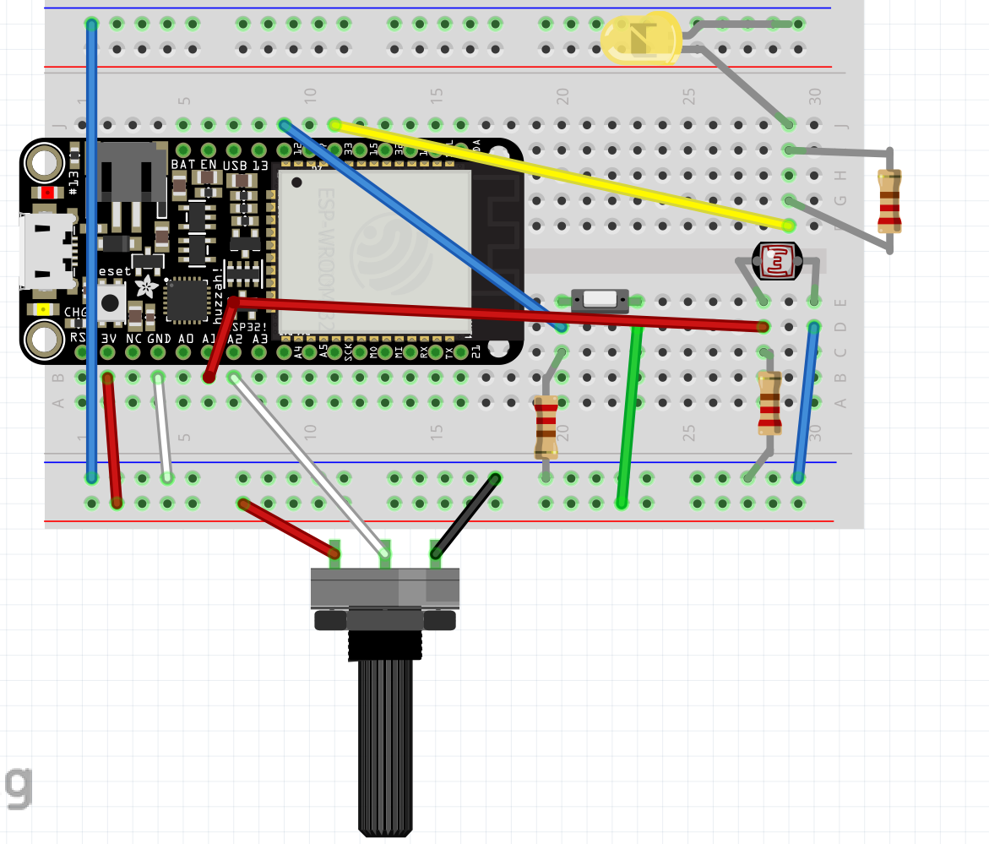

Schematic:
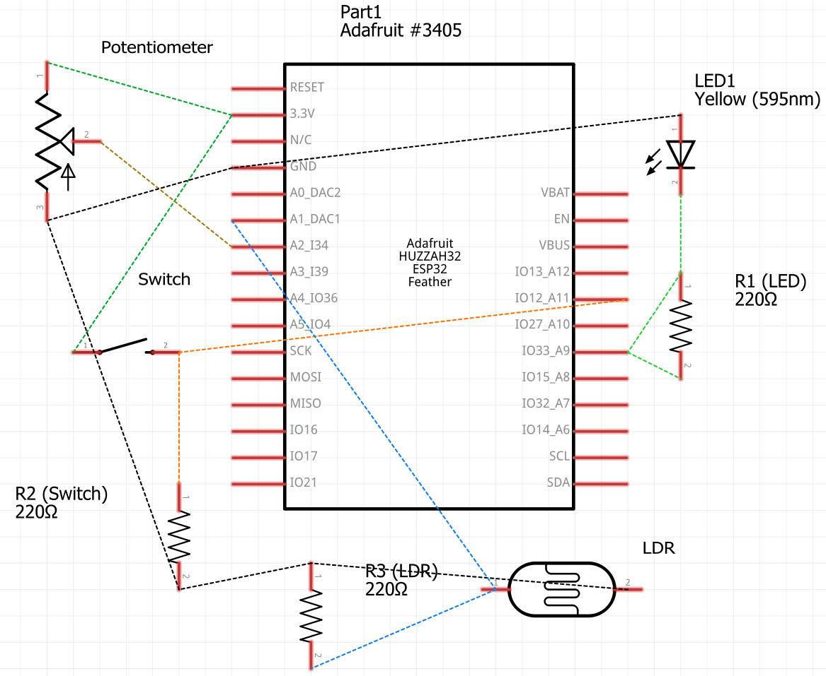

Reflections: For now, the difficult part for me is coding the Processing. I am not the world’s best coder, so I always must double-check whether I have not made any mistakes. However, I understand how the timers work. Essentially, for my sketch, it checks whether the two timers have reached the end, and for at least one, it will change the text color while the other will increment a variable that will cause the text to change. My only issue is making sure that the default text does not appear at the same time as any new text that appears. I managed to solve this problem by rewriting my draw() function to only call drawText() when all my Boolean variables are false and added the title text to all my display functions. However, for the next few assignments, I will have to review whether my algorithms are correct, especially for if and if else clauses.

