Alvin, ART385, LED Complexity, 3/17/20

Statement: Develop 'complex' functionality over break with switches and LEDs.
Feel free to interpret this as you'd like. Don't put too much thought into it, just spend a little time with the code for your ESP32 and make your LED(s) light up in some interesting way. Use the LDR or button (or both) to trigger events.
You will be assessed on code legibility (specifically the comments), proper structure for the state machine, GitHub management, experimentation, the look-and-feel of the design document itself and following all the instructions.
The GitHub repo should be Called “LED Complexity” and should include a README.md and LICENSE file and the Art385 Design Document (called DesignDocument.pdf).

Hand Drawn Sketches:
Breadboard:
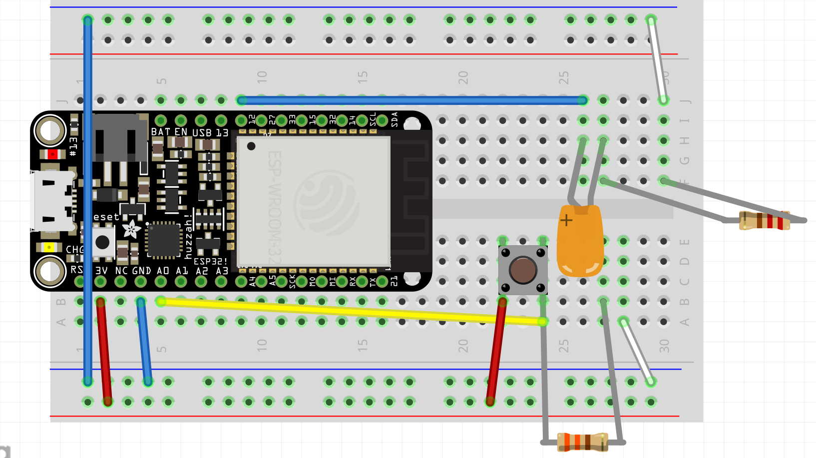

Schematic:
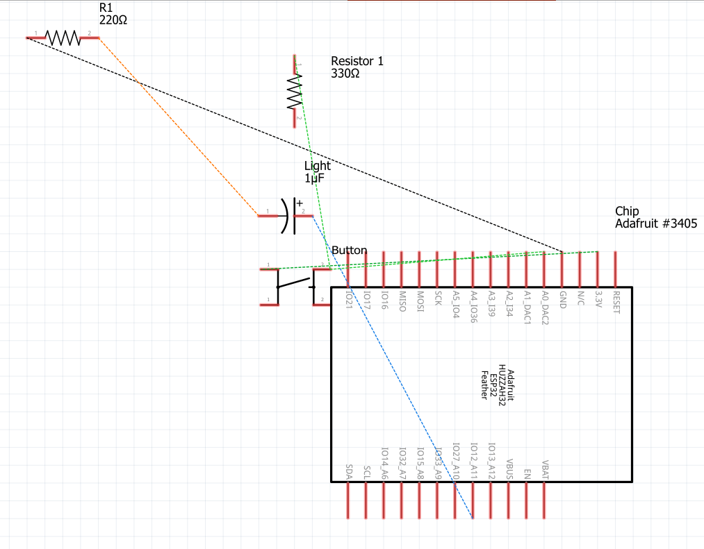

PCB:
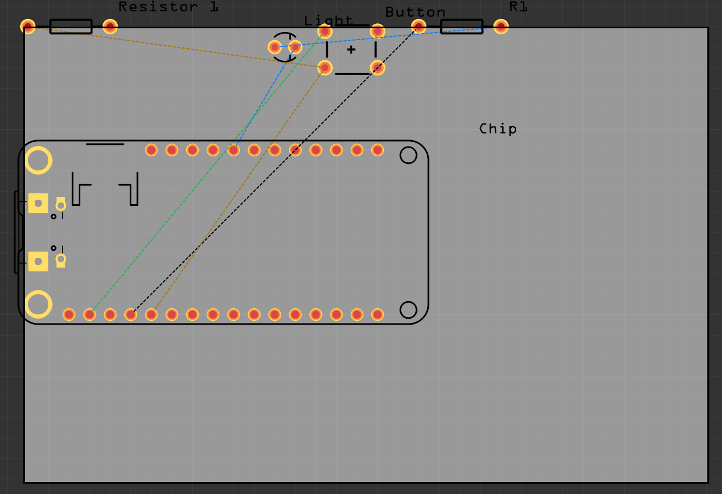
Reflections: I consider myself an above average coder. If I have the syntax handy, I can write any code I need. Unfortunately, the same cannot be said for hooking up a chip. I have zero idea how to hook up a chip. In fact, taking out the resistors and lightbulb so I can put my chip in a backpack turned out to be a mistake, because now I have no idea how to hook it back up. The port is also continuing to be difficult; there are moments where uploading the sketches allows me to see the ports, and there are moments when it refuses to recognize the port.
However, I managed to get everything going, I managed to get the lights flashing on and off via a for loop. After one button push, it can enter a for loop that flashes the lights on and off ten times. I had used for loops for the past two years in CS classes, so once I figured out where to put it, it was easy as heck to get my chip to work.

