Alvin, ART385, LightPatterns, 4/7/20 (https://youtu.be/kqM7G1cVMBw)

Statement: The purpose of this program is to demonstrate the different light patterns that can be programmed, as well as using a button and light-dependent resistor to manipulate them. My intention is to not only demonstrate the different light patterns than can be drawn, it also demonstrates how the millis function can manipulate the lights with the use of a state machine and without the use of the delay function and how the light dependent resistor can manipulate the lights. The point of this project is to demonstrate how a user can manipulate lights via a button press and LDR input. While this program uses the example of sirens as a starting point, I hope that my program could be a beginning that would lead to more advanced programs.

Sketch:
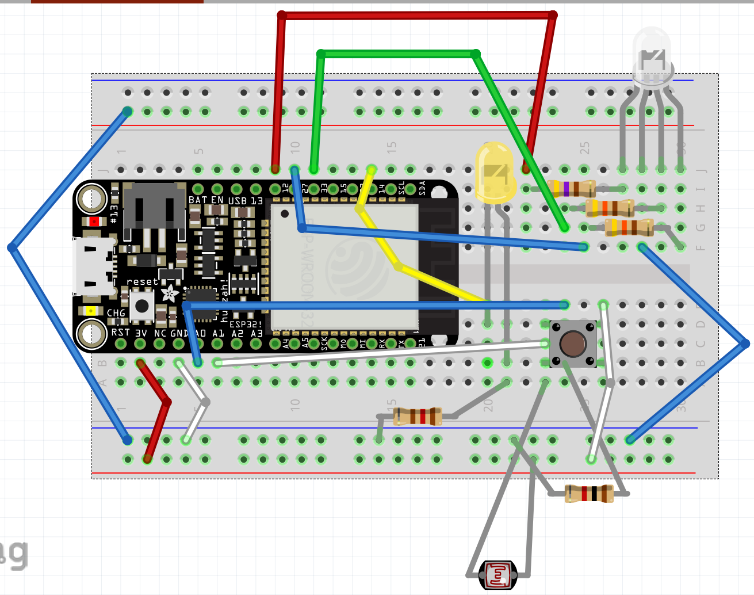

Concept: The concept of this program is to demonstrate how a switch case, functions, and state machine can manipulate the lights on the breadboard via the button and light dependent resistor. The button tracks what case the sketch should run. Inside the case, a function is called. These three functions execute a set of commands. While the first two (Introduction and Sirens) run off a state machine tracked by the millis and ledState variable, the third program (LightAdjust) turns on and off according to the input from the LDR.

Interaction Diagram
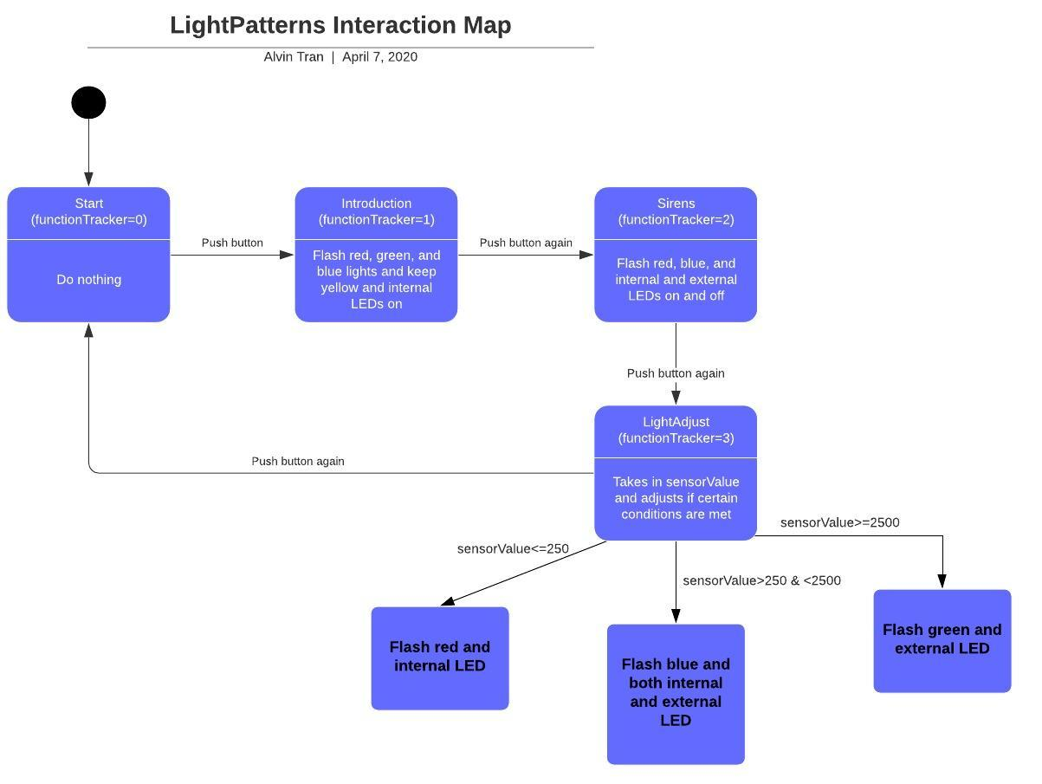

State Diagram:
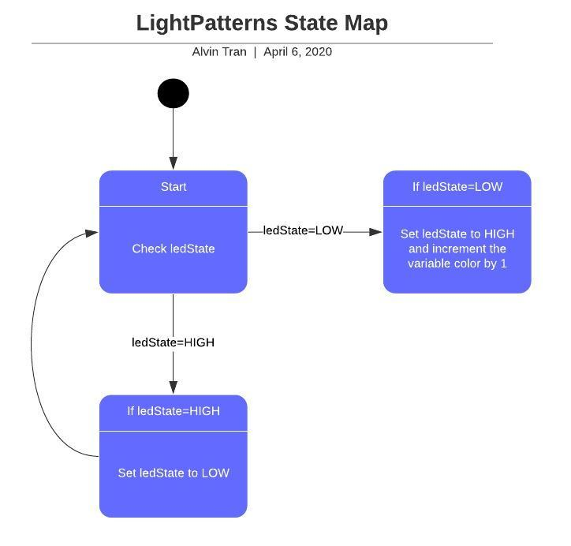

Schematic:
