Alvin, ART385, StoveSafety, 4/7/20
Statement: The purpose of my project is to create a device that would alert a cook if they are too close to a stove light. It will take in data from a potentiometer and a light-dependent resistor. If the potentiometer is turned past a certain value and the LDR does not receive a certain amount of light, the Processing sketch will flash a warning message.
The intended audience is people who work in the kitchen. Naturally, this is a large variety of people. There will be a focus however on people who might lack the situational awareness to avoid accidentally burning themselves on a stove.
Sketch:
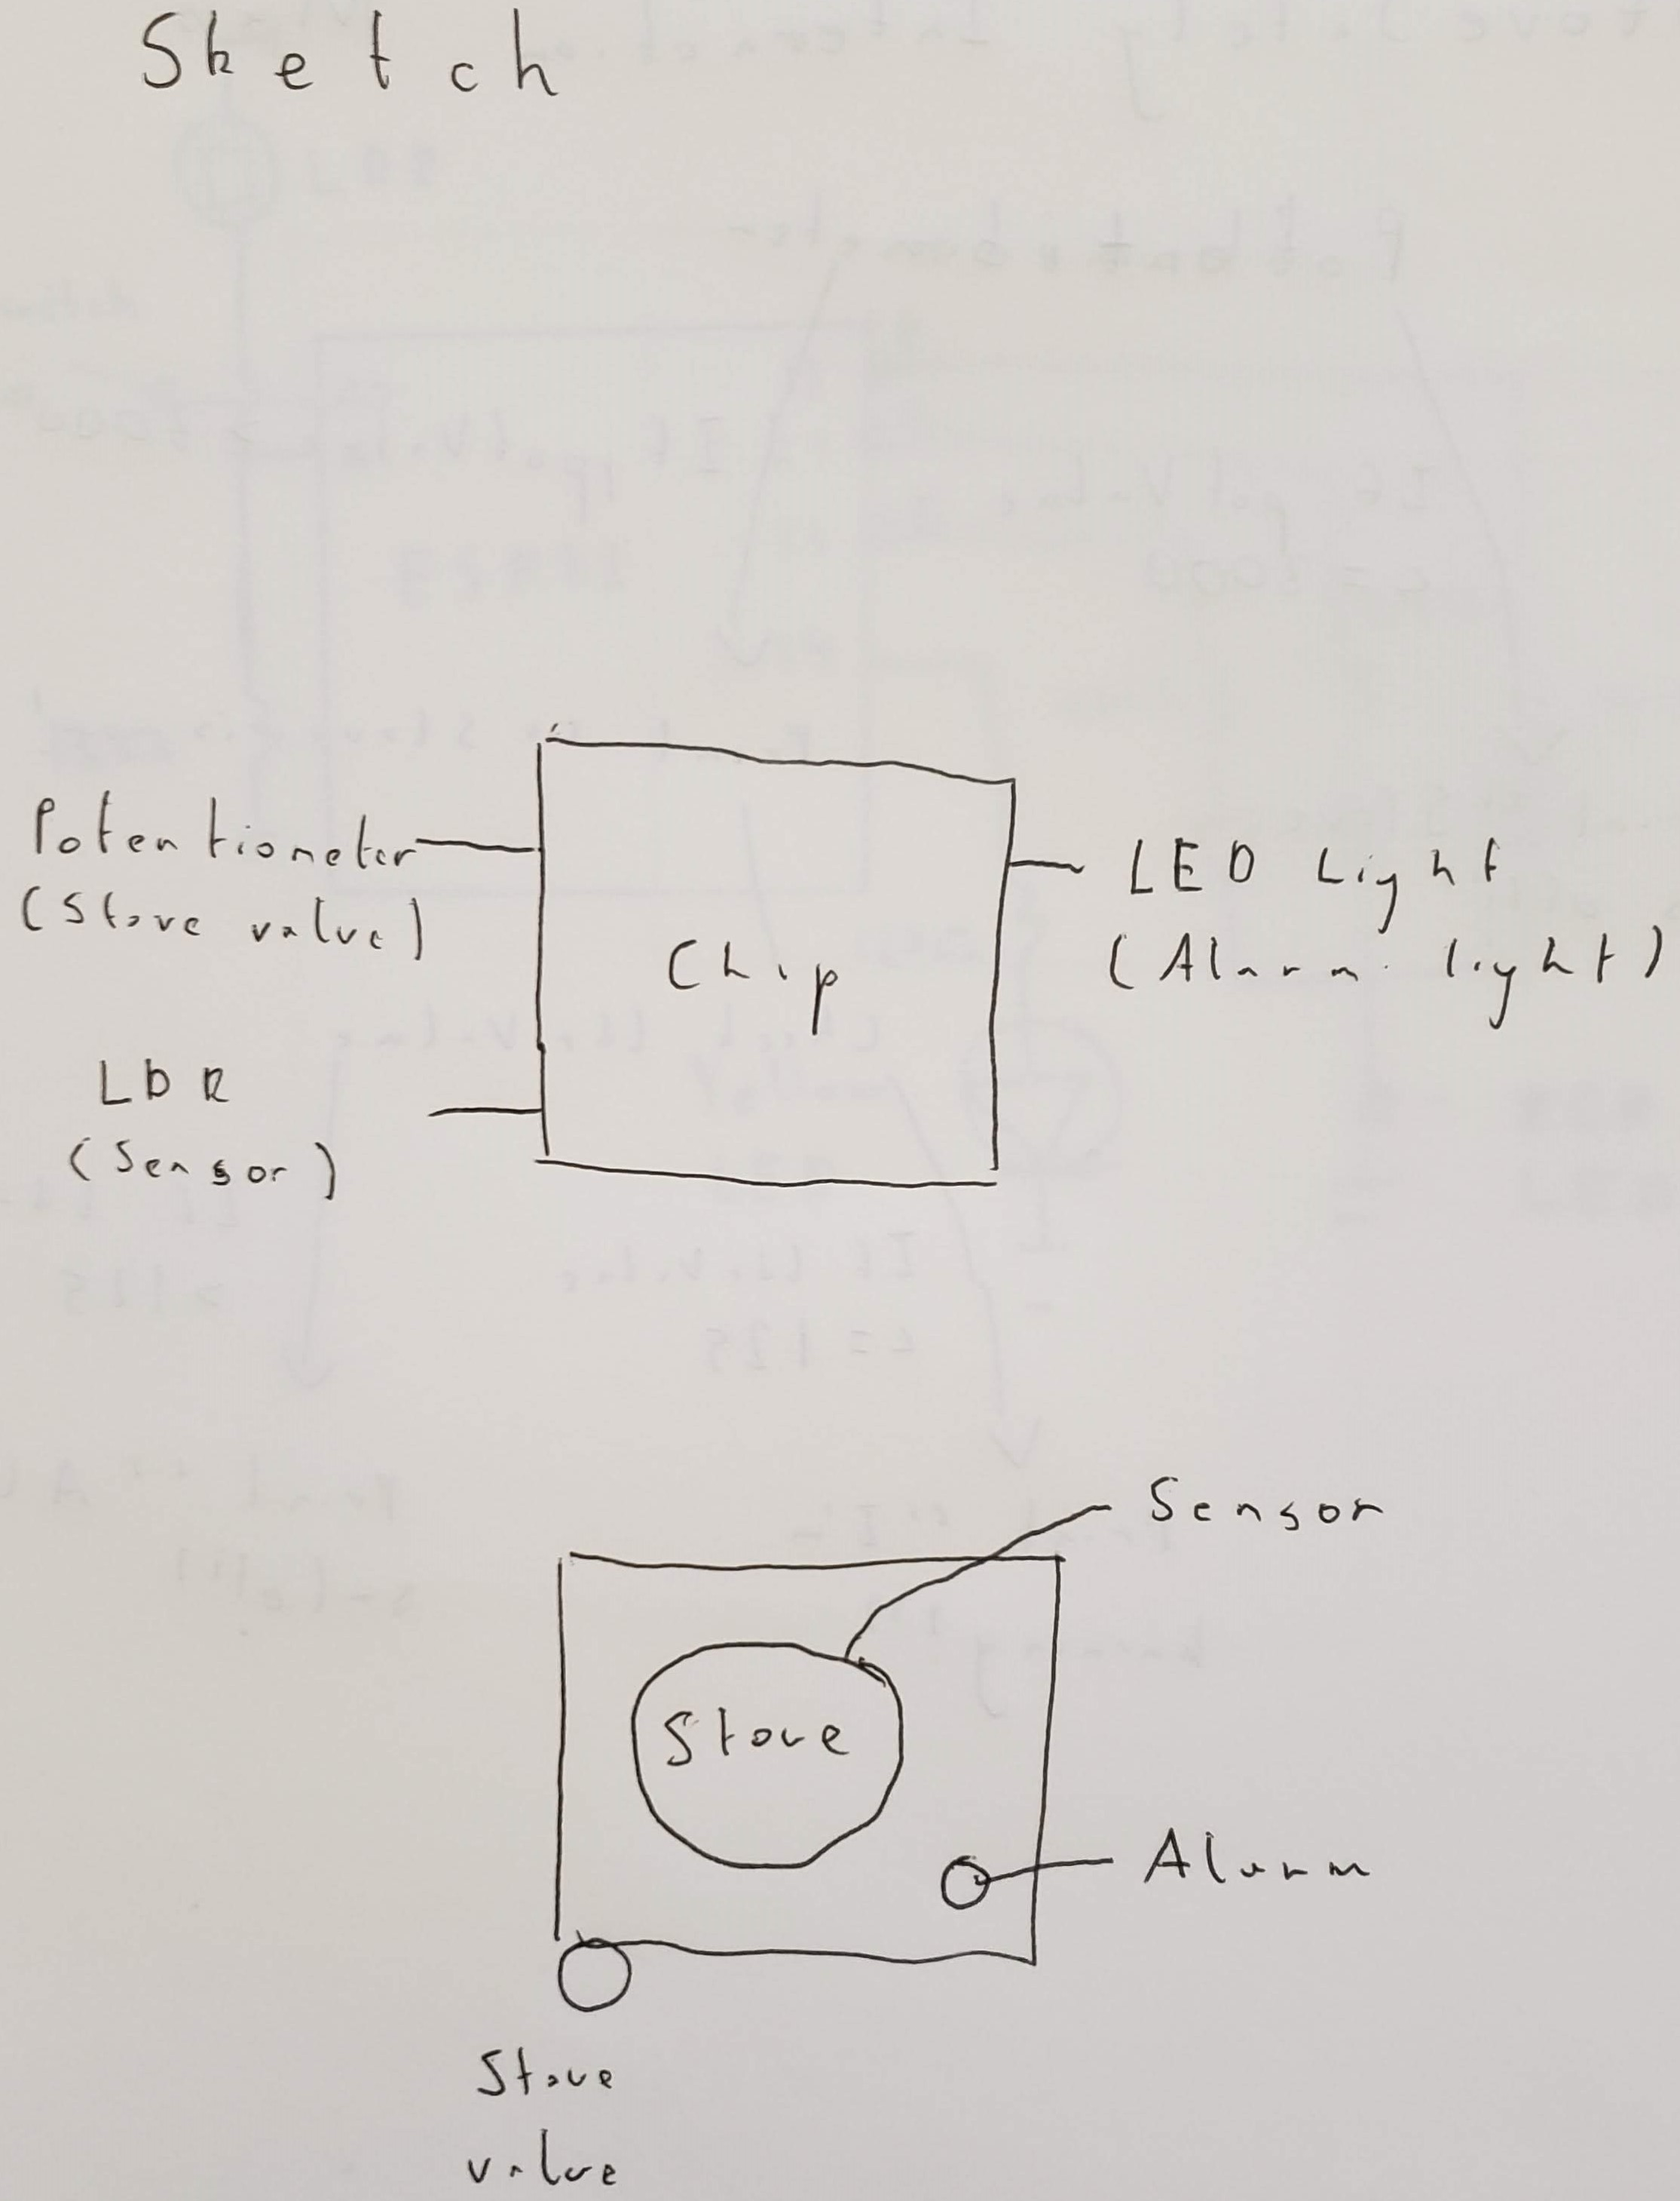

Interaction Diagram:
