Alvin, ART385, Digital Drawing, Project 1: PuppyEmotions (User Input and States (Software)), 2/27/20
Statement:
My intended environment is the classroom. The purpose of this program is to teach non-programmers how a state machine works and how it is manipulated. The plan is to distribute the source code in a classroom to all students and have them manipulate it as they wished. Essentially, the goal is to teach non-programmers what state machines are and how they work.
My idea on this project is a simple demonstration on how state machines work. Essentially, my plan is to allow the user to enter an input and display a different state depending in the user input. The screen will not only display a screen, it will also display some text depending on what state the state machine is displaying. The goal of this program is an easy-to-read and easy-to-edit source code that anyone can use. I originally planned on having the user enter in a string, but that proved to be too difficult to implement, especially in trying to return to a normal state. I found it much easier to have the user use the number pad of the keyboard.
Having a series of images with some basic animations turned out to be easy to manipulate. While an initial plan to use P5 with an HTML input failed to pan out, using the number pad of the keyboard turned out to be much easier. Also, it turned out to be easy to have every state be its own function and the animations present on it another function called inside the states. Also, the images are of puppies; who does not like puppies. In all seriousness, the puppies that were the subjects of the images I chose made it easy for me to place animated text and shapes. After creating my states and text, the hardest part was making all the various animations. Placement of animations is still a weak point, but the mousePressed function made it easy to track my coordinates. Most of my animations used if…else clauses combined with increments and decrements, but the drawNormal and drawScared states used millis as part of an experiment to see how it worked. Ultimately, whiles explaining states in the actual program might be difficult, my explanation of state machines using this program demonstrates how users can manipulate states. While I can only use the 1-5 and 0 on the number pad to manipulate this program, I believe that this program demonstrates how and why a state machine works and how the user can choose to manipulate.

State Map:

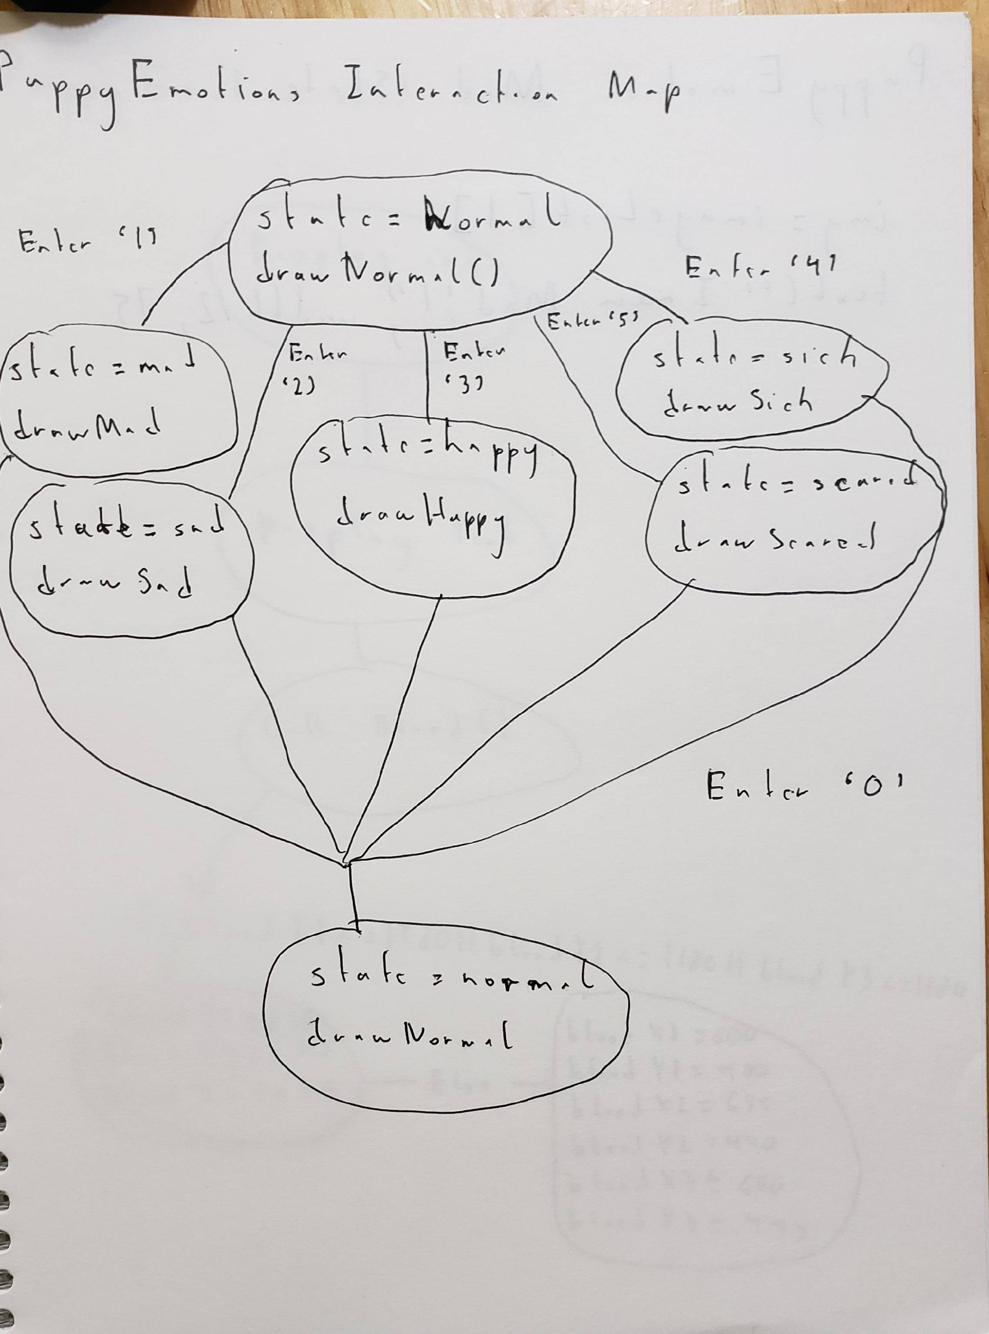

Illustration of mad State:
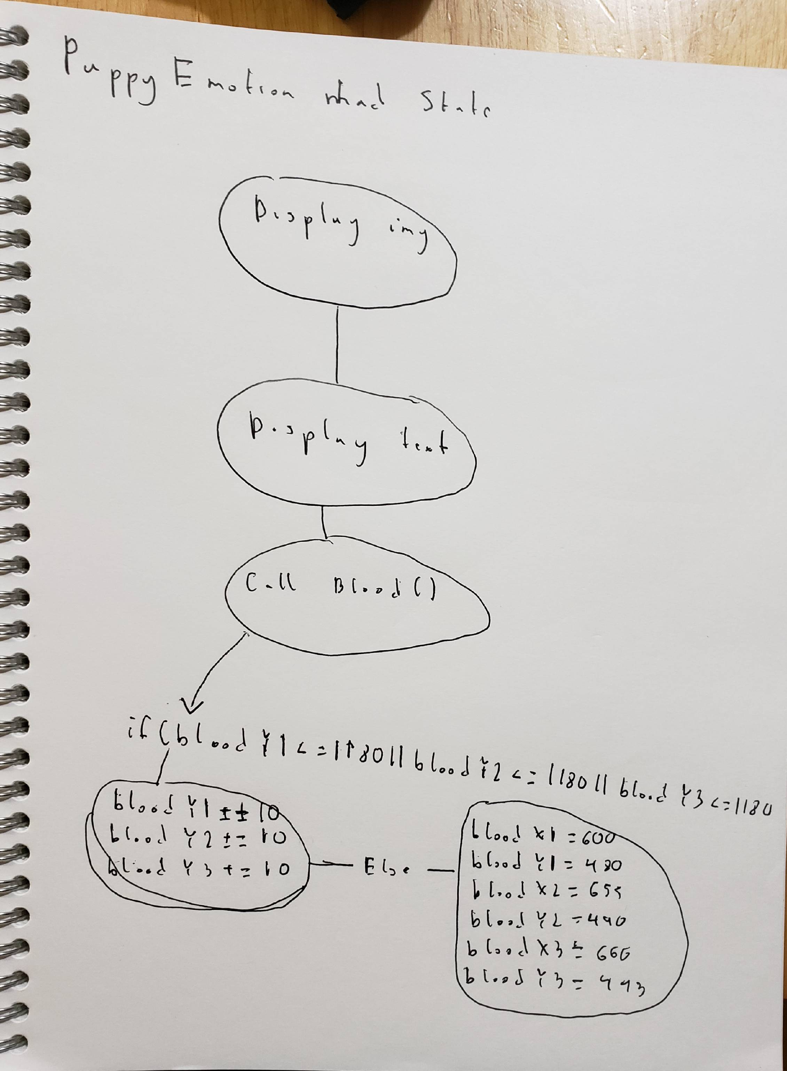

Illustration of sick State:
