Alvin, ART385, Simple State Machine, 3/24/20

Statement: Code a state machine that changes the state of an LED when the button is pushed 4 times. Start there and get more complex if you have time.

Create a state machine that controls the state of 1 or more LEDs. Start by writing code so that 4 it takes button pushes to turn on the LED. Maybe it takes 4 more pushes to turn the LED off. Maybe it only takes one more push to turn the LED off. Your call. See if you can make an engaging interaction with only one button and 1 (or more) LED(s). You might even consider using an RGB LED!

Please include a simple ART385 Design Document, which should be saved as a PDF and include the following sections:

Document Info
Restate the Assignment
Hand-drawn or digitally-drawn schematic diagram (that shows how your components are connected)
Reflections

You will be assessed on code legibility (specifically the comments), proper structure for the state machine, GitHub management, experimentation, the look-and-feel of the design document itself, and following all the instructions.

The GitHub repo should be Called “SimpleStateMachine” and should include a README.md and LICENSE file and the Art385 Design Document (called DesignDocument.pdf).

Hand Drawn Sketches:
Breadboard:
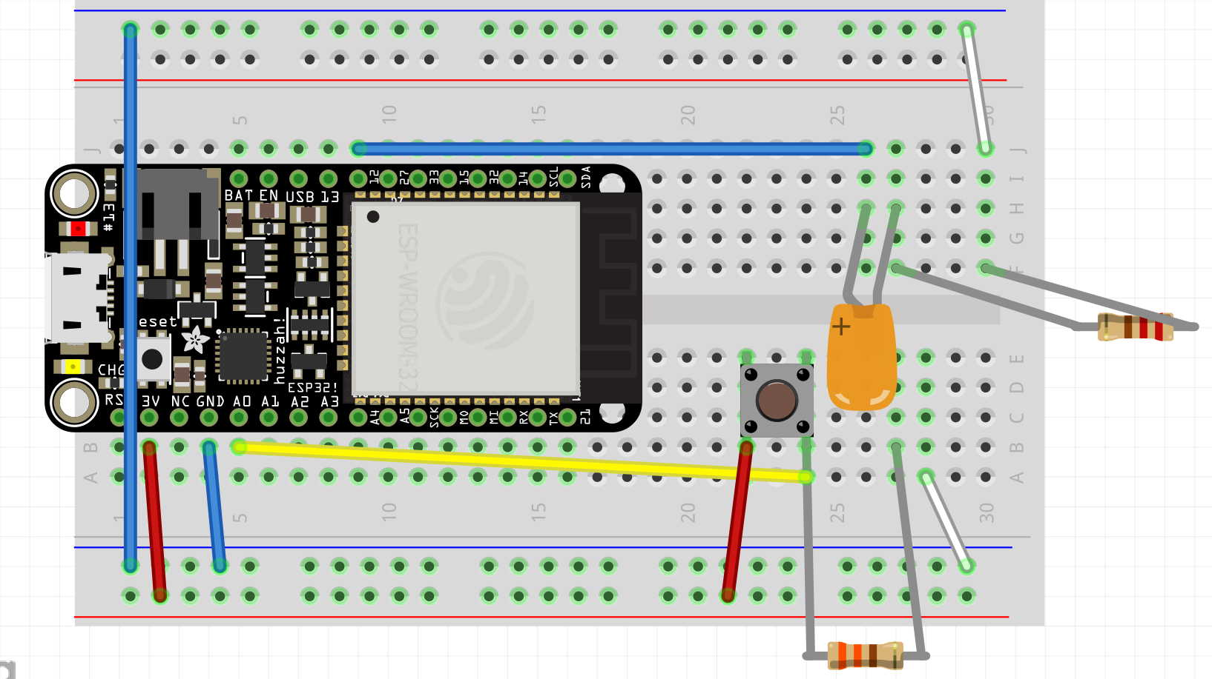

Schematic:
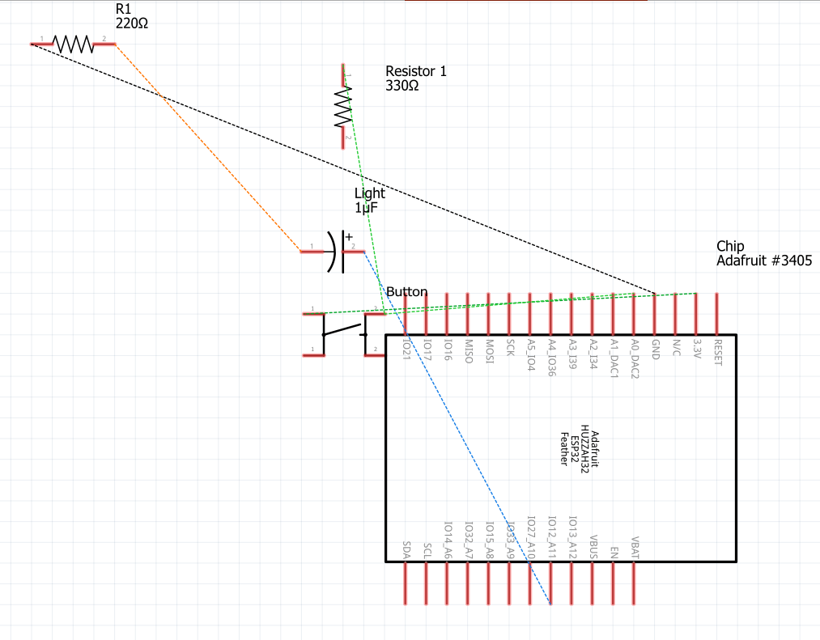

PCB:
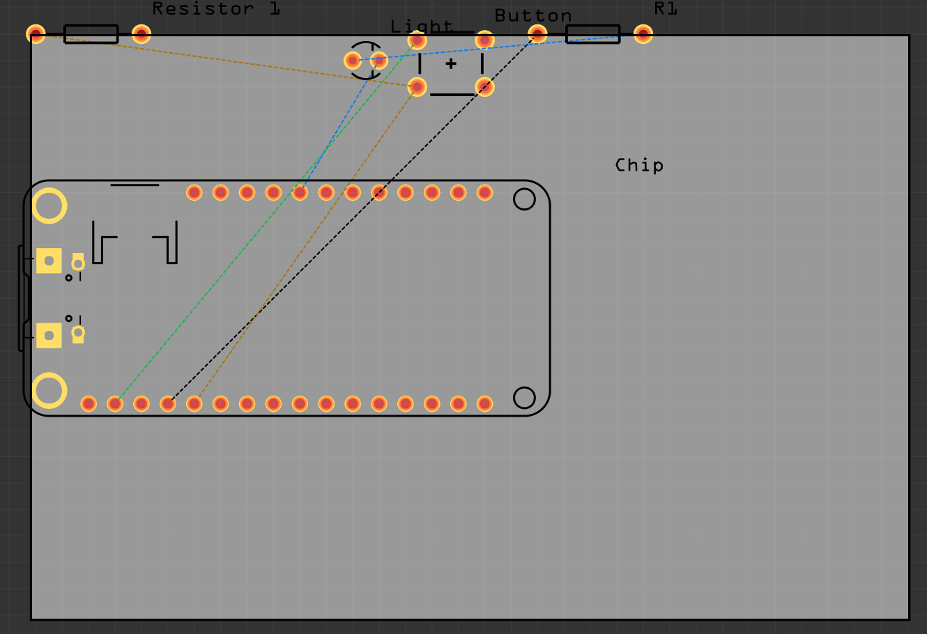
Reflections: Once again, my COM3 port can be temperamental. I often must plug and unplug my USB and restart my Arduino. Right now, it is a minor problem I can easily work through. However, I am worried that it is a sign that my Surface Pro 3 is at an age where I must consider replacing it.

For wiring, I decided to use the exact same layout as my LEDComplexity. I believed that experimenting with wiring is not in my favor right now. After all, this assignment is to get a light working with a state machine. Considering that wiring is not my strong suit, trying to experiment with something I am not too confident in could lead to a major issue.

Coding turned to be much more difficult than I thought it would be. For one, my biggest problem was that my pushCount was being incremented after only one button push. At first, it was because I was trying to use a For loop, which did not work because it kept breaking out of the loop. The while loop turned out to work, but the pushCount still incremented automatically. I had to insert a delay after the digitalRead in order to stabilize the software. Even so, I haave tp be careful with how long I hold down the button. Anything longer than half a second, and it will increment beyond 1.

According to my father, the software and hardware are not synchronized. As a result, the delay is needed to allow the user to enter in their button pushes. However, this has taught me that I am working with a coding language that I am actually unfamiliar with, and even though I have worked with Java, C, and Python in the past, Arduino’s C++ is something I have to learn to read to help with future assignments.
.

