**<intelliQ>**

**Software Requirements Specification**

Version <1.0.0>

# Revision History

|  |  |  |  |
| --- | --- | --- | --- |
| Date | Version | Description | Author |
| <MM/DD/YYYY> | <version> | <description> | <author> |
|  |  |  |  |
|  |  |  |  |

# Table of Contents

Revision History 2

Table of Contents 3

Introduction 4

Purpose 4

Scope 4

Definition, Acronyms and Abbreviations 4

References 4

Overall Description 4

Problem Statement 4

Background 4

Objectives 4

Constraints 4

Functional Requirements 4

Use Cases 4

Requirements 5

User Requirements 5

Technical Requirements 5

Performance 5

Scalability 5

Security 5

Maintainability 5

Usability 5

Localization Support 5

Auditing and Logging 5

Availability 6

Hardware Requirements 6

Network 6

Client Computers 6

Deployment Requirements 6

Nodes 6

Components 6

Artifacts 6

Other Requirements 6

Appendices 6

# Introduction

<Introduction of this Software Requirements Specification. What will be covered in this document? What is the aim of this document? What are the main focuses? >

## Purpose

<Purpose of this document. Do you write this document to define the system to be developed? Do you expect the end user will gain a better understanding by reading this document? Do you expect designer and developer to gain understanding of the system by reading this document?>

## Scope

<Scope of this document. What parties or systems will be mentioned or focused? Will you describe the company that hire your team? Will you talk about the stakeholders, the existing system and even the as-is business process?>

## Definition, Acronyms and Abbreviations

<Collection of terms to be used in this document, with their definition. For example, you may want to describe the word RAID that appears in your hardware requirement section>

|  |  |
| --- | --- |
| Term | Definition |
|  |  |

## References

<A list of reference material used by this document.>

# Overall Description

## Problem Statement

<Description of problems that the end user is currently facing. E.g. lack of functionalities of the existing system, slow performance, etc>

## Background

<Description of why the problems stated in the problem statement exists. For example, a slow performance of system can be due to an increasing amount of users, arising from changes in the business environment, or from a change of business policy.>

## Objectives

<Describe what your system will achieve.>

## Constraints

<Honestly list out the limitations of the system to be implemented. E.g. poor scalability, can only run on Windows, etc)

# Functional Requirements

<Detailed description of system features. >

## Use Cases

### Use Case Diagram1

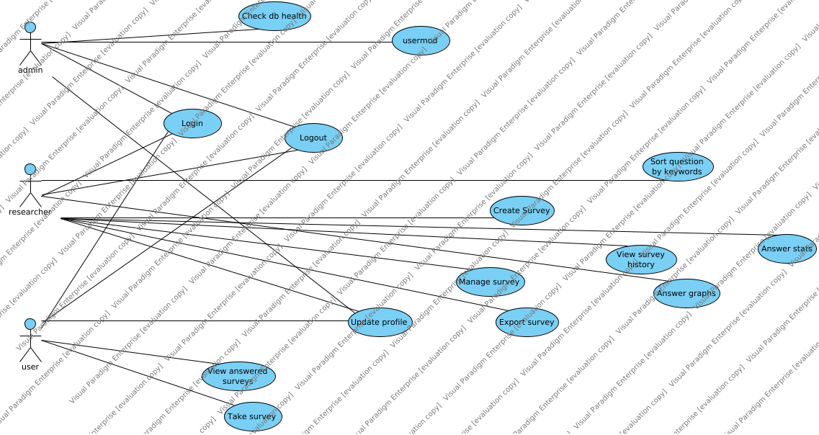

|  |  |
| --- | --- |
| Use Case | Description |
| Answer graphs |  |
| Answer stats |  |
| Check db health |  |
| Create Survey |  |
| Export survey |  |
| Login |  |
| Logout |  |
| Manage survey |  |
| Sort question by keywords |  |
| Take survey |  |
| Update profile |  |
| usermod |  |
| View answered surveys |  |
| View survey history |  |

## Requirements

|  |  |
| --- | --- |
| Requirement | Description |

# User Requirements

<Description of the intended users of your system. You should clearly define who will be using your system and the environment(s) in which it will be used>

|  |  |
| --- | --- |
| Actor | Description |
| admin |  |
| researcher |  |
| user |  |

# Technical Requirements

## Performance

## Scalability

## Security

## Maintainability

## Usability

## Localization Support

## Auditing and Logging

## Availability

# Hardware Requirements

<Description of hardware requirements to install and run your system>

## Network

## Client Computers

# Deployment Requirements

## Deployment Diagram1

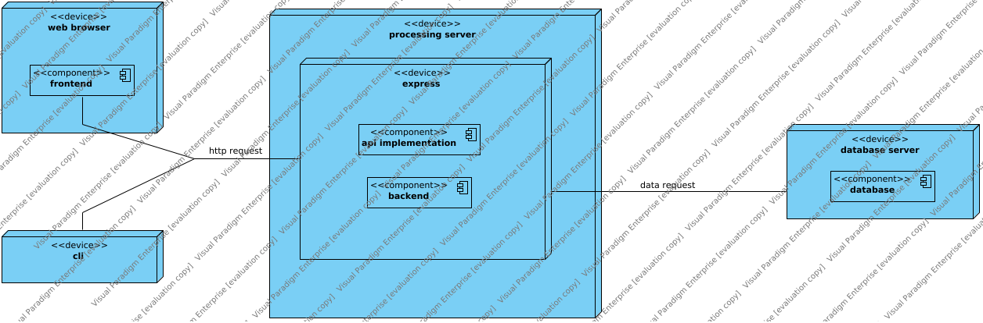

## Nodes

|  |  |
| --- | --- |
| Name | Description |
| cli |  |
| database server |  |
| express |  |
| processing server |  |
| web browser |  |

## Components

|  |  |
| --- | --- |
| Name | Description |
| API implementation |  |
| api implementation |  |
| backend |  |
| backend |  |
| database |  |
| database |  |
| database server |  |
| frontend |  |
| processing server |  |
| web app (frontend) |  |
| Web UI |  |

## Artifacts

|  |  |
| --- | --- |
| Name | Description |

# Other Requirements

# Appendices