**PROJECT 1**

TIC TAC TOE

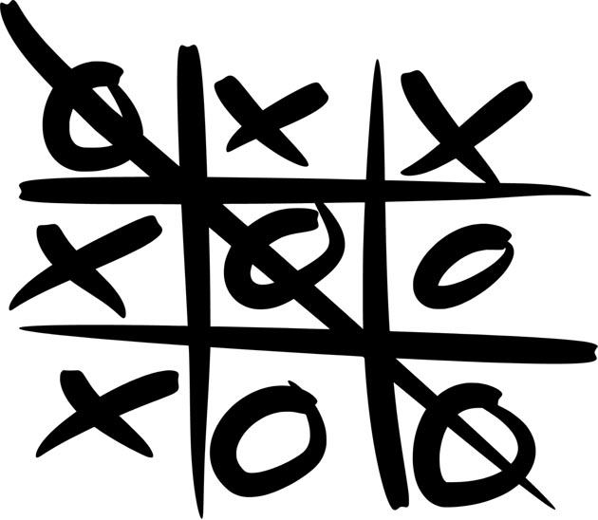

Anh Vu

CSC 5 – 46023

July 18th, 2014

**TABLE OF CONTENTS**

**Cover**……………………………………………………………………………………….…….1

**Introduction**……………………………………………………………………………………...3

**Rules**…………………………………………………………………………………...…3

**INTRODUCTION**

Tic-Tac-Toe is a game in which two players, X and O, mark a 3 x 3 grid until one player wins. The objective of the game is to mark 3 spaces that are horizontally, vertically, or diagonally adjacent to one another before the other team does.

**Rules –**

* Each player will take turns marking the grid. No player will mark the grid more than once at a time.
* You must only mark the empty spaces in the grid.
* Many times you will find that neither player wins. This game is considered a draw, or a cat’s game.

**Instructions –**

* Please designate which player will be represented as ‘X’ or ‘O’
* The program will randomly decide which player (‘X’ or ‘O’) will play first
* Each space in the 3 x 3 grid will be represented by a number. Please select the numbered space in which you would like to place your mark. Your mark will be placed on the grid after each time you input.
* The game will continue to run until 1) one person wins, or 2) all spaces are occupied and no one wins.