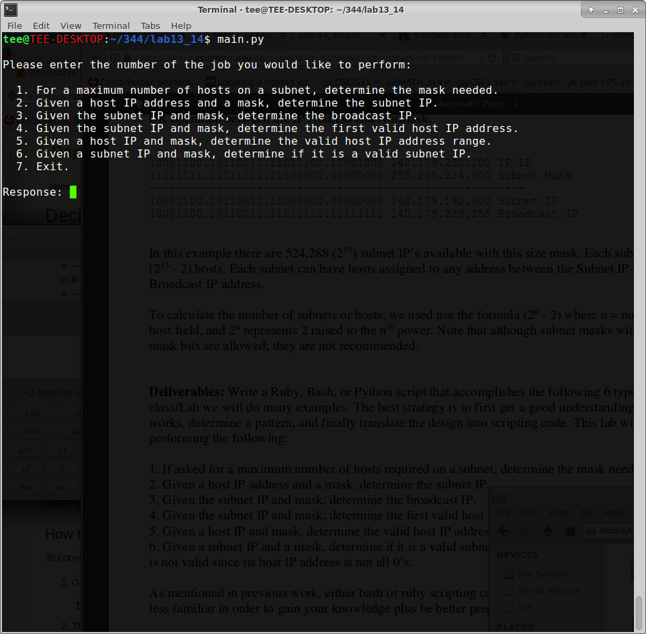
Athit Vue
Date: May 6, 2017

This lab was pretty interesting. It took a lot of research but learning about it was pretty interesting.
There were many things that was new to me, thus it was pretty difficult to began the lab. So after a few long hours of research I finally had enough information to get started.

Menu of program:

First job with results:
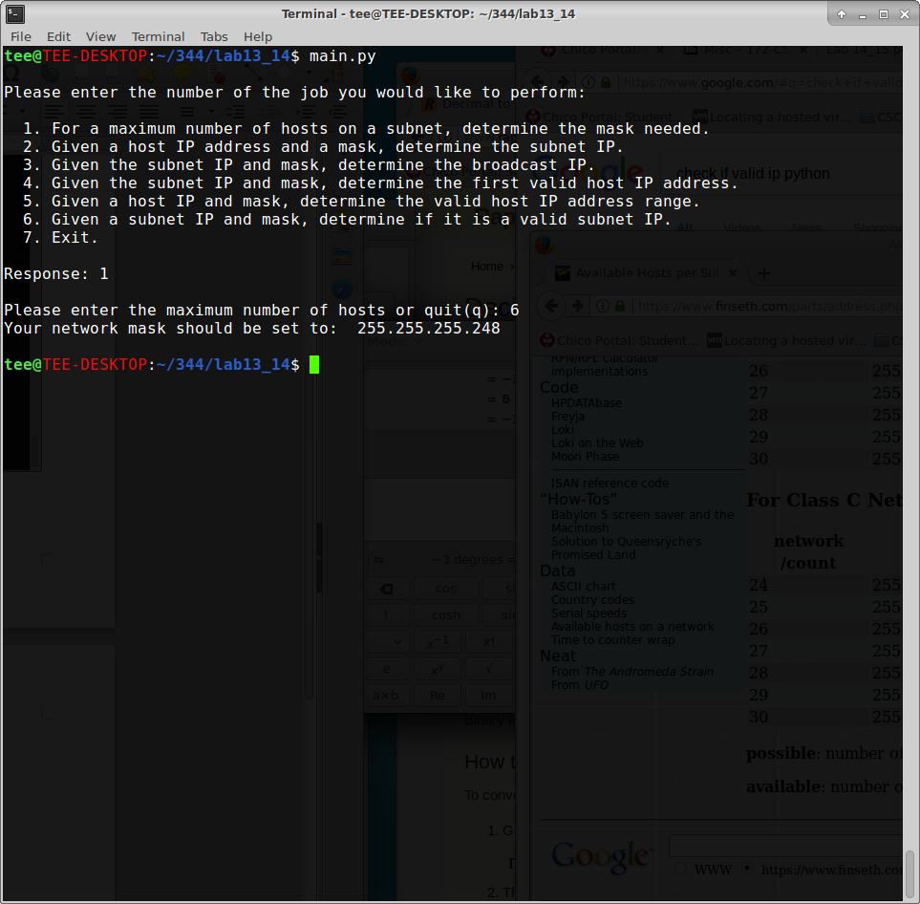

Host Ip and subnet mask, output subnet IP:
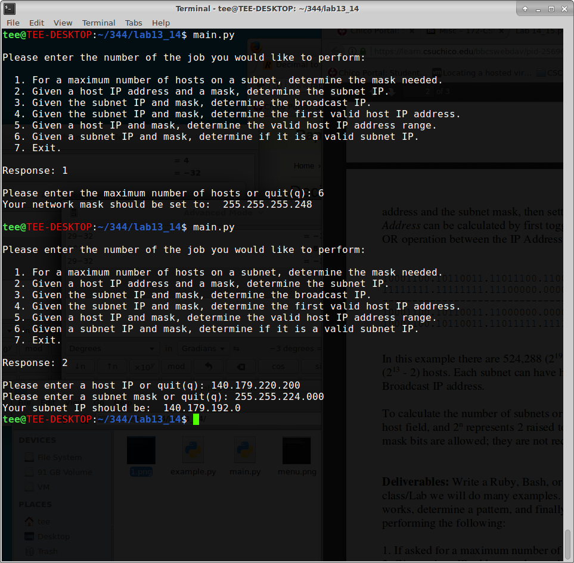

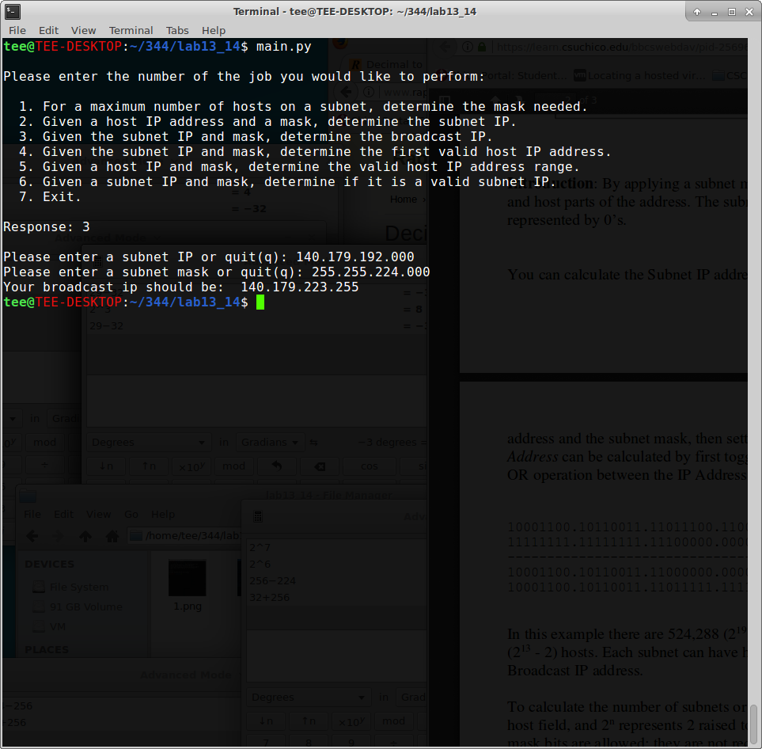
Getting the broadcast ip given subnet ip and subnet mask:

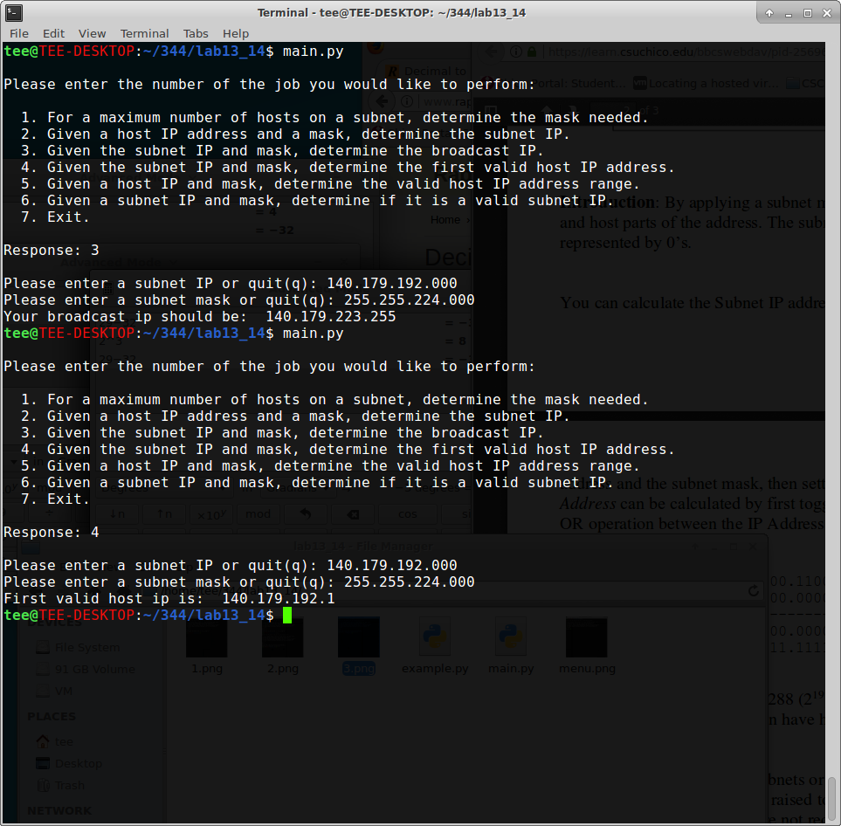
First valid host IP address:

Determine valid host ip range given host ip and mask:
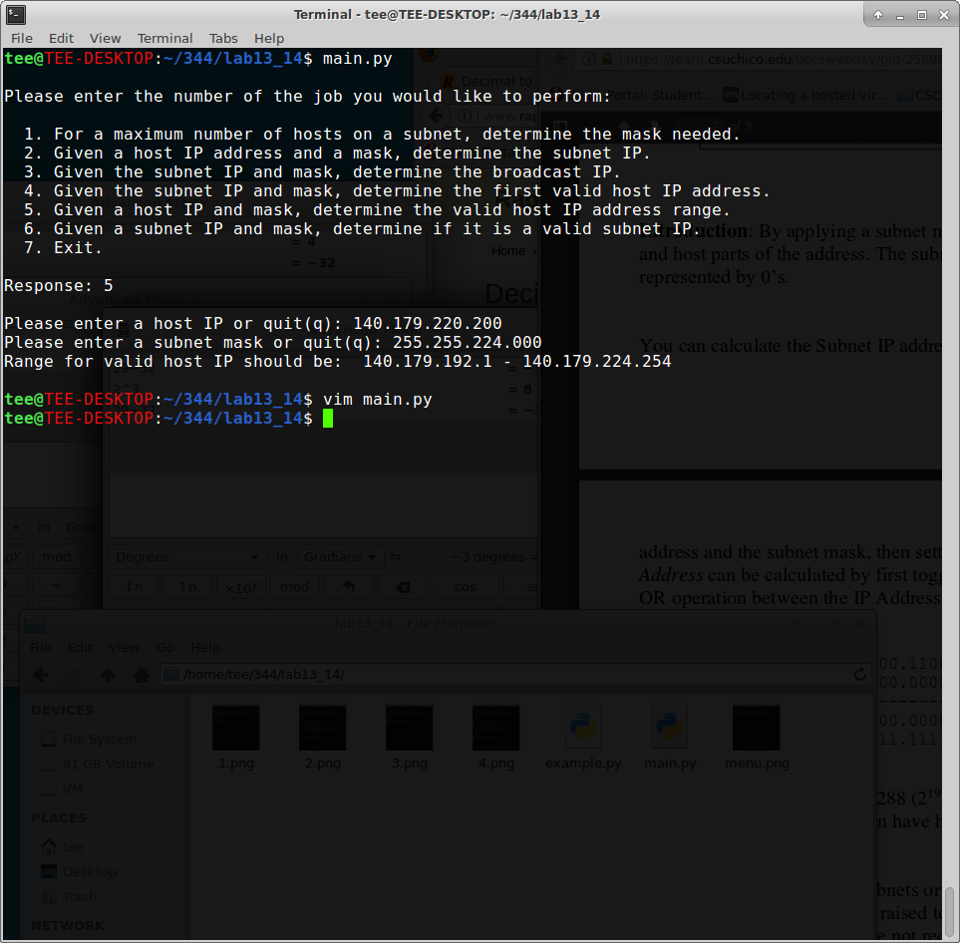

Determine if subnet ip is valid (Throws an error to screen if not valid):

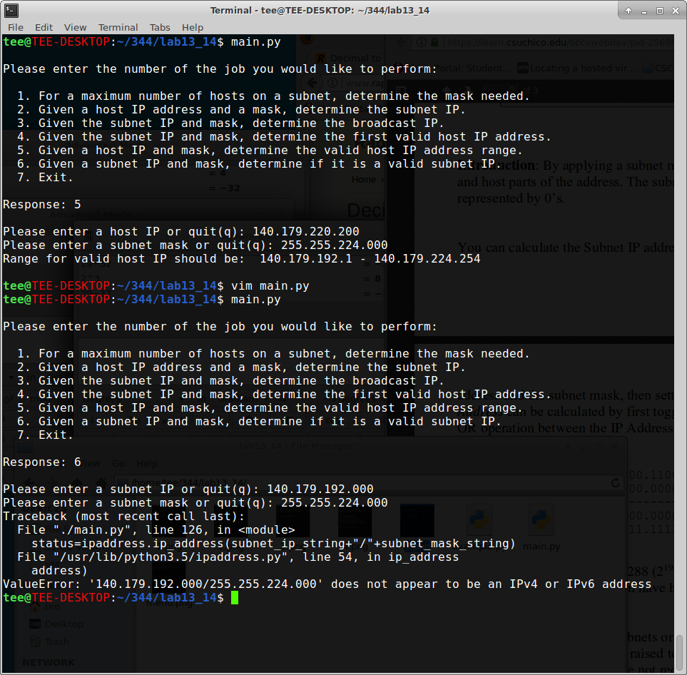

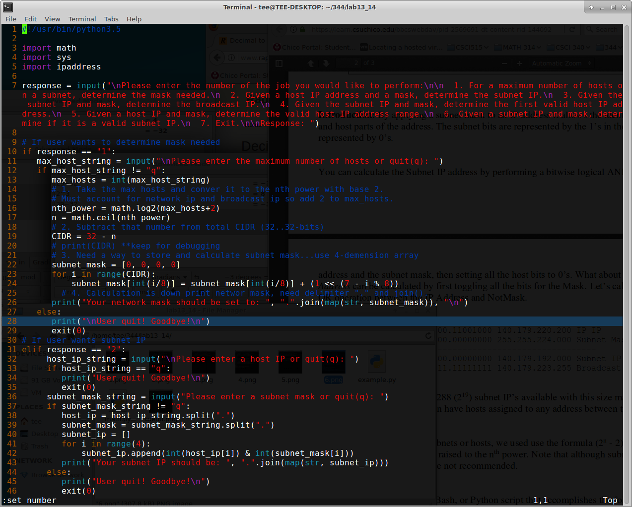

Line 7 is where I do all the asking user for input. I’ve decided to make a menu for the operations that users may want to render. On line 10 – 29 is where I do the determination of mask needed based on a subset. I use CIDR and some logical operations to get through, on lines 31 – 47 is where I execute the functionality for finding the broadcast IP

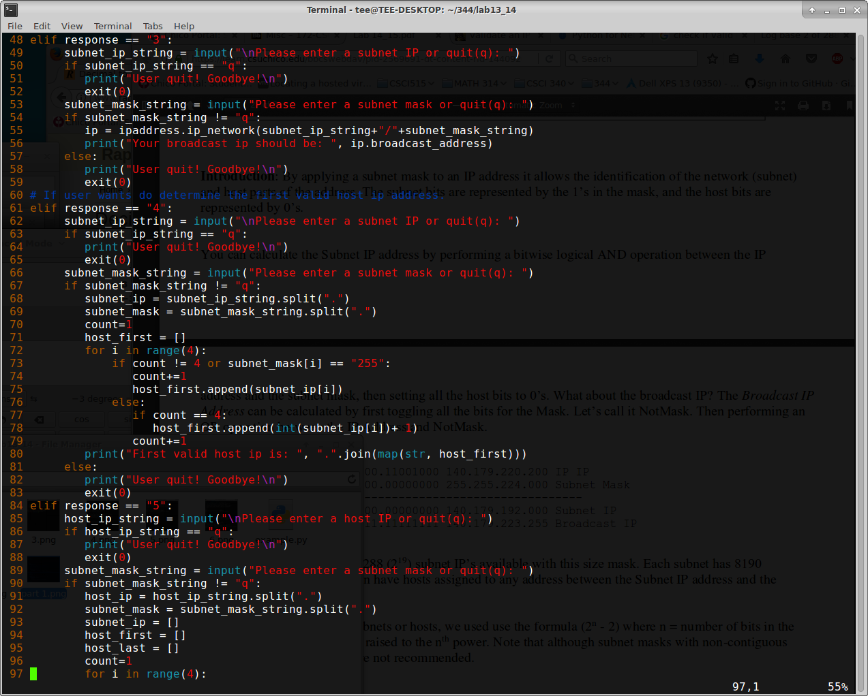
And the rest just follow suits. On the execution for number 4 was quite confusing at first. However I used some loop and knowledge that I read from my online researches and it seems to be not that hard now. What I had to do for the first one to just getting the subnet and the first valid host will always be after that one. The ending part was the tricky part. But after numerous of research, I finally was able to solve the riddle by nesting the loop functions.

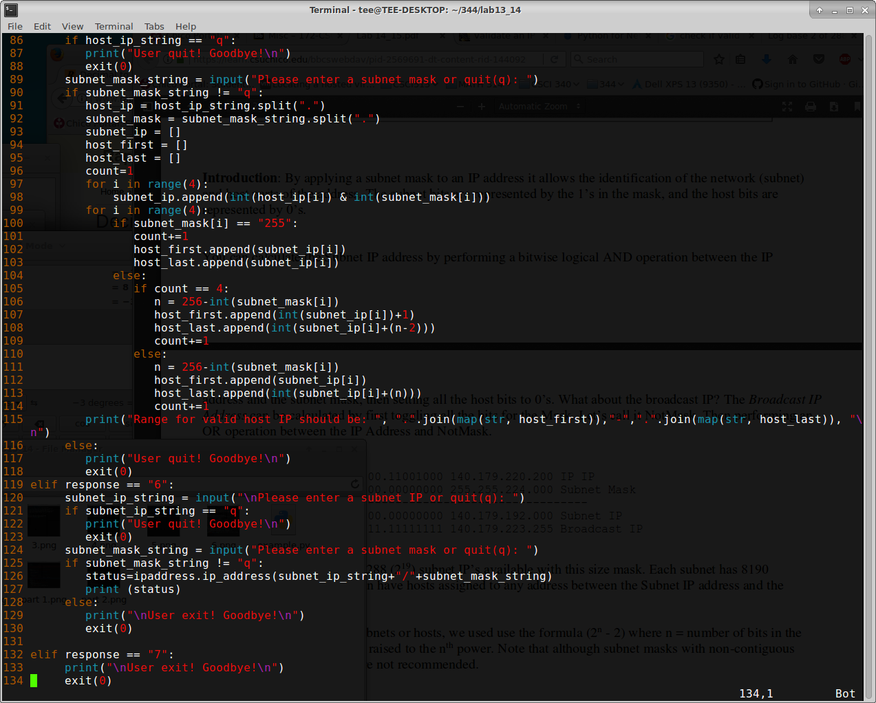
In conclusion:
Athough this lab was difficult at first, doing some research really helped pave the road. I got to learn a lot about IP addresses and its components. I am glad that we had this lab .

