AI Data Classification Using Machine Learning
Project 2: Data Classification Using AI
Submitted By:
Name: Avula Bhavani
Internship: Artificial Intelligence Internship
Batch: 2026
1. Objective
The objective of this project is to build a machine learning classification model that can classify data into different categories using supervised learning techniques.
2. Problem Statement
Develop a classification model using a dataset, split the data into training and testing sets, train the model, and evaluate its performance using accuracy metrics.
3. Tools and Technologies Used
- Python 3
- Scikit-learn
- Visual Studio Code
- GitHub
4. Project Description
Data Classification is a supervised machine learning technique used to predict the category of new data based on previously learned patterns.
In this project, the Iris Dataset is used to train a Decision Tree Classification model. The model learns from training data and predicts flower categories based on input features.
5. Dataset Information
Dataset Name: Iris Dataset
Total Samples: 150
Features:
- Sepal Length
- Sepal Width
- Petal Length
- Petal Width
Target Classes:
- Setosa
- Versicolor
- Virginica
6. Algorithm
- Import required libraries.
- Load the Iris dataset.
- Separate features and target values.
- Split dataset into training and testing sets.
- Create a Decision Tree Classifier.
- Train the model using training data.
- Predict results using testing data.
- Calculate model accuracy.
- Display predictions and classification report.
- Accept user input for custom prediction.
7. Source Code
from sklearn.datasets import load_iris
from sklearn.model_selection import train_test_split
from sklearn.tree import DecisionTreeClassifier
from sklearn.metrics import accuracy_score, classification_report
print("=" * 60)
print(" AI DATA CLASSIFICATION USING MACHINE LEARNING")
print("=" * 60)
# Load Iris Dataset
iris = load_iris()
X = iris.data
y = iris.target
# Dataset Information
print("\nDATASET INFORMATION")
print("-" * 60)
print("Dataset Name : Iris Dataset")
print("Total Samples :", len(X))
print("Total Features :", len(iris.feature_names))
print("Total Classes :", len(iris.target_names))
print("\nFeature Names:")
for feature in iris.feature_names:
print("•", feature)
print("\nTarget Classes:")
for index, flower in enumerate(iris.target_names):
print(f"• Class {index}: {flower}")
# Split Dataset
X_train, X_test, y_train, y_test = train_test_split(
X,y,
test_size=0.20,
random_state=42
)
print("\n" + "=" * 60)
print("DATA SPLITTING")
print("=" * 60)
print("Training Samples :", len(X_train))
print("Testing Samples :", len(X_test))
# Create Classification Model
model = DecisionTreeClassifier(random_state=42)
# Train Model
model.fit(X_train, y_train)
print("\nModel Training Completed Successfully!")
# Make Predictions
predictions = model.predict(X_test)
# Calculate Accuracy
accuracy = accuracy_score(y_test, predictions)
print("\n" + "=" * 60)
print("MODEL PERFORMANCE")
print("=" * 60)
print(f"Accuracy Score : {accuracy * 100:.2f}%")
# Show Sample Predictions
print("\n" + "=" * 60)
print("SAMPLE PREDICTIONS")
print("=" * 60)
for i in range(10):
actual_flower = iris.target_names[y_test[i]]
predicted_flower = iris.target_names[predictions[i]]
print(f"\nSample {i + 1}")
print(f"Actual Flower : {actual_flower}")
print(f"Predicted Flower : {predicted_flower}")
# Classification Report
print("\n" + "=" * 60)
print("CLASSIFICATION REPORT")
print("=" * 60)
print(classification_report(
y_test,
predictions,
target_names=iris.target_names
)
)
# User Testing Section
print("\n" + "=" * 60)
print("CUSTOM FLOWER PREDICTION")
print("=" * 60)
print("\nEnter Flower Measurements:")
sepal_length = float(input("Sepal Length (cm): "))
sepal_width = float(input("Sepal Width (cm): "))
petal_length = float(input("Petal Length (cm): "))
petal_width = float(input("Petal Width (cm): "))
user_data = [[
sepal_length,
sepal_width,
petal_length,
petal_width
]]
prediction = model.predict(user_data)
flower_name = iris.target_names[prediction[0]]
print("\nPredicted Flower Type :", flower_name)
print("\n" + "=" * 60)
print("PROJECT COMPLETED SUCCESSFULLY")
print("=" * 60)
8. Output Screenshots
Screenshot 1: Dataset Information
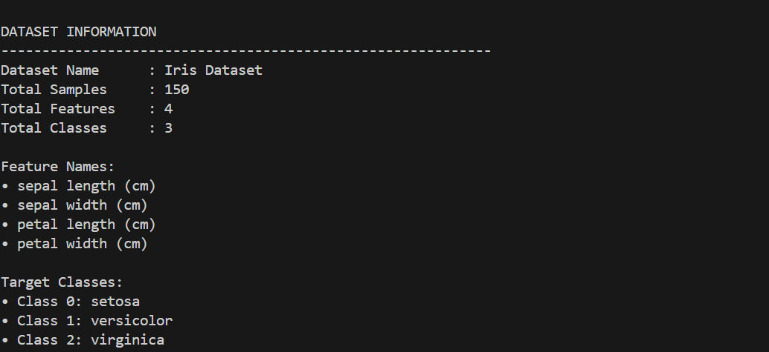
Screenshot 2: Training and Testing Split
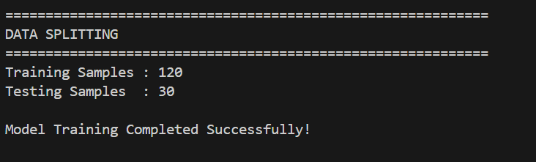
Screenshot 3: Model Accuracy
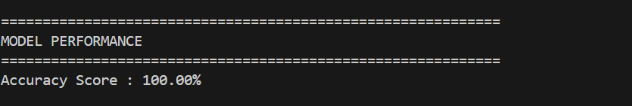
Screenshot 4: Sample Predictions
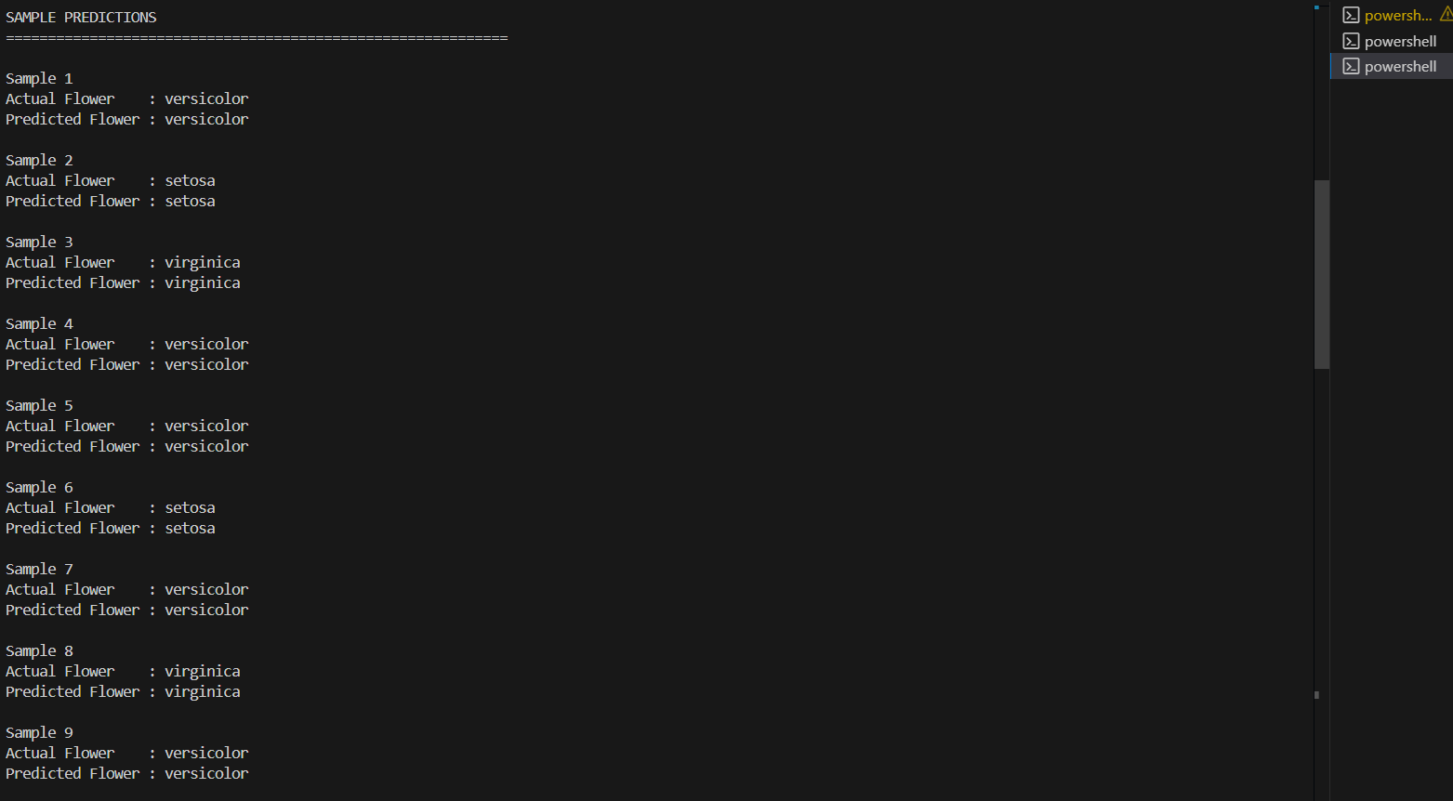
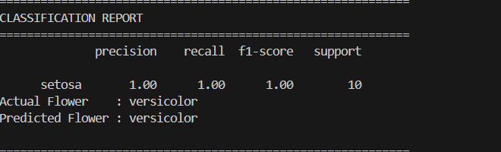
Screenshot 5: Custom Flower Prediction
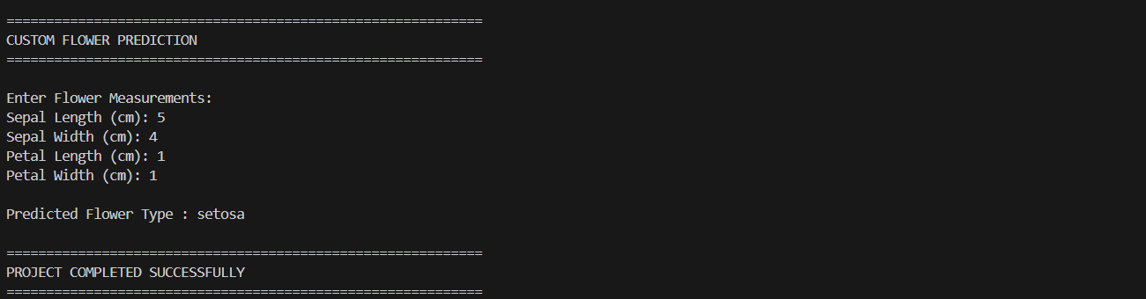

9. Features
- Dataset Loading
- Data Analysis
- Training and Testing Split
- Decision Tree Classification
- Prediction System
- Accuracy Evaluation
- Classification Report
- User Input Prediction
10. Result
The classification model was successfully trained using the Iris Dataset. The model accurately classified flower species and achieved a high accuracy score on the testing dataset.
11. Conclusion
This project demonstrates the fundamentals of supervised machine learning and data classification. The Decision Tree Classifier successfully learned patterns from the dataset and predicted flower categories accurately. The project helped in understanding data handling, model training, testing, and performance evaluation in Artificial Intelligence.

