**Name : Hemalatha Reddy Avula**

**Email :** [**avulahemalatha1202@gmail.com**](mailto:avulahemalatha1202@gmail.com)

**Phone No : 6305733179**

**Roll No : 20NN1A1201**

**College Name : Vignan’s Nirula Institute of Technology and Science for Women**

**Source Code :**

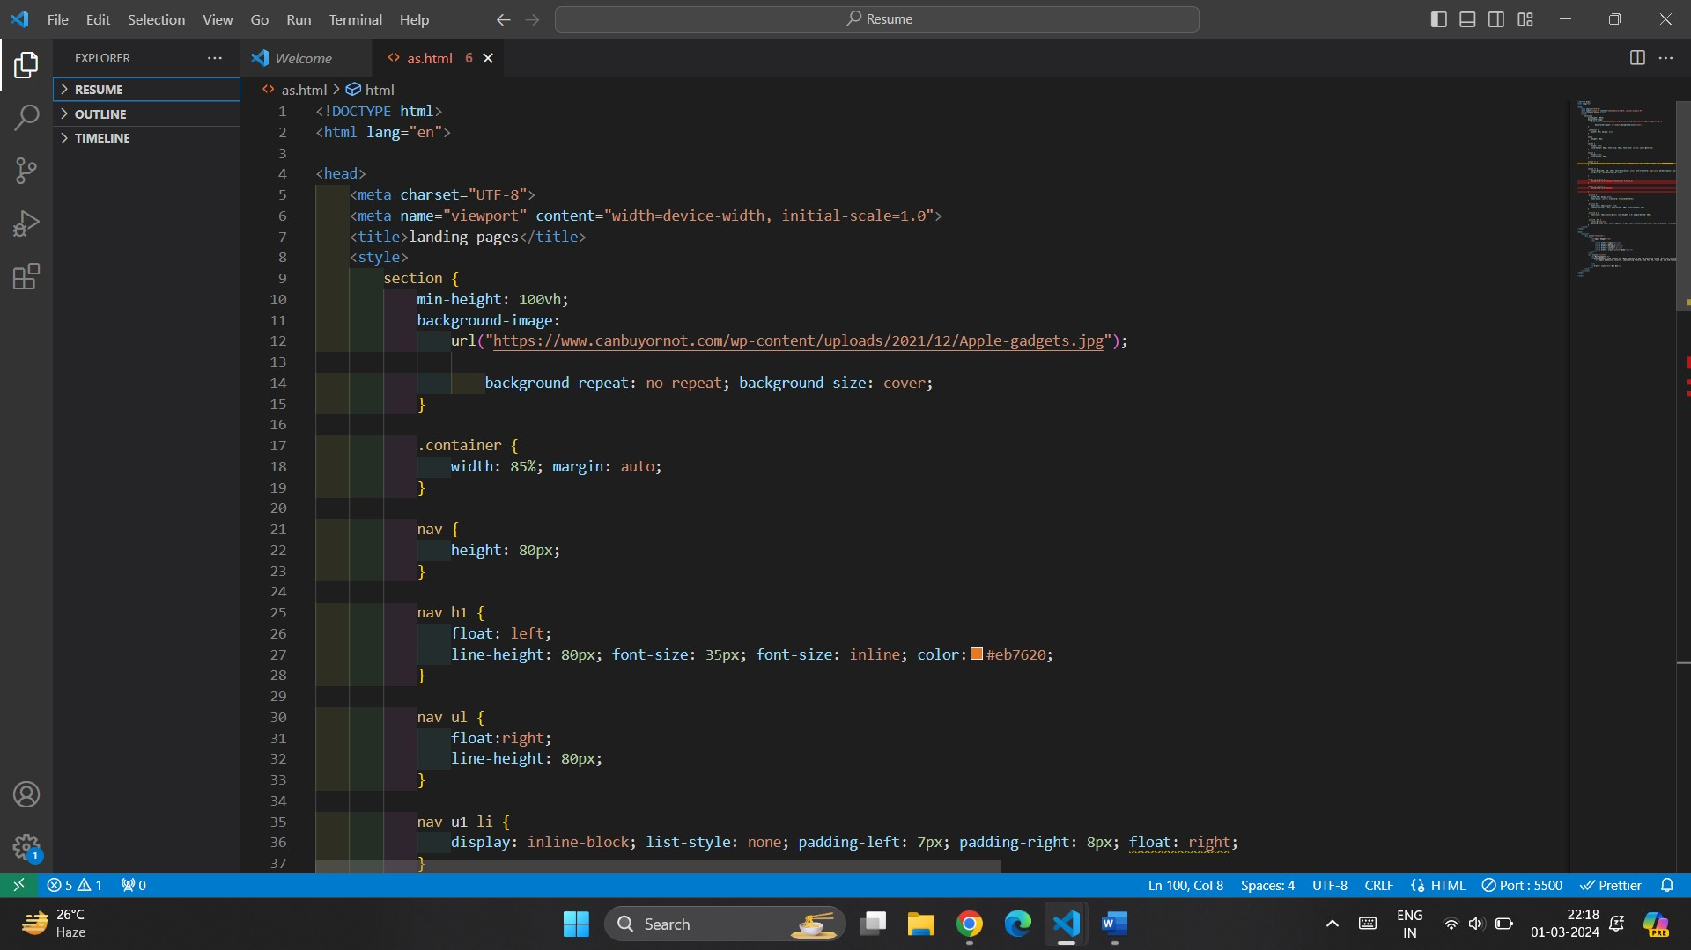

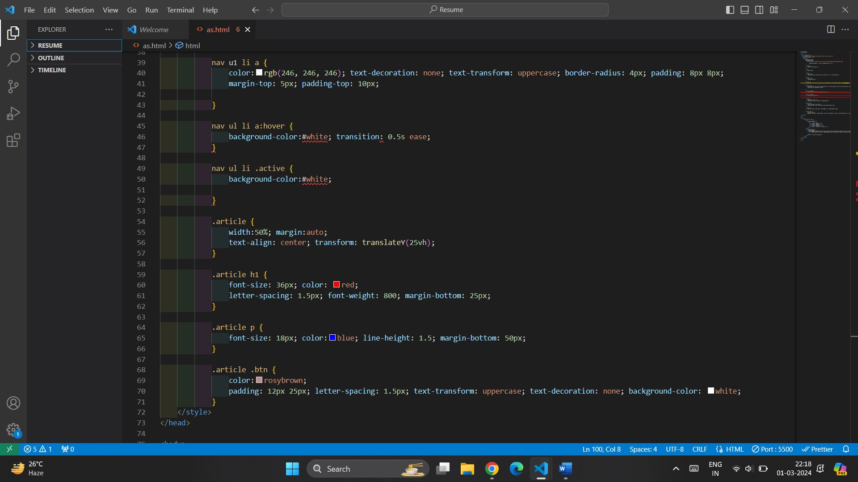

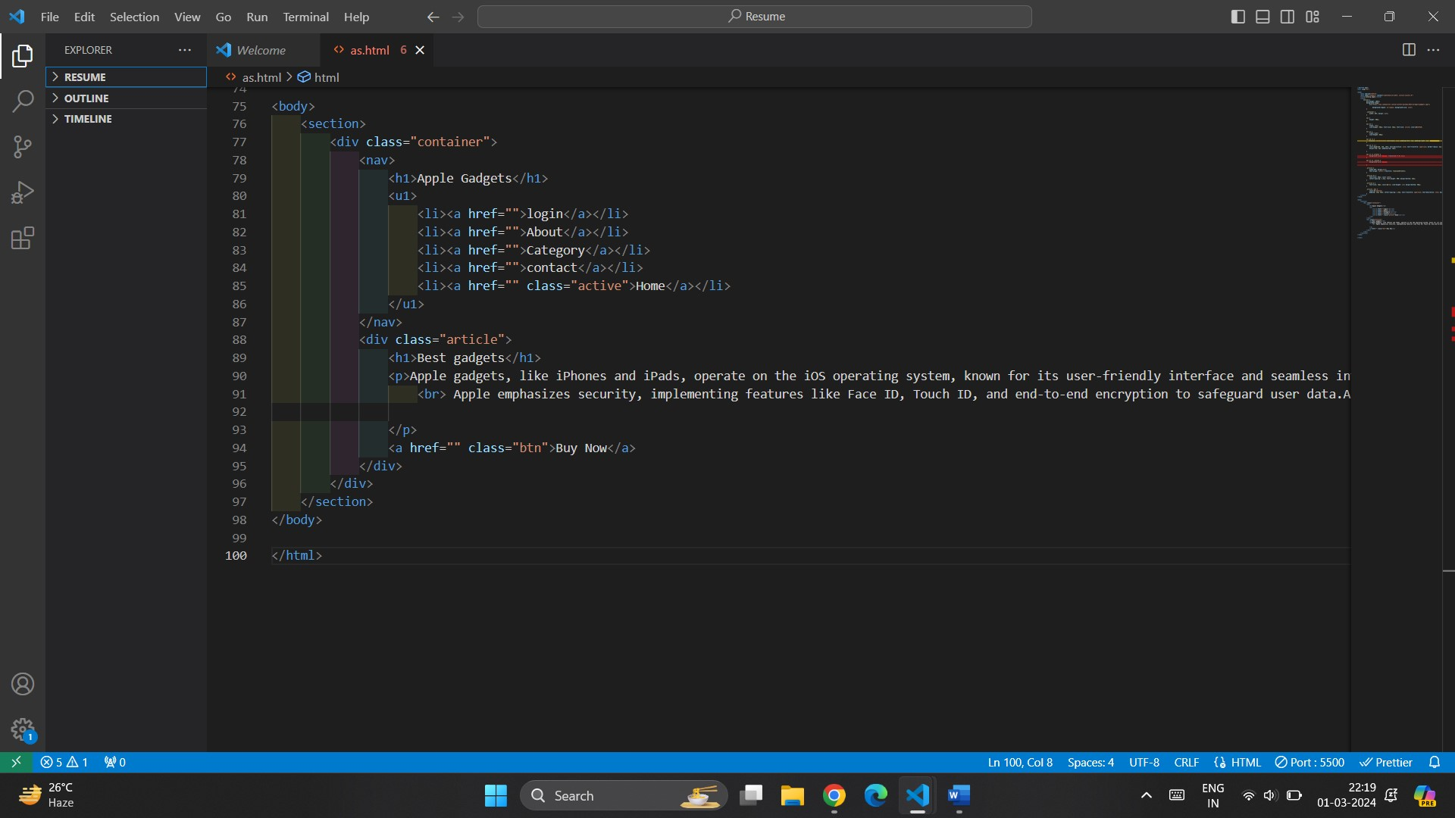

**OUTPUT:**

