1. Write a program to read the *stock_price.csv* file and perform the following operations:

* Convert *Price* to a numeric value (example: *1.02K = 1020*)
* Display the names of the two companies – one whose stock value is maximum and the other whose stock value is minimum.
* Display the names of the companies whose stock value is within the price range that is input by the user.

1. Write a program to read the data from the file *stock_price.xlsx,* select the columns (*Name, Symbol, Last, Market Cap*) and write the data of these columns into another excel file with title *out_stock_price.xlsx*.
2. Write a program to read the file *Result.xlsx* which has the following information about students:
   1. USN
   2. NAME
   3. Subject information: INTERNAL, EXTERNAL (scores)
   4. TOTAL
   5. Grade
   6. Credit of each subject

Find the SGPA of each student using the following formula:

SGPA (Si) = Σ(Ci x Gi) / Σci

where Ci is the number of credits of the ith course and Gi is the Grade Point scored by the student in that ith course. The table below displays the method to calculate the Grade Point.

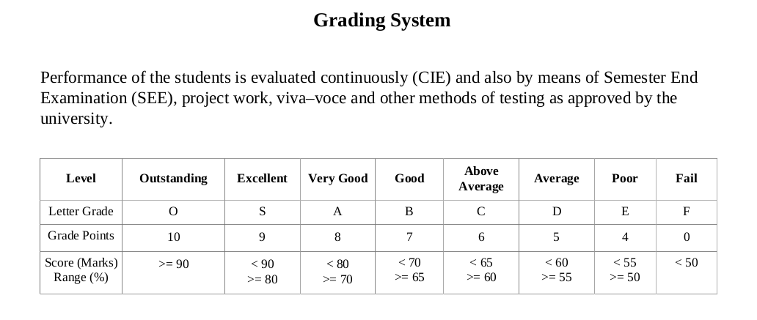

Finally, display the following information: USN, NAME, SCGP of all the students.

1. Write a program to read data from the file *story.txt* and determine the following:

* Total number of words in the file
* The word that occurs maximum number of times
* The number of conjunctions of various types (example: and, but, if)