Stat_fp_red.R

pravallikaavula

2022-12-08

library(tidyverse)

## ── Attaching packages ─────────────────────────────────────── tidyverse 1.3.2 ──  
## ✔ ggplot2 3.4.0 ✔ purrr 0.3.5   
## ✔ tibble 3.1.8 ✔ dplyr 1.0.10  
## ✔ tidyr 1.2.1 ✔ stringr 1.4.1   
## ✔ readr 2.1.3 ✔ forcats 0.5.2   
## ── Conflicts ────────────────────────────────────────── tidyverse_conflicts() ──  
## ✖ dplyr::filter() masks stats::filter()  
## ✖ dplyr::lag() masks stats::lag()

library(dplyr)  
library(GGally)

## Registered S3 method overwritten by 'GGally':  
## method from   
## +.gg ggplot2

library(corrplot)

## corrplot 0.92 loaded

library(rpart)  
library(rpart.plot)  
library(DMwR2) # Contains rt.prune

## Registered S3 method overwritten by 'quantmod':  
## method from  
## as.zoo.data.frame zoo

library(ISLR)   
library(MASS)

##   
## Attaching package: 'MASS'  
##   
## The following object is masked from 'package:dplyr':  
##   
## select

library(randomForest)

## randomForest 4.7-1.1  
## Type rfNews() to see new features/changes/bug fixes.  
##   
## Attaching package: 'randomForest'  
##   
## The following object is masked from 'package:dplyr':  
##   
## combine  
##   
## The following object is masked from 'package:ggplot2':  
##   
## margin

library(cluster) # clustering algorithms  
library(factoextra) # clustering algorithms & visualization

## Welcome! Want to learn more? See two factoextra-related books at https://goo.gl/ve3WBa

library(maditr)

##   
## To aggregate data: take(mtcars, mean_mpg = mean(mpg), by = am)  
##   
##   
## Attaching package: 'maditr'  
##   
## The following objects are masked from 'package:dplyr':  
##   
## between, coalesce, first, last  
##   
## The following object is masked from 'package:purrr':  
##   
## transpose  
##   
## The following object is masked from 'package:readr':  
##   
## cols

library(ggpubr)  
library(Metrics)  
library(glmnet)

## Loading required package: Matrix  
##   
## Attaching package: 'Matrix'  
##   
## The following objects are masked from 'package:tidyr':  
##   
## expand, pack, unpack  
##   
## Loaded glmnet 4.1-4

library(mlbench)  
library(caret) # use createDataPartition() function

## Loading required package: lattice  
##   
## Attaching package: 'caret'  
##   
## The following objects are masked from 'package:Metrics':  
##   
## precision, recall  
##   
## The following object is masked from 'package:purrr':  
##   
## lift

library(gridExtra)

##   
## Attaching package: 'gridExtra'  
##   
## The following object is masked from 'package:randomForest':  
##   
## combine  
##   
## The following object is masked from 'package:dplyr':  
##   
## combine

#Data reading  
red_df <- read.csv(file = "winequality-red.csv", as.is = TRUE,sep = ";", header = TRUE)  
head(red_df)

## fixed.acidity volatile.acidity citric.acid residual.sugar chlorides  
## 1 7.4 0.70 0.00 1.9 0.076  
## 2 7.8 0.88 0.00 2.6 0.098  
## 3 7.8 0.76 0.04 2.3 0.092  
## 4 11.2 0.28 0.56 1.9 0.075  
## 5 7.4 0.70 0.00 1.9 0.076  
## 6 7.4 0.66 0.00 1.8 0.075  
## free.sulfur.dioxide total.sulfur.dioxide density pH sulphates alcohol  
## 1 11 34 0.9978 3.51 0.56 9.4  
## 2 25 67 0.9968 3.20 0.68 9.8  
## 3 15 54 0.9970 3.26 0.65 9.8  
## 4 17 60 0.9980 3.16 0.58 9.8  
## 5 11 34 0.9978 3.51 0.56 9.4  
## 6 13 40 0.9978 3.51 0.56 9.4  
## quality  
## 1 5  
## 2 5  
## 3 5  
## 4 6  
## 5 5  
## 6 5

dim(red_df)

## [1] 1599 12

#Data overview  
str(red_df)

## 'data.frame': 1599 obs. of 12 variables:  
## $ fixed.acidity : num 7.4 7.8 7.8 11.2 7.4 7.4 7.9 7.3 7.8 7.5 ...  
## $ volatile.acidity : num 0.7 0.88 0.76 0.28 0.7 0.66 0.6 0.65 0.58 0.5 ...  
## $ citric.acid : num 0 0 0.04 0.56 0 0 0.06 0 0.02 0.36 ...  
## $ residual.sugar : num 1.9 2.6 2.3 1.9 1.9 1.8 1.6 1.2 2 6.1 ...  
## $ chlorides : num 0.076 0.098 0.092 0.075 0.076 0.075 0.069 0.065 0.073 0.071 ...  
## $ free.sulfur.dioxide : num 11 25 15 17 11 13 15 15 9 17 ...  
## $ total.sulfur.dioxide: num 34 67 54 60 34 40 59 21 18 102 ...  
## $ density : num 0.998 0.997 0.997 0.998 0.998 ...  
## $ pH : num 3.51 3.2 3.26 3.16 3.51 3.51 3.3 3.39 3.36 3.35 ...  
## $ sulphates : num 0.56 0.68 0.65 0.58 0.56 0.56 0.46 0.47 0.57 0.8 ...  
## $ alcohol : num 9.4 9.8 9.8 9.8 9.4 9.4 9.4 10 9.5 10.5 ...  
## $ quality : int 5 5 5 6 5 5 5 7 7 5 ...

summary(red_df)

## fixed.acidity volatile.acidity citric.acid residual.sugar   
## Min. : 4.60 Min. :0.1200 Min. :0.000 Min. : 0.900   
## 1st Qu.: 7.10 1st Qu.:0.3900 1st Qu.:0.090 1st Qu.: 1.900   
## Median : 7.90 Median :0.5200 Median :0.260 Median : 2.200   
## Mean : 8.32 Mean :0.5278 Mean :0.271 Mean : 2.539   
## 3rd Qu.: 9.20 3rd Qu.:0.6400 3rd Qu.:0.420 3rd Qu.: 2.600   
## Max. :15.90 Max. :1.5800 Max. :1.000 Max. :15.500   
## chlorides free.sulfur.dioxide total.sulfur.dioxide density   
## Min. :0.01200 Min. : 1.00 Min. : 6.00 Min. :0.9901   
## 1st Qu.:0.07000 1st Qu.: 7.00 1st Qu.: 22.00 1st Qu.:0.9956   
## Median :0.07900 Median :14.00 Median : 38.00 Median :0.9968   
## Mean :0.08747 Mean :15.87 Mean : 46.47 Mean :0.9967   
## 3rd Qu.:0.09000 3rd Qu.:21.00 3rd Qu.: 62.00 3rd Qu.:0.9978   
## Max. :0.61100 Max. :72.00 Max. :289.00 Max. :1.0037   
## pH sulphates alcohol quality   
## Min. :2.740 Min. :0.3300 Min. : 8.40 Min. :3.000   
## 1st Qu.:3.210 1st Qu.:0.5500 1st Qu.: 9.50 1st Qu.:5.000   
## Median :3.310 Median :0.6200 Median :10.20 Median :6.000   
## Mean :3.311 Mean :0.6581 Mean :10.42 Mean :5.636   
## 3rd Qu.:3.400 3rd Qu.:0.7300 3rd Qu.:11.10 3rd Qu.:6.000   
## Max. :4.010 Max. :2.0000 Max. :14.90 Max. :8.000

#Checking missing values  
which(is.na(red_df))

## integer(0)

colSums(is.na(red_df))

## fixed.acidity volatile.acidity citric.acid   
## 0 0 0   
## residual.sugar chlorides free.sulfur.dioxide   
## 0 0 0   
## total.sulfur.dioxide density pH   
## 0 0 0   
## sulphates alcohol quality   
## 0 0 0

#Build correlation and order by decreasing  
set.seed(123)  
  
red_dfcor <- cor(red_df)  
corrplot(red_dfcor, method = "color", addCoef.col = "black",number.cex = .6,  
 tl.col = "black", tl.srt = 90, diag = FALSE)

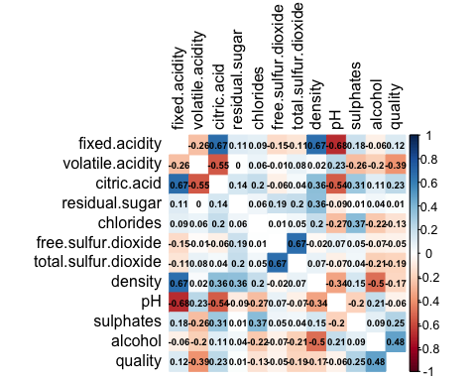

#Build correlation atts with Quality variable  
dfcor <- cor(red_df)  
quality_cor <- dfcor[,12]  
absoutcome_cor <- abs(quality_cor)  
head(absoutcome_cor[order(absoutcome_cor, decreasing = TRUE)],12)

## quality alcohol volatile.acidity   
## 1.00000000 0.47616632 0.39055778   
## sulphates citric.acid total.sulfur.dioxide   
## 0.25139708 0.22637251 0.18510029   
## density chlorides fixed.acidity   
## 0.17491923 0.12890656 0.12405165   
## pH free.sulfur.dioxide residual.sugar   
## 0.05773139 0.05065606 0.01373164

#Analysing the overall quality  
ggplot(red_df, aes(quality))+   
 geom_histogram() +   
 labs(title = "Histogram of quality of Red wine") +   
 theme(plot.title=element_text(hjust=0.5)) +  
 geom_vline(aes(xintercept=mean(quality)), color="blue", linetype="dashed", size=1) +  
 geom_text(aes(x=5.6, label="Mean Value", y=400), colour="red", angle=90, vjust = 1.2)

## Warning: Using `size` aesthetic for lines was deprecated in ggplot2 3.4.0.  
## ℹ Please use `linewidth` instead.

## `stat_bin()` using `bins = 30`. Pick better value with `binwidth`.

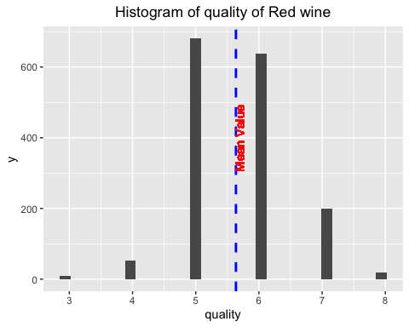

mean(red_df$quality)

## [1] 5.636023

#Plotting the marginal distributions of numerical quantities of interest using density plots  
  
d0 <- ggplot(red_df, aes(x=quality)) +   
 geom_density()  
d0 <- d0 + geom_vline(aes(xintercept=mean(quality)),  
 color="blue", linetype="dashed")  
d1 <- ggplot(red_df, aes(x=fixed.acidity)) +   
 geom_density()  
d1 <- d1 + geom_vline(aes(xintercept=mean(fixed.acidity)),  
 color="blue", linetype="dashed")  
d2 <- ggplot(red_df, aes(x=volatile.acidity)) +   
 geom_density()  
d2 <- d2 + geom_vline(aes(xintercept=mean(volatile.acidity)),  
 color="blue", linetype="dashed")  
d3 <- ggplot(red_df, aes(x=citric.acid)) +   
 geom_density()  
d3 <- d3 + geom_vline(aes(xintercept=mean(citric.acid)),  
 color="blue", linetype="dashed")  
d4 <- ggplot(red_df, aes(x=residual.sugar)) +   
 geom_density()  
d4 <- d4 + geom_vline(aes(xintercept=mean(residual.sugar)),  
 color="blue", linetype="dashed")  
d5 <- ggplot(red_df, aes(x=chlorides)) +   
 geom_density()  
d5 <- d5 + geom_vline(aes(xintercept=mean(chlorides)),  
 color="blue", linetype="dashed")  
d6 <- ggplot(red_df, aes(x=free.sulfur.dioxide)) +   
 geom_density()  
d6 <- d6 + geom_vline(aes(xintercept=mean(free.sulfur.dioxide)),  
 color="blue", linetype="dashed")  
d7 <- ggplot(red_df, aes(x=total.sulfur.dioxide)) +   
 geom_density()  
d7 <- d7 + geom_vline(aes(xintercept=mean(total.sulfur.dioxide)),  
 color="blue", linetype="dashed")  
d8 <- ggplot(red_df, aes(x=density)) +   
 geom_density()  
d8 <- d8 + geom_vline(aes(xintercept=mean(density)),  
 color="blue", linetype="dashed")  
d9 <- ggplot(red_df, aes(x=pH)) +   
 geom_density()  
d9 <- d9 + geom_vline(aes(xintercept=mean(pH)),  
 color="blue", linetype="dashed")  
d10 <- ggplot(red_df, aes(x=sulphates)) +   
 geom_density()  
d10 <- d10 + geom_vline(aes(xintercept=mean(sulphates)),  
 color="blue", linetype="dashed")  
d11 <- ggplot(red_df, aes(x=alcohol)) +   
 geom_density()  
d11 <- d11 + geom_vline(aes(xintercept=mean(alcohol)),  
 color="blue", linetype="dashed")  
ggarrange(d0, d1, d2, d3, nrow = 2, ncol =2)

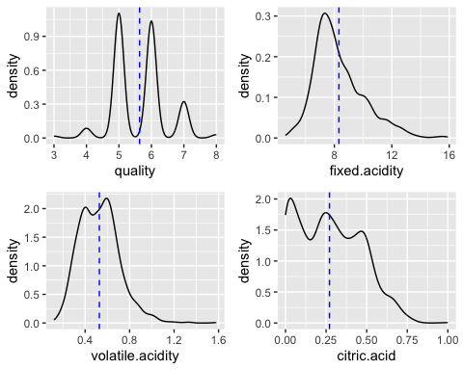

ggarrange(d4, d5, d6, d7, nrow = 2, ncol =2)

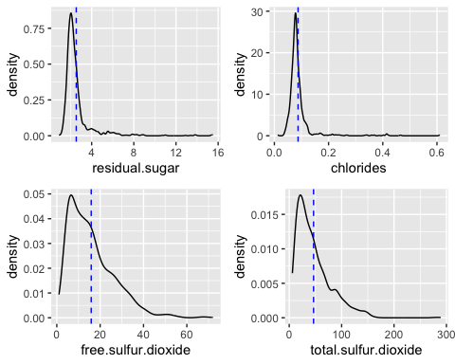

ggarrange(d8, d9, d10, d11, nrow = 2, ncol =2)

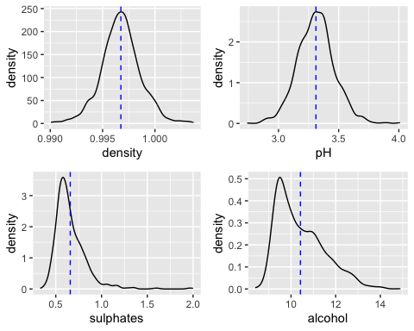

#Plotting the marginal distributions of numerical quantities of interest using box plots  
b1 <- boxplot(red_df$fixed.acidity, col="slategray2", pch=20)

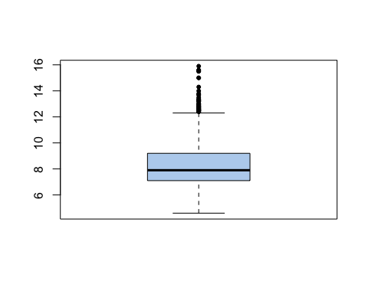

b2 <- boxplot(red_df$volatile.acidity, col="slategray2", pch=20)

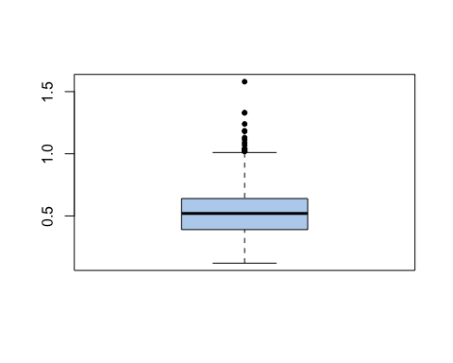

b3 <- boxplot(red_df$citric.acid, col="slategray2", pch=20)

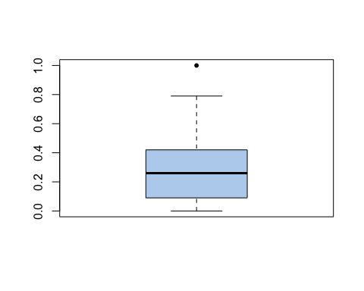

b4 <- boxplot(red_df$residual.sugar, col="slategray2", pch=20)

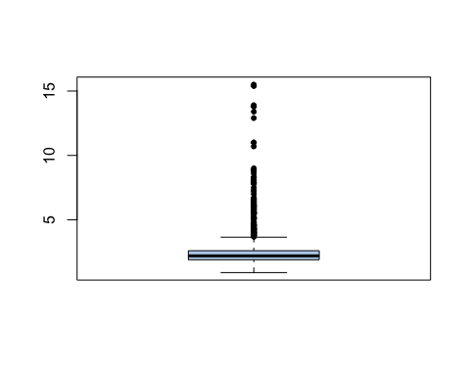

b5 <- boxplot(red_df$chlorides, col="slategray2", pch=20)

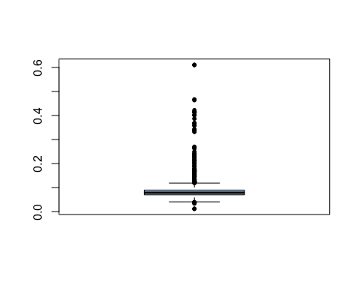

b6 <- boxplot(red_df$free.sulfur.dioxide, col="slategray2", pch=20)

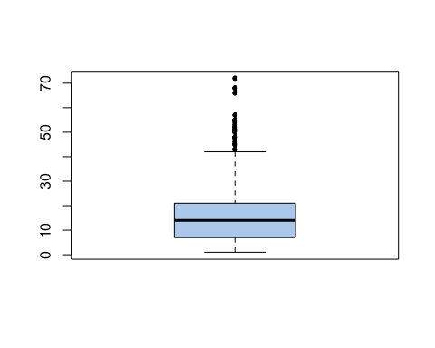

b7 <- boxplot(red_df$total.sulfur.dioxide, col="slategray2", pch=20)

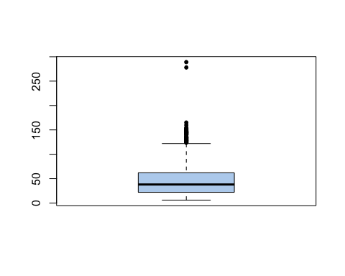

b8 <- boxplot(red_df$density, col="slategray2", pch=20)

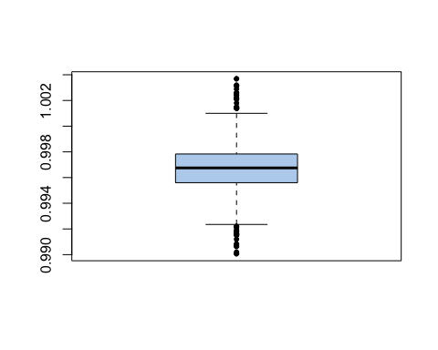

b9 <- boxplot(red_df$pH, col="slategray2", pch=20)

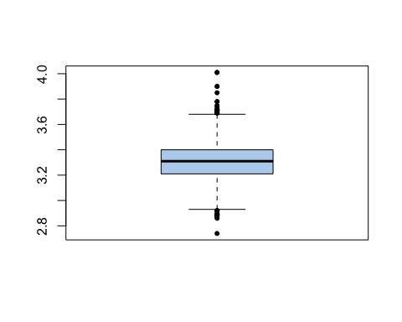

b10 <- boxplot(red_df$sulphates, col="slategray2", pch=20)

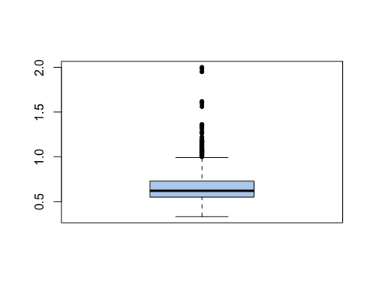

b11 <- boxplot(red_df$alcohol, col="slategray2", pch=20)

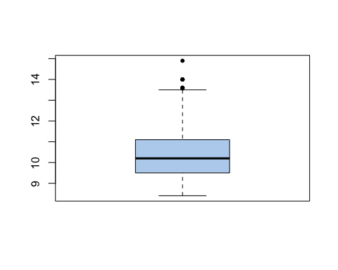

b12 <- boxplot(red_df$quality, col="slategray2", pch=20)

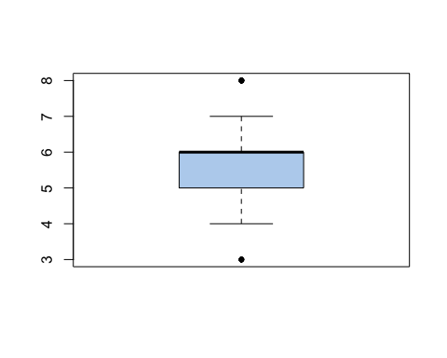

#Plotting quality against numerical variables  
bp1 <- ggplot(red_df, aes(factor(quality), fixed.acidity, fill=factor(quality))) +   
 geom_boxplot() +  
 labs(x = "quality", y = "fixed.acidity", title = "Boxplot of Quality vs. fixed.acidity") +   
 theme(legend.position = 'none', plot.title = element_text(size = 10, hjust=0.5))  
bp1

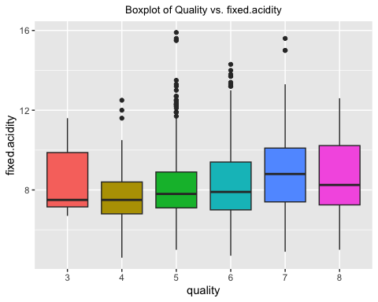

bp2 <- ggplot(red_df, aes(factor(quality), volatile.acidity, fill=factor(quality))) +   
 geom_boxplot() +  
 labs(x = "quality", y = "volatile.acidity", title = "Boxplot of Quality vs. volatile.acidity") +   
 theme(legend.position = 'none', plot.title = element_text(size = 10, hjust=0.5))  
bp2

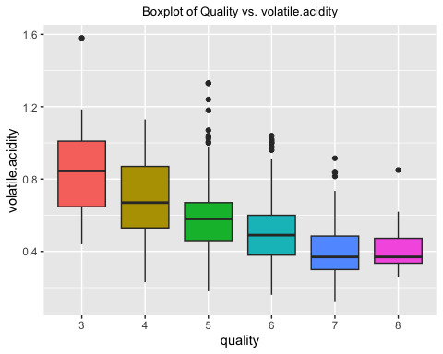

bp3 <- ggplot(red_df, aes(factor(quality), citric.acid, fill=factor(quality))) +   
 geom_boxplot() +  
 labs(x = "quality", y = "citric.acid", title = "Boxplot of Quality vs. citric.acid") +   
 theme(legend.position = 'none', plot.title = element_text(size = 10, hjust=0.5))  
bp3

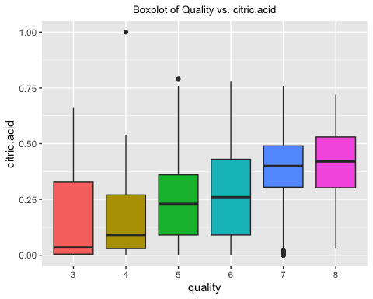

bp4 <- ggplot(red_df, aes(factor(quality), residual.sugar, fill=factor(quality))) +   
 geom_boxplot() +  
 labs(x = "quality", y = "residual.sugar", title = "Boxplot of Quality vs. residual.sugar") +   
 theme(legend.position = 'none', plot.title = element_text(size = 10, hjust=0.5))  
bp4

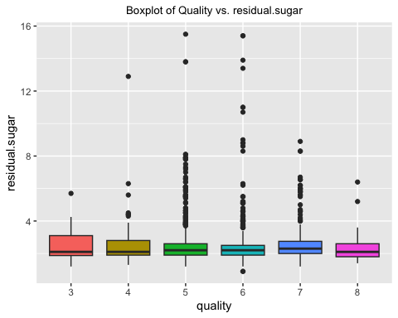

ggarrange(bp1, bp2, bp3, bp4, nrow = 2, ncol =2)

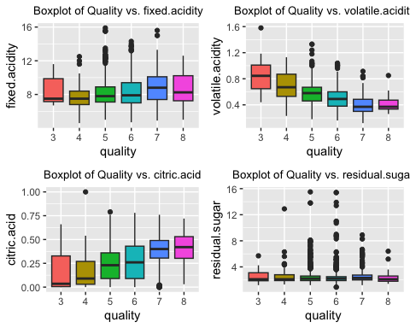

bp5 <- ggplot(red_df, aes(factor(quality), chlorides, fill=factor(quality))) +   
 geom_boxplot() +  
 labs(x = "Quality", y = "chlorides", title = "Boxplot of Quality vs. chlorides") +   
 theme(legend.position = 'none', plot.title = element_text(size = 10, hjust=0.5))  
bp5

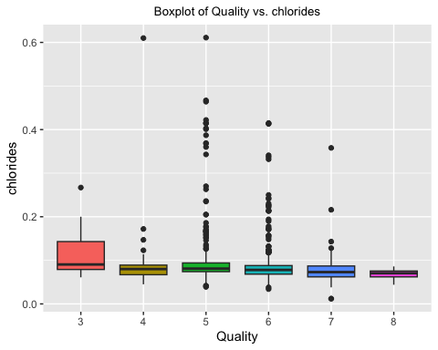

bp6 <- ggplot(red_df, aes(factor(quality), free.sulfur.dioxide, fill=factor(quality))) +   
 geom_boxplot() +  
 labs(x = "quality", y = "free.sulfur.dioxide", title = "Boxplot of quality vs. free.sulfur.dioxide") +   
 theme(legend.position = 'none', plot.title = element_text(size = 10, hjust=0.5))  
bp6

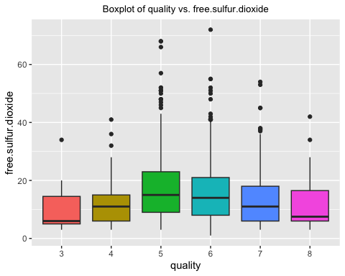

bp7 <- ggplot(red_df, aes(factor(quality), total.sulfur.dioxide, fill=factor(quality))) +   
 geom_boxplot() +  
 labs(x = "quality", y = "total.sulfur.dioxide", title = "Boxplot of quality vs. total.sulfur.dioxide") +   
 theme(legend.position = 'none', plot.title = element_text(size = 10, hjust=0.5))  
bp7

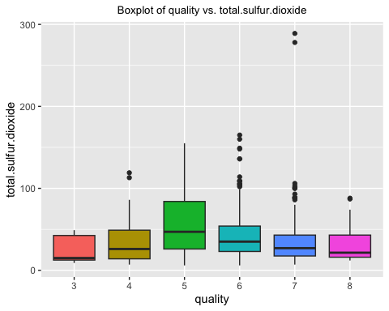

bp8 <- ggplot(red_df, aes(factor(quality), density, fill=factor(quality))) +   
 geom_boxplot() +  
 labs(x = "quality", y = "density", title = "Boxplot of quality vs. density") +   
 theme(legend.position = 'none', plot.title = element_text(size = 10, hjust=0.5))  
bp8

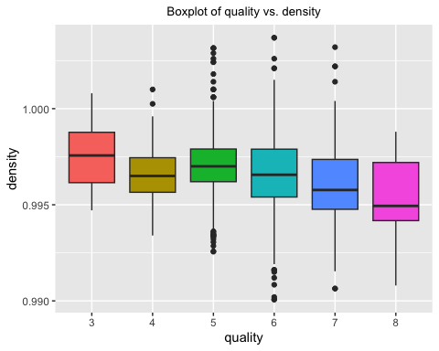

ggarrange(bp5, bp6, bp7, bp8, nrow = 2, ncol =2)

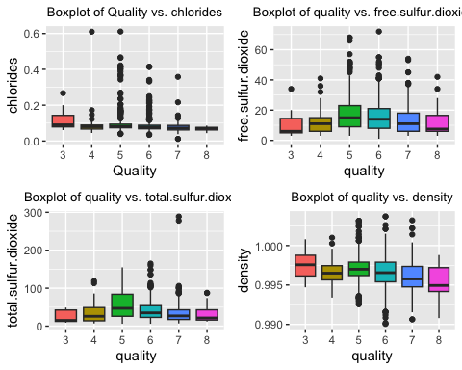

bp9 <- ggplot(red_df, aes(factor(quality), pH, fill=factor(quality))) +   
 geom_boxplot() +  
 labs(x = "quality", y = "pH", title = "Boxplot of Quality vs. pH") +   
 theme(legend.position = 'none', plot.title = element_text(size = 10, hjust=0.5))  
bp9

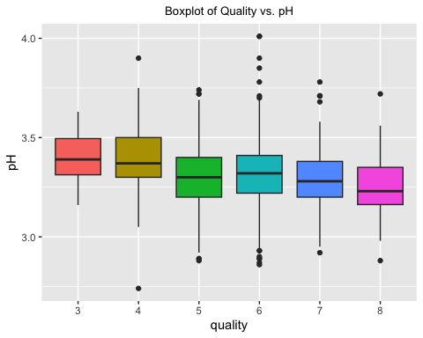

bp10 <- ggplot(red_df, aes(factor(quality), sulphates, fill=factor(quality))) +   
 geom_boxplot() +  
 labs(x = "quality", y = "sulphates", title = "Boxplot of quality vs. sulphates") +   
 theme(legend.position = 'none', plot.title = element_text(size = 10, hjust=0.5))  
bp10

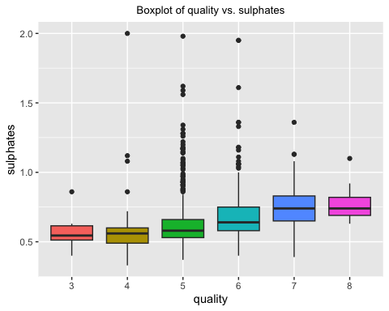

bp11 <- ggplot(red_df, aes(factor(quality), alcohol, fill=factor(quality))) +   
 geom_boxplot() +  
 labs(x = "quality", y = "alcohol", title = "Boxplot of quality vs. alcohol") +   
 theme(legend.position = 'none', plot.title = element_text(size = 10, hjust=0.5))  
bp11

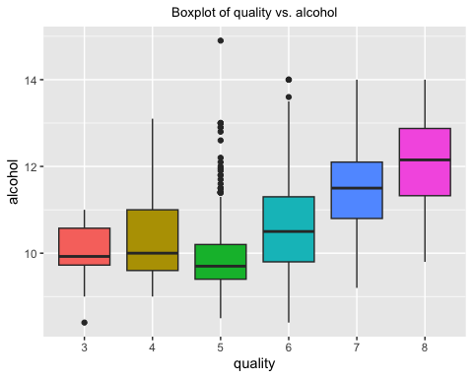

ggarrange(bp9, bp10, bp11, nrow = 2, ncol =2)

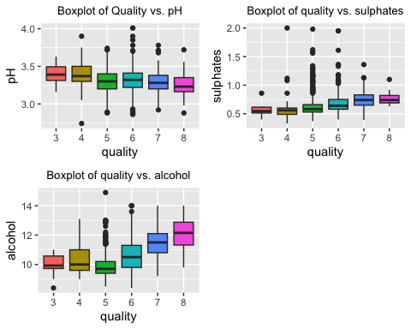

#Analysing relationship among numerical variables  
gg1 <- ggplot(red_df, aes(x=residual.sugar, y=density)) +  
 geom_point(color="blue",size=0.7) +   
 labs(title="density vs. residual sugar") +  
 geom_smooth(formula=y~x,method=lm, color="red") +  
 theme(plot.title=element_text(hjust=0.5))  
gg1

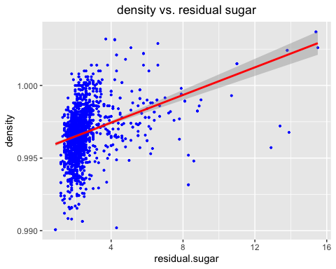

gg2 <- ggplot(red_df, aes(x=alcohol, y=density)) +  
 geom_point(color="blue",size=0.7) +   
 labs(title="density vs. alcohol") +  
 geom_smooth(formula=y~x,method=lm, color="red") +  
 theme(plot.title=element_text(hjust=0.5))  
gg2

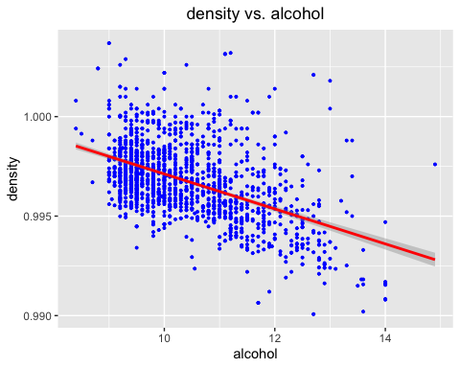

gg3 <- ggplot(red_df, aes(x=fixed.acidity, y=pH)) +  
 geom_point(color="blue",size=0.7) +   
 labs(title="pH vs. fixed.acidity") +  
 geom_smooth(formula=y~x,method=lm, color="red") +  
 theme(plot.title=element_text(hjust=0.5))  
gg3

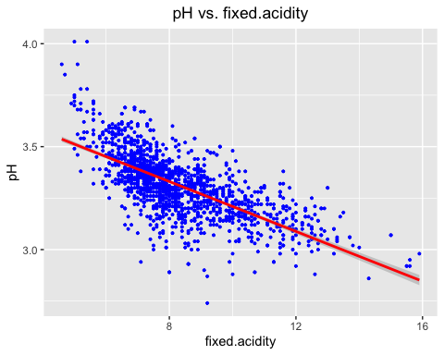

gg4 <- ggplot(red_df, aes(x=volatile.acidity, y=pH)) +  
 geom_point(color="blue",size=0.7) +   
 labs(title="pH vs. volatile.acidity") +  
 geom_smooth(formula=y~x,method=lm, color="red") +  
 theme(plot.title=element_text(hjust=0.5))  
gg4

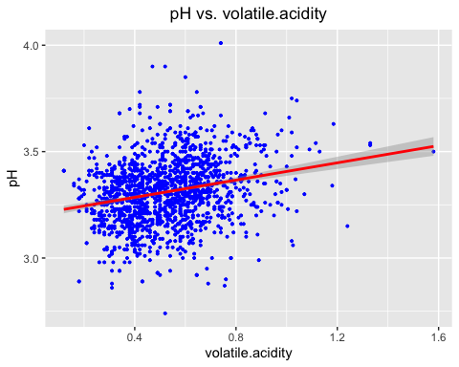

gg5 <- ggplot(red_df, aes(x=citric.acid, y=pH)) +  
 geom_point(color="blue",size=0.7) +   
 labs(title="pH vs. citric.acid") +  
 geom_smooth(formula=y~x,method=lm, color="red") +  
 theme(plot.title=element_text(hjust=0.5))  
gg5

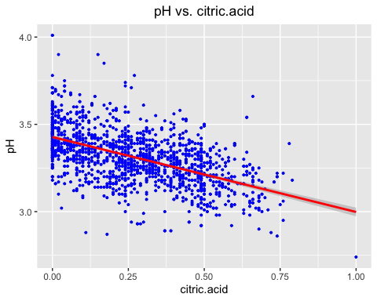

gg6 <- ggplot(red_df, aes(x=free.sulfur.dioxide, y=total.sulfur.dioxide)) +  
 geom_point(color="blue",size=0.7) +   
 labs(title="free.sulfur.dioxide vs. total.sulfur.dioxide") +  
 geom_smooth(formula=y~x,method=lm, color="red") +  
 theme(plot.title=element_text(hjust=0.5))  
gg6

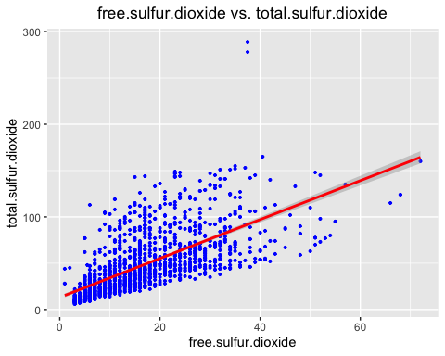

gg7 <-ggplot(red_df, aes(x=sulphates, y=free.sulfur.dioxide)) +  
 geom_point(color="blue",size=0.7) +   
 labs(title="free.sulfur.dioxide vs. sulphates") +  
 geom_smooth(formula=y~x,method=lm, color="red") +  
 theme(plot.title=element_text(hjust=0.5))  
gg7

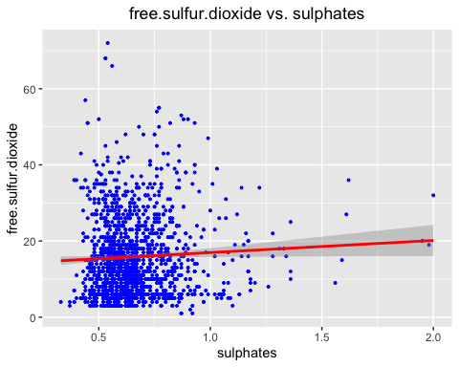

gg8 <-ggplot(red_df, aes(x=sulphates, y=total.sulfur.dioxide)) +  
 geom_point(color="blue",size=0.7) +   
 labs(title="total.sulfur.dioxide vs. sulphates") +  
 geom_smooth(formula=y~x,method=lm, color="red") +  
 theme(plot.title=element_text(hjust=0.5))  
gg8

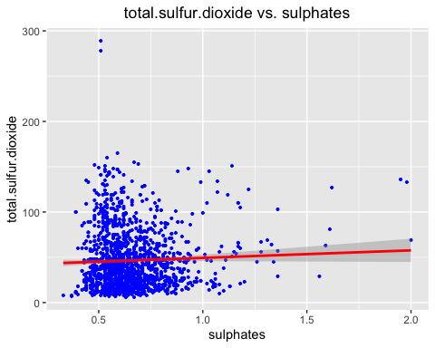

ggarrange(gg1, gg2, gg3, gg4, nrow = 2, ncol =2)

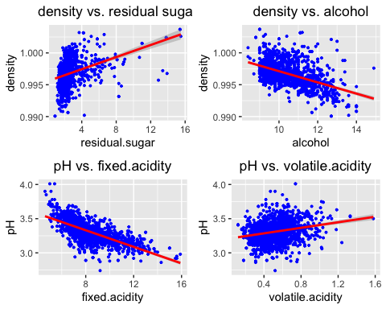

ggarrange(gg5, gg6, gg7, gg8, nrow = 2, ncol =2)

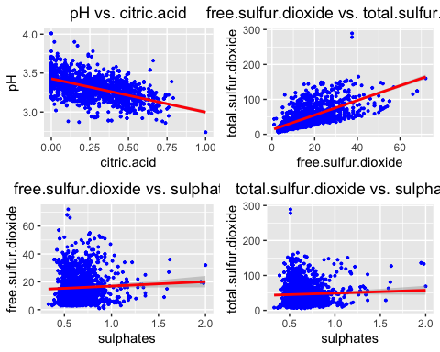

#Baseline Random Forest Model  
redwineRF<-randomForest(quality ~ .,data=red_df,ntree=150)  
  
redwineRF

##   
## Call:  
## randomForest(formula = quality ~ ., data = red_df, ntree = 150)   
## Type of random forest: regression  
## Number of trees: 150  
## No. of variables tried at each split: 3  
##   
## Mean of squared residuals: 0.3197216  
## % Var explained: 50.94

# Get importance  
Importance <- importance(redwineRF)  
varImportance <- data.frame(Variables = row.names(Importance),   
 Importance = (Importance))  
  
# Create a rank variable based on importance  
rankImportance <- varImportance %>%  
 mutate(Rank = paste0('#',dense_rank(desc(Importance))))  
  
# Use ggplot2 to visualize the relative importance of variables  
ggplot(rankImportance, aes(x = reorder(Variables, Importance),   
 y = Importance, fill = Importance)) +  
 geom_bar(stat='identity') +   
 geom_text(aes(x = Variables, y = 0.5, label = Rank),  
 hjust=0, vjust=0.55, size = 4, colour = 'white') +  
 labs(x = 'Variables') +  
 coord_flip()

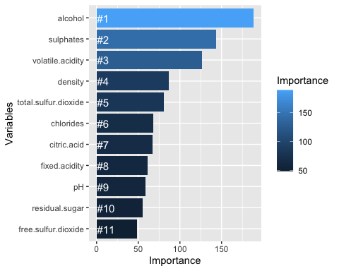

#importance plot  
importance(redwineRF)

## IncNodePurity  
## fixed.acidity 61.11190  
## volatile.acidity 126.46765  
## citric.acid 67.09380  
## residual.sugar 55.13986  
## chlorides 68.19421  
## free.sulfur.dioxide 48.89042  
## total.sulfur.dioxide 81.01511  
## density 86.90260  
## pH 58.26993  
## sulphates 143.15981  
## alcohol 188.37172

varImpPlot(redwineRF, main="Plots of importance measures")

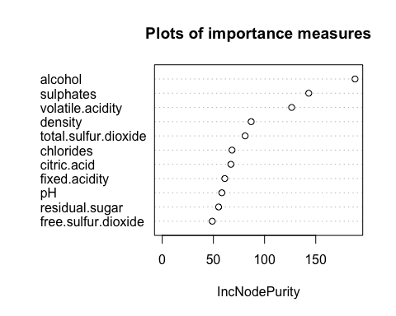

ggpairs(red_df)

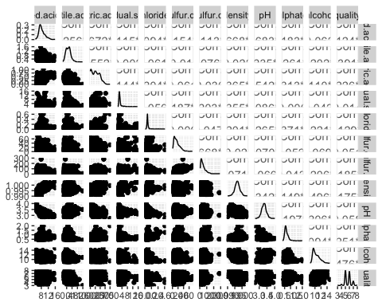

#Linear regression model with top 4 highest correlation with Total Incidents  
red_lm <- lm(quality ~ alcohol + volatile.acidity + sulphates + total.sulfur.dioxide, data = red_df)  
summary(red_lm)

##   
## Call:  
## lm(formula = quality ~ alcohol + volatile.acidity + sulphates +   
## total.sulfur.dioxide, data = red_df)  
##   
## Residuals:  
## Min 1Q Median 3Q Max   
## -2.72716 -0.38486 -0.06503 0.44980 2.13257   
##   
## Coefficients:  
## Estimate Std. Error t value Pr(>|t|)   
## (Intercept) 2.8258128 0.2006892 14.081 < 2e-16 ***  
## alcohol 0.2953105 0.0160331 18.419 < 2e-16 ***  
## volatile.acidity -1.1985632 0.0966011 -12.407 < 2e-16 ***  
## sulphates 0.7121396 0.1005146 7.085 2.08e-12 ***  
## total.sulfur.dioxide -0.0022354 0.0005108 -4.376 1.28e-05 ***  
## ---  
## Signif. codes: 0 '***' 0.001 '**' 0.01 '*' 0.05 '.' 0.1 ' ' 1  
##   
## Residual standard error: 0.655 on 1594 degrees of freedom  
## Multiple R-squared: 0.3438, Adjusted R-squared: 0.3421   
## F-statistic: 208.8 on 4 and 1594 DF, p-value: < 2.2e-16

# Define training control  
set.seed(555)  
train <- red_df[1:800, ]  
test <- red_df[801:nrow(red_df), ]  
# Train the model  
red_model <- lm(quality ~ alcohol + volatile.acidity + sulphates + total.sulfur.dioxide, data=train)  
summary(red_model)

##   
## Call:  
## lm(formula = quality ~ alcohol + volatile.acidity + sulphates +   
## total.sulfur.dioxide, data = train)  
##   
## Residuals:  
## Min 1Q Median 3Q Max   
## -2.29129 -0.41439 -0.06258 0.44028 2.13996   
##   
## Coefficients:  
## Estimate Std. Error t value Pr(>|t|)   
## (Intercept) 3.0940601 0.2658198 11.640 < 2e-16 ***  
## alcohol 0.2826331 0.0232910 12.135 < 2e-16 ***  
## volatile.acidity -1.0201384 0.1302268 -7.834 1.52e-14 ***  
## sulphates 0.5282305 0.1206150 4.379 1.35e-05 ***  
## total.sulfur.dioxide -0.0041631 0.0006662 -6.249 6.73e-10 ***  
## ---  
## Signif. codes: 0 '***' 0.001 '**' 0.01 '*' 0.05 '.' 0.1 ' ' 1  
##   
## Residual standard error: 0.6369 on 795 degrees of freedom  
## Multiple R-squared: 0.3058, Adjusted R-squared: 0.3023   
## F-statistic: 87.55 on 4 and 795 DF, p-value: < 2.2e-16

#calculate MSE  
mean(red_model$residuals^2)

## [1] 0.403121

#calculate RMSE  
sqrt(mean(red_model$residuals^2))

## [1] 0.6349181

#calculate MAE  
predValues <- predict(red_model,test)  
#MAE for the model  
mean(abs(test$quality -predValues))

## [1] 0.5233042

#Lasso regression  
x <- model.matrix(quality~., red_df)[,-1]  
y <- red_df$quality  
mod <- cv.glmnet(as.matrix(x), y, alpha=1)  
  
#coefficients with the minimum cross-validation error  
as.matrix(coef(mod, mod$lambda.min))

## s1  
## (Intercept) 4.113819e+00  
## fixed.acidity 0.000000e+00  
## volatile.acidity -1.026243e+00  
## citric.acid 0.000000e+00  
## residual.sugar 8.124684e-05  
## chlorides -1.643697e+00  
## free.sulfur.dioxide 1.928718e-03  
## total.sulfur.dioxide -2.500755e-03  
## density 0.000000e+00  
## pH -3.635424e-01  
## sulphates 8.060690e-01  
## alcohol 2.845865e-01

#coefficients with the "largest value of lambda such that error is   
#within 1 standard error of the minimum  
as.matrix(coef(mod, mod$lambda.1se))

## s1  
## (Intercept) 3.1816088105  
## fixed.acidity 0.0000000000  
## volatile.acidity -1.0152991147  
## citric.acid 0.0000000000  
## residual.sugar 0.0000000000  
## chlorides -0.0882356401  
## free.sulfur.dioxide 0.0000000000  
## total.sulfur.dioxide -0.0008119338  
## density 0.0000000000  
## pH 0.0000000000  
## sulphates 0.4577249926  
## alcohol 0.2623533623

#Lasso regression model using above independent variables  
red_lm1 <- lm(quality ~ fixed.acidity + volatile.acidity + chlorides + total.sulfur.dioxide   
 + sulphates + alcohol, data=red_df)  
summary(red_lm1)

##   
## Call:  
## lm(formula = quality ~ fixed.acidity + volatile.acidity + chlorides +   
## total.sulfur.dioxide + sulphates + alcohol, data = red_df)  
##   
## Residuals:  
## Min 1Q Median 3Q Max   
## -2.70812 -0.37181 -0.06238 0.45933 1.99472   
##   
## Coefficients:  
## Estimate Std. Error t value Pr(>|t|)   
## (Intercept) 2.7365412 0.2325021 11.770 < 2e-16 ***  
## fixed.acidity 0.0236576 0.0099187 2.385 0.0172 *   
## volatile.acidity -1.0856214 0.0996323 -10.896 < 2e-16 ***  
## chlorides -1.7376885 0.3913566 -4.440 9.61e-06 ***  
## total.sulfur.dioxide -0.0021460 0.0005121 -4.191 2.93e-05 ***  
## sulphates 0.8846921 0.1108310 7.982 2.72e-15 ***  
## alcohol 0.2825603 0.0166180 17.003 < 2e-16 ***  
## ---  
## Signif. codes: 0 '***' 0.001 '**' 0.01 '*' 0.05 '.' 0.1 ' ' 1  
##   
## Residual standard error: 0.6504 on 1592 degrees of freedom  
## Multiple R-squared: 0.3538, Adjusted R-squared: 0.3514   
## F-statistic: 145.3 on 6 and 1592 DF, p-value: < 2.2e-16

# Define training control  
set.seed(555)  
train <- red_df[1:800, ]  
test <- red_df[801:nrow(red_df), ]  
# Train the model  
red_model1 <- lm(quality ~ fixed.acidity + volatile.acidity + chlorides + total.sulfur.dioxide   
 + sulphates + alcohol, data=train)  
summary(red_model1)

##   
## Call:  
## lm(formula = quality ~ fixed.acidity + volatile.acidity + chlorides +   
## total.sulfur.dioxide + sulphates + alcohol, data = train)  
##   
## Residuals:  
## Min 1Q Median 3Q Max   
## -2.23168 -0.39914 -0.07055 0.45416 2.04570   
##   
## Coefficients:  
## Estimate Std. Error t value Pr(>|t|)   
## (Intercept) 3.0774808 0.2912846 10.565 < 2e-16 ***  
## fixed.acidity 0.0177703 0.0127942 1.389 0.16524   
## volatile.acidity -0.9332460 0.1344362 -6.942 8.05e-12 ***  
## chlorides -1.3764407 0.4649166 -2.961 0.00316 **   
## total.sulfur.dioxide -0.0040524 0.0006758 -5.997 3.06e-09 ***  
## sulphates 0.6873536 0.1345356 5.109 4.06e-07 ***  
## alcohol 0.2655413 0.0237330 11.189 < 2e-16 ***  
## ---  
## Signif. codes: 0 '***' 0.001 '**' 0.01 '*' 0.05 '.' 0.1 ' ' 1  
##   
## Residual standard error: 0.6333 on 793 degrees of freedom  
## Multiple R-squared: 0.3153, Adjusted R-squared: 0.3101   
## F-statistic: 60.86 on 6 and 793 DF, p-value: < 2.2e-16

#calculate MSE  
mean(red_model1$residuals^2)

## [1] 0.3976104

#calculate RMSE  
sqrt(mean(red_model1$residuals^2))

## [1] 0.6305636

#calculate MAE  
predValues <- predict(red_model1,test)  
#MAE for the model  
mean(abs(test$quality -predValues))

## [1] 0.5179756

#Random forest  
set.seed(555)  
train <- red_df[1:800, ]  
test <- red_df[801:nrow(red_df), ]  
red_model3 <- randomForest(quality ~ ., train, mtry = 3,   
 importance = TRUE, na.action = na.omit)  
print(red_model3)

##   
## Call:  
## randomForest(formula = quality ~ ., data = train, mtry = 3, importance = TRUE, na.action = na.omit)   
## Type of random forest: regression  
## Number of trees: 500  
## No. of variables tried at each split: 3  
##   
## Mean of squared residuals: 0.3123345  
## % Var explained: 46.21

#Plot the error vs the number of trees graph   
plot(red_model3)

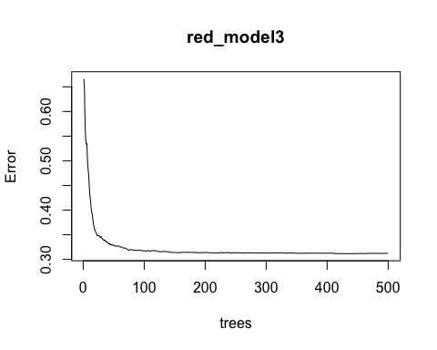

importance(red_model3)

## %IncMSE IncNodePurity  
## fixed.acidity 21.90628 36.29757  
## volatile.acidity 28.48120 50.45388  
## citric.acid 21.39634 32.39123  
## residual.sugar 17.38764 25.73327  
## chlorides 19.30311 27.15030  
## free.sulfur.dioxide 17.97617 21.62821  
## total.sulfur.dioxide 34.88990 43.17906  
## density 21.37384 31.40464  
## pH 17.57445 28.33563  
## sulphates 36.74733 61.10011  
## alcohol 43.73199 79.66182

varImpPlot(red_model3,type=2)

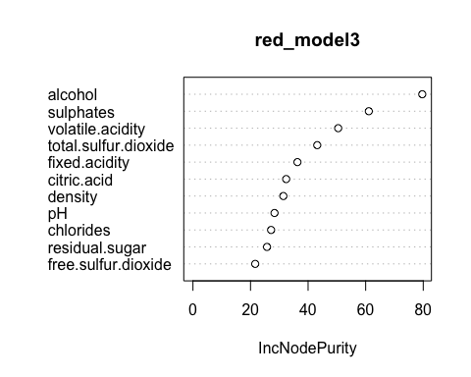

# MSE for the model  
red_model3$mse[length(red_model3$mse)]

## [1] 0.3123345

# RMSE for the model  
sqrt(red_model3$mse[length(red_model3$mse)])

## [1] 0.558869

predValues <- predict(red_model3,test)  
#MAE for the model  
mean(abs(test$quality -predValues))

## [1] 0.5192442

#Comparing models  
Model <- c("Linear", "Lasso", "Random-Forest")  
R_squared <- c(0.3058, 0.3153, 0.4621)  
RMSE <- c(0.6349181, 0.6305636, 0.558869)  
MAE <- c(0.5233042, 0.5179756, 0.5192442)  
MSE <- c(0.403121, 0.3976104, 0.3123345)  
ml <- data.frame(Model, R_squared, RMSE, MAE, MSE)  
  
  
p1 <- ggplot(ml, aes(Model, RMSE)) + geom_point(aes(colour = factor(Model), size = 4)) + labs(title="RMSE") + theme(plot.title=element_text(hjust=0.5), axis.title.y = element_blank(),axis.title.x = element_blank(), legend.position="none")  
p2 <- ggplot(ml, aes(Model, R_squared)) + geom_point(aes(colour = factor(Model), size = 4)) + labs(title="R-Squared") + theme(plot.title=element_text(hjust=0.5), axis.title.y = element_blank(),axis.title.x = element_blank(), legend.position="none")  
p3 <- ggplot(ml, aes(Model, MAE)) + geom_point(aes(colour = factor(Model), size = 4)) + labs(title="MAE") + theme(plot.title=element_text(hjust=0.5), axis.title.y = element_blank(),axis.title.x = element_blank(), legend.position="none")  
p4 <- ggplot(ml, aes(Model, MSE)) + geom_point(aes(colour = factor(Model), size = 4)) + labs(title="MSE") + theme(plot.title=element_text(hjust=0.5), axis.title.y = element_blank(),axis.title.x = element_blank(), legend.position="none")  
ggarrange(p2,p1,p3,p4, nrow=2, ncol=2)

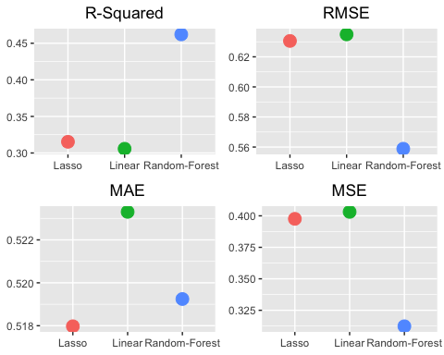

#clustering to find relation between predictors  
set.seed(1941)  
red_k <- kmeans(red_df, 2, nstart = 25)  
names(red_k)

## [1] "cluster" "centers" "totss" "withinss" "tot.withinss"  
## [6] "betweenss" "size" "iter" "ifault"

red_k$centers

## fixed.acidity volatile.acidity citric.acid residual.sugar chlorides  
## 1 8.025952 0.5516429 0.2834286 2.944524 0.09313810  
## 2 8.424258 0.5193342 0.2665394 2.394275 0.08544614  
## free.sulfur.dioxide total.sulfur.dioxide density pH sulphates  
## 1 25.70833 91.72857 0.9969427 3.298738 0.6626905  
## 2 12.37193 30.34436 0.9966768 3.315522 0.6565310  
## alcohol quality  
## 1 10.09389 5.388095  
## 2 10.54022 5.724343

c1 <- ggplot(red_df)+geom_point(aes(x=pH,y=alcohol ,color=red_k$cluster))  
c1

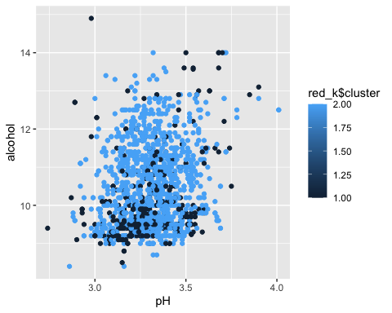

c2 <- ggplot(red_df)+geom_point(aes(x=pH,y=total.sulfur.dioxide ,color=red_k$cluster))  
c2

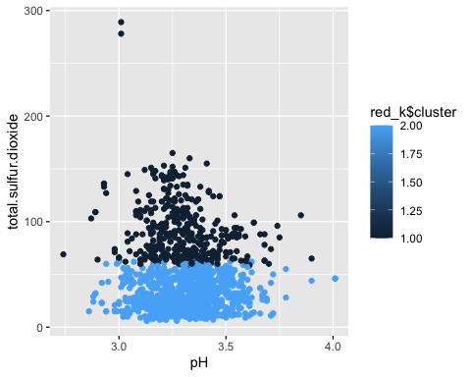

c3 <- ggplot(red_df)+geom_point(aes(x=pH,y=citric.acid ,color=red_k$cluster))  
c3

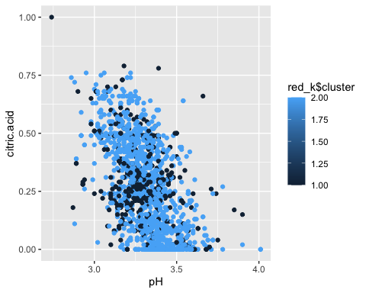

c4 <- ggplot(red_df)+geom_point(aes(x=alcohol,y=volatile.acidity ,color=red_k$cluster))  
c4

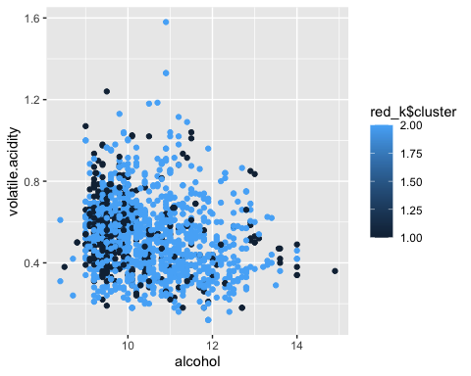

ggarrange(c2,c1,c3,c4, nrow=2, ncol=2)

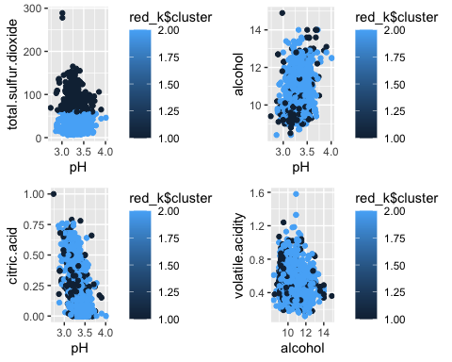

#clustering  
set.seed(1406)  
kmeans.re <- kmeans(red_df, centers = 3, nstart = 25)  
kmeans.re

## K-means clustering with 3 clusters of sizes 519, 839, 241  
##   
## Cluster means:  
## fixed.acidity volatile.acidity citric.acid residual.sugar chlorides  
## 1 8.258189 0.5210019 0.2688632 2.488054 0.09184586  
## 2 8.481764 0.5192431 0.2709416 2.370977 0.08448987  
## 3 7.887552 0.5723651 0.2756432 3.232365 0.08839834  
## free.sulfur.dioxide total.sulfur.dioxide density pH sulphates  
## 1 21.939306 55.69750 0.9968552 3.322428 0.6767630  
## 2 9.171633 22.93802 0.9966256 3.310286 0.6483909  
## 3 26.151452 108.50622 0.9969347 3.289627 0.6520332  
## alcohol quality  
## 1 10.34399 5.603083  
## 2 10.59078 5.750894  
## 3 10.00892 5.307054  
##   
## Clustering vector:  
## [1] 2 1 1 1 2 2 1 2 2 3 1 3 1 2 3 3 3 1 2 1 1 1 2 1 1 2 2 2 2 2 1 1 3 3 1 2 2  
## [38] 2 2 3 3 1 2 2 2 1 3 2 2 3 2 2 2 3 1 1 2 3 1 1 1 3 2 1 2 2 2 2 1 2 2 3 3 1  
## [75] 3 1 1 2 1 3 2 1 1 1 1 1 3 2 3 2 3 3 3 2 3 3 2 2 2 2 1 2 2 1 2 1 1 1 1 3 1  
## [112] 3 3 1 1 1 2 2 1 3 3 1 2 2 3 3 2 2 2 2 3 3 3 2 2 1 1 1 3 3 1 1 1 2 1 3 3 3  
## [149] 2 1 2 1 3 3 3 3 3 3 2 3 2 2 2 3 3 3 3 1 1 1 2 2 2 1 2 1 2 2 2 1 1 3 1 1 1  
## [186] 3 1 2 3 3 3 1 3 2 2 3 1 2 3 2 2 3 1 2 2 2 2 3 3 2 2 1 2 1 2 3 1 2 1 3 1 1  
## [223] 2 2 1 1 1 2 1 2 3 1 1 2 2 2 2 2 2 2 1 2 3 2 2 2 1 1 2 2 2 2 2 3 2 3 2 1 1  
## [260] 2 1 1 2 1 2 2 1 2 2 2 1 2 1 2 3 1 2 2 2 1 2 2 1 1 1 1 1 1 1 3 1 2 1 2 1 2  
## [297] 1 2 2 2 1 2 2 2 3 2 1 2 2 2 2 3 3 3 1 1 3 1 1 1 1 3 2 1 1 1 2 2 2 2 2 2 3  
## [334] 1 2 2 2 1 3 2 2 2 2 2 2 1 2 2 1 2 2 2 2 1 3 2 1 2 2 2 1 1 2 2 2 2 2 2 1 2  
## [371] 1 2 1 1 1 2 1 2 2 1 2 1 2 2 1 2 1 1 1 1 3 1 2 3 2 2 3 1 1 1 3 1 1 2 2 2 2  
## [408] 2 2 1 3 1 1 2 3 3 2 3 2 1 1 1 1 2 1 1 1 2 2 2 2 1 2 2 1 2 1 2 1 1 2 2 2 2  
## [445] 2 2 1 2 2 2 2 2 2 2 1 2 2 1 2 1 2 2 2 3 2 2 1 2 2 1 1 1 1 2 2 2 2 2 2 2 2  
## [482] 2 2 2 2 2 2 2 1 2 1 2 2 1 3 2 2 3 2 1 2 1 1 2 2 2 2 2 1 1 1 1 1 2 2 3 2 2  
## [519] 2 3 2 1 3 3 3 1 3 3 1 2 2 1 1 2 2 2 2 2 2 2 1 2 2 1 2 3 2 2 1 2 2 1 1 3 2  
## [556] 2 2 2 2 1 2 3 3 1 1 2 2 2 2 1 2 1 2 1 1 1 2 3 3 1 2 2 2 2 3 2 1 3 1 2 1 3  
## [593] 1 1 1 3 2 2 2 2 2 2 2 2 1 2 2 1 1 2 1 2 2 2 3 1 1 2 2 2 3 3 2 1 1 1 2 2 2  
## [630] 3 2 2 1 3 3 2 3 3 2 1 1 1 1 1 1 2 2 2 2 3 2 3 1 2 2 1 2 1 2 2 2 1 2 2 1 1  
## [667] 2 2 2 2 1 2 3 2 2 2 2 2 3 1 1 2 1 2 3 2 2 2 2 2 2 3 1 3 3 1 2 2 1 2 3 2 2  
## [704] 3 2 1 2 2 2 2 3 3 2 1 1 2 1 1 2 1 2 3 1 3 2 2 1 2 2 1 2 2 2 1 2 2 2 1 3 1  
## [741] 2 3 2 3 3 2 1 1 2 2 1 1 1 1 2 1 2 2 2 3 3 2 2 2 1 1 1 3 3 2 3 3 3 2 1 2 1  
## [778] 2 2 3 1 2 3 2 3 1 1 1 1 3 1 3 3 2 2 1 1 1 2 2 3 2 3 1 2 2 2 2 2 2 2 2 1 2  
## [815] 1 1 2 2 1 1 2 1 2 2 2 2 2 2 1 2 2 2 1 1 2 1 3 3 2 2 2 2 1 3 1 2 2 2 2 2 2  
## [852] 2 3 1 1 2 1 1 2 2 3 3 2 3 3 3 2 2 2 1 1 1 1 2 2 2 2 1 1 3 2 1 2 3 1 2 2 1  
## [889] 1 3 1 3 2 3 3 1 1 1 1 2 2 2 2 2 2 3 1 2 1 2 2 2 2 2 2 2 1 1 1 1 2 1 1 1 2  
## [926] 1 1 1 2 2 2 2 1 2 2 1 1 2 1 2 2 2 1 1 2 2 2 2 2 2 2 2 2 2 2 2 2 1 1 2 2 2  
## [963] 2 2 2 1 2 3 1 2 2 2 2 2 2 1 1 3 2 2 2 2 1 2 2 2 2 1 2 2 2 1 1 1 3 1 2 2 2  
## [1000] 2 2 1 2 2 1 2 2 2 2 1 2 2 2 2 2 2 2 3 3 2 2 2 2 2 2 1 2 1 1 2 2 2 2 2 1 2  
## [1037] 2 1 1 1 2 2 1 1 1 1 1 1 2 2 1 1 2 2 1 1 2 3 1 2 2 2 2 2 2 2 2 2 2 1 2 3 1  
## [1074] 2 3 1 2 2 2 3 2 3 1 1 1 1 2 2 1 1 1 2 2 2 2 2 2 2 2 2 2 2 2 2 2 1 2 2 2 1  
## [1111] 2 1 2 2 1 2 2 2 2 2 2 2 2 2 2 2 2 1 3 1 2 3 2 2 2 1 2 2 3 3 1 1 2 2 1 1 2  
## [1148] 2 2 2 2 1 2 2 1 2 3 3 1 2 2 2 2 2 2 2 1 1 1 2 2 1 2 1 1 1 1 2 1 1 1 2 1 1  
## [1185] 3 2 2 2 3 2 2 2 2 2 1 1 3 2 1 3 2 2 2 1 1 1 1 1 1 2 2 1 2 2 2 2 1 1 2 1 1  
## [1222] 1 3 2 2 1 1 2 3 1 1 3 1 2 2 3 2 2 2 2 1 1 1 3 3 2 1 2 2 1 1 1 2 2 2 1 1 1  
## [1259] 2 2 1 2 1 2 1 2 2 2 1 3 1 1 1 1 2 1 2 2 1 2 1 1 2 1 2 1 2 2 3 3 2 1 2 2 1  
## [1296] 1 1 2 2 2 2 1 2 1 1 3 3 2 3 1 3 2 1 1 1 3 1 2 3 1 3 1 2 1 2 2 2 2 2 3 3 1  
## [1333] 2 1 2 1 2 2 2 2 2 2 2 2 2 2 2 2 2 1 1 1 1 1 2 2 2 1 3 2 2 1 2 1 2 1 1 3 1  
## [1370] 2 1 2 1 3 2 3 2 1 2 2 2 2 3 3 3 3 2 2 1 3 2 2 2 1 1 2 2 3 2 2 3 3 2 2 1 2  
## [1407] 2 1 1 1 2 2 2 3 2 2 2 2 2 3 2 1 1 2 2 2 1 2 1 1 1 1 2 2 3 3 3 2 2 3 2 3 2  
## [1444] 2 3 3 2 1 1 2 2 2 1 3 2 2 3 3 2 2 1 2 2 2 1 1 1 2 1 1 2 2 1 1 3 3 3 3 2 2  
## [1481] 2 2 2 2 2 2 2 2 2 2 2 2 2 3 2 2 3 2 2 2 2 1 1 2 2 2 2 2 2 2 1 2 2 1 1 1 1  
## [1518] 1 2 2 1 2 1 1 1 2 2 2 1 1 2 2 2 3 2 2 1 2 2 1 2 1 1 2 2 2 2 2 1 2 2 2 1 2  
## [1555] 2 2 2 2 3 3 3 3 2 2 2 1 1 2 1 2 2 2 3 1 3 2 2 2 2 2 2 2 2 3 2 1 1 2 3 1 2  
## [1592] 2 1 1 1 1 1 1 1  
##   
## Within cluster sum of squares by cluster:  
## [1] 113849.5 88801.2 193638.5  
## (between_SS / total_SS = 79.3 %)  
##   
## Available components:  
##   
## [1] "cluster" "centers" "totss" "withinss" "tot.withinss"  
## [6] "betweenss" "size" "iter" "ifault"

plot(red_df[c("pH", "quality")],   
 col = kmeans.re$cluster,   
 main = "Red Wine clusters")

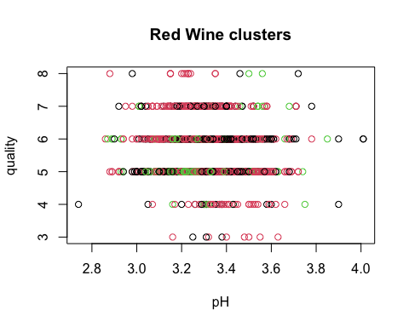

#Classification trees  
library(party)

## Loading required package: grid  
## Loading required package: mvtnorm  
## Loading required package: modeltools  
## Loading required package: stats4  
## Loading required package: strucchange  
## Loading required package: zoo  
##   
## Attaching package: 'zoo'  
##   
## The following objects are masked from 'package:base':  
##   
## as.Date, as.Date.numeric  
##   
## Loading required package: sandwich  
##   
## Attaching package: 'strucchange'  
##   
## The following object is masked from 'package:stringr':  
##   
## boundary

tree1=ctree(quality~alcohol+volatile.acidity,data=red_df) #~target variable,predicting   
tree1

##   
## Conditional inference tree with 10 terminal nodes  
##   
## Response: quality   
## Inputs: alcohol, volatile.acidity   
## Number of observations: 1599   
##   
## 1) alcohol <= 10.5; criterion = 1, statistic = 362.322  
## 2) volatile.acidity <= 0.33; criterion = 1, statistic = 88.693  
## 3) alcohol <= 9.7; criterion = 0.963, statistic = 5.545  
## 4)* weights = 37   
## 3) alcohol > 9.7  
## 5)* weights = 48   
## 2) volatile.acidity > 0.33  
## 6) volatile.acidity <= 0.65; criterion = 1, statistic = 43.251  
## 7) alcohol <= 9.8; criterion = 1, statistic = 31.696  
## 8)* weights = 429   
## 7) alcohol > 9.8  
## 9)* weights = 228   
## 6) volatile.acidity > 0.65  
## 10)* weights = 241   
## 1) alcohol > 10.5  
## 11) volatile.acidity <= 0.865; criterion = 1, statistic = 105.187  
## 12) volatile.acidity <= 0.44; criterion = 1, statistic = 44.243  
## 13) alcohol <= 11.5; criterion = 0.999, statistic = 12.315  
## 14)* weights = 156   
## 13) alcohol > 11.5  
## 15)* weights = 145   
## 12) volatile.acidity > 0.44  
## 16) alcohol <= 11.4; criterion = 1, statistic = 22.228  
## 17)* weights = 167   
## 16) alcohol > 11.4  
## 18)* weights = 121   
## 11) volatile.acidity > 0.865  
## 19)* weights = 27

library(rpart)  
mytree=rpart(quality~alcohol+volatile.acidity,data=red_df,method="class")  
mytree

## n= 1599   
##   
## node), split, n, loss, yval, (yprob)  
## * denotes terminal node  
##   
## 1) root 1599 918 5 (0.0063 0.033 0.43 0.4 0.12 0.011)   
## 2) alcohol< 10.25 842 323 5 (0.0083 0.034 0.62 0.31 0.03 0.0024)   
## 4) volatile.acidity>=0.3175 788 280 5 (0.0089 0.036 0.64 0.29 0.022 0.0013) *  
## 5) volatile.acidity< 0.3175 54 21 6 (0 0.019 0.2 0.61 0.15 0.019) *  
## 3) alcohol>=10.25 757 379 6 (0.004 0.032 0.21 0.5 0.23 0.021) *

library(rattle)

## Loading required package: bitops  
##   
## Attaching package: 'bitops'  
##   
## The following object is masked from 'package:Matrix':  
##   
## %&%  
##   
## Rattle: A free graphical interface for data science with R.  
## Version 5.5.1 Copyright (c) 2006-2021 Togaware Pty Ltd.  
## Type 'rattle()' to shake, rattle, and roll your data.  
##   
## Attaching package: 'rattle'  
##   
## The following object is masked from 'package:randomForest':  
##   
## importance

library(RColorBrewer)  
fancyRpartPlot(mytree,caption="Red wine Classification")

