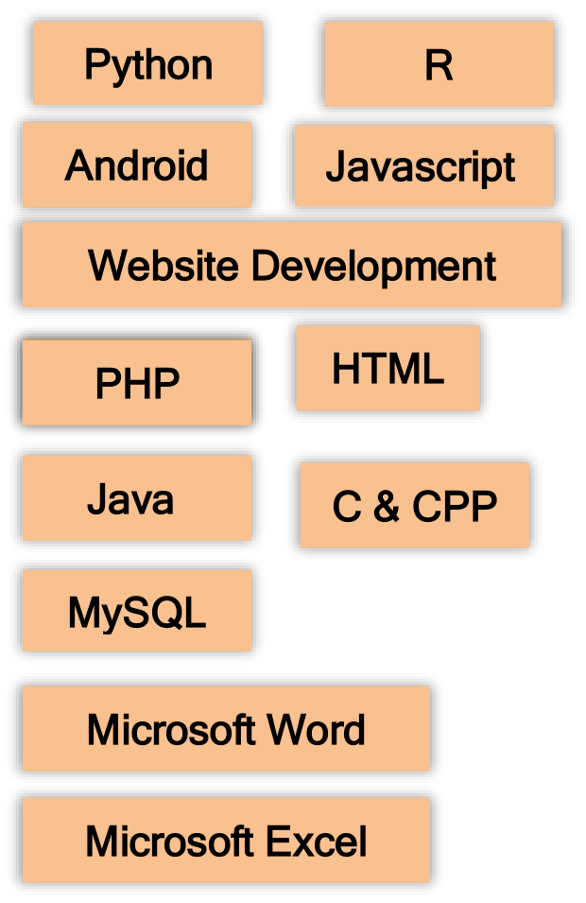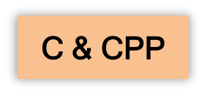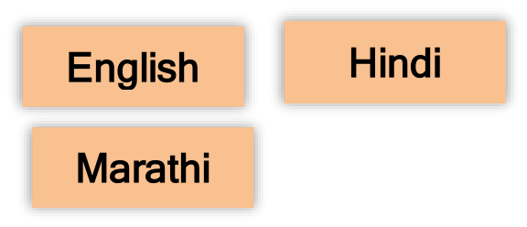

MAHESH CHAUDHARI

I have a passion for working for data-driven, innovative companies. I like advanced technology to address everyday problems for

consumers and businesses alike. I also enjoy solving issues using an analytical approach and am passionate about incorporating

technology into my work.

Contact Info Education



|  |  |  |  |
| --- | --- | --- | --- |
|  | | Bachelor's Computer Science (Data Science & AI/ML) DY Patil International University, Akurdi | Jul 2019 – Jul 2023 |
|  | Wakad, Pune |
|  | 9405961281 | Certifications    Java Development Certified Professional (AICPE & ITT-COUNCIL) Associate Android Developer Certification (AICPE & ITT-COUNCIL) | |
|  | maheshchaudhari842 @gmail.com |
| [LinkedIn:](http://www.linkedin.com/in/mahes)  [www.linkedin.com/in/mahes h-chaudhari-30072a205](http://www.linkedin.com/in/mahes) | |

Python Data Science Workshop (IIT BOMBAY)

Microsoft AI Classroom Certificate (NASSCOM)

|  |  |  |
| --- | --- | --- |
| Skills | | Advanced C & CPP Professional Certificate (Coursera) Introduction to Cloud Computing (Coursera) |
| |  | | --- | | Python | | |  | | --- | | R | | Amazon Cloud Developer Certification (Amazon) |
| |  | | --- | | Android | | |  | | --- | | Javascript | | Oracle Database Administrative Certificate (AICPE & ITT-COUNCIL) |

|  |  |  |
| --- | --- | --- |
|  | | |
| |  | | --- | | Website Development | | |  |
| Projects |
| |  | | --- | | Node.Js | | |  | | --- | | HTML | |
| |  | | --- | | Java | | |  | | --- | | C & CPP | | **1. FoodFlights Private Limited (Self Startup)** |
| |  | | --- | | MySQL |  |  | | --- | | Microsoft Word |  |  | | --- | | Microsoft Excel |   Language | |  |
| TECHNOLOGY USED: (Java/ Android Studio). |
| PROJECT DESCRIPTION |
| FoodFlights is Android Native Application which is based on Cloud Kitchen like Zomato and Swiggy which I have started in rural area like Shahada, Nandurbar, |
| Shirpur where there are not any option of Zomato and Swiggy. FoodFlights has 5000+ Downloads and 200+ User Reviews on Google Play Store. FoodFlights generates Rs.30,000+ per month.  ROLES AND RESPONSIBILITES  Connect android application to back end services. |
| |  | | --- | | English | | |  | | --- | | Hindi | | Android UI Design in XML.  Design and implemented Rest full web services. |
| |  | | --- | | Marathi | | | Worked on SQLite Database.  Firebase Authentication, Storage, Cloud Messaging, Analytics. Amazon ec2 instance.  Google Cloud Platform & Google Maps Platform. |

**2. Twitter sentiment Analysis (Python)**

Handcrafted feature bases approach on boston Marathon bombing (April 15 , 2013). In this I have worked on real time rumour debunking algorithm for twitter by using beliefs of the crowd & perfomed text analysis on data.

**3. How can Wellness Technology Company play it Smart (Capstone case study) (Python)**

Using the trends discovered in smart device usage using R language & Data Visualization to help influence Bellabeat Marketing Strategy & unlock new growth opportunity for the company.

**4. Internship (3 Months)- DoorStepPath (Online Lab Appointment Android Application)**

DoorStepPath is Online Lab Appointment Android Application used to book lab test doorstep. I was team leader at the time of internship under Research Scientist Dr. Bahubali Shirsagar. We have used Data Mining, Data Analysis using Python & R during this internship and have build Realtime Application.

**5. Face Detector App (Python)**

In this project I have developed a program which locate and visualize the human faces in any digital image**.** I have used OpenCV dependency/package in this project. OpenCV is the most popular library for computer vision.

**6. Self Driving Car App (Python)**

In this project I have developed a program with features like Detecting Lane, Traffic Signal Classification, Behavioral Cloning, Advanced Lane Finding, Vehicle Detection & Tracking, Path Planning, Road Segmentation. I have used Computer Vission, Deep Learning, OpenCV etc for this project.

**7. Disease Prediction System (Android, Python)**

In this project I have developed Android App which predicts disease a person is suffering using symptoms. In this project Data Mining, Data Analysis, Data Structure Algorithm were used.

Strength



Analytical Skills, Leadership Skills, Communication Skills, Ability to work in A team. I always try to learn new things on daily basis, I can easily adapt to any environment, always being ready to help others.

Weekness



Overthinking, getting emotional easily, sometimes doesn't speak at times when I should. (I’m working on transforming my weekness into strength)