|  |
| --- |
| **M A H I M A M A H A J A N** |

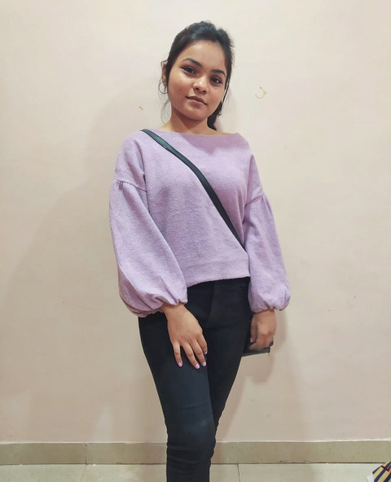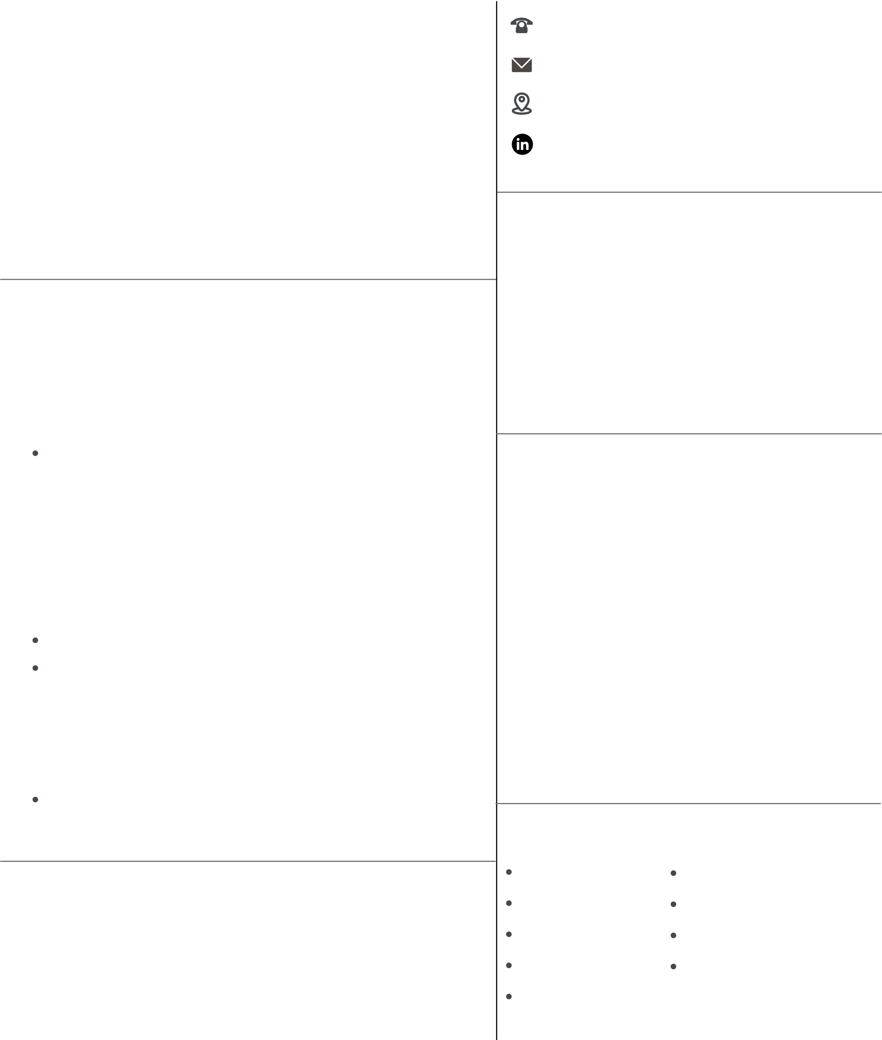

|  |  |
| --- | --- |
| **D A T A A N A L Y S T**  **F R O N T E N D D E V E L O P E R**  **P Y T H O N / R** | |
| **PROFILE** | 7709842561 |
| My name is Mahima Mahajan. I am from Madhya Pradesh. I am in | mahimamahajan0906@gmail.com |
| my final year of my graduation course in B-Tech CSE pursuing from | Pune, Maharashtra |
| D.Y. Patil International University, Akurdi, Pune. My specialization subject is focused on Data Science but have other interests such as UI Design, Cyber Security and Fronted Developement. As a | https://www.linkedin.com/in/  mahima09 |
| computer science student, I have good problem-solving skills as well as hands on practice in various technical fields and tools. | **E D U C A T I O N**  **DIPLOMA- COMPUTER SCIENCE** |
| **E X P E R I E N C E** | Y. B. Patil College of Engineering 2018 - 2020 |
| **DATA ANNOTATION (AI/ML)** | **B-TECH COMPUTER SCIENCE** |
| STRATA UNISON (New York) I Apr 2022 | D. Y. Patil International University |
| 2022 - Present | 2020 - 2023 |
| During the internship the responsibility is to perform data | **PROJECTS** |
| annotation on the given dataset that are going to be used to train machine [earning model.  **WEB DEVELOPMENT**  TECTIQ TECHNOLOGY | **TARGETED ADVERTISMENT &**  **MARKETING ANALYTICS**  Performed ML techniques on the dummy dataset where the model will suggest the ads based on the interest and spending times on Instagram reels |
| May 2019 -June 2019   worked on a project received from company.  Responsibility to manage database and build website design. | **LIBRARY**  Developed a library website based on the concept of  DBMS which performs simple functions like storing the  books and records of books issued and many more. |
| **CAMPUS AMBASSADOR**  NEO EDUCATIONAL FOUNDATION Apr 2021 - May 2021 | **DATA ANALYSIS/ ML ALGORITHM**  Performed various statistical operation and exploratory data analysis on the dataset. Also, used various  techniques and steps from data pre-processing to build model developing to predict the outcomes. |

Spreading awareness about the National Engineering Olympiad

|  |  |  |
| --- | --- | --- |
| exam with the help of different social media platforms. | **S K I L L S** | Data Visualization |
| Data Analyst |
| **A C T I V I T Y** | Power BI/Excel | UI & UX Design |
| • State Level Students Convention (TECHWIZARD 2.0) | Python/C/C++/R | Microsoft Office Suite |
| • TANTROTSAV 2K19 | Front-End Developer | MySQL / Databases |
| HTML / CSS / PHP. |