|  |
| --- |
| NIDHI SINHA |

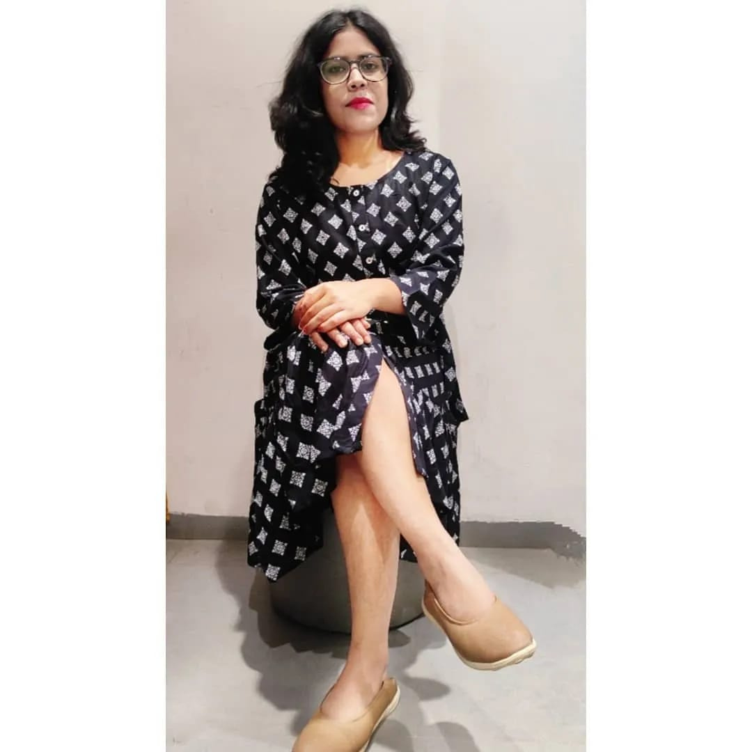

|  |  |
| --- | --- |
| PERSONAL INFO | 3rd Year B-tech Computer Science Student  SUMMARY |

|  |  |
| --- | --- |
| 8579088290  nidhisinha288@gmail.com  li[nkedin.com/in/nidhi-sinha0](https://www.linkedin.com/in/nidhi-sinha01)1  https://github.com/nidhi433 | I'm currently an undergraduate student pursuing a bachelor degree in B-Tech computer science with a specialization in AlML Artificial Intelligence machine learning. I'm looking forward to an opportunity to start my career as machine learning engineer along with a web developer in a company.  I 'm really passionate about implementing new projects |

which provide me with challenges and opportunities to

|  |  |
| --- | --- |
| TECHNICAL SKILLS  - Python & MySQL - Data Visualization using Power BI & Tableau- Data Analysis in MS Excel - Web Scrapping in Python - Web Development in HTML, CSS & PHP - Web Automation using selenium - AI and Machine Learning - Probability & Statistics | improve my skills.  EDUCATION  D Y PATIL INTERNATIONAL UNIVERSITY  B-techCSE - Specialization in AIML | Aug 2019-July 2023 SHIVAM CONVENT  Intermediate in PCM | 67.8%  HOLY FAITH INTERNATIONAL PUBLIC SCHOOL |

Matriculation in Science & Maths | 8.4 CGPA

|  |  |  |  |
| --- | --- | --- | --- |
| CHARACTERISTICAL SKILLS-Motivated, well-disciplined individual -Works constructively with the tea -Can lead team to achieve goals -Effective Motivator and Negotiator -Communicate Effectively  **WORK EXPERIENCE**  Web Development Intern  The Sparks Foundation | June 2021 - July 2021 | | PROJECTS  Neuroscience Data Analysis  DYPIU | Jun 2021 - Jul 2021 | |
|  | Studied real-world dataset of Parkinson’s |
| Disease | |
|  | Performed data visualization & regression |
| Car Price Prediction App (08/2021 - 11/2020) | |
|  | Performed data preprocessing, data cleaning, |
| data analysis on an existing dataset. | |
|  | Contributed with the lead to create a |  | XGboost was used to build the model, and |
| web-based banking app. | | Streamlit was used to create the web application. Diabetes Predicting | |
|  | Used HTML, CSS & Javascript for making |
| the website. | |

DYPIU | Nov 2021 - Dec 2021

|  |  |  |
| --- | --- | --- |
| Campus Ambassador |  | Performed EDA on the given dataset |
| MyCaptain's | April 2021-May 2021 |  |
| Used keras for sequential modeling & |
| Volunteering Internship |  | training the data |
| And evaluated the model using the |
| Youth Empowerment Foundation | May 2021 - June 2021 |

Confusion matrix and ROC curve

|  |  |
| --- | --- |
| Strata Analytica  Student Volunteer | May 2022 - Present  Strata is a startup with a mission to improve and manage infrastructure needs of cities and town around the world | Covid-19 management system   DYPIU | Feb 2021- April 2021   This project is intended to be used as a tool to |

gather information about the patients who are

vaccinated and those who are yet to get vaccine.