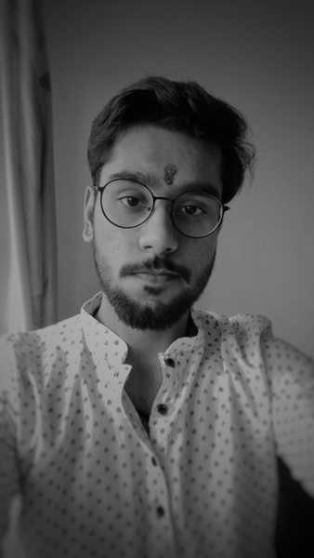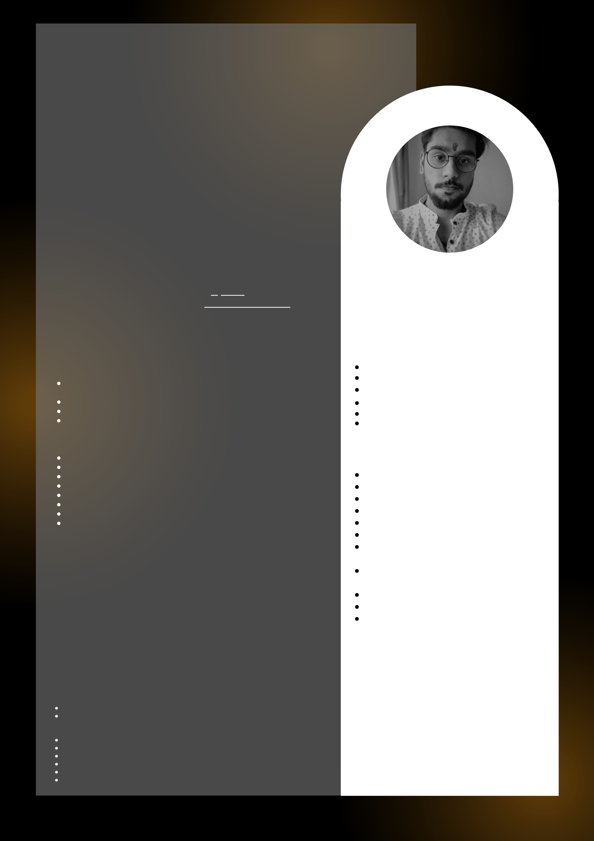

HIMANISH BAJAJ

**Artificial**   
**Intelligence and Data scientist #Student**

himanishbajaj696@gmail.com linkedin.com/in/himanish-  
bajaj-bb42991a5   
**+91 9996585013**

Artificial Intelligence Engineer and Data Scientist ,   
gained the one experience by initiating the Startup.   
Intermediate with writing the codes and complex   
neural networks. Have good hands on with handling   
middle weight data . Flexible to perform and learn .   
Use Logical approach to amend the statement into   
programs . Seeking for the core industry experience .

Confident programming language : Python   
Known Programming Language : C, C++, HTML, CSS

Experience

**Artificial Intelligence**   
Conceptualized :

NLP (Senti[ment analysis, m](https://www.goeduhub.com/10675/what-is-sequence-to-sequence-model)ultiple chat bots , tts / stt , OCR , [Seq2Seq Model](https://www.goeduhub.com/10675/what-is-sequence-to-sequence-model) , etc)   
Computer [Vision (Open cv,](https://www.goeduhub.com/10675/what-is-sequence-to-sequence-model) IBM Watson)   
ML Algorithms   
IBM Watson, GCP

**Data Science**   
Conceptualized :   
 Understanding Exploratory Data Analysis Machine Learning   
 Model selection and evaluation   
 [Data Prepro](https://leverageedu.com/blog/data-mining-techniques/)cessing   
 [Data Mining](https://leverageedu.com/blog/data-mining-techniques/)   
 [Data Visuali](https://leverageedu.com/blog/data-mining-techniques/)zation   
 Business Intelligence   
 Data Modelling

**Drone Development (2021):**   
Working as a founder of DROP, developed the drone under INR 60k from scratch with the team, performing the major functions of night vision capturing, obstacle detection , air route mapping , Ware house   
management .

Continuing to develop more tech with low budget.

**Mixed Reality (2021):**   
Working as a founder of RADIUS , developing an VR Console application based on Mixed Reality (AR + VR) in the field of education, being the first ones developing the VR Filter that automatically adjusts the factors like brightness, hue , saturation etc , for better user   
experience using multiple AI techniques to come up with the parameters

**Minor Projects :**   
Face detection using IBM , GCP , Open CV   
Processed multiple Datasets Like: Cancer detection, Geo population , Probability outcome analysis , disease detection, IRIS, Crypto analysis etc.

OCR , Chatbots (scratch python, IBM Watson, GCP) Sentiment analysis (dataset + image synthesis)   
 Density / population detection   
 Web scaping cricbuzz.com   
 Basic crypto mining (visuals)   
 Power bi, Visualization algorithms, Excel , IBM Watson and many more

Soft Skills   
Communication skills   
Time management skills Analysis

Creative   
Critical Thinking   
Decision Making

Major   
 Certifications   
 AI with IBM Watson   
 Machine Learning   
 Data Visualization   
 Web Scrapping   
 Deep Learning   
 Beginning C Programming Design Thinking and Global Startup   
 Data Analysis   
**Current Courses**   
 Big Data analysis   
 Google Analytics   
 Neural Networks

Education

**DY Patil International**  **2023**

**University**

*B.Tech In Computer Science*  **9.0 (Current)**

**IIT/JEE Mains**  **2019**

**94 percentile**

**Vishwa Bharti Public**   
**Sccool**  **2019**

*12 class / Senior Secondary*

**Terii Public School**  **2017**

*10 class / Matriculation*