|  |  |
| --- | --- |
| **CLINSAN**   **FERNANDES Student (3rd Year)**  **B-tech-CSE** | Performance oriented engineering student working towards B-tech in Computer Science Engineering (Artificial Intelligence and Machine Learning), who surmounts in maintaining Hardware and Software, developing automation scripts and resolving any technical requests. Possesses well developed communication skills and has the ability to perform as a team.  **EDUCATION** |

BTech | Dy Patil International University Present: 2022 Expected Graduation Date: June 2023-August 2023 Course: BTech- Computer Science and Engineering   
 CGPA: 8.3/10.0 (4th Semester)   
**clinsanfernandes01@gmail.com** 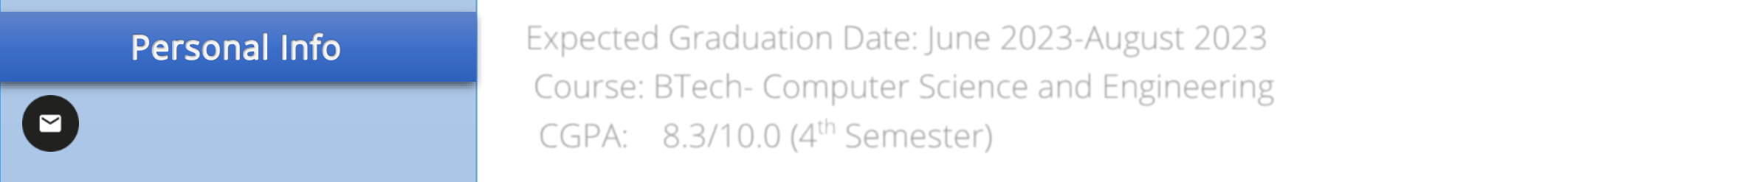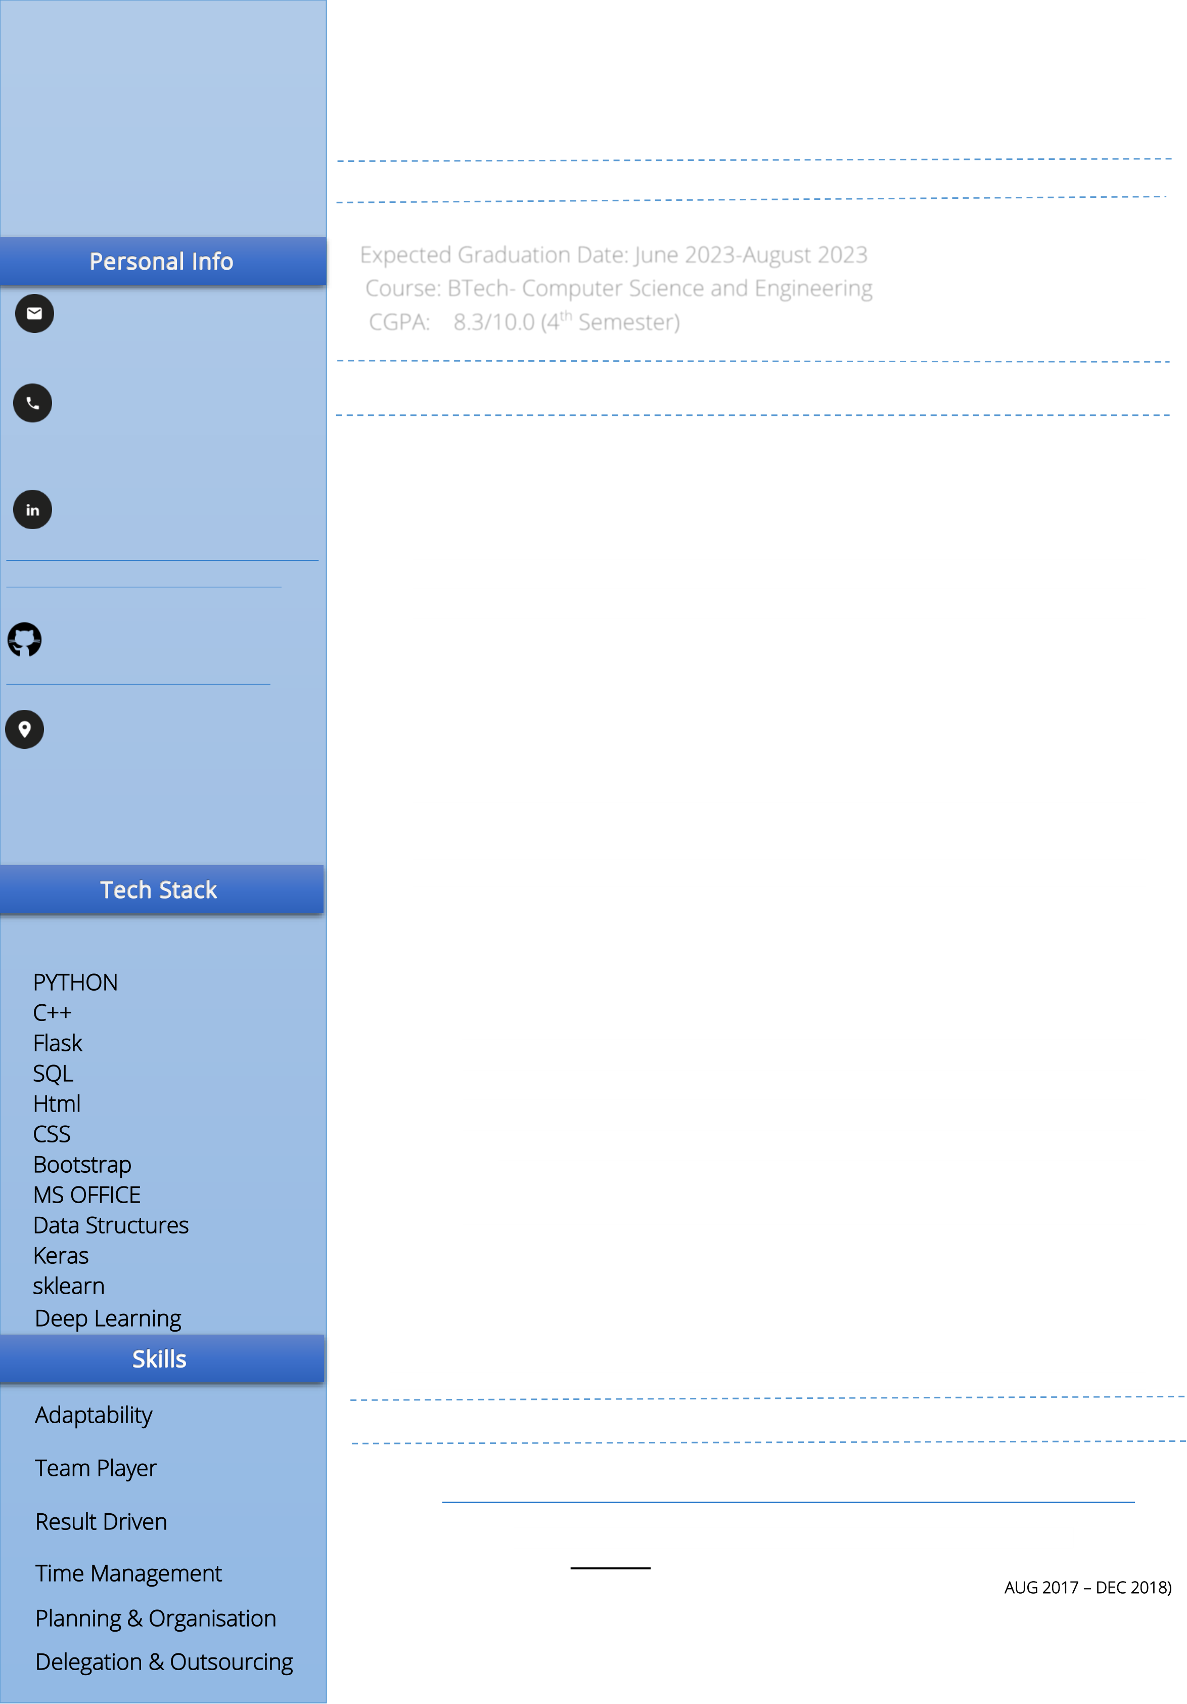

**EXPERIENCE**

|  |  |
| --- | --- |
| **91-8698898180** | **DATA Annotator (Student volunteer Intern)** *Remote* |

***Strata-Unison, New York, NY*** */ September 2021 – November 2021*

**[https://www.linkedin.com/in/cli](https://www.linkedin.com/in/clinsan-fernandes-34085819b)** •Tag and annotate large volumes of Images to serve as input for the

**[nsan-fernandes-34085819b](https://www.linkedin.com/in/clinsan-fernandes-34085819b)**  machine learning team   
 •Help aggregate, clean, and organize data for machine learning applications

|  |  |
| --- | --- |
| **https://github.com/Clinsan** | **Research Intern** |

***DY. PATIL INTERNATIONAL UNIVERSITY, Pune, India*** */ June 2021 – July 2021* **Hno. 67,Igreza Waddo,Marna,**   
**Siolim ,Bardez Goa;**  •Developed an Automatic Evaluation of answer sheet and Marking **INDIA 403517**  System   
 •***Helped to refactor the system. Eliminated 40% of team efforts of***  ***existing code, with an overall code base reduction of about 30%.***

•Developed using Python , Tkinter, XLRD and fuzzywuzzy logic

|  |  |  |
| --- | --- | --- |
| PYTHON  C++  Flask  SQL  Html  CSS  Bootstrap  MS OFFICE  Data Structures Keras  sklearn  Deep Learning  Adaptability  Team Player  Result Driven  Time Management  Planning & Organisation  Delegation & Outsourcing | **PROJECTS**  ❖**Cancer Detection System (SKIN AND BRAIN)**  •Built a Webapp to predict if a person suffers from skin cancer and brain tumor using MRI scans and Dermoscopic images.  •Built using Flask, Keras Model,Html,CSS,Javascript,Bootstrap.  ❖**Hospital Management System:**  •A Webapp used to book appointments and handle Hospital operations.  •***Worked as an equal member of a three person team. Contributed***  ***to develop the frontend and database.***  •Built using Flask,Html,CSS,Javascript,Bootstrap,PHP,SQL.  **Activities**  ❖Participated in GOOGLE 30 DAYS OF CODE   <https://www.qwiklabs.com/public_profiles/6c5d345c-08a7-4220-8f87-4b3ac89d91ab> | |
| • | **[The program was a kickstart to Computing, Application Development, Bi](https://www.qwiklabs.com/public_profiles/6c5d345c-08a7-4220-8f87-4b3ac89d91ab)g Data & [Machine](https://google.qwiklabs.com/) Learning using Google Cloud's training platform**  **called [Qwiklabs](https://google.qwiklabs.com/) .** |
| ❖Student Council Member (DMC High Secondary School) (AUG 2017 – DEC 2018) | |
| • • | **Was In charge of the core team of the Science Section that Planned and Organized Activities, Events and Competition.**  **Held Monthly Council and Coordination Meets and Activities.** |