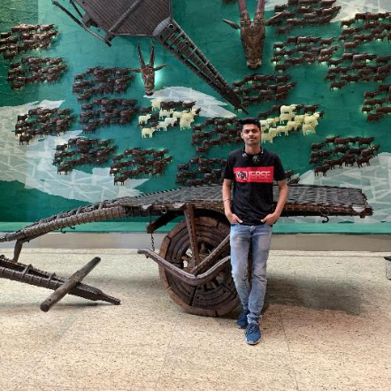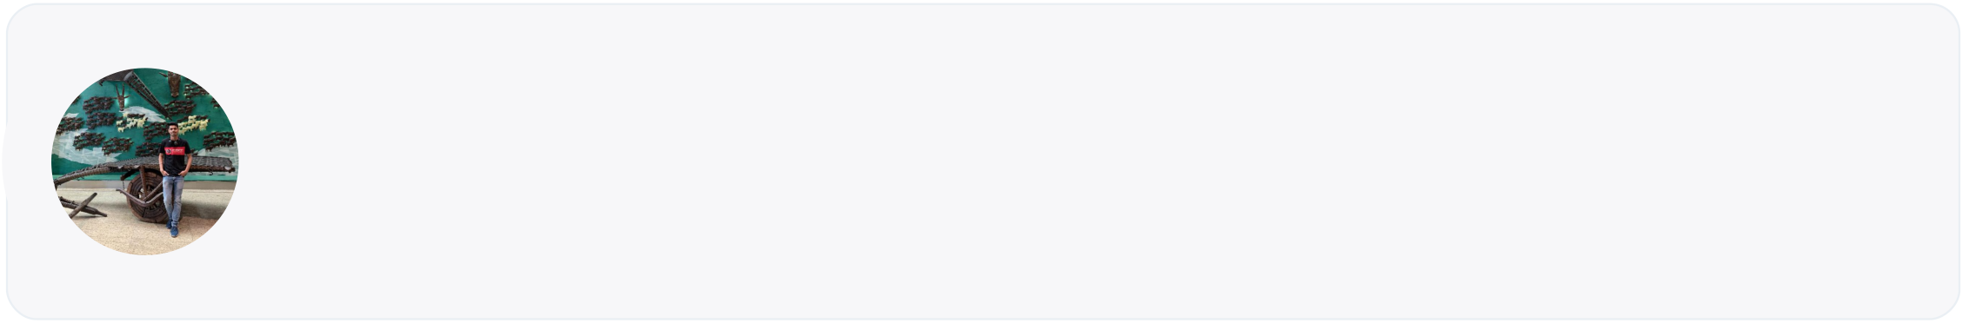

viplav patwardhan   
Full-stack Developer • Data Science • Front-end Developer

D. Y. Patil International University • 2023 Pass out

[LinkedIn](https://www.linkedin.com/in/viplav-pramod-patwardhan-0667a31b7/) • [Github](https://github.com/viplav113) • [Cuvette Profile](https://links.cuvette.tech/student/622261dd0825f80385e49151) • [Email](mailto:viplavpatwardhan777@gmail.com) • 9146941442

|  |  |
| --- | --- |
| Work Experience  Web development @ The spark Foundation, Pune  May 2021 - June 2021 (1 month) | Part-time  01. My task is to developed basic banking system which contains the transactions history.  02. I have developed the UI and done the backend part using html, css, and for backend part I have used java, MySQL for dataset.  03. In this we can see payment history and remaining payments of users. And we can enter a amount what we have pay . | Tagline  Experience in developing web applications using HTML, CSS, JavaScript, AngularJS, NodeJs.  Technical Skills  HTML | CSS | Python | Angular | NodeJs | MySQL  Additional Skills  Quick Learner | Time management | Creativity |

Skills Developed: HTML, CSS, Java, MySQL

|  |  |
| --- | --- |
| Team Members: Jigar sable (Full stack developer ) | Education |

Chate school

|  |  |
| --- | --- |
| Projects  House Rental Management System  01. By this management system user can easily find house. 02. Firstly we developed the login page then we work on home page. | Class X |  2015 - 2017  D. Y. Patil International University, Gurudwara Colony, Nigdi, Pune, Maharashtra  B.Tech, Computer Science & Information  Technology (CSIT) |  2019 - 2023 |
| 03. In this project, we use four tables. Houses, tenants, payment, and house type. This system manages the payments and  recommends houses.  Skills Developed: MySQL, HTML, CSS  RestApi  01. ability to add/delete/update/modify todo  02. Start from index file then created config, model, routes and schemas file.  03. basic todo rest Api along with auth and ability to  add/delete/update/modify todo and use proper folder structure  Skills Developed: MongoDB, Python, API  Brain Tumor Classification  01. To automatically segment tumor regions in brain.  02. I am using Mask R-CNN to build an actual detector which will point out the location of the tumor on the scan.  03. The aim of this project is to predict the position of tumor in brain MRI using deep learning algorithms. | Certifications & Courses  web development  March 2020 | [Certificate Link](https://trainings.internshala.com/verify_certificate)  Computational Thinking with beginning C programming specialization  August 2020 | Certificate Link  Data Analysis and Representation, Selection and Iteration  July 2020 | Certificate Link  Object-Oriented Data Structures in C++  August 2020 | Certificate Link  Simulation, Algorithm Analysis, and Pointers September 2020 | Certificate Link  Android App Development  July 2021 | Certificate Link |

Skills Developed: Python, API, XML